MINISTRY OF EDUCATION AND TRAINING



**Capstone Project Document**

**Photographic Studio Management**

**Project Code: PSM**

|  |  |  |
| --- | --- | --- |
| PSM Team | | |
| Group members | Nguyen Manh Huy | SE03199 |
| Nguyen Sy Bach | SE03704 |
| Pham Tuan Dung | SE03655 |
| Cao Lam Vu | SE03800 |
| Nguyen Hoang Trung | SE03608 |
| Supervisor | **Mr. Phan Truong Lam** | |
| Capstone Project Code | **PSM** | |

*Acknowledgements*

*We wish to express our deepest gratitude to our supervisor: Mr. Phan Truong Lam for his tutorial, sharing and motivating throught the project. Under the instructions of Mr. Phan Truong Lam, the project team has always complete at doing all assigned tasks and solving all problems. Apart from all the technologies and methodologies, Mr. Phan Truong Lam shared with us the philosophy of keeping the right attitude towards problems. We believe that was the most important factor that led to the success of this project.*

*We would also like to thank the instructors at FPT University for all the classes. We hope you will find this project as a reflection of the knowledge and experiences you have given us.*

*Finally, we truly appreciate all of our friends who has discussed with us. With your help, we have been recognized and solve every arised problem.*

Table of Contents 目次

1 INTRODUCTION はじめに 9

1.1 Purpose　目的 9

1.2 Project information　プロジェクトの情報 9

1.3 Project members　プロジェクトメンバー 9

1.4 Our proposal　提案 10

1.4.1 Problem　問題 10

1.4.2 Solution　解決 10

1.4.3 Idea　アイディア 10

1.5 Product　商品 10

1.5.1 Basic Functions　基本的な機能 10

1.6 Benefit from project　プロジェクトからベネフィット 12

1.6.1 For our group　グループのために 12

1.6.2 For user　ユーザーのために 12

2 SOFTWARE PROJECT MANAGEMENT　ソフトウェアプロジェクト管理 13

2.1 Software development process　ソフトウェア開発のプロセス 13

2.2 Project Organization　プロジェクト組織 15

2.2.1 Project Organizational Structure　組織構造 15

2.2.2 Project Team　プロジェクトチーム 16

2.3 Project schedule　プロジェクトスケジュール 18

2.4 Meeting minutes　打ち合わせ議事録 18

2.5 Project Milestones　プロジェクトマイルストーン 20

2.6 Project Deliverables　プロジェクトの成果物 20

2.7 Resource　リソース 22

2.7.1 Human resource　人的リソース 22

2.7.2 System Resource　システムリソース 23

2.8 Risk Management　リスク管理 24

2.9 Communication Management　コミュニケーション管理 26

2.9.1 Communication between Team Members　チームメンバーの間のコミュニケーション 26

2.9.2 Communication with Supervisor　指導教員とコミュニケーション 26

2.10 Configuration Management Process　コンフィグレーション管理 26

2.10.1 Project Infrastructure　プロジェクトインフラストラクチャ 26

2.10.2 Directory structure　ディレクトリ構造 27

2.10.3 Coding convention　コーディング規約 28

3 SOFTWARE REQUIREMENTS SPECIFICATIONソフトウェア要件仕様 30

3.1 Overview　概要 30

3.2 Introduction　はじめに 30

3.2.1 Purpose　目的 30

3.2.2 Scope　範囲 30

3.2.3 References　参照資料 31

3.3 Non-Funtionality Requirements 31

3.3.1 Usability 　ユーザビリティ 31

3.3.2 Reliability 　信頼性 31

3.3.3 Maintainability　保全性 31

3.4 Overall Description　概要説明 31

3.5 Specific Requirements 　 要求仕様 35

3.5.1 Business Rules　ビジネスルール 35

3.5.2 Actor 35

3.5.3 Use Case List 36

3.5.4 Functionality　機能要求 38

3.6 Entity Relation Modelエンティティ関係モデル 88

3.6.1 Entity-Relationship Diagram エンティティ- 関係図 88

3.6.2 Entity descriptionエンティティの説明 92

3.6.3 Relationship 関係 93

4 ARCHITECTURE DESIGN　アーキテクチャ設計書 95

4.1 Introduction　はじめに 95

4.1.1 Purpose　目的 95

4.1.2 References　参照資料 95

4.2 Architectural Overview　アーキテクチャ概要 95

4.2.1 System Architecture　システムアーキテクチャ 95

4.3 System Architecture Explanation　システムアーキテクチャについての説明 96

4.4 Design of PhotoGraphic Studio Manager 97

4.4.1 Database Design データベース設計 97

4.4.2 Database detail　データベースの詳細 97

4.5 Component Diagramコンポーネント図 102

4.6 Detail Design　詳細設計 103

❖ Admin 103

❖ Manager 146

❖ Customer 191

5 SOFWARE TESTING ソフトウェアテスト 208

5.1 Introduction　はじめに 208

5.1.1 Purpose　目的 208

5.1.2 References　参照資料 208

5.1.3 Background information　背景情報 208

5.1.4 Scope of testing　テスト範囲 208

5.2 Constraints　制約事項 208

5.2.1 Risk list 　リスク一覧 209

5.3 Requirements for Test　テスト要求 209

❖ Test items　テスト頭目 209

5.4 Test strategy　テスト戦略 212

5.4.1 Test types テストタイプ 212

5.4.2 Function Testing　機能テスト 213

5.4.3 User Interface Testing　ユーザーインターフェーステスト 214

5.4.4 Test stages　テストステージ 214

5.5 Resource　リソース 215

5.5.1 Human Resource　人的リソース 215

5.5.2 Test management　テスト管理 215

5.5.3 Defect management　欠陥管理 216

5.6 Test environment　たテスト環境 216

5.7 Test Milestones　テストマイルストーン 218

5.8 Deliverables　納品物 219

5.9 Test Case　テストケース 219

5.10 Test Report　テストレポート 227

5.10.1 Unit Test Report 227

5.10.2 Integration Test Report　統合テストレポート 228

5.10.3 System Test Report　システムテストレポート 228

5.10.4 Test Report　テストレポート 229

6 USER MANUAL　ユーザーマニュアル 230

6.1 Home Page /ホームページ 230

6.2 Admin Guidelines /管理者ガイドライン 231

6.2.1 Login/ログイン 231

6.2.2 Log out /ログアウト 232

6.2.3 Admin Manager /管理者マネージャ 232

6.2.4 List Manager /リストマネージャー 233

6.2.5 Search Manager /検索マネージャ 233

6.2.6 Edit Manager /編集マネージャ 236

6.2.7 Delete Manager /マネージャを削除 238

6.2.8 Studio Manager. /スタジオマネージャー。 242

6.2.9 Search Studio /スタヂオを検索します。 242

6.2.10 Show Studio location/スタジオロケーションを表示。 244

6.2.11 Edit Studio / スタヂオの編集 244

6.2.12 Delete Studio. 247

6.2.13 Add Studio 248

6.2.14 District Manager /地区マネージャー。 250

6.2.15 Search District /地区の検索 251

6.2.16 Add new District/新しい地区を追加します。 252

6.3 Manager Guidelines.マネージャガイドラン。 253

6.3.1 Login ログイン 253

6.3.2 Logoutログアウト 254

6.3.3 Studio Profileスタジオのプロフィール 254

6.3.4 Edit Studio Profile / スタヂオプロフィールを編集 255

6.3.5 Package Manager ・パッケージマネージャー 255

6.3.6 Search Package 検索パッケージ 256

6.3.7 Edit Package ・パッケージの編集 257

6.3.8 Delete Package. パッケージを削除します。 259

6.3.9 Picture Manager 画像マネージャ 260

6.3.10 Search Contract Detail by keyword/キーワード別検索契約の詳細 260

6.3.11 View Picture写真を見ます 262

6.3.12 Search Picture検索画像 263

6.3.13 Upload Picture 263

6.3.14 Update Picture Detail 写真の詳細を更新します。 264

6.3.15 Delete Picture. 画像を削除します。 265

6.3.16 Contract Manager 契約マネージャー 266

6.3.17 Search Contract 検索契約 267

6.3.18 Add Contract 契約を追加します。 271

6.3.19 View Contract Detail. 契約の詳細を表示します。 275

6.3.20 Edit Contract Detail. 契約の詳細を編集します。 275

6.3.21 Delete Contract Detail. 契約の詳細を削除します。 276

6.3.22 View Picture form Contract Detail. 画像形式の契約の詳細を表示します。 276

6.3.23 Add new Picture Detail. 新しい画像の詳細を追加します。 276

6.4 Customer Guidelines. 顧客ガイドライン。 279

6.4.1 Open Home Page ホームページを開く。 279

6.4.2 View Studio Listスタジオリストを表示します。 279

6.4.3 View Studio Detail Page Studio Studioスタジオの詳細ページスタジオを表示する 281

6.4.4 View Package Detailパッケージの詳細を表示します。 281

6.4.5 Add Package on Cart. カートにパッケージを追加します。 282

6.4.6 View review Album. アルバムを見ます。 284

6.4.7 View one of Album type. アルバムタイプの1つを表示します。 284

6.4.8 Show own Contract. 自分の契約を表示します。 286

6.4.9 Show About Us. 私たちについて 286

Definition and acronyms

|  |  |  |
| --- | --- | --- |
| Acronym | Definition | Note |
| PSM | Photographic Studio Management | Project’s name |
| SRS | Software Requirement Specifications |  |
| CI | Configuration Item |  |
| CM | Configuration Management |  |
| Admin | Administrator |  |
| Manager | Photo Studio Manager |  |
| PM | Project Manager |  |
| PTL | Project Technical Leader |  |
| CRC | Class-Responsibility-Collaborators |  |
| AT | Acceptance Test |  |
| IT | Integration Test |  |
| KLOC | 1000 lines of code |  |
| PM | Project Manager |  |
| PTL | Project Technical Leader |  |
| PT/TT | Program Test/ Total Test |  |
| QA | Quality Assurance |  |
| UT | Unit Test |  |
| PC | Personal Computer |  |
| UI | User Interface |  |

# INTRODUCTION はじめに

## Purpose　目的

This chapter provides an overview of Photographic Studio Management system, it includes background information, literature review of existing system and raising a proposal for ideas of improvement.

## Project information　プロジェクトの情報

|  |  |
| --- | --- |
| Project name: | Photographic Studio Management |
| Project code: | PSM |
| Project type: | Website |
| Project category: | New development |
| Business type: | Website Service |
| Project manager: | Nguyen Manh Huy |
| Timeline: | 08/01/2018 – 10/05/2018 |

Table 1.1 - Project Information

## Project members　プロジェクトメンバー

* Supervisor:

|  |  |  |
| --- | --- | --- |
| Full name | E-mail | Title |
| Phan Truong Lam | Lampt2@fe.edu.vn | Lecturer |

* Team member:

|  |  |  |  |  |
| --- | --- | --- | --- | --- |
| Full name | Roll number | E-mail | Phone | Position |
| Nguyen Manh Huy | SE03199 | HuynmSE03199@fpt.edu.vn | 01689597078 | Leader |
| Nguyen Sy Bach | SE03704 | BachnsSE03704@fpt.edu.vn | 01228245737 | Member |
| Cao Lam Vu | SE03800 | VuclSE03800@fpt.edu.vn | 01689181825 | Member |
| Pham Tuan Dung | SE03655 | DungptSE03655@fpt.edu.vn | 01646426345 | Member |
| Nguyen Hoang Trung | SE03608 | TrungnhSE03608@fpt.edu.vn | 01635105330 | Member |

## Our proposal　提案

### Problem　問題

When someone want to find a photo studio to make an album nowaday, they will ask their family and friend or search for one on the internet. However, there are so much information about unknow photo studio on the internet, customer find it difficult to find their ideal photo studio because of the number and confusing information.  
When they find a good studio, the website usually just for advertisement and have no management use for both the studio manager and customer. It makes the customer wasted more time to come to take photoshoot, and come again later to collect the photos. And without a management tools, the studio manager will have problems keep track of customer and photo contract.  
Therefore, the posed problems are making an interaction between customer and photo studio, help the customer to search for the best studio as quick as possible, and make it easier for studio manager manage customer and contract.

### Solution　解決

Create a website that allow customer to find and choose their wanted photo package, make and keep track their contract and receive their photo online. For studio manager, they can have a website that have all the management tool to manage their studio information, photo packages, customers and contracts.

### Idea　アイディア

Project idea is creating a website not only to link customer and photo studio but also to help customer manage information about the photo conctract quickly and efficiently.

## Product　商品

After learning about the market needs of photo conctract, we have chosen main functions which are necessary and important to our system. It will help the manager easy to use and operate.

For customer, they will only need to visit the website, browse the photopackage that the studio provides, view the package detail info, add to cart and place their order. The website will save the customer info and send the order to the manager. Finish a deal with customer, an order is created. If the order is paid, the studio takes pictures of the customer then upload photos on the website; customer can get the photos at anytime, anywhere.

The target user of the website is Vietnamese. Therefore, Vietnamese is the primary language.

### Basic Functions　基本的な機能

#### Customer

* View studio basic informations and sample album.
* View and choose a photo package.
* Leave contact information.
* See photo uploaded after photo shoot.

#### Photo Studio Manager

* Login & Logout.
* Change password & Forgot password.
* **Manage Photo Studio**
* View studio information.
* Edit studio information
* **Manage Package**
* Search & View photo package.
* Edit photo package.
* Add photo package.
* Delete photo package
* **Manage Contract**
* Search & View contract information.
* Edit Contract.
* Add Contract.
* **Manage Picture**
* Edit picture info.
* Upload Picture.
* Delete Picture.
* **Manage Customer**
* View customer informations.

#### Admin

* Login & Logout.
* Change password.
* Forgot password.
* **Manage Photo Studio**
* Search studio profile.
* View studio profile
* Edit studio profile.
* Add studio.
* Delete Studio.
* **Manage Photo Studio Manager**
* Search manager profile.
* View manager profile
* Edit a manager profile.
* Add a manager.
* Delete a manager.
* **Manage Province and District**
* Search province and district information.
* View province and district information.
* Edit province and district information.
* Add a province or district.
* Delete a province or district.

Out of scope

* **Manage Website’s payment activities**

Online payment and comunication between customer and studio shop to make a contract are out of the scope of the project.

## Benefit from project　プロジェクトからベネフィット

### For our group　グループのために

After developing and implementing this project, our group will get some benefits:

* Have more experiences of software project management: how to manage plan, time, member and risk.
* Have more knowledge and skill about Node.js, and HTML, MySQL.
* Know how to communicate with team members and how to make teamwork more effective.

### For user　ユーザーのために

* Improving chances to finding the best photo studio.
* Saving time and costs for studio.
* Customer can track photo contract.

# SOFTWARE PROJECT MANAGEMENT　ソフトウェアプロジェクト管理

In this section, we will describe our organization and plan of project. Each member of team must use this section as a guideline tracking assigned tasks and deadlines. In addition, we introduce our team and overview about project. Meeting minute also present in this section. Moreover, we will describe risks of project and the way communication of our team.

## Software development process　ソフトウェア開発のプロセス

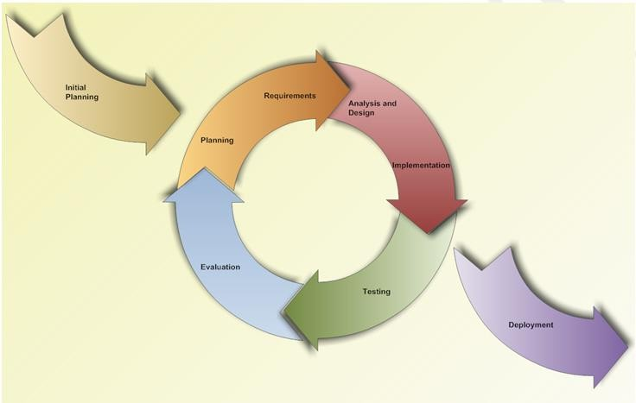This figure below will describe the information and Iterative software process model.

Figure 2.1Iterative software process model

PSM project uses the Iterative software process.

We have chosen the Iterative software process model because the scope of our project is not too big. Our project starts with a simple implementation of a small set of the software requirements, which iteratively enhances the evolving versions until the complete system is implemented and ready to be deployed.

By using this software process model, we can implement the project during the earlier stages of software development process, which allows developers and testers to find functional or design related flaws as early as possible.

This model makes the project needs less time on documenting and more time for designing. Easier to manage risks because risks are identified and resolved during iteration; and each iteration is an easily managed. Besides, the iterative model is easier than other models when the issues are discovered. All issue will be raised to the team. They will be solved while the project is still developed.

## Project Organization　プロジェクト組織

### 2.2.1 Project Organizational Structure　組織構造

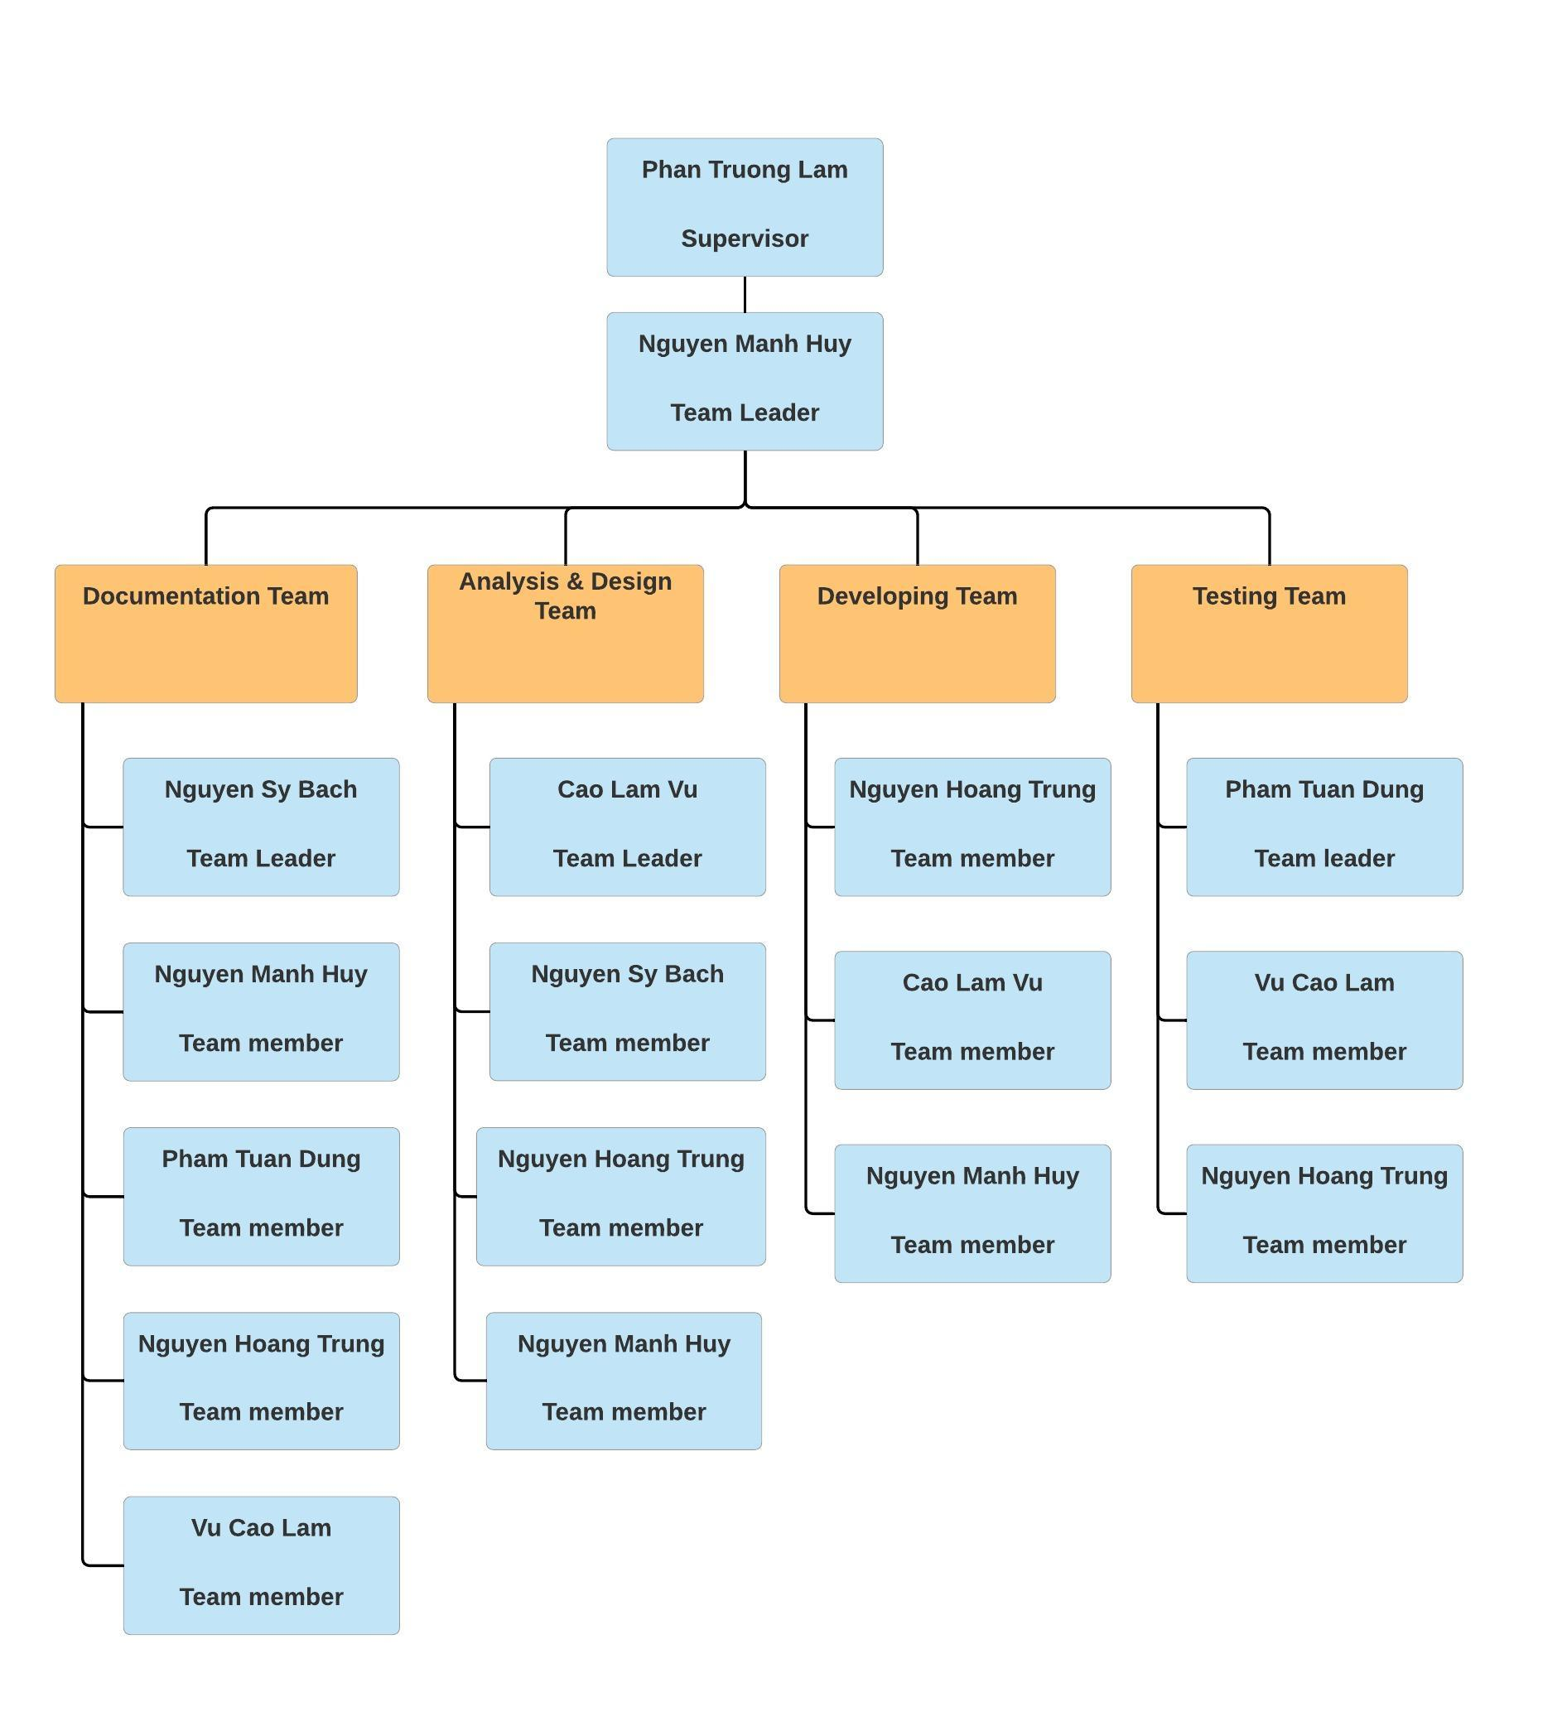

Figure 2.2.1Organizational structure chart

### 2.2.2 Project Team　プロジェクトチーム

|  |  |  |  |  |  |
| --- | --- | --- | --- | --- | --- |
| Role | Responsibility | Full name | Start date | | End date |
| Instructor | * Provide templates & tools * Review deliverables * Review project status * Resolve escalated issues * Consultant | Pham Truong Lam | January  08th,2018 | May  03th,2018 | |
| PM | * Planning and defining scope * Developing schedule * Reviewing and Tracking document * Identify resources and assign individual responsibilities * Assign task to team members * Coordinating communication | Nguyen Manh Huy | January  08th,2018 | May  03th,2018 | |
| Analysis and Design Team | | | | | |
| Team Leader | * Reviewing and Tracking design * Identify main UI * Draw prototype, Architecture Design * Database Design | Cao Lam Vu | January  09th,2018 | May  02th,2018 | |
| Team member #1 | * Database Design * Draw prototype, Architecture Design | Nguyen Hoang Trung | January  09th,2018 | May  01th,2018 | |
| Team member #2 | * Database Design * Draw prototype, Architecture Design. | Nguyen Sy Bach | January  09th,2018 | May  01th,2018 | |
| Team member #3 | * Screen Design. | Nguyen Manh Huy | January  09th,2018 | May  01th,2018 | |
| Documentation Team | | | | | |
| Team Leader | * Reviewing and Tracking Requirement. | Nguyen Sy Bach | January  09th,2018 | May  02th,2018 | |
| Team member #1 | * Create SRS document. * Create Project Schedule. * Create Usecase. * Create User Manual. | Nguyen Manh Huy | January  09th,2018 | May  02th,2018 | |
| Team member #2 | * Create Class Diagram and Sequence. | Vu Cao Lam | January  09th,2018 | May  02th,2018 | |
| Team member #3 | * Create Class Diagram and Sequence. | Nguyen Hoang Trung | January  09th,2018 | May  02th,2018 | |
| Team member #4 | * Create Software Testing. | Pham Tuan Dung | January  09th,2018 | May  02th,2018 | |
| Development Team | | | | | |
| Team Leader | * Developing and review tracking. | Nguyen Hoang Trung | January  09th,2018 | May  02th,2018 | |
| Developer #1 | * Developing. | Cao Lam Vu | January  09th,2018 | May  02th,2018 | |
| QA and Test Team | | | | | |
| Test Leader | * Responsible for test execution. * Test results recording * Evaluation of test run and error recovery. | Pham Tuan Dung | Febuary 11th,2018 | May  02th,2018 | |
| Tester #1 | * Creat Unit test | Nguyen Manh Huy | Feburary 20th,2018 | May  02th,2018 | |
| Tester #2 | * Testing. | Cao Lam Vu | Febuary  11th,2018 | May  02th,2018 | |

Table 2.2.2 Project Team

## Project schedule　プロジェクトスケジュール

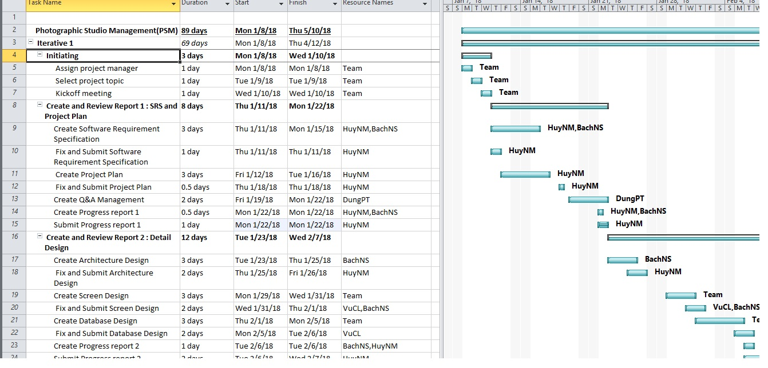

## Meeting minutes　打ち合わせ議事録

All meeting minutes will be written follow this template:

|  |  |  |  |
| --- | --- | --- | --- |
| Meeting Minutes 1 | | | |
| Subject | Comment on Report 1 | **Date** | 19/01/2018 |
| Conductor | Prof. LamPT | **Time** | 10h30’ |
| Location | Room 105L Beta building | **Secretary** | BachNS |
| Attendees | HuyNM, VuCL, TrungNH, DungPT, BachNS | | |
| Absent | No | | |
| Meeting Objective | 1. Review and tracking task of member. 2. Assign new task for member. 3. Do report 2. | | |

|  |  |  |
| --- | --- | --- |
| Key Points Discussed | | |
| No. | Topic | Highlights |
| 1 | Common work progress. | Done: report 1.  Progress: report 2. |
| 2 | Setup working environment :Tools to manage source code, documents, database... | Done |
| 3 | Learn Nodejs, Learn Css | In progress |
| 4 | Assigning someone looking data for Studio. | TrungNH |

|  |  |  |  |
| --- | --- | --- | --- |
| Action Plan | | | |
| No. | Action Item(s) | Owner | Target Date |
| 1 | Define the roles & responsibilities of each team member. | HuyNM | 22/01/2018 |
| 2 | Analyze requirement, make project plan to be written in template format. | HuyNM, TrungNH | 24/01/2018 |
| 3 | Design: ERD, System architecture, Class diagram, Sequence diagram, Use case diagram... | HuyNM, VuCL,  TrungNH,BachNS | 17/01/2018 |
| 4 | Estimate number of use cases, the number of 30 use cases is appropriate. | VuCL,TrungNH, BachNS | 19/01/2018 |
| 5 | Write the report 2, report 3 | HuyNM,BachNS | 22/01/2018 |

## Project Milestones　プロジェクトマイルストーン

|  |  |  |  |
| --- | --- | --- | --- |
| No | Milestone | Completion Date | Verification |
| 1 | Project Start | 08/01/2018 | Instructor approval |
| 2 | Submit report 1 | 21/01/2018 | Instructor approval |
| 3 | Submit report 2 | 07/02/2018 | Instructor approval |
| 4 | Submit report 3 | 01/03/2018 | Instructor approval |
| 5 | Submit report 4 | 28/03/2018 | Instructor approval |
| 6 | Submit report 5 | 12/04/2018 | Instructor approval |
| 7 | Submit report 6 | 26/04/2018 | Instructor approval |
| 8 | Submit final report | 03/05/2018 | Instructor approval |
| 9 | Final presentation | 10/05/2018 | Instructor approval |

## Project Deliverables　プロジェクトの成果物

|  |  |  |  |  |  |
| --- | --- | --- | --- | --- | --- |
| **No** | **Deliverable** | **Committed Delivery date** | **Assign to** | **Description of Deliverable** | **Delivery media** |
| 1 | Capstone project register | 25/04/2018 | HuyNM |  | Hard copy |
| **Iteration 1** | | | | | |
| 2 | Software Requirement Specifications - SRS | 11/01/2018 | HuyNM, BachNS | Document | Commit to Github |
| 3 | Project plan | 12/01/2018 | HuyNM | Document | Commit to Github |
| 4 | User requirements | 18/01/2018 | BachNS | Document | Commit to Github |
| 5 | Q&A Management | 19/01/2018 | HuyNM, DungPT | Document | Commit to Github |
| 6 | **Progress report 1** | 22/01/2018 | HuyNM, BachNS | Document | Commit to Github |
| 7 | Architecture design | 23/01/2018 | BachNS | Document | Commit to Github |
| 8 | User interface design | 25/01/2018 | VuCL | Document | Commit to Github |
| 9 | Database Design | 30/01/2018 | VuCL, TrungNH | Document | Commit to Github |
| 10 | **Progress report 2** | 07/02/2018 | HuyNM, BachNS | Document | Commit to Github |
| 11 | Test plan | 10/02/2018 | DungPT | Document | Commit to Github |
| 12 | Use case | 16/02/2018 | DungPT, HuyNM | Document | Commit to Github |
| 13 | **Progress report 3** | 01/03/2018 | BachNS, HuyNM | Document | Commit to Github |
| 14 | Developing | 08/03/2018 | TrungNH,VuCL | Coding | Commit to Github |
| 15 | Create Unit Test | 16/03/2018 | HuyNM | Coding | Commit to Github |
| 16 | Create Integeration Test | 20/03/2018 | DungPT, HuyNM | Document | Commit to Github |
| 17 | **Progress report 4** | 26/03/2018 | TrungNH, VuCL | Document | Commit to Github |
| 18 | System Test | 30/03/2018 | DungPT | Document | Commit to Github |
| 19 | Test case - execute | 02/04/2018 | DungPT | Document | Commit to Github |
| 20 | Test report | 16/03/2018 | BachNS | Document | Commit to Github |
| 21 | **Progress report 5** | 12/04/2018 | Team | Document | Commit to Github |
| **Iteration 2** | | | | | |
| 22 | User manual | 16/04/2018 | HuyNM, BachNS, DungPT | Document | Commit to Github |
| 23 | **Progress report 6** | 26/04/2018 | HuyNM, BachNS | Document | Commit to Github |
| 24 | Final Report | 03/05/2018 | Team | Document | Hard copy |

## Resource　リソース

### Human resource　人的リソース

* Team members
* Supervisor

|  |  |  |  |  |
| --- | --- | --- | --- | --- |
| **Worker/Doer** | **Role** | **Man/Month** | **Skills/Abilities** | **Location** |
| HuyNM | PM | 89 days | * Planning and defining scope. * Developing schedule . * Reviewing and Tracking document. * Identify resources and assign individual responsibilities. * Assign task to team members. * Coordinating communication. | FPT University, Hoalac |
| TrungNH | Developer | 89 days | * Developing and review tracking. * Writing class diagram and Sequence. | FPT University, Hoalac |
| VuCL | Developer | 89 days | * Reviewing and Tracking design. * Identify main UI. * Draw prototype, Architecture Design. * Database Design. * Writing class diagram and Sequence. | FPT University, Hoalac |
| DungPT | Tester | 89 days | * Responsible for test execution. * Test results recording. * Evaluation of test run and error recovery. | FPT University, Hoalac |
| BachNS | Document | 89 days | * Reviewing and Tracking Requirement. * Draw prototype, Architecture Design. * Usecase design. | FPT University, Hoalac |

Table *.2.1:* *Human Resourse*

### System Resource　システムリソース

|  |  |  |  |  |
| --- | --- | --- | --- | --- |
| **Name** | **System Configuration** | **Detail** | **Purpose** | **Location and time** |
| ASUS TP550LA | * CPU: Core i5, 2.4GHz * RAM: 4GB * Screen: 15,6inch * Resolution: 1366x768pixels | Microsoft windows 10 Professional 64bit | Create testing document materials and execute test phase. | - Location: Room 313R Alfa building and room 105R Alfa building at FPT university Hoa Lac.  - Time: 11am to 6pm Monday to Friday. |
| Laptop Sony Vaio Fit15-E | * CPU: Core i7, 2.4GHz * RAM: 8GB * Screen: 15,6inch * Resolution: 1366x768pixels | Microsoft windows 10 Professional 64bit | Run web application, Fix and setup environment. | - Location: Room 313R Alfa building and room 105R Alfa building at FPT university Hoa Lac.  - Time: 11am to 6pm Monday to Friday. |
| Laptop HP Pro G0 | * CPU: Core i5, 2.6GHz * RAM: 8GB * Screen: 15,6inch * Resolution: 1366x768pixels | Microsoft windows 10 Education 64bit | Run web application, Fix and setup environment. | - Location: Room 313R Alfa building and room 105R Alfa building at FPT university Hoa Lac.  - Time: 11am to 6pm Monday to Friday. |
| Dell Vostro 5560 | * CPU: Core i5, 2.4GHz * RAM: 8GB * Screen: 15,6inch * Resolution: 1366x768pixels | Microsoft windows 10 Professional 64bit | Create unit test cases and execute unit test. | - Location: 17 Duy Tan, Cau Giay, Ha Noi.  - Time: 11am to 6pm Monday to Friday. |
| MacBook Pro | * CPU: Core i5, 2.5GHz * RAM: 4GB * Screen: 15,6inch * Resolution: 1366x768pixels | MacOS HighSierra  Ver 10.13.2 | Create and run Unit Test, Test case, Usecase. | - Location: Room 313R Alfa building and room 105R Alfa building at FPT university Hoa Lac.  - Time: 11am to 6pm Monday to Friday. |

Table 2.7.3: System Resourse

## Risk Management　リスク管理

|  |  |  |  |  |  |  |
| --- | --- | --- | --- | --- | --- | --- |
| No | Name | Root Cause | Probability | Avoidance plan | Contingency plan | Impact |
| 1 | Team don’t keep the deadline on time. | Members lack of responsibility, sick.  Lack of management. | Medium | Make rules and penalties for people who doesn’t meet the deadline. | Working overtime to complete on time  Punish member by money... | High |
| 2 | Requirement changed while project is processing. | SRS is not providing all information about user requirement such as: lack of customer’s requirement, misunderstand requirement of customer. | High | SRS should be review carefully by PM and the Supervisor.  Always do brainstorming carefully to design detail system. Hold all meeting and make minimize effort to change and improve design by requirement changes. | Team members will have meetings with supervisor to analyze the requirement change, and make a specific action to resolve that problem. | High |
| 3 | Delivery does not meet the deadline. | Team member work late, have other family business. | High | Assign tasks to suitable team members depending on their strengths and weakness. | Team leader should regularly care about deadline and project schedule to inform members.  Break down task to smaller tasks and assign new tasks to team members. | Medium |
| 4 | Lack of knowledge about technology needs for project. | With some member, they want to study new technology through this project. | Medium | Each team member must study to understand the technology, framework, which is needed for project. | Take advice from superviser. Self-study. | Medium |
| 5 | Conflict among team members. | Team member doesn't understand each other. | Medium | Plan some games or team building activities to improve teammate’s relationship and to understand each other.  Clear role and responsibility between members. | Have a meeting to resolve conflict problems. | High |
| 6 | Data or Source Code Lost. | Delete Brand in GitHub.  Delete wrong source code. | Medium | Back up source code carefully. Commit all small tasks after complete to GitHub. | Restore data from backed up data.  Restore source code from history versions. | High |

Table 2.8 Risk Management

## Communication Management　コミュニケーション管理

### Communication between Team Members　チームメンバーの間のコミュニケーション

* **Face-to-face meeting:** at least twice a week at Monday and Thursday. This is the fastest way of communication to solve big problems in the project and members can help out each other easily.
* **E-mail and message:** Email, Skype and Facebook are used for members to keep tracking other team member’s progress and team members can also help each other online.
* **Mobile Phone:** is using for emergency to directly contact to others.
* **Collaboration tool:** GitHub is used for document and source code management.

### Communication with Supervisor　指導教員とコミュニケーション

* **Face-to-face meeting:** Weekly on every Thursday afternoons to make sure that supervisor can keep tracking of the team’s progress.
* **E-mail:** Gmail is the fastest way to get advice and document checking from supervisor.
* **Mobile phone:** is used to get time and place arranged for the meeting every weeks.

## Configuration Management Process　コンフィグレーション管理

### Project Infrastructure　プロジェクトインフラストラクチャ

Below is the list of tools and infrastructure requirements needed for development environment.

#### Software　ソフトウェア

|  |  |
| --- | --- |
| Programming languages | **Node.js , HTML, CSS, Javascript, JQuery** |
| Framework | **Express.js, Bootstrap v3.3.7, JQuery** |
| Version Control | **Github** |
| IDEs | **Webstorm, Visual studio Code** |
| DBMS | **MySQL v5.7, MySQL Workbench v6.3.7** |
| Deployment tools | **Webstorm, Visual studio Code** |
| Communication tools | **Skype, Facebook, Phone, Email.** |
| UML tools | **Lucidchart, WAVI** |
| Management tools | **Microsoft Project Professional 2013** |
| Web server | **StudioWeb v1.0** |
| Other | **Microsoft Office 2013** |

Table 2.10.2 Tools

#### Hardware　ハードウェア

* Personal computer for developing and testing with the configuration: 16GB RAM, 1TB of hard disk, Intel Core i7 Processor.
* Other computers and phone for testing.
* Internet network connection with minimum speech 512KByte/s.

#### Other infrastructure　その他のインフラストラクチャ

* Rooms for meeting and working.
* Internet and mobile phone services for communication.

### Directory structure　ディレクトリ構造

|  |  |  |
| --- | --- | --- |
| Main folder | Sub-folder | Purpose |
| Documents | Meeting minutes | Store project meeting minutes |
| Q&A | Store QA Management Sheet version English and version Japanese |
| Report | Store project reports |
| Final deliverable | Report 1 | Store final deliverables of phase 1 |
| Report 2 | Store final deliverables of phase 2 |
| Report 3 | Store final deliverables of phase 3 |
| Report 4 | Store final deliverables of phase 4 |
| Report 5 | Store final deliverables of phase 5 |
| Report 6 | Store final deliverables of phase 6 |
| Plan |  | Store project plan, Task list |
| Resource | Reference materials | Store Reference materials needed in project |
| Template | Store template needed in project |
| Tool | Store tool needed in project |
| Working space | Each team members has a folder.  ( Example: Them) | Team member’s working area |
| Archive | Baseline Name | To released versions of CIs at baselines |

### Coding convention　コーディング規約

The following rules follow the standard rule of developing applications using JavaScrips and HTML. It refers to the coding convention on websites:

[https://www.w3schools.com/js/js_conventions.asp](https://l.facebook.com/l.php?u=https%3A%2F%2Fwww.w3schools.com%2Fjs%2Fjs_conventions.asp&h=ATP7YxbSkr15ISF95nAB9mIcs8LEFZ9ckzXvzOYmp4cUIWLvJnUX_QPIrvRoLYiq36GY6O15TXx0jlut3C8AzRhq2tHV6Gfj1kP9NmnJmoDDEH50SexXuw)

[https://www.w3schools.com/html/html5_syntax.asp](https://l.facebook.com/l.php?u=https%3A%2F%2Fwww.w3schools.com%2Fhtml%2Fhtml5_syntax.asp&h=ATP7YxbSkr15ISF95nAB9mIcs8LEFZ9ckzXvzOYmp4cUIWLvJnUX_QPIrvRoLYiq36GY6O15TXx0jlut3C8AzRhq2tHV6Gfj1kP9NmnJmoDDEH50SexXuw)

Coding conventions are **style guidelines for programming**. They typically cover:

* Naming and declaration rules for variables and functions.
* Rules for the use of white space, indentation, and comments.
* Programming practices and principles

Coding conventions **secure quality**:

* Improves code readability
* Make code maintenance easier

Coding conventions can be documented rules for teams to follow, or just be your individual coding practice.

#### Code Indentation

Always use 4 spaces for indentation of code blocks:

function toCelsius(fahrenheit) {  
    return (5 / 9) * (fahrenheit - 32);  
}

#### Statement Rules

General rules for simple statements:

* Always end a simple statement with a semicolon.

var values = ["Volvo", "Saab", "Fiat"];  
  
var person = {  
    firstName: "John",  
    lastName: "Doe",  
    age: 50,  
    eyeColor: "blue"  
};

General rules for complex (compound) statements:

* Put the opening bracket at the end of the first line.
* Use one space before the opening bracket.
* Put the closing bracket on a new line, without leading spaces.
* Do not end a complex statement with a semicolon

##### **Functions:**

function toCelsius(fahrenheit) {  
    return (5 / 9) * (fahrenheit - 32);  
}

##### **Loops:**

for (i = 0; i < 5; i++) {  
    x += i;  
}

##### **Conditionals:**

if (time < 20) {  
    greeting = "Good day";  
} else {  
    greeting = "Good evening";  
}

Short objects can be written compressed, on one line, using spaces only between properties, like this:

var person = {firstName:"John", lastName:"Doe", age:50, eyeColor:"blue"};

#### Line Length < 80

For readability, avoid lines longer than 80 characters.

If a JavaScript statement does not fit on one line, the best place to break it, is after an operator or a comma

##### Example

document.getElementById("demo").innerHTML =  
    "Hello Dolly.";

# SOFTWARE REQUIREMENTS SPECIFICATIONソフトウェア要件仕様

## Overview　概要

The rest of this document contains 4 sections:

* **Introduction**: provides an overview of this document. It includes the purpose, scope, definitions, acronyms, abbreviations, references, and overview.
* **Non-functionality Requirements**: Provide some other reference and requirement information that out of funtionality.
* **Overall Description**: describes the general factors that affect to the product and their requirements.
* **Specific Requirement**: Contains all requirements to a level of detail sufficient to help designers and testers satisfy those requirements.

## Introduction　はじめに

### Purpose　目的

This document is created as the introduction for project PSM – our Capstone Project at FPT University. In this document, we provide the describing of general requirement and non-functional requirements. These requirements will assure that the system will correctly and reliably perform its intended functionality. This specification will provide general, as well as specific requirements to be used in the design, testing and validation of the system. It is intended for both stakeholders and the project team of the system.

### Scope　範囲

PSM is a system that build on web platform to create the connect between photo studio managers and customers by provide all necessary informations that all managers and customers need, and help them manage their photoshoot contract.

### References　参照資料

|  |  |  |
| --- | --- | --- |
| No. | Document | Source/Web Address |
| 1 | System Requirements Specification Template | FPT Software Cop. |

## Non-Funtionality Requirements

### Usability 　ユーザビリティ

* Interface should be beauty, simple, easy-to-use, clear.
* Provide an introduction to support users.

### Reliability 　信頼性

* Search result return must be correctly.
* Use’s information must be reliable.
* The database must be backed up daily and can be recovered if necessary.

### Maintainability　保全性

* The output of the project must include naming conventions and coding standards documentations. Code implementation must be easy to maintain.
* All code must be comment clearly, including class and method documentations.
* The design of the system must be loosely coupled that chances on some module will not affect others.

## Overall Description　概要説明

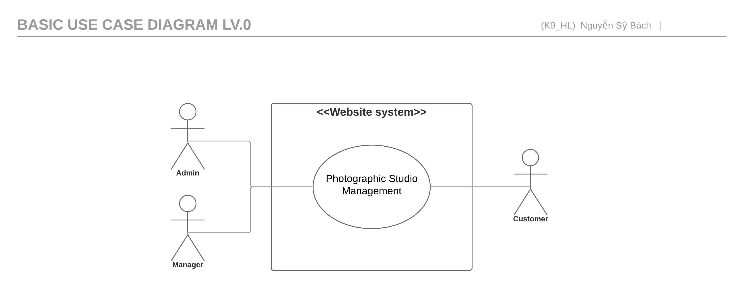

Figure 3.3.1: PSM Use Case Level-0

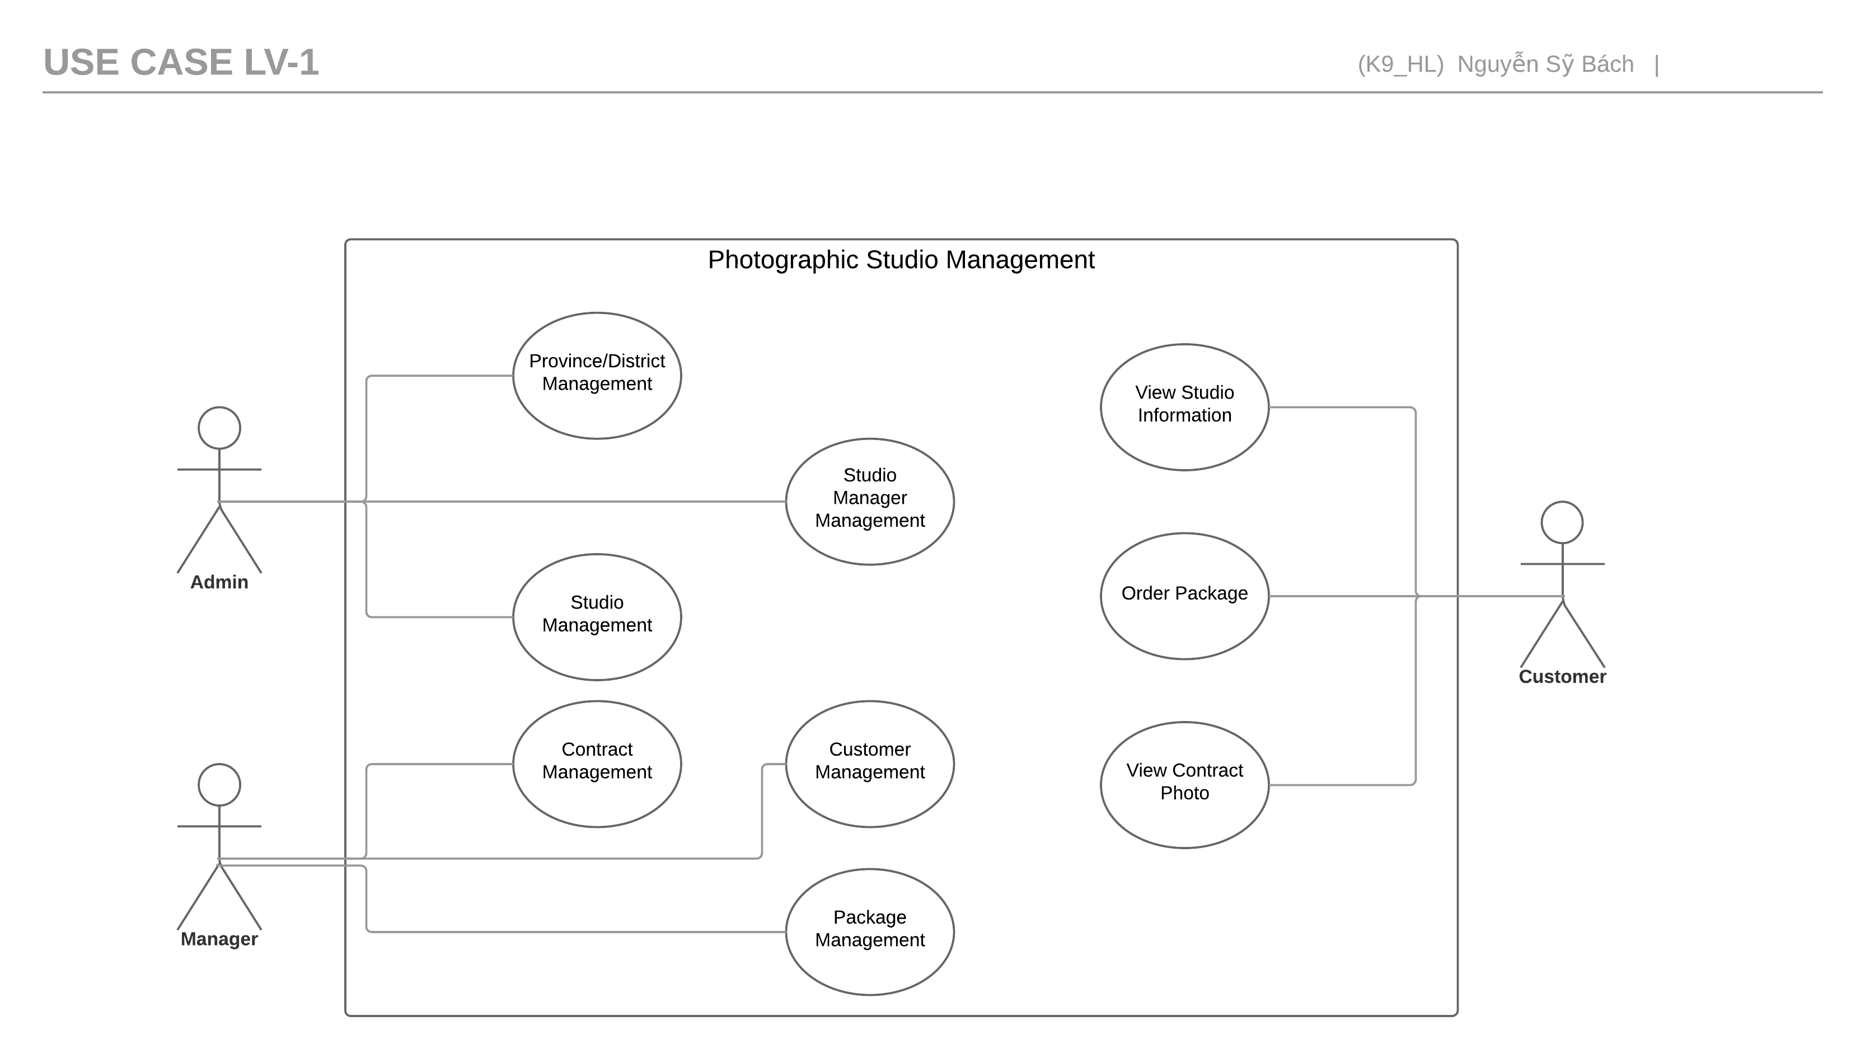

Figure 3.3.2: PSM Use Case Level-1

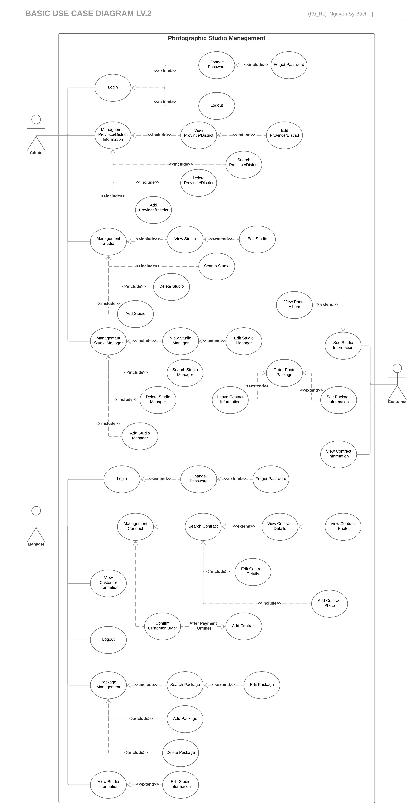

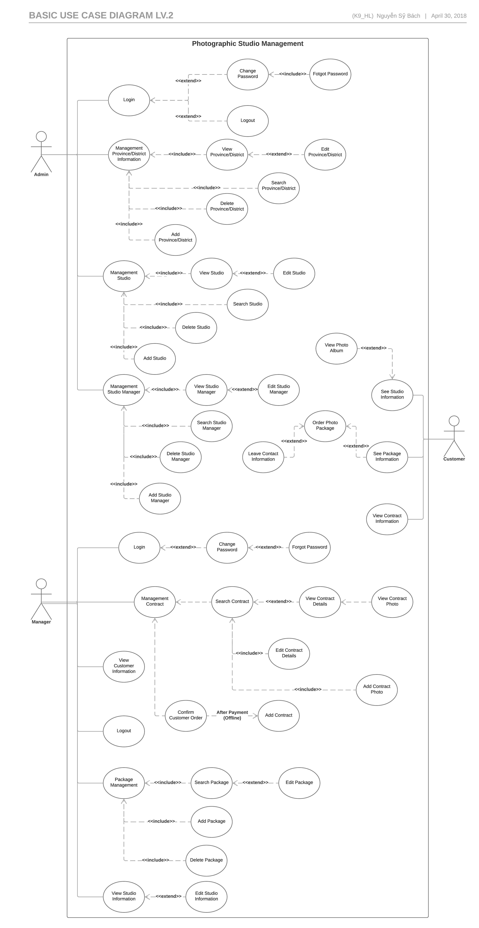

Figure 3.3.3: PSM Use Case diagram

## Specific Requirements 　 要求仕様

### Business Rules　ビジネスルール

|  |  |
| --- | --- |
| No | Description |
|  | Search textbox empty equal show all. |
|  | Text field cannot be empty |
|  | Content of post is limited to 1000 characters |
|  | Table content cannot be empty |
|  | If user accesses to nonexistent page, PSM displays error message “Page not found” |
|  | Email must characters ‘@’ and ‘.’content |
|  | Date of birth must be chosen |
|  | Displayed date is mm/dd/yyyy format |
|  | Number is rounded to 2 decimal number |
|  | Unit of money is VND |
|  | Displayed money is rounded to 2 decimal number |
|  | Allowed file extension: .jpg, .png, .bmp |
|  | File size is limited to 100 MB |

Table 3.5: Business Rules

### Actor

|  |  |
| --- | --- |
| Actor | Description |
| Admin | Manage all studio and studio manager. |
| Manager | Manage work of one Studio include package, photo and contract with customer. Need an account from Admin. |
| Customer | People who browsing the web and order photo package. |

Table 3.5.1: Actor

### Use Case List

|  |  |  |  |
| --- | --- | --- | --- |
| ID | Primary Actor | Secondary Actor | Name |
| UC-001 | Admin | Manager | Login |
| UC-002 | Admin | Manager | Logout |
| UC-003 | Admin | Manager | Change Password |
| UC-004 | Admin | Manager | Forgot Password |
| UC-005 | Admin |  | View and Search Province/District |
| UC-006 | Admin |  | Edit Province/District |
| UC-007 | Admin |  | Delete Province/District |
| UC-008 | Admin |  | Add Province/District |
| UC-009 | Admin |  | View and Search Studio |
| UC-010 | Admin |  | Edit Studio |
| UC-011 | Admin |  | Delete Studio |
| UC-012 | Admin |  | Add Studio |
| UC-013 | Admin |  | View and Search Studio Manager |
| UC-014 | Admin |  | Edit Studio Manager |
| UC-015 | Admin |  | Delete Studio Manager |
| UC-016 | Admin |  | Add Studio Manager |
| UC-017 | Manager |  | Search & View Contract Information |
| UC-018 | Manager |  | Edit Contract |
| UC-019 | Manager |  | Add Contract |
| UC-020 | Manager |  | Search & View Package |
| UC-021 | Manager |  | Add Package |
| UC-022 | Manager |  | Edit Package |
| UC-023 | Manager |  | View Picture |
| UC-024 | Manager |  | Edit Picture Info |
| UC-025 | Manager |  | Upload Picture |
| UC-026 | Manager |  | Delete Picture |
| UC-027 | Manager |  | View Customer Information |
| UC-028 | Manager |  | View Studio Information |
| UC-029 | Manager |  | Edit Studio Information |
| UC-030 | Customer |  | See Studio Information |
| UC-031 | Customer |  | See Album |
| UC-032 | Customer |  | See Package Information |
| UC-033 | Customer |  | Order photo Package & Leave Information |
| UC-034 | Customer |  | View Contract |
| UC-034 | Customer |  | View Contract photo |

Table 3.5.1: Use Case List

* For simple design purposes, the use case writing will be in English.

### Functionality　機能要求

#### Admin

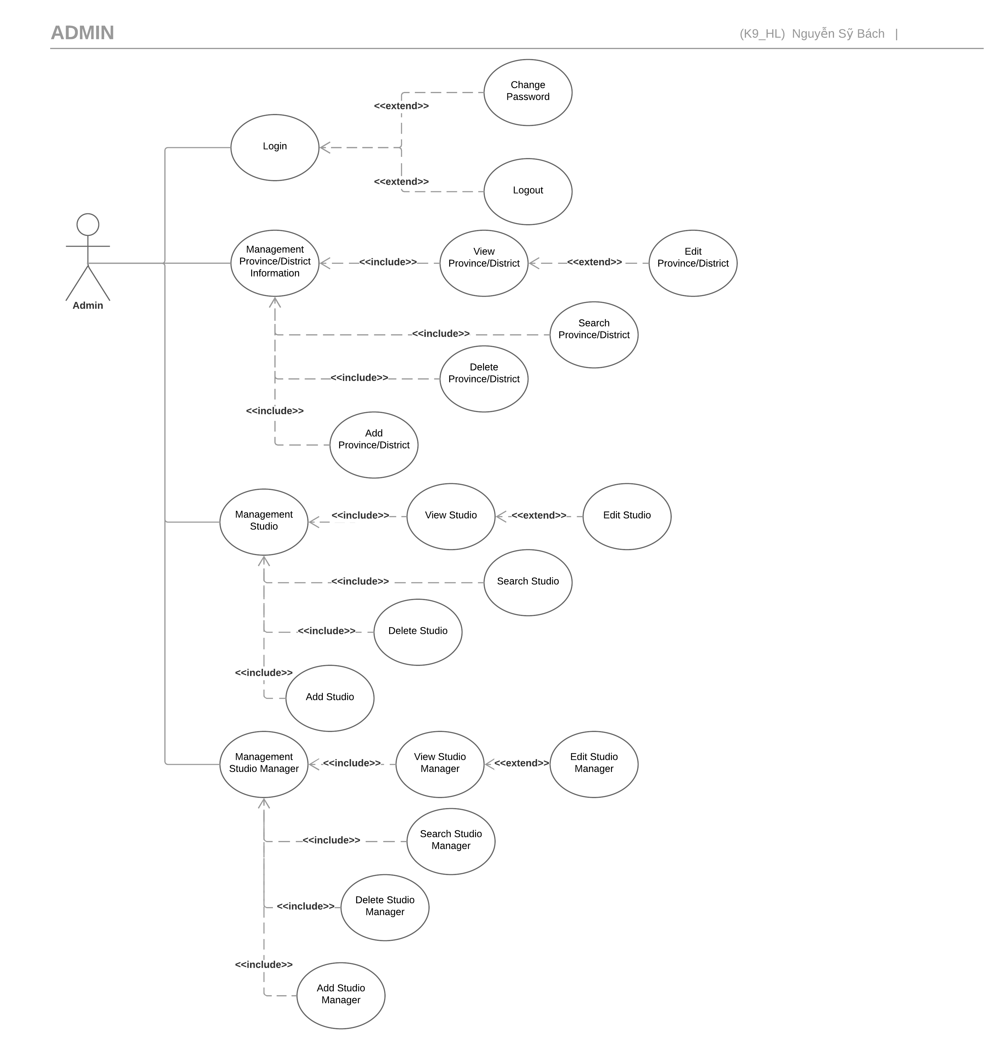Figure 3.5.2**:** Admin Use Case Diagram

##### Login

|  |  |  |  |  |
| --- | --- | --- | --- | --- |
| Use Case ID | | UC-001 | Version | 1.0 |
| Use Case Name | | Login | | |
| Created by: | | BachNS | **Date Created:** | 05/03/2018 |
| Primary Actor | | Admin | **Secondary Actor** | Manager |
| Description: | | When Actor want to login by registered account to use more functions in website. | | |
| Preconditions: | | Systems must be connected to the Internet. | | |
| Trigger: | | Click on”Login”quick menu. | | |
| Post conditions: | | * 1. Log Actor into system.   2. Redirect Actor to Studio Management page. | | |
| Normal Flow | | | | |
| Step | **Actor Event** | **System Response** | | |
| 1 | Click on”Login”quick menu at the homepage. |  | | |
| 2 |  | Display”Login”page include:   * 1. Username textbox.   2. Password textbox.   3. “Login”button.   4. “Forgot password”hyperlink. | | |
| 3 | 1. Enter Username and Password. 2. Click”Login”button. |  | | |
| 4 |  | * 1. Log Actor in to the systems.   2. Display Studio Management page with message:”Login Successfully”. | | |
| Alternative Flows: N/A | | | | |
| Exceptions | | | | |
| EC1 | At step 3 in main flow, if actor entered wrong User name or Password | | | |
| Step | **Actor Event** | **System Response** | | |
| 3.1 | Actor entered wrong User name or Password |  | | |
|  |  | Pop error message. | | |
|  | | | | |
| Priority | | High | | |
| Frequency of Use: | | High | | |
| Business Rules: | | B2 | | |

##### Logout

|  |  |  |  |  |
| --- | --- | --- | --- | --- |
| Use Case ID | | UC-002 | Version | 1.0 |
| Use Case Name | | Logout | | |
| Created by: | | BachNS | **Date Created:** | 05/03/2018 |
| Primary Actor | | Admin | **Secondary Actor** | Manager |
| Description: | | This function allows a Actor to logout | | |
| Preconditions: | | * 1. Systems must be connected to the Internet.   2. Actor has login to the systems. | | |
| Trigger: | | Click on”Logout”quick menu. | | |
| Post conditions: | | * 1. Log actor out of the systems.   2. Redirect actor back to the home page. | | |
| Normal Flow | | | | |
| Step | **Actor Event** | **System Response** | | |
| 1 | Click on”Logout”quick menu. |  | | |
| 2 |  | * 1. Log actor out of the systems.   2. Redirect actor back to the home page as customer. | | |
| Alternative Flows: N/A | | | | |
| Exceptions: N/A | | | | |
|  | | | | |
| Priority | | High | | |
| Frequency of Use: | | Normal | | |
| Business Rules: | | N/A | | |

##### Change Password

|  |  |  |  |  |  |
| --- | --- | --- | --- | --- | --- |
| Use Case ID | | | UC-003 | Version | 1.0 |
| Use Case Name | | | Change Password | | |
| Created by: | | | BachNS | **Date Created:** | 05/03/2018 |
| Primary Actor | | | Admin | **Secondary Actor** | Manager |
| Description: | | | This function allows Actor to change password or forgot their password. | | |
| Preconditions: | | | Systems must be connected to the Internet. | | |
| Trigger: | | | Click on “Change Password” header. | | |
| Post conditions: | | | Systems redirect actor to”Change Password”page. | | |
| Normal Flow | | | | | |
| Step | **Actor Event** | | **System Response** | | |
| 1 | Click on “Change Password” header | |  | | |
| 2 |  | | Display” Change Password” page include:   1. Old password textbox. 2. New password textbox. 3. New password confirms. 4. OK button 5. Cancel button. | | |
| 3 | 1. Enter old pass and new password. 2. Click on OK button. | |  | | |
| 4 |  | | Display password has been changed suscessful. Redirect actor back to manager page. | | |
| Alternative Flows | | | | | |
| AT1 | At step 2, Actor click ”Cancel”button. | | | | |
| Step | **Actor Event** | | **System Response** | | |
| 2.1 | Click”Cancel”button | |  | | |
| 2.2 |  | | Redirect actor back to Manager page. | | |
|  | | | | | |
| Exceptions | | | | | |
| EC1 | | At step 3 in main flow, if actor entered wrong User name or Password | | | |
| Step | | **Actor Event** | **System Response** | | |
| 3.1 | | Actor entered wrong old password |  | | |
| 3.2 | |  | Pop error message. | | |
|  | | | | | |
| Priority | | | High | | |
| Frequency of Use: | | | Low | | |
| Business Rules: | | | B2 | | |

##### Forgot Password

|  |  |  |  |  |  |
| --- | --- | --- | --- | --- | --- |
| Use Case ID | | | UC-004 | Version | 1.0 |
| Use Case Name | | | Forgot Password | | |
| Created by: | | | BachNS | **Date Created:** | 05/03/2018 |
| Primary Actor | | | Admin | **Secondary Actor** | Manager |
| Description: | | | This function allows Actor to change password or forgot their password. | | |
| Preconditions: | | | Systems must be connected to the Internet. | | |
| Trigger: | | | Click on “Forgot Password” hyperlink. | | |
| Post conditions: | | | Systems redirect actor to ”Forgot Password”page. | | |
| Normal Flow | | | | | |
| Step | **Actor Event** | | **System Response** | | |
| 1 | Click on ”Login”quick menu at the homepage. | |  | | |
| 2 |  | | Display “Login”page include:   1. Username textbox. 2. Password textbox. 3. “Login”button. 4. “Forgot password”hyperlink. | | |
| 3 | Click on”Forgot password”hyperlink. | |  | | |
| 4 |  | | Redirect actor to”Forgot Password”page include:   1. Username textbox. 2. Email textbox. 3. “Please enter your username”message. 4. “Please enter your email”message. 5. “Enter”button. | | |
| 5 | 1. Enter Username. 2. Enter email. 3. Click”Enter”button. | |  | | |
| 6 |  | | Change”Forgot Password”page to:   1. “Old password has been send to your email”message. 2. “Old password”textbox. 3. “New password”textbox. 4. “OK”button. | | |
| 7 | Enter”Old password”,”New password”. | |  | | |
| 8 | Click”OK”button. | |  | | |
| 9 |  | | Change actor password, redirect actor to login page. | | |
| Alternative Flows: N/A | | | | | |
| Exceptions | | | | | |
| EC1 | | At step 7 in main flow, if actor entered wrong User name or Password | | | |
| Step | | **Actor Event** | **System Response** | | |
| 7.1 | | Actor entered wrong old password |  | | |
| 7.2 | |  | Pop error message. | | |
|  | | | | | |
| Priority | | | High | | |
| Frequency of Use: | | | Low | | |
| Business Rules: | | | B2 | | |

##### View and Search Province/District

|  |  |  |  |  |  |  |
| --- | --- | --- | --- | --- | --- | --- |
| Use Case ID UC-005 | | | | Version | | 1.0 |
| Use Case Name | | | View province/District | | | |
| Created by: | | | HuyNM | **Date Created:** | | 05/03/2018 |
| Primary Actor | | | Admin |  | | |
| Description: | | | Show information about province and district. | | | |
| Preconditions: | | | Login by account admin PSM. | | | |
| Trigger: | | | Click “Province&District Management” hyper link. | | | |
| Post conditions: | | | Information of Studio need to exist. | | | |
| Normal Flow | | | | | | |
| Step | **Actor event** | | | | **System response** | |
| 1 | Select province in combo box then click “Search”. | | | |  | |
| 2 |  | | | | Display all districts of the province. | |
| 3 | Click to the name of district hyperlink. | | | |  | |
| 4 |  | | | | Display district details and display all Studios in the district. | |
| Alternative Flows: N/A | | | | | | |
|  | | | | | | |
| Exceptions | | | | | | |
| EC1 | | At step 4 in main flow, if don’t have studio in district. | | | | | |
| Step | | **Actor Event** | | **System Response** | | | |
| 4.1 | | Actor search unvalid district. | |  | | | |
| 4.2 | |  | | Pop error message “No studio found”. | | | |
|  | | | | | | | |
| Priority | | High | | | | | |
| Frequency of Use: | | Low | | | | | |
| Business Rules: | | B4,B2 | | | | | |

##### Edit Province/District

|  |  |  |  |  |  |
| --- | --- | --- | --- | --- | --- |
| Use Case ID UC-006 | | | | Version | 1.0 |
| Use Case Name | | | Edit Province/District | | |
| Created by: | | | HuyNM | **Date Created:** | 05/03/2018 |
| Primary Actor | | | Admin |  | |
| Description: | | | Edit province and district. | | |
| Preconditions: | | | Login by account admin PSM.  Province/district data has been added to the database.  Display district details. | | |
| Trigger: | | | Click one District hyper link. | | |
| Post conditions: | | | Information of District need to exist. | | |
| Normal Flow | | | | | |
| Step | | **Actor event** | | **System response** | |
| 1 | | Write the textbox in table “Edit Province&District” then click button “Edit”. | |  | |
| 2 | |  | | Display popup “Confirm change?” | |
| 3 | | Click “OK” button. | |  | |
| 4 | |  | | Display district details | |
| Alternative Flows: N/A | | | | | |
| AT1 | At step 3, Actor click “Cancel” button. | | | | |
| Step | **Actor Event** | | | **System Response** | |
| 3.1 | Click “Cancel” button. | | |  | |
| 3.2 |  | | | PSM return Page District. | |
|  | | | |  | |
| Exceptions | | | |  | |
| EC1 | At step 4 in main flow, if actor entered same Province/District. | | | | |
| Step | **Actor Event** | | | **System Response** | |
| 4.1 | Actor entered same Province/District. | | |  | |
| 4.2 |  | | | Popup “Province/District already exist”. | |
| 4.3 | Click “ok”. | | |  | |
| 4.4 |  | | | PSM return Page District manger. | |
|  | | | | | |
| Priority | High | | | | |
| Frequency of Use: | Low | | | | |
| Business Rules: | B4,B2 | | | | |

##### Delete Province/District

|  |  |  |  |  |  |  |
| --- | --- | --- | --- | --- | --- | --- |
| Use Case ID UC-007 | | | | | Version | 1.0 |
| Use Case Name | | | Delete Province/District | | | |
| Created by: | | | HuyNM | | **Date Created:** | 05/03/2018 |
| Primary Actor | | | Admin | |  | |
| Description: | | | Delete province and district. | | | |
| Preconditions: | | | Login by account admin PSM.  Province/District data has been added to the database.  Display district details. | | | |
| Trigger: | | | Click one “Province/District” hyper link. | | | |
| Post conditions: | | | District removed in database. | | | |
| Normal Flow | | | | | | |
| Step | | **Actor event** | | | **System response** | |
| 1 | | Select Province in combo box then click “Search”. | | |  | |
| 2 | |  | | | Display name of district. | |
| 3 | | Click to the district name. | | |  | |
| 4 | |  | | | 1. Displayed district information page. 2. Button “Delete” | |
| 5 | | Click “Delete”. | | |  | |
| 6 | |  | | | PSM return page district Actor. | |
| Alternative Flows: N/A | | | | | | |
| AT1 | At step 5, Actor click “Back” button. | | | | | |
| Step | **Actor Event** | | | **System Response** | | |
| 5.1 | Click “Back” button | | |  | | |
| 5.2 |  | | | PSM return page district manager. | | |
|  | | | |  | | |
| Exceptions | | | |  | | |
| EC1 | At step 5 in main flow, if actor Delete district exist studio. | | | | | |
| Step | **Actor Event** | | | **System Response** | | |
| 5.1 | Actor delete district. | | |  | | |
| 5.2 |  | | | Popup error “Can’t delete province/district with studio”. | | |
| 5.3 | Click “ok”. | | |  | | |
| 5.4 |  | | | PSM return page district manage. | | |
|  | | | | | | |
| Priority | High | | | | | |
| Frequency of Use: | Low | | | | | |
| Business Rules: | B4 | | | | | |

##### Add Province/District

|  |  |  |  |  |  |
| --- | --- | --- | --- | --- | --- |
| Use Case ID UC-008 | | | Version | | 1.0 |
| Use Case Name | | Add Province/District | | | |
| Created by: | | HuyNM | **Date Created:** | | 05/03/2018 |
| Primary Actor | | Admin |  | | |
| Description: | | Add province and district. | | | |
| Preconditions: | | Login by account admin PSM.  Province/District data has been added to the database.  Display district details. | | | |
| Trigger: | | Click one “Province&District Management” hyper link. | | | |
| Post conditions: | | Information of new District have to exist. | | | |
| Normal Flow | | | | | |
| Step | **Actor event** | | **System response** | | |
| 1 | 1.Select Province in table “Add Province&District”  2.Write in the text box Province\District  3.Click “Add”. | |  | | |
| 2 |  | | Display popup “Sucessful”. | | |
| 3 | Click to the “OK”. | |  | | |
| 4 |  | | Added new province\district. | | |
| Alternative Flows | | | | | |
| AT1: At Step 3 click Button “Cancel”. | | | | | |
| Step | **Actor Event** | | | **System Response** | |
| 3.1 | Click “Cancel”button. | | |  | |
| 3.2 |  | | | PSM return page district manager. | |
|  | | | | | |
|  | | | | | |
| Exceptions | | | |  | |
| EC1 | At step 3 in main flow, if actor entered same district, | | | | |
| Step | **Actor Event** | | | **System Response** | |
| 3.1 | Actor entered same district. | | |  | |
| 3.2 |  | | | Pop error message “Province\District already exist”. | |
|  | | | | | |
| Priority | High | | | | |
| Frequency of Use: | Low | | | | |
| Business Rules: | B4,B2 | | | | |

##### View and search Studio

|  |  |  |  |  |  |  |  |  |  |
| --- | --- | --- | --- | --- | --- | --- | --- | --- | --- |
| Use Case ID UC-009 | | | | | | | | Version | 1.0 |
| Use Case Name | | | | View Studio | | | | | |
| Created by: | | | | HuyNM | | **Date Created:** | | | 05/03/2018 |
| Primary Actor | | | | Admin | |  | | | |
| Description: | | | | Show all information about Studio in PSM. | | | | | |
| Preconditions: | | | | Login by account admin PSM.  Studio data has been added to the database. | | | | | |
| Trigger: | | | | Click to “Studio Management” hyper link. | | | | | |
| Post conditions: | | | | Information of Studio need to exist. | | | | | |
| Normal Flow | | | | | | | | | |
| Step | | **Actor event** | | | | **System response** | | | |
| 1 | | Select “Show all”. | | | |  | | | |
| 2 | |  | | | | PSM will display:   1. Number of Studio 2. Studio ID 3. Studio name 4. Package Detail 5. Studio Email 6. Studio phone 7. Studio map point 8. Province/district located | | | |
| Alternative Flows | | | | | | | | | |
| AT1 | At step 1, Actor click “Tìm kiếm” button. | | | | | | | | |
| Step | **Actor Event** | | | | | **System Response** | | | |
| 1.1 | Click “Tìm kiếm” button | | | | |  | | | |
| 1.2 |  | | | | | PSM will display:   1. Number of Studio 2. Studio ID 3. Studio name 4. Package Detail 5. Studio Email 6. Studio phone 7. Studio map point 8. Province/district located | | | |
| Exceptions | | | | | | | | | |
| EC1: If admin enter characters unlike existing studio names. | | | | | | | | | |
| Step | | | **Actor event** | | | | **System response** | | |
| 1.1 | | | Enter wrong studio name. | | | |  | | |
| 1.2 | | |  | | | | Popup “No studio found”. | | |
|  | | | | | | | | | |
| Priority | | | | | Normal | | | | |
| Frequency of Use: | | | | | Normal | | | | |
| Business Rules: | | | | | B2,B6 | | | | |

##### Edit Studio

|  |  |  |  |  |  |
| --- | --- | --- | --- | --- | --- |
| Use Case ID UC-010 | | | | Version | 1.0 |
| Use Case Name | | Edit Studio | | | |
| Created by: | | HuyNM | | **Date Created:** | 05/03/2018 |
| Primary Actor | | Admin | |  | |
| Description: | | Edit information of Studio. | | | |
| Preconditions: | | Login by account admin PSM.  Studio data has been added to the database. | | | |
| Trigger: | | Click to “Edit” hyper link. | | | |
| Post conditions: | | Information of Studio changed. | | | |
| Normal Flow | | | | | |
| Step | **Actor event** | | | **System response** | |
| 1 | Click Button ”Edit” in Studio Management page | | |  | |
| 2 |  | | | Display table “Chỉnh Sửa Studio”   1. Number of Studio 2. Studio ID 3. Studio name 4. Package Detail 5. Studio Email 6. Studio phone 7. Studio map point 8. Province/district located | |
| 3 | Input to the textbox then click “Edit” | | |  | |
| 4 |  | | | Popup appear “Confirm changes?”. | |
| 5 | Click “Ok” | | |  | |
| 6 |  | | | Popup appear “Sucessful”. | |
| Alternative Flows | | | | | |
| ET1: At Step 5 click “Cancel” button. | | | | | |
| Step | **Actor event** | | | **System response** | |
| 5.1 | Click “Cancel”button. | | |  | |
| 5.2 |  | | | PSM return Studio information Page. | |
|  | | | | | |
| Exceptions | | | | | |
| EC1: When admin entered wrong email. | | | | | |
| Step | **Actor event** | | | **System response** | |
| 1.1 | Admin entered wrong email. | | |  | |
| 1.2 |  | | | Invalid email | |
| EC2: When admin entered wrong number. | | | | | |
| Step | **Actor event** | | | **System response** | |
| 2.1 | Admin entered wrong number. | | |  | |
| 2.2 |  | | | Invalid phone number | |
| EC3: When admin entered wrong location coordinate. | | | | | |
| Step | **Actor event** | | | **System response** | |
| 3.1 | Admin entered wrong location coordinate. | | |  | |
| 3.2 |  | | | Invalid location. | |
|  | | | | | |
| Priority | | | Normal | | |
| Frequency of Use: | | | Normal | | |
| Business Rules: | | | B2 ,B4, B6 | | |

##### Delete Studio

|  |  |  |  |  |  |  |  |
| --- | --- | --- | --- | --- | --- | --- | --- |
| Use Case ID UC-011 | | | | | | Version | 1.0 |
| Use Case Name | | | Delete Studio | | | | |
| Created by: | | | HuyNM | | | **Date Created:** | 05/03/2018 |
| Primary Actor | | | Admin | | |  | |
| Description: | | | Delete Studio information. | | | | |
| Preconditions: | | | Login by account admin PSM.  Studio information data has been added to the database. | | | | |
| Trigger: | | | Click to “Delete” hyper link. | | | | |
| Post conditions: | | | Information of Studio remove in the data. | | | | |
| Normal Flow | | | | | | | |
| Step | | **Actor event** | | | | **System response** | |
| 1 | | Click to delete in table Studio information. | | | |  | |
| 2 | |  | | | | Display popup “Confirm Delete”. | |
| 3 | | Click “OK”. | | | |  | |
| 4 | |  | | | | Display new table information of Studio. | |
| Alternative Flows | | | | | | | |
| AT1 | At step 3, click “Cancel” button. | | | | | | |
| Step | **Actor Event** | | | | **System Response** | | |
| 5.1 | Click “Cancel” button | | | |  | | |
| 5.2 |  | | | | Display new table information of Studio. | | |
| Exceptions: N/A | | | | | | | |
| Priority | | | | Normal | | | |
| Frequency of Use: | | | | Normal | | | |
| Business Rules: | | | | N/A | | | |

##### Add Studio

|  |  |  |  |  |  |  |
| --- | --- | --- | --- | --- | --- | --- |
| Use Case ID UC-012 | | | | Version | 1.0 | |
| Use Case Name | | Add Studio | | | | |
| Created by: | | HuyNM | | **Date Created:** | | 05/03/2018 |
| Primary Actor | | Admin | |  | | |
| Description: | | Add Studio information | | | | |
| Preconditions: | | Login by account admin PSM.  Province/District data has been added to the database.  Display district details. | | | | |
| Trigger: | | Click “Add Studio”hyper link. | | | | |
| Post conditions: | | Updated new Studio in database. | | | | |
| Normal Flow | | | | | | |
| Step | **Actor event** | | | **System response** | | |
| 1 | Click to Add new Studio hyperlink. | | |  | | |
| 2 |  | | | Display add form:   1. Number of Studio 2. Studio ID 3. Studio name 4. Package Detail 5. Studio Email 6. Studio phone 7. Studio map point 8. Province/district located | | |
| 3 | Click “Thêm mới”. | | |  | | |
| 4 |  | | | Thêm Studio thành công. | | |
| Alternative Flows | | | | | | |
| AT1: At Step 3 click “Reset” button. | | | | | | |
| Step | **Actor event** | | | **System response** | | |
| 1.1 | Click “Reset”button. | | |  | | |
| 1.2 |  | | | Information in all textbox will reset. | | |
| Exceptions | | | | | | |
| EC1: When admin entered wrong email. | | | | | | |
| Step | **Actor event** | | | **System response** | | |
| 1.1 | Admin entered wrong email. | | |  | | |
| 1.2 |  | | | Invalid email | | |
| EC2: When admin entered wrong number. | | | | | | |
| Step | **Actor event** | | | **System response** | | |
| 2.1 | Admin entered wrong number. | | |  | | |
| 2.2 |  | | | Invalid Phone number | | |
| EC3: When admin entered wrong coordinate. | | | | | | |
| Step | **Actor event** | | | **System response** | | |
| 3.1 | Admin entered wrong coordinate. | | |  | | |
| 3.2 |  | | | Invalid location coordinate. | | |
| Priority | | | Normal | | | |
| Frequency of Use: | | | Normal | | | |
| Business Rules: | | | B2, B6, B3 | | | |
| Other Information: | | | N/A | | | |

##### View and Search Studio Manager

|  |  |  |  |  |  |  |  |
| --- | --- | --- | --- | --- | --- | --- | --- |
| Use Case ID UC-013 | | | | | | Version | 1.0 |
| Use Case Name | | | View Studio Manager | | | | |
| Created by: | | | HuyNM | | | **Date Created:** | 05/03/2018 |
| Primary Actor | | | Admin | | |  | |
| Description: | | | Show all information about Studio manager in PSM. | | | | |
| Preconditions: | | | Login by account admin PSM.  Studio manager data has been added to the database. | | | | |
| Trigger: | | | Click to “Manager management” hyper link. | | | | |
| Post conditions: | | | Show information about searched manager. | | | | |
| Normal Flow | | | | | | | |
| Step | | **Actor event** | | | | **System response** | |
| 1 | | Select “Show all”. | | | |  | |
| 2 | |  | | | | PSM will display:   1. Number of manager. 2. Account name. 3. Password. 4. Studio name. 5. Permission. | |
| Alternative Flows | | | | | | | |
| AT1: Select button “Tìm kiếm”. | | | | | | | |
| Step | | **Actor event** | | | | **System response** | |
| 1.1 | | Write the textbox name or character of Studio Manager want to show then Select “Search”. | | | |  | |
| 1.2 | |  | | | | Display all studio manager have name or character same that. | |
| Exceptions | | | | | | | |
| EC1 | At step 1.1 in main flow, if don’t have studio manager. | | | | | | |
| Step | **Actor Event** | | | | **System Response** | | |
| 1.1.1 | Actor search invalid manager. | | | |  | | |
| 1.1.2 |  | | | | Pop up error message “No manager found”. | | |
|  | | | | | | | |
| Priority | | | | Normal | | | |
| Frequency of Use: | | | | Normal | | | |
| Business Rules: | | | | B4 | | | |

##### Edit Studio Manager

|  |  |  |  |  |  |
| --- | --- | --- | --- | --- | --- |
| Use Case ID UC-014 | | | | Version | 1.0 |
| Use Case Name | | Edit Studio Manager | | | |
| Created by: | | HuyNM | | **Date Created:** | 05/03/2018 |
| Primary Actor | | Admin | |  | |
| Description: | | Edit information of studio manager. | | | |
| Preconditions: | | Login by account admin PSM.  Actor data has been added to the database.  Display actor details. | | | |
| Trigger: | | Click to “Edit” hyper link. | | | |
| Post conditions: | | Information of manager changed. | | | |
| Normal Flow | | | | | |
| Step | **Actor event** | | | **System response** | |
| 1 | Click Button “Edit” | | |  | |
| 2 |  | | | Display table “Edit manager”  1. Username  2. Password  3.Studio | |
| 3 | 1.Input textbox.  2.Pick studio.  3.Click Edit button. | | |  | |
| 4 |  | | | Popup appear “Confirm change”. | |
| 5 | Click “Ok” | | |  | |
| 6 |  | | | Popup appear “Suscessful”. | |
| Alternative Flows | | | | | |
| ET1: At Step 5 click “Cancel” button. | | | | | |
| Step | **Actor event** | | | **System response** | |
| 5.1 | Click “Cancel” button. | | |  | |
| 5.2 |  | | | PSM return to management page. | |
|  | | | | | |
| Exceptions | | | | | |
| EC1: When admin entered wrong mật khẩu. | | | | | |
| Step | **Actor event** | | | **System response** | |
| 1.1 | Admin entered invalid password | | |  | |
| 1.2 |  | | | Invalid password | |
|  | | | | | |
| Priority | | | Normal | | |
| Frequency of Use: | | | Normal | | |
| Business Rules: | | | B2, B3 | | |

##### Delete Studio Manager

|  |  |  |  |  |  |  |  |
| --- | --- | --- | --- | --- | --- | --- | --- |
| Use Case ID UC-015 | | | | | | Version | 1.0 |
| Use Case Name | | | Delete Studio Manager | | | | |
| Created by: | | | HuyNM | | | **Date Created:** | 05/03/2018 |
| Primary Actor | | | Admin | | |  | |
| Description: | | | Delete studio manager information. | | | | |
| Preconditions: | | | Login by account admin PSM.  Studio manager information data has been added to the database. | | | | |
| Trigger: | | | Click to “Delete” hyper link. | | | | |
| Post conditions: | | | Information of Studio manager remove in the data. | | | | |
| Normal Flow | | | | | | | |
| Step | | **Actor event** | | | | **System response** | |
| 1 | | Click to delete in table Studio manager information. | | | |  | |
| 2 | |  | | | | Display popup “Confirm delete”. | |
| 3 | | Click “OK”. | | | |  | |
| 4 | |  | | | | Deleted sucessful. | |
| Alternative Flows: N/A | | | | | | | |
| AT1 | At step 3, click “Cancel” button. | | | | | | |
| Step | **Actor Event** | | | | **System Response** | | |
| 3.1 | Click “Cancel” button | | | |  | | |
| 3.2 |  | | | | Return to management page. | | |
| Exceptions: N/A | | | | | | | |
| Priority | | | | Normal | | | |
| Frequency of Use: | | | | Normal | | | |
| Business Rules: | | | | N/A | | | |

##### Add Studio Manager

|  |  |  |  |  |  |
| --- | --- | --- | --- | --- | --- |
| Use Case ID UC-016 | | | | Version | 1.0 |
| Use Case Name | | Add Studio Manager | | | |
| Created by: | | HuyNM | | **Date Created:** | 05/03/2018 |
| Primary Actor | | Admin | | **Secondary Actor** |  |
| Description: | | Add studio manager information | | | |
| Preconditions: | | Login by account admin PSM. | | | |
| Trigger: | | Click “Add manager” hyper link. | | | |
| Post conditions: | | Updated new studio manager in database. | | | |
| Normal Flow | | | |  | |
| Step | **Actor event** | | | **System response** | |
| 1 | Click to Add new studio manager hyperlink. | | |  | |
| 2 |  | | | Display table “Add manager”   1. Username 2. Password 3. Studio | |
| 3 | Click “Add”. | | |  | |
| 4 |  | | | Message “Add sucessful”. | |
| Alternative Flows: At step 3 click “Reset”. | | | | | |
| Step | **Actor event** | | | **System response** | |
| 3.1 | Admin click “Reset”. | | |  | |
| 3.2 |  | | | Return to management page. | |
|  | | | | | |
| Exceptions | | | | | |
| EC1: When admin entered invalid Username. | | | | | |
| Step | **Actor event** | | | **System response** | |
| 2.1 | Admin entered invalid Username. | | |  | |
| 2.2 |  | | | Message “invalid Username”. | |
| EC2: When admin entered ivalid password | | | | | |
| Step | **Actor event** | | | **System response** | |
| 2.1 | Admin entered ivalid password | | |  | |
| 3.2 |  | | | Message “ivalid password”. | |
| Step | | | | | |
| Priority | | | Normal | | |
| Frequency of Use: | | | Normal | | |
| Business Rules: | | | B2, B3 | | |

#### Manager

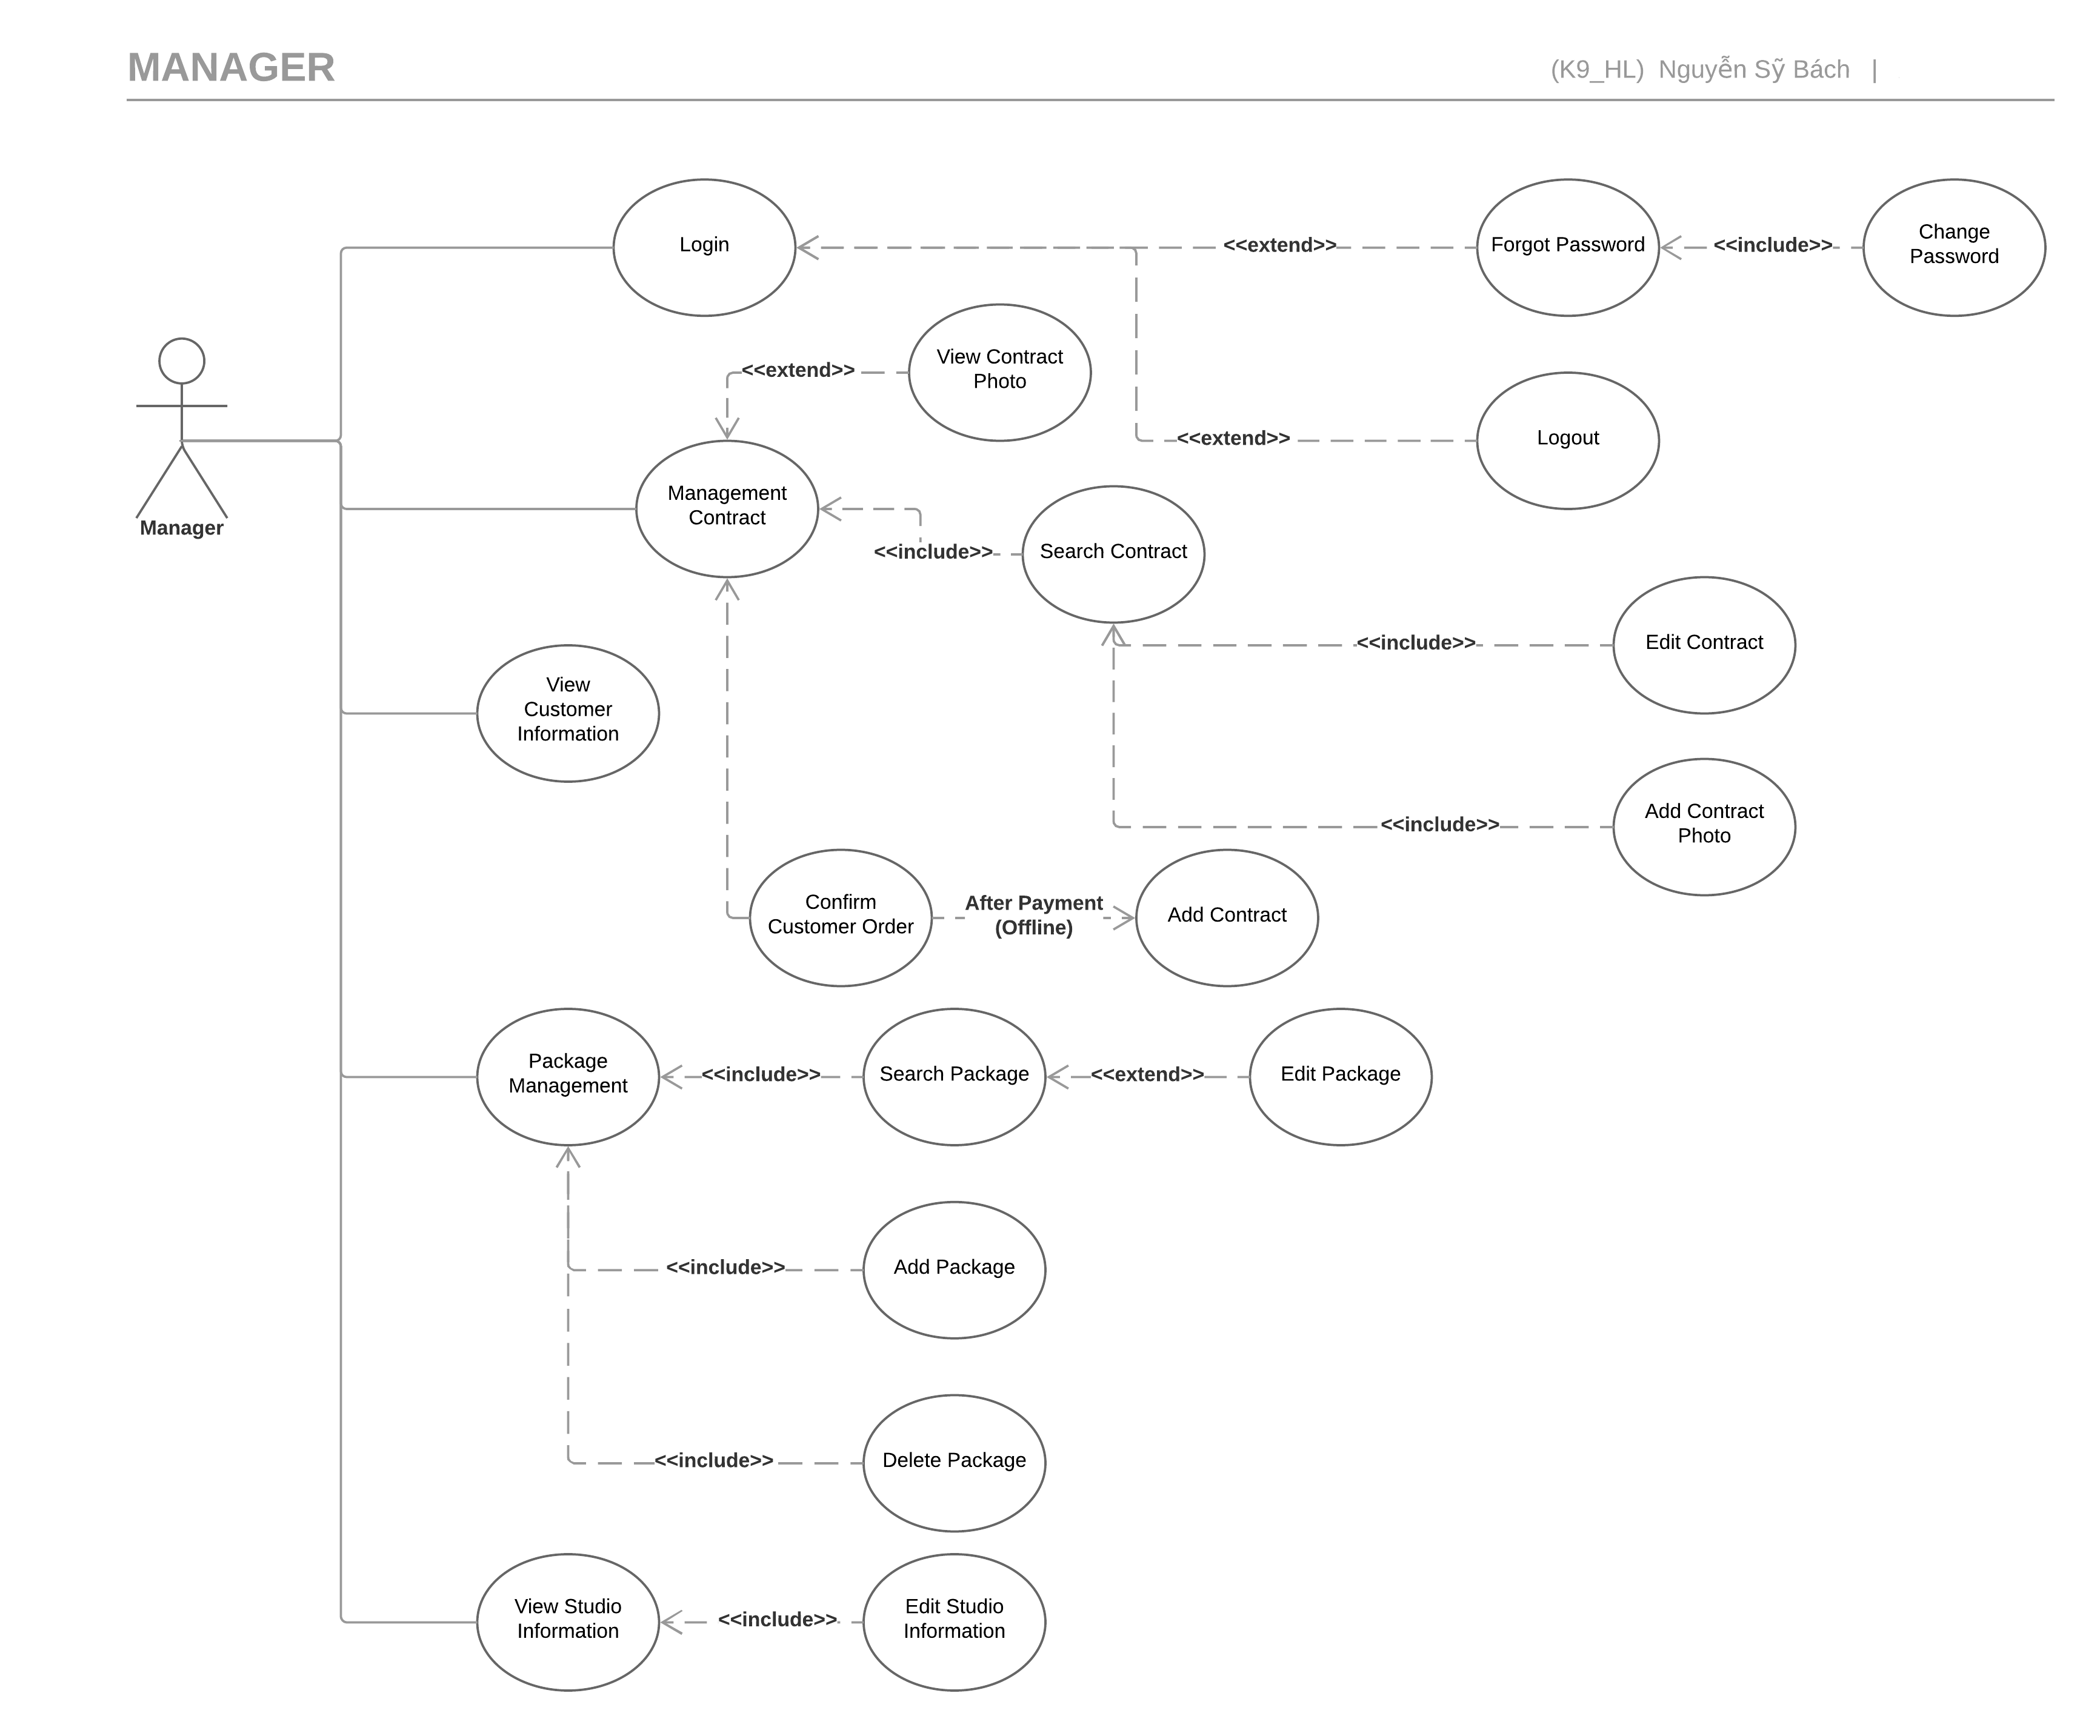

Figure .5.2.2.1**:** Manager Use Case Diagram

##### Search & View Contract Information

|  |  |  |  |  |  |
| --- | --- | --- | --- | --- | --- |
| Use Case ID | | | UC-017 | Version | 1.0 |
| Use Case Name | | | Search & View Contract Information | | |
| Created by: | | | BachNS | **Date Created:** | 05/03/2018 |
| Primary Actor | | | Manager |  | |
| Description: | | | Actor can search old Contract | | |
| Preconditions: | | | Actor must login to the systems. | | |
| Trigger: | | | Click on “Contract” hyperlink in the menu. | | |
| Post conditions: | | | Open table of detail information of the search contract. | | |
| Normal Flow | | | | | |
| Step | **Actor Event** | | **System Response** | | |
| 1 | Click on”Contract”hyperlink menu. | |  | | |
| 2 |  | | Show search table include:   1. Dropdown menu include: “ContractID, CutomerName, CustomerPhone”. 2. Textbox field for dropdown menu choice 3. “Search” button. | | |
| 3 | 1. Pick dropdown menu options, enter textbox field. 2. Click “Search”button. | |  | | |
| 4 |  | | Show table with fitted Contract information include:   1. Number of Contract found. 2. Contract ID 3. Customer ID 4. Studio ID 5. Contract Description. 6. Create Date. 7. Start Date. 8. End Date. 9. Status 10. “Edit” button. | | |
| Alternative Flows | | | | | |
| AT1 | At step 3, Actor type nothing in the Search textbox. | | | | |
| Step | **Actor Event** | | **System Response** | | |
| 3.1 | Leave textbox empty, click Search. | |  | | |
| 3.2 |  | | List all Contract. | | |
|  | | | | | |
| Exceptions: | | | | | |
| EC1 | | At step 3 in main flow, if actor entered invalid Contract information | | | |
| Step | | **Actor Event** | **System Response** | | |
| 3.1 | | Actor entered invalid information |  | | |
| 3.2 | |  | Pop error message. | | |
|  | | | | | |
| Priority | | | Normal | | |
| Frequency of Use: | | | Normal | | |
| Business Rules: | | | B2, B3, B8 | | |

##### Edit Contract

|  |  |  |  |  |
| --- | --- | --- | --- | --- |
| Use Case ID | | UC-018 | Version | 1.0 |
| Use Case Name | | Edit Contract | | |
| Created by: | | BachNS | **Date Created:** | 05/03/2018 |
| Primary Actor | | Manager |  | |
| Description: | | Actor can change old contract information. | | |
| Preconditions: | | 1. Actor must log-in to the systems. 2. Case UC-017 “Search Contract & View Contract “must be executed successful first. | | |
| Trigger: | | Actor click on “Edit” button in the Contract Information table. | | |
| Post conditions: | | New edit information saved in the Contract. | | |
| Normal Flow | | | | |
| Step | **Actor Event** | **System Response** | | |
| 1 | Click on “Edit” Button. |  | | |
| 2 |  | Open “Edit Contract” table include:   1. “Name” textbox. 2. “Phone number” textbox. 3. “Gender” checkbox. 4. “Old customer” checkbox. 5. “Email” textbox. 6. “Address” textbox. 7. “Contract Studio” dropdown box. 8. “Package name” dropdown box. 9. “Package detail” textbox. 10. “Note” textbox. 11. “Contract detail” textbox. 12. “Contract start date” datetime. 13. “Contract end date” datetime. 14. “Photoshoot date” datetime. 15. “Add” button. 16. “Reset” button. | | |
| 3 | Enter new edit information |  | | |
| 4 |  | Save new edit information. | | |
| Alternative Flows | | | | |
| AT1 | At step 2, Actor click “Reset” button. | | | |
| Step | **Actor Event** | **System Response** | | |
| 2.1 | Click “Reset” button. |  | | |
| 2.2 |  | Discard all textbox. Keep old information. | | |
| Exceptions | | | | |
| EX1 | At step 2, Actor leave on of the textbox empty, exclude “Note”. | | | |
| Step | **Actor Event** | **System Response** | | |
| 2.1 | Actor leave on of the textbox empty, exclude “Note”. |  | | |
| 2.2 |  | Show error messages. | | |
|  | | | | |
| Priority | | Normal | | |
| Frequency of Use: | | Normal | | |
| Business Rules: | | B2, B3, B8, B10 | | |
| Other Information: | | N/A | | |

##### Add Contract

|  |  |  |  |  |  |
| --- | --- | --- | --- | --- | --- |
| Use Case ID | | | UC-019 | Version | 1.0 |
| Use Case Name | | | Add Contract | | |
| Created by: | | | BachNS | **Date Created:** | 05/03/2018 |
| Primary Actor | | | Manager |  | |
| Description: | | | Actor can add new Contract with customer. | | |
| Preconditions: | | | Actor must log-in to the systems. | | |
| Trigger: | | | Actor click on “Add Contract” hyperlink. | | |
| Post conditions: | | | New Contract added to the systems. | | |
| Normal Flow | | | | | |
| Step | **Actor Event** | | **System Response** | | |
|  | Actor click on “Add Contract” hyperlink. | |  | | |
|  |  | | Open “Add Contract” table include:   1. “Name” textbox. 2. “Phone number” textbox. 3. “Gender” checkbox. 4. “Old customer” checkbox. 5. “Email” textbox. 6. “Address” textbox. 7. “Contract Studio” dropdown box. 8. “Package name” dropdown box. 9. “Package detail” textbox. 10. “Note” textbox. 11. “Contract detail” textbox. 12. “Contract start date” datetime. 13. “Contract end date” datetime. 14. “Photoshoot date” datetime. 15. “Add” button. 16. “Reset” button. | | |
|  | 1. Enter new Contract information 2. Click “Add” | |  | | |
|  |  | | Added new Contract to the systems. | | |
| Alternative Flows | | | | | |
| AT1 | At step 3, Actor click “Reset” button. | | | | |
| Step | **Actor Event** | | **System Response** | | |
| 3.1 | Actor click “Reset” button | |  | | |
| 3.2 |  | | Discard all textbox. | | |
| Exceptions | | | | | |
| EX1 | At step 3, Actor leave on of the textbox empty, exclude “Note”. | | | | |
| Step | **Actor Event** | **System Response** | | | |
| 3.1 | Actor leave on of the textbox empty, exclude “Note”. |  | | | |
| 3.2 |  | Show error messages. | | | |
| EX2 | At step 3, Actor enter wrong type text to textbox (special character). | | | | |
| Step | **Actor Event** | **System Response** | | | |
| 3.1 | Actor enter wrong type text to textbox (special character). |  | | | |
| 3.2 |  | Show error messages. | | | |
| EX2 | At step 3, Actor check on “Khách hàng cũ” checkbox but type in wrong key information. | | | | |
| Step | **Actor Event** | **System Response** | | | |
| 3.1 | Actor check on “Old customer” checkbox but type in wrong key information. |  | | | |
| 3.2 |  | Show error messages. | | | |
|  | | | | | |
| Priority | | | Normal | | |
| Frequency of Use: | | | Normal | | |
| Business Rules: | | | B2, B3, B8, B10 | | |

##### Search & View Package

|  |  |  |  |  |  |
| --- | --- | --- | --- | --- | --- |
| Use Case ID | | | UC-020 | Version | 1.0 |
| Use Case Name | | | Search & View Package | | |
| Created by: | | | BachNS | **Date Created:** | 05/03/2018 |
| Primary Actor | | | Manager |  | |
| Description: | | | Actor can search Photo Package | | |
| Preconditions: | | | Actor must login to the systems. | | |
| Trigger: | | | Click on “Package Actor” hyperlink in the menu. | | |
| Post conditions: | | | Open table of detail information of the search package. | | |
| Normal Flow | | | | | |
| Step | **Actor Event** | | **System Response** | | |
| 1 | Click on “Package Manager” hyperlink menu. | |  | | |
| 2 |  | | Show search table include:   1. Package name textbox. 2. Search button. | | |
| 3 | 1.Enter search package name.  2.Click Search button. | |  | | |
| 4 |  | | Show search package table include:   1. Number of Package found. 2. Package ID. 3. Package name. 4. Package Detail. 5. Package Price. 6. Package preview picture. 7. Available. 8. Edit button. | | |
| Alternative Flows: N/A | | | | | |
| Exceptions | | | | | |
| EC1 | | At step 3 in main flow, if actor entered invalid Contract information | | | |
| Step | | **Actor Event** | **System Response** | | |
| 3.1 | | Actor entered invalid information |  | | |
| 3.2 | |  | Pop error message. | | |
|  | | | | | |
| Priority | | | Normal | | |
| Frequency of Use: | | | Normal | | |
| Business Rules: | | | B3 | | |

##### Add Package

|  |  |  |  |  |
| --- | --- | --- | --- | --- |
| Use Case ID | | UC-021 | Version | 1.0 |
| Use Case Name | | Add Package | | |
| Created by: | | BachNS |  | |
| Primary Actor | | Manager | **Secondary Actor** |  |
| Description: | | Actor can add new package for customer. | | |
| Preconditions: | | Actor must log-in to the systems. | | |
| Trigger: | | Actor click on “Add Package” hyperlink. | | |
| Post conditions: | | New Contract added to the systems. | | |
| Normal Flow | | | | |
| Step | **Actor Event** | **System Response** | | |
| 1 | Actor click on “Add Contract” hyperlink. |  | | |
| 2 |  | Open “Add Package” table include:   1. Package name textbox. 2. Package details textbox. 3. Package price textbox. 4. Package availability drop check box. 5. Package preview picture textbox. 6. “Add” button. 7. “Reset” button. | | |
| 3 | 1. Enter new Package information  2. Click “Add” |  | | |
| 4 |  | Added new Package to the systems. | | |
| Alternative Flows | | | | |
| AT1 | At step 3, Actor click “Reset” button. | | | |
| Step | **Actor Event** | **System Response** | | |
| 3.1 | Actor click “Reset” button |  | | |
| 3.2 |  | Discard all textbox. | | |
| Exceptions: N/A | | | | |
| Priority | | Normal | | |
| Frequency of Use: | | Normal | | |
| Business Rules: | | B2, B3 | | |

##### Edit Package

|  |  |  |  |  |
| --- | --- | --- | --- | --- |
| Use Case ID | | UC-022 | Version | 1.0 |
| Use Case Name | | Edit Package | | |
| Created by: | | BachNS | **Date Created:** | 05/03/2018 |
| Primary Actor | | Manager |  | |
| Description: | | Actor can edit old package information. | | |
| Preconditions: | | 1. Actor must log-in to the systems. 2. Case UC-020 “Search Package” must be executed successful first. | | |
| Trigger: | | Actor click on “Edit” button in the Package Information table. | | |
| Post conditions: | | New edit information saved in the Package. | | |
| Normal Flow | | | | |
| Step | **Actor Event** | **System Response** | | |
| 1 | Click on “Edit” button. |  | | |
| 2 |  | Open “Edit package” table include:   1. Package Id (Cannot edit). 2. Package Name textbox. 3. Package Detail textbox. 4. Package price textbox. 5. Package preview picture. 6. Package availability drop check box. 7. “Add” button. 8. “Reset” button | | |
| 3 | Enter new edit information |  | | |
| 4 |  | Save new edit information. | | |
| Alternative Flows | | | | |
| AT1 | At step 3, Actor click “Reset” button. | | | |
| Step | **Actor Event** | **System Response** | | |
| 3.1 | Click”Reset”Button. |  | | |
| 3.2 |  | Discard all textbox. Keep old information. | | |
| Exceptions: N/A | | | | |
| Priority | | Normal | | |
| Frequency of Use: | | Normal | | |
| Business Rules: | | B2, B3, B110 | | |

##### Search & View Picture

|  |  |  |  |  |
| --- | --- | --- | --- | --- |
| Use Case ID | | UC-023 | Version | 1.0 |
| Use Case Name | | Search & View Picture | | |
| Created by: | | BachNS | **Date Created:** | 05/03/2018 |
| Primary Actor | | Manager |  | |
| Description: | | Actor can view Contract uploaded picture. | | |
| Preconditions: | | Actor must login to the systems. | | |
| Trigger: | | Click on “Picture” hyperlink in the menu. | | |
| Post conditions: | | Open all Contract picture. | | |
| Normal Flow | | | | |
| Step | **Actor Event** | **System Response** | | |
| 1 | Click on “Picture” menu. |  | | |
| 2 |  | Show Picture table include:   1. No. 2. ContractID. 3. Contract DetailID. 4. View Picture Button. | | |
| 3 | Click on View Picture button. |  | | |
| 4 |  | Show Picture page. | | |
| Alternative Flows: N/A | | | | |
| Exceptions: N/A | | | | |
| Priority | | Normal | | |
| Frequency of Use: | | Normal | | |
| Business Rules: | | N/A | | |
| Other Information: | | N/A | | |

##### Edit Picture Info

|  |  |  |  |  |
| --- | --- | --- | --- | --- |
| Use Case ID | | UC-024 | Version | 1.0 |
| Use Case Name | | Edit Picture Info | | |
| Created by: | | BachNS | **Date Created:** | 05/03/2018 |
| Primary Actor | | Manager | **Secondary Actor** |  |
| Description: | | Actor can upload Contract uploaded picture. | | |
| Preconditions: | | 1. Actor must login to the systems. 2. Case UC-017 “Search & View Contract” must be executed successful first. | | |
| Trigger: | | Click on” Update Picture Detail” button. | | |
| Post conditions: | | Picture information has changed. | | |
| Normal Flow | | | | |
| Step | **Actor Event** | **System Response** | | |
| 1 | Click on Picture. |  | | |
| 2 |  | Show Picture detail:   1. Contract Detail ID. 2. Picture name. 3. Picture URL. 4. Update Picture’s Detail Button. 5. Delete Button. | | |
| 3 | Click “Update Picture’s Detail Button” button. |  | | |
| 4 |  | Update new picture to the systems. | | |
| Alternative Flows: N/A | | | | |
| Exceptions: N/A | | | | |
| Priority | | Normal | | |
| Frequency of Use: | | Normal | | |
| Business Rules: | | B2 | | |

##### Upload Picture

|  |  |  |  |  |  |
| --- | --- | --- | --- | --- | --- |
| Use Case ID | | UC-025 | | Version | 1.0 |
| Use Case Name | | Upload Picture | | | |
| Created by: | | BachNS | | **Date Created:** | 05/03/2018 |
| Primary Actor | | Manager | |  | |
| Description: | | Actor can upload Contract uploaded picture. | | | |
| Preconditions: | | 1. Actor must login to the systems. 2. Case UC-017 “Search & View Contract” must be executed successful first. | | | |
| Trigger: | | Click on “Upload Pictures” button. | | | |
| Post conditions: | | Uploaded all picture to the Contract. | | | |
| Normal Flow | | | | | |
| Step | **Actor Event** | **System Response** | | | |
| 1 | Click on”Upload”button |  | | | |
| 2 |  | Show Upload pop-up:   1. Upload button. 2. Cancel button. | | | |
| 3 | 1. Choose picture to upload. 2. Click “Upload” button. |  | | | |
| 4 |  | Upload picture to the systems. | | | |
| Alternative Flows | | | | | |
| AT1 | At step 3, Actor click “Cancel” button. | | | | |
| Step | **Actor Event** | | **System Response** | | |
| 3.1 | Actor click “Cancel” button | |  | | |
| 3.2 |  | | Discard all upload picture. Close upload pop-up. | | |
| Exceptions: N/A | | | | | |
| Priority | | Normal | | | |
| Frequency of Use: | | Normal | | | |
| Business Rules: | | B12, B13. | | | |

##### Delete Picture

|  |  |  |  |  |
| --- | --- | --- | --- | --- |
| Use Case ID | | UC-026 | Version | 1.0 |
| Use Case Name | | Upload Picture | | |
| Created by: | | BachNS | **Date Created:** | 05/03/2018 |
| Primary Actor | | Manager |  | |
| Description: | | Actor can upload Contract uploaded picture. | | |
| Preconditions: | | 1. Actor must login to the systems. 2. Case UC-017 “Search &View Contract” must be executed successful first. | | |
| Trigger: | | Click on “Delete” button. | | |
| Post conditions: | | Delete picture to the Contract. | | |
| Normal Flow | | | | |
| Step | **Actor Event** | **System Response** | | |
| 1 | Click on “Delete” button |  | | |
| 2 |  | Delete picture. | | |
| Alternative Flows: N/A | | | | |
| Exceptions: N/A | | | | |
| Priority | | Normal | | |
| Frequency of Use: | | Normal | | |
| Business Rules: | | N/A | | |

##### View Customer Information

|  |  |  |  |  |
| --- | --- | --- | --- | --- |
| Use Case ID | | UC-027 | Version | 1.0 |
| Use Case Name | | View Customer Information | | |
| Created by: | | BachNS | **Date Created:** | 05/03/2018 |
| Primary Actor | | Manager |  | |
| Description: | | Actor can view Customers information. | | |
| Preconditions: | | Actor must log-in to the systems. | | |
| Trigger: | | Actor click on “View Customer Information” hyperlink. | | |
| Post conditions: | | Actor can view table of customer information. | | |
| Normal Flow | | | | |
| Step | **Actor Event** | **System Response** | | |
| 1 | Click on “View Customer Information” hyperlink. |  | | |
| 2 |  | Open “Customer Information” table include:   1. Name. 2. Phone. 3. Email. 4. Gender. 5. Address. 6. Purchase history. | | |
| Alternative Flows: N/A | | | | |
| Exceptions: N/A | | | | |
| Priority | | Normal | | |
| Frequency of Use: | | Normal | | |
| Business Rules: | | B4, B6 | | |

##### View Studio Information

|  |  |  |  |  |
| --- | --- | --- | --- | --- |
| Use Case ID | | UC-028 | Version | 1.0 |
| Use Case Name | | View Studio Information. | | |
| Created by: | | BachNS | **Date Created:** | 05/03/2018 |
| Primary Actor | | Manager |  | |
| Description: | | Actor can View Studio Information | | |
| Preconditions: | | Actor must login to the systems. | | |
| Trigger: | | Click on “Studio” in the menu. | | |
| Post conditions: | | Open table of detail information of the studio. | | |
| Normal Flow | | | | |
| Step | **Actor Event** | **System Response** | | |
| 1 | Click on “Studio” menu. |  | | |
| 2 |  | Show Studio table include:   1. Studio name. 2. Studio Icon. 3. Address. 4. Province. 5. District. 6. Email. 7. Studio location coodirnate. 8. Studio wallpaper. 9. Photo project. 10. Studio description. 11. Studio Quote. | | |
| Alternative Flows: N/A | | | | |
| Exceptions: N/A | | | | |
|  | | | | |
| Priority | | Normal | | |
| Frequency of Use: | | Normal | | |
| Business Rules: | | B4, B6 | | |

##### Edit Studio Information

|  |  |  |  |  |
| --- | --- | --- | --- | --- |
| Use Case ID | | UC-029 | Version | 1.0 |
| Use Case Name | | Edit Studio information | | |
| Created by: | | BachNS | **Date Created:** | 05/03/2018 |
| Primary Actor | | Manager |  | |
| Description: | | Actor can View Studio Information | | |
| Preconditions: | | Actor must login to the systems. Actor must do the UC-032 “View Studio Information” first | | |
| Trigger: | | Click on “Edit” in the button. | | |
| Post conditions: | | Open table of detail information of the studio. | | |
| Normal Flow | | | | |
| Step | **Actor Event** | **System Response** | | |
| 1 | Click on ”Edit” button. |  | | |
| 2 |  | Show Studio edit page include:   1. Studio name. 2. Studio Icon. 3. Address. 4. Province. 5. District. 6. Email. 7. Studio location coodirnate. 8. Studio wallpaper. 9. Photo project. 10. Studio description. 11. Studio Quote. 12. Edit button. | | |
| 3. | 1. Input new information.  2. Click Edit button. |  | | |
| 4 |  | Saved new edited button. | | |
| Alternative Flows: N/A | | | | |
| Exceptions: N/A | | | | |
| Priority | | Normal | | |
| Frequency of Use: | | Normal | | |
| Business Rules: | | B2, B4, B6 | | |

#### Customer

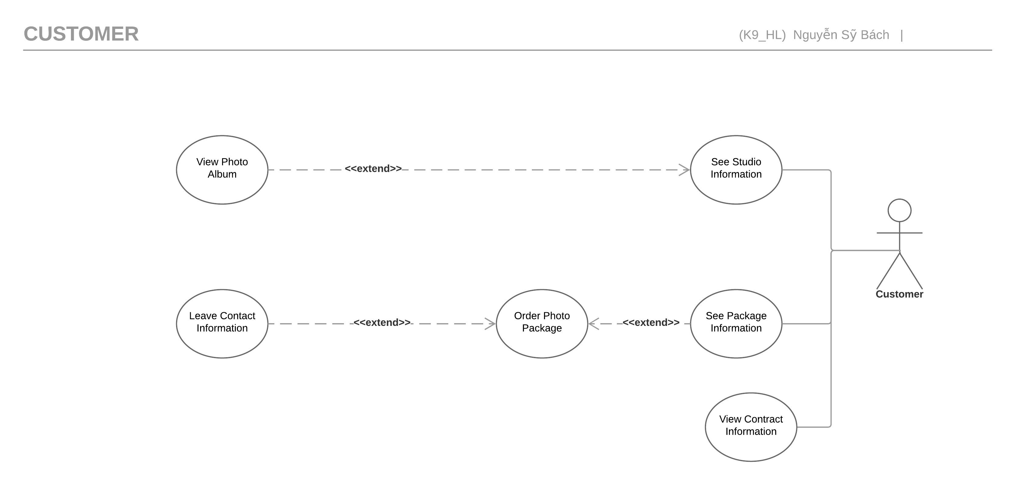

Figure .5.2.2.2: Customer Use Case Diagram

##### See Studio Information

|  |  |  |  |  |  |
| --- | --- | --- | --- | --- | --- |
| Use Case ID UC-030 | | | | Version | 1.0 |
| Use Case Name | | See Studio Information | | | |
| Created by: | | HuyNM | | **Date Created:** | 05/03/2018 |
| Primary Actor | | Customer | |  | |
| Description: | | Add studio manager information. | | | |
| Preconditions: | | Actor must to go PSM website. | | | |
| Trigger: | | Actor click to button “Studio”. | | | |
| Post conditions: | | Display all information Studio. | | | |
| Normal Flow | | | | | |
| Step | **Actor event** | | | **System response** | |
| 1 | Click to button “Studio” | | |  | |
| 2 |  | | | Display above “Studio” is list of Studio. | |
| 3 | Click on name of Studio. | | |  | |
| 4 |  | | | Display all Information studio at bottom of website.   1. Name Studio 2. Studio Phone number 3. Studio Email 4. Studio address 5. Studio map location | |
| Alternative Flows | | | | | |
| AT1: Move mouse to button “Studio”. | | | | | |
| Step | **Actor event** | | | **System response** | |
| 1 | Move mouse to button “Studio”. | | |  | |
| 2 |  | | | List of Studio will display dropdown below “Studio” button. | |
| 3 | Select and Click to Studio want to show. | | |  | |
| 4 |  | | | PSM will go to the page of Studio. | |
|  | | | | | |
| Exceptions: N/A | | | | | |
|  | | | | | |
| Priority | | | Normal | | |
| Frequency of Use: | | | Normal | | |
| Business Rules: | | | N/A | | |

##### See album

|  |  |  |  |  |  |
| --- | --- | --- | --- | --- | --- |
| Use Case ID UC-031 | | | | Version | 1.0 |
| Use Case Name | | See album | | | |
| Created by: | | HuyNM | | **Date Created:** | 05/03/2018 |
| Primary Actor | | Customer | |  | |
| Description: | | Someone want to see sample picture of studio. | | | |
| Preconditions: | | Actor must to go PSM website.  Actor must to go page of Studio on PSM. | | | |
| Trigger: | | Actor click on Picture. | | | |
| Post conditions: | | Picture is showed | | | |
| Normal Flow | | | | | |
| Step | **Actor event** | | | **System response** | |
| 1 | Actor go to page of Studio on PSM. | | |  | |
| 2 |  | | | Show album. | |
| 3 | Click album. | | |  | |
| 4 |  | | | Show Detail of album. | |
| Alternative Flows: N/A | | | | | |
| Exceptions: N/A | | | | | |
|  | | | | | |
| Priority | | | Normal | | |
| Frequency of Use: | | | Normal | | |
| Business Rules: | | | N/A | | |

##### See Package Information

|  |  |  |  |  |  |  |
| --- | --- | --- | --- | --- | --- | --- |
| Use Case ID UC-032 | | | | Version | | 1.0 |
| Use Case Name | | See Package Information | | | | |
| Created by: | | HuyNM | | **Date Created:** | | 05/03/2018 |
| Primary Actor | | Customer | |  | | |
| Description: | | Show for Actor packages of studio. | | | | |
| Preconditions: | | Actor must to go PSM website. | | | | |
| Trigger: | | Actor selected to name of Studio. | | | | |
| Post conditions: | | Show all package Studio. | | | | |
| Normal Flow | | | | | | |
| Step | **Actor event** | | | | **System response** | |
| 1 | Actor go to page of Studio on PSM. | | | |  | |
| 2 |  | | | | Website will show   1. Package 2. Studio description. | |
| 3 | At functions “Package” Click to the “More” on package. | | | |  | |
|  |  | | | | Detail of package will show all.   1. Package name 2. Package detail 3. Package price | |
| Alternative Flows | | | | | | |
| Step | **Actor event** | | | | **System response** | |
| 1 | Click to “More package”. | | | |  | |
|  |  | | | | PSM show all information of Package. | |
| Exceptions: N/A | | | | | | |
| Priority | | | Normal | | | |
| Frequency of Use: | | | Normal | | | |
| Business Rules: | | | B10 | | | |

##### Order photo Package and leave Information

|  |  |  |  |  |  |
| --- | --- | --- | --- | --- | --- |
| Use Case ID UC-033 | | | | Version | 1.0 |
| Use Case Name | | Order photo Package and leave Information | | | |
| Created by: | | HuyNM | | **Date Created:** | 05/03/2018 |
| Primary Actor | | Customer | |  | |
| Description: | | Actor Order package. | | | |
| Preconditions: | | Actor must to go PSM website.  Actor need choose the Studio want to take picture. | | | |
| Trigger: | | Actor click to icon “Cart” for order package. | | | |
| Post conditions: | | PSM will send email for Actor. | | | |
| Normal Flow | | | | | |
| Step | **Actor event** | | | **System response** | |
| 1 | After Actor select the cart. Click to the button “Buy”. | | |  | |
| 2 |  | | | PSM will move to checkout page and show price of package. | |
| 3 | Write in table Actor information:   1. Name 2. Gender 3. Phone number 4. Email 5. Note.   Then click “Order”. | | |  | |
| 4 |  | | | 1. Message “Order sended”. 2. PSM send email for Actor and manager of package. | |
| 5 |  | | |  | |
| Alternative Flows: N/A | | | | | |
| Exceptions | | | | | |
| EC1: Phone number need is number 11~13. | | | | | |
| Step | **Actor event** | | | **System response** | |
| 3.1 | Actor entered invalid. | | |  | |
| 3.2 |  | | | Message “Invalid phone number” | |
|  | | | | | |
| EC2: Email khách hàng The email must be valid. | | | | | |
| Step | **Actor event** | | | **System response** | |
| 3.3 | Actor entered invalid email. | | |  | |
| 3.4 |  | | | Message “Invalid email.” | |
| Priority | | | Normal | | |
| Frequency of Use: | | | Normal | | |
| Business Rules: | | | B2, B4, B6 | | |

##### View contract

|  |  |  |  |  |  |  |
| --- | --- | --- | --- | --- | --- | --- |
| Use Case ID UC-034 | | | | Version | | 1.0 |
| Use Case Name | | View contract | | | | | |
| Created by: | | HuyNM | | **Date Created:** | 05/03/2018 | |
| Primary Actor | | Customer | |  | | |
| Description: | | Show contract for Actor | | | | | |
| Preconditions: | | Actor must to go PSM website. | | | | | |
| Trigger: | | Actor click to “Contract” hyperlink. | | | | | |
| Post conditions: | | All information displayed. | | | | | |
| Normal Flow | | | | | | | |
| Step | **Actor event** | | | **System response** | | |
| 1 | Click to contract hyperlink | | |  | | |
| 2 |  | | | PSM will display table contract. | | |
| 3 | 1.Input ContractId  2.Click ok | | |  | | |
| 4 |  | | | PSM will display detail of actor contract picture, contract status. | | |
| Alternative Flows: N/A | | | | | | | |
| Exceptions: N/A | | | | | | | |
| Priority | | | Normal | | | | |
| Frequency of Use: | | | Normal | | | | |
| Business Rules: | | | B1 | | | | |
| Other Information: | | | N/A | | | | |

## Entity Relation Modelエンティティ関係モデル

### Entity-Relationship Diagram エンティティ- 関係図

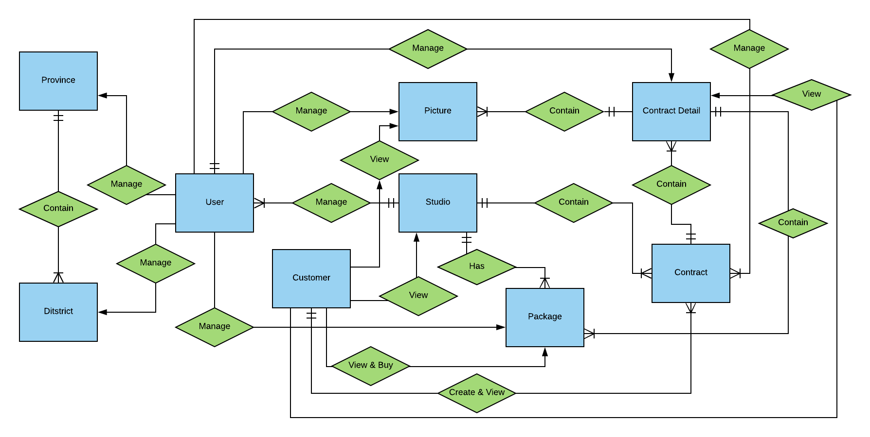

Figure 3.4.1**:** Entity Relationship Diagram

#### Manager

|  |  |  |  |  |
| --- | --- | --- | --- | --- |
| No | Attribute | Type | Mandatory | Description |
| 1 | User_ID | String | Y | User’s username |
| 2 | Studio_ID | int | Y | Studio’s ID |
| 3 | User_Role | String | Y | User’s role |
| 4 | User_Password | String | Y | User’s password |

#### Studio

|  |  |  |  |  |
| --- | --- | --- | --- | --- |
| No | Attribute | Type | Mandatory | Description |
| 1 | Studio_ID | Int | Y | Studio’s ID |
| 2 | District_ID | String | Y | District’s ID. |
| 3 | Studio_Name | String | Y | Studio’s name |
| 4 | Studio_Address | String | Y | Studio’s physical address |
| 5 | Studio_Email | String | Y | Studio’s email address |
| 6 | Studio_Number | Number | Y | Studio’s phone number |
| 7 | Studio_Coordinate | String | Y | Studio’s location coordinate |
| 8 | Studio_Icon | String | N | Studio’s icon |
| 9 | Studio_main_pic | String | N | Studio’s main picture at studio’s page |
| 10 | Studio_project_1 | String | N | Studio’s project 1 picture at studio’s page |
| 11 | Studio_project_2 | String | N | Studio’s project 2 picture at studio’s page |
| 12 | Studio_project_3 | String | N | Studio’s project 3 picture at studio’s page |
| 13 | Studio_project_4 | String | N | Studio’s project 4 picture at studio’s page |
| 14 | Studio_project_5 | String | N | Studio’s project 5 picture at studio’s page |
| 15 | Studio_project_6 | String | N | Studio’s project 6 picture at studio’s page |
| 16 | Studio_project_7 | String | N | Studio’s project 7 picture at studio’s page |
| 17 | Studio_quote_pic | String | N | Quote’s picture |
| 18 | Studio_quote | String | N | Studio’s quote |
| 19 | Studio_about_pic | String | N | About’s picture |

#### District

|  |  |  |  |  |
| --- | --- | --- | --- | --- |
| No | Attribute | Type | Mandatory | Description |
| 1 | District_ID | Int | Y | District’s ID |
| 2 | Province_ID | Int | Y | Province that have the current district |
| 3 | District_Name | String | Y | District’s Name |

#### Province

|  |  |  |  |  |
| --- | --- | --- | --- | --- |
| No | Attribute | Type | Mandatory | Description |
| 1 | Province_ID | Int | Y | Province’s ID |
| 2 | Province_Name | String | Y | Province’s Name |

#### Contract

|  |  |  |  |  |
| --- | --- | --- | --- | --- |
| No | Attribute | Type | Mandatory | Description |
|  | Contract_ID | String | Y | Contract’s ID |
|  | Customer_ID | Int | Y | Customer’s ID |
|  | Studio_ID | Int | Y | Studio’s ID |
|  | Contract_Description | String | N | The Description about the current contract |
|  | Contract_cDate | Date | Y | The create date of the contract |
|  | Contract_sDate | Date | N | The start the contract start have effectness |
|  | Contract_eDate | Date | N | The date the contract end lost effectness |
|  | Contract_State | String | Y | The state of the contract |

#### Customer

|  |  |  |  |  |
| --- | --- | --- | --- | --- |
| No | Attribute | Type | Mandatory | Description |
| 1 | Customer_ID | Int | Y | Customer’s ID |
| 2 | Customer_Name | String | Y | Customer’s name |
| 3 | Customer_Gender | String | Y | Customer’s gender |
| 4 | Customer_Address | String | Y | Customer’s address |
| 5 | Customer_Email | String | Y | Customer’s email |
| 6 | Customer_Number | String | Y | Customer’s number |
| 7 | Customer_Note | String | N | Customer’s note |
| 8 | Customer_Other | String | N | Customer’s social media |

#### Contract Detail

|  |  |  |  |  |
| --- | --- | --- | --- | --- |
| No | Attribute | Type | Mandatory | Description |
| 1 | ConDetail_ID | Int | Y | Feedback’s ID |
| 2 | Contract_ID | String | Y | Contract’s ID that relate to the contract’s detail |
| 3 | Package_ID | Int | Y | Real time that member create feedback |
| 4 | Package_Name | String | Y | Name of the current available package |
| 5 | Package_Detail | String | Y | Detail of the current available package |
| 6 | Package_Price | Int | Y | Price of the current available package |
| 7 | Package_Note | String | N | Note about package |

#### Package

|  |  |  |  |  |
| --- | --- | --- | --- | --- |
| No | Attribute | Type | Mandatory | Description |
|  | Package_ID | Int | Y | package’s ID |
|  | Package_Name | String | Y | Package’s Name |
|  | Package_Detail | String | Y | Package’s Detail |
|  | Package_Price | Int | Y | Package’s price |
|  | Package_Available | Boolean | Y | Define that the package is available or not |
|  | Package_pic | String | N | The picture represent the package |

#### Picture

|  |  |  |  |  |
| --- | --- | --- | --- | --- |
| No | Attribute | Type | Mandatory | Description |
| 1 | Picture_ID | Int | Y | Picrure’s ID |
| 2 | ConDetail_ID | Int | Y | Comtract’s ID |
| 3 | Picture_Detail | String | N | Picture’s detail |
| 4 | Picture_Url | String | N | Picture’s Url link |

### Entity descriptionエンティティの説明

|  |  |  |
| --- | --- | --- |
| No | Table Name | Description |
|  | User | Account of member of Studio. Manage Users, Studios, Provinces, Districts, Package, Contract, Contract Detail, Picture, Customer depend on role of the User. |
|  | Picture | The Picture of the current Contract Detail. |
|  | Province | The information of the Province. |
|  | District | The information of the District where it belong in a Province. |
|  | Package | The information of the Contract . |
|  | Studio | The information of the Studio. |
|  | Contract | A contract of a Studio where Customer order Packages. |
|  | Contract Detail | Details of the current Contract that contain the information of the Packages that the Customer order. |
|  | Customer | Customer who buy Packages. |
|  | User | Account of member of Studio. Manage Users, Studios, Provinces, Districts, Package, Contract, Contract Detail, Picture, Customer depend on role of the User. |
|  | Picture | The Picture of the current Contract Detail. |
|  | Province | The information of the Province. |
|  | District | The information of the District where it belong in a Province. |

### Relationship 関係

|  |  |  |  |  |  |
| --- | --- | --- | --- | --- | --- |
| No | Relation | Properties | From | To | Description |
|  | CONTAIN | Province_ID | Province | District | A Province has one or many District. |
|  | MANAGE | District_ID | User | District | User role Admin manages all district at District management page. |
|  | MANAGE | Province_ID | User | Province | User role Admin manages all Province at Province management page. |
|  | MANAGE | Package_ID | User | Package | User role manager manages all packages of the User’s current Studio at Package management page. |
|  | MANAGE | Contract_ID | User | Contract | User role manager manages all their contracts of the user’s current Studio at Contract management page. |
|  | MANAGE | ConDetail_ID | User | Contract Detail | User role manager manages all thier contract’s details of it current contract at Contract management page. |
|  | MANAGE | Picture_ID | User | Picture | User role manager manages all pictures of the current contract’s detail page at view picture page. |
|  | MANAGE | Studio_ID | User | Studio | User role Admin manages all Studios at Studio Management page. User role manager manage their own Studio at Profile management page. |
|  | MANAGE | Customer_ID | User | Customer | User role manager can manages their own Customer at Contract management page. |
|  | VIEW | None | Customer | Picture | A customer can view picture of the contract they order at Contract view page. |
|  | VIEW | None | Customer | Contract Detail | A customer can view contract’s detail at Contract view page. |
|  | VIEW | None | Customer | Studio | A customer can view Studio information and Packages’s information inside the Studio view page. |
|  | VIEW & CREATE | Contract_ID | Customer | Contract | A customer can view contract’s information at Contract view page. Customer can also create new Contract by buying one or many packages at checkout page |
|  | VIEW & BUY | None | Customer | Package | A customer can buy packages by add to cart at the Studio view page. Customer can also view them at Studio view page |
|  | HAS | Package_ID | Studio | Package | A studio can have one or many Packages. |
|  | CONTAIN | Studio_ID | Studio | Contract | A studio can have one or many Contracts. |

# ARCHITECTURE DESIGN　アーキテクチャ設計書

## Introduction　はじめに

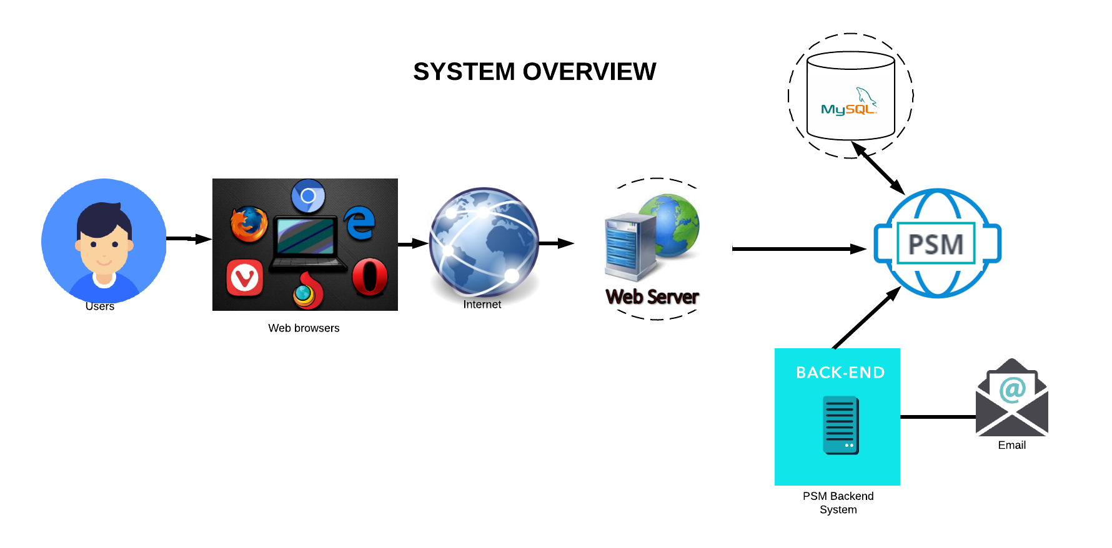

### Purpose　目的

The purpose of this chapter is to give developers the overview and the detailed technical design of Photographic Studio Manager. This chapter consist of:

* Architecture overview
* Component diagram
* Detailed design
* Detailed description of components
* Database design

### References　参照資料

|  |  |  |
| --- | --- | --- |
| No. | Document | Source/Web Address |
| 1 | Architecture Design Template | FPT Software Cop. |

## Architectural Overview　アーキテクチャ概要

### System Architecture　システムアーキテクチャ

In our project we use MVC architectural model.

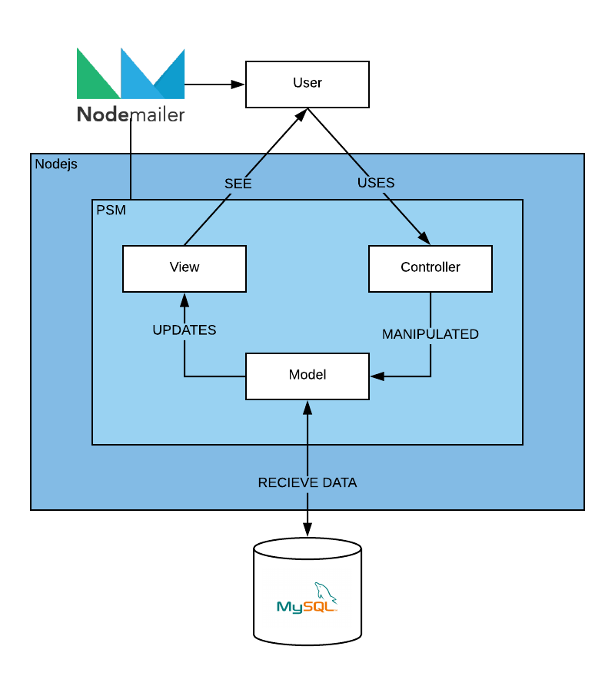

***Figure 4.1****: System Overview*

## System Architecture Explanation　システムアーキテクチャについての説明

The following is the explanation of the function and mechanism of each unit in the System Design.

**Nodejs:** The entire system will be deployed by using Nodejs. Our target is developing a highly available and responsive system.

**Nodemailer**: We use Nodemailer to send information to Users by email. Nodemailer is a email service that provides reliable transactional email delivery and real time analytics.

**MySQL**: MySQL is an open-source relational database management system. We use MySQL for adding, accessing and managing content of our system’s database.

## Design of PhotoGraphic Studio Manager

### Database Design データベース設計

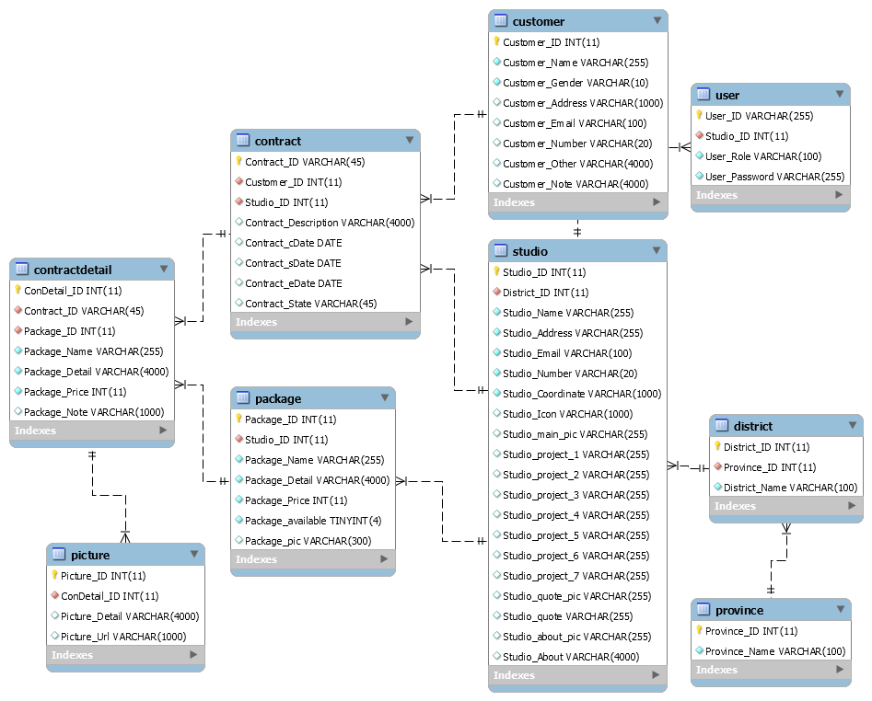

**Figure 4.4.1:** Table Diagram

### Database detail　データベースの詳細

#### Manager

|  |  |  |  |  |
| --- | --- | --- | --- | --- |
| No | Attribute | Type | Mandatory | Description |
| 1 | User_ID | String | Y | User’s username |
| 2 | Studio_ID | int | Y | Studio’s ID |
| 3 | User_Role | String | Y | User’s role |
| 4 | User_Password | String | Y | User’s password |

#### Studio

|  |  |  |  |  |
| --- | --- | --- | --- | --- |
| No | Attribute | Type | Mandatory | Description |
| 1 | Studio_ID | Int | Y | Studio’s ID |
| 2 | District_ID | String | Y | District’s ID. |
| 3 | Studio_Name | String | Y | Studio’s name |
| 4 | Studio_Address | String | Y | Studio’s physical address |
| 5 | Studio_Email | String | Y | Studio’s email address |
| 6 | Studio_Number | Number | Y | Studio’s phone number |
| 7 | Studio_Coordinate | String | Y | Studio’s location coordinate |
| 8 | Studio_Icon | String | N | Studio’s icon |
| 9 | Studio_main_pic | String | N | Studio’s main picture at studio’s page |
| 10 | Studio_project_1 | String | N | Studio’s project 1 picture at studio’s page |
| 11 | Studio_project_2 | String | N | Studio’s project 2 picture at studio’s page |
| 12 | Studio_project_3 | String | N | Studio’s project 3 picture at studio’s page |
| 13 | Studio_project_4 | String | N | Studio’s project 4 picture at studio’s page |
| 14 | Studio_project_5 | String | N | Studio’s project 5 picture at studio’s page |
| 15 | Studio_project_6 | String | N | Studio’s project 6 picture at studio’s page |
| 16 | Studio_project_7 | String | N | Studio’s project 7 picture at studio’s page |
| 17 | Studio_quote_pic | String | N | Quote’s picture |
| 18 | Studio_quote | String | N | Studio’s quote |
| 19 | Studio_about_pic | String | N | About’s picture |

#### District

|  |  |  |  |  |
| --- | --- | --- | --- | --- |
| No | Attribute | Type | Mandatory | Description |
| 1 | District_ID | Int | Y | District’s ID |
| 2 | Province_ID | Int | Y | Province that have the current district |
| 3 | District_Name | String | Y | District’s Name |

#### Province

|  |  |  |  |  |
| --- | --- | --- | --- | --- |
| No | Attribute | Type | Mandatory | Description |
| 1 | Province_ID | Int | Y | Province’s ID |
| 2 | Province_Name | String | Y | Province’s Name |

#### Contract

|  |  |  |  |  |
| --- | --- | --- | --- | --- |
| No | Attribute | Type | Mandatory | Description |
|  | Contract_ID | String | Y | Contract’s ID |
|  | Customer_ID | Int | Y | Customer’s ID |
|  | Studio_ID | Int | Y | Studio’s ID |
|  | Contract_Description | String | N | The Description about the current contract |
|  | Contract_cDate | Date | Y | The create date of the contract |
|  | Contract_sDate | Date | N | The start the contract start have effectness |
|  | Contract_eDate | Date | N | The date the contract end lost effectness |
|  | Contract_State | String | Y | The state of the contract |

#### Customer

|  |  |  |  |  |
| --- | --- | --- | --- | --- |
| No | Attribute | Type | Mandatory | Description |
| 1 | Customer_ID | Int | Y | Customer’s ID |
| 2 | Customer_Name | String | Y | Customer’s name |
| 3 | Customer_Gender | String | Y | Customer’s gender |
| 4 | Customer_Address | String | Y | Customer’s address |
| 5 | Customer_Email | String | Y | Customer’s email |
| 6 | Customer_Number | String | Y | Customer’s number |
| 7 | Customer_Note | String | N | Customer’s note |
| 8 | Customer_Other | String | N | Customer’s social media |

#### Contract Detail

|  |  |  |  |  |
| --- | --- | --- | --- | --- |
| No | Attribute | Type | Mandatory | Description |
| 1 | ConDetail_ID | Int | Y | Feedback’s ID |
| 2 | Contract_ID | String | Y | Contract’s ID that relate to the contract’s detail |
| 3 | Package_ID | Int | Y | Real time that member create feedback |
| 4 | Package_Name | String | Y | Name of the current available package |
| 5 | Package_Detail | String | Y | Detail of the current available package |
| 6 | Package_Price | Int | Y | Price of the current available package |
| 7 | Package_Note | String | N | Note about package |

#### Package

|  |  |  |  |  |
| --- | --- | --- | --- | --- |
| No | Attribute | Type | Mandatory | Description |
|  | Package_ID | Int | Y | package’s ID |
|  | Package_Name | String | Y | Package’s Name |
|  | Package_Detail | String | Y | Package’s Detail |
|  | Package_Price | Int | Y | Package’s price |
|  | Package_Available | Boolean | Y | Define that the package is available or not |
|  | Package_pic | String | N | The picture represent the package |

#### Picture

|  |  |  |  |  |
| --- | --- | --- | --- | --- |
| No | Attribute | Type | Mandatory | Description |
| 1 | Picture_ID | Int | Y | Picrure’s ID |
| 2 | ConDetail_ID | Int | Y | Comtract’s ID |
| 3 | Picture_Detail | String | N | Picture’s detail |
| 4 | Picture_Url | String | N | Picture’s Url link |

## Component Diagramコンポーネント図

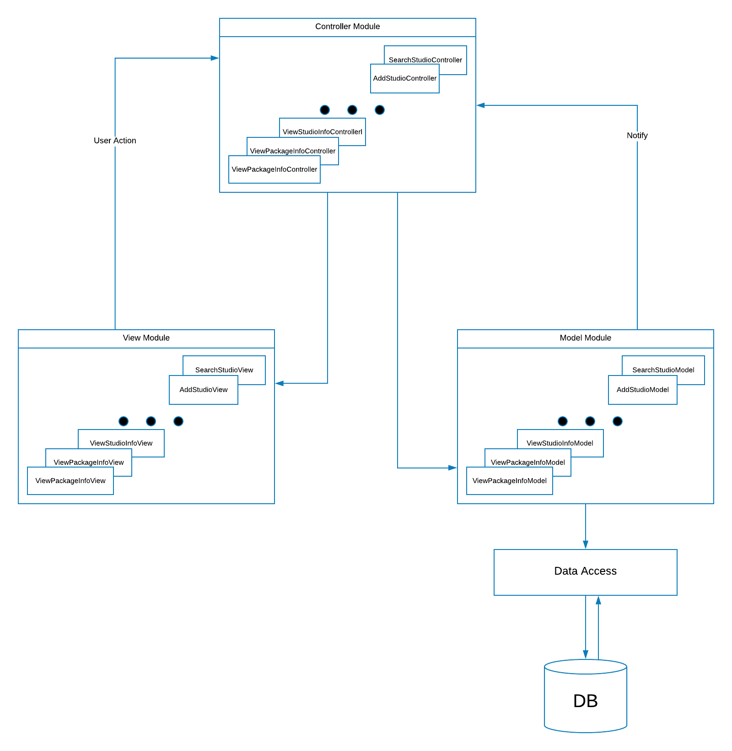

Figure 4.5 Componet Diagram

The **Model** manages behavior of application in terms of its problem domain including data, logic and rules of application. It takes request form controller layer and makes changes to database of the system.

The **View** provides the user interface element of the application. It takes information form model and display in a form that suitable for users.

The **Controller** receives user action and makes calls to model object.

## Detail Design　詳細設計

### Admin

#### Login

##### Description

Admin can Login to the systems.

##### Design

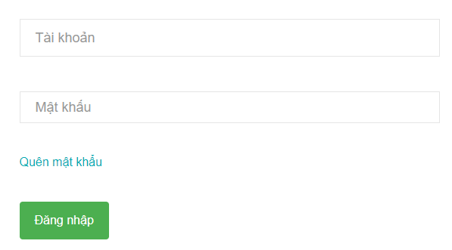

##### Class Diagram

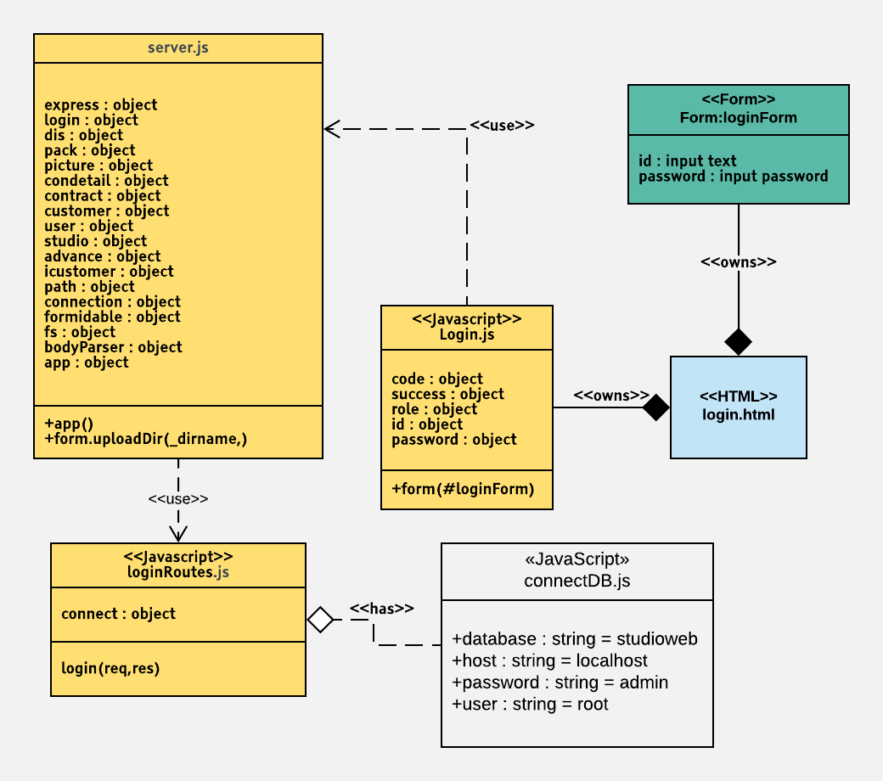

##### Class Specification

|  |  |  |  |  |
| --- | --- | --- | --- | --- |
| **Class** | loginRoutes | | | |
| **Description** | Control Admin login action | | | |
| **Base Class** | Controller | | | |
| **Source File** | loginRoutes.js | | | |
| **Namespace** | app/public/routes/ | | | |
| **Attributes** | **N/A** | | | |
| **Methods** | **Name** | **Input** | **Output** | **Description** |
| login | Request, result | View | Allow user to login into the system |

##### Sequence Diagram

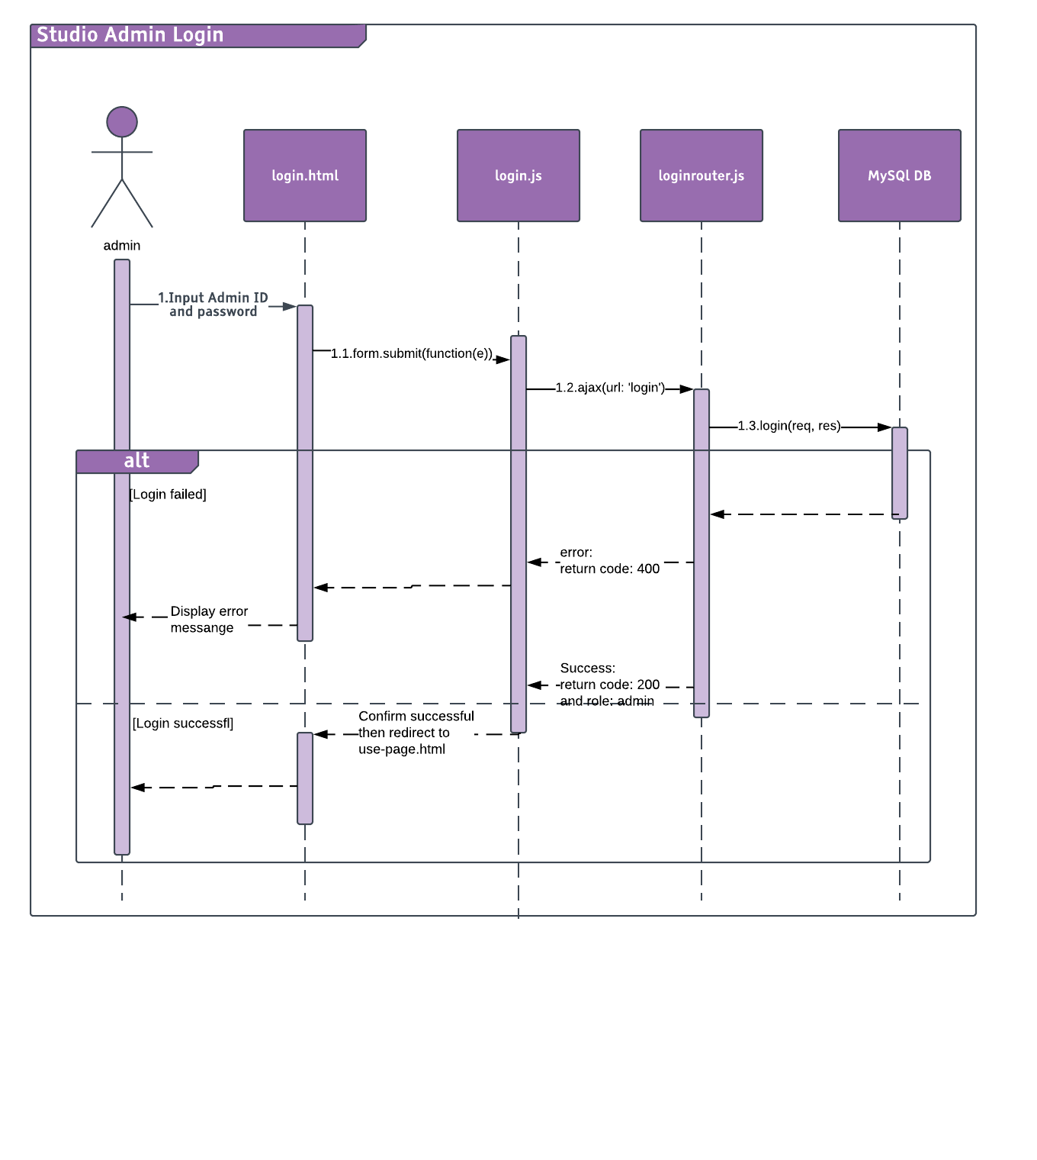

#### Logout

##### Description

Admin can Logout the system.

##### Design

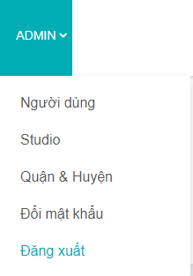

##### Class Diagram

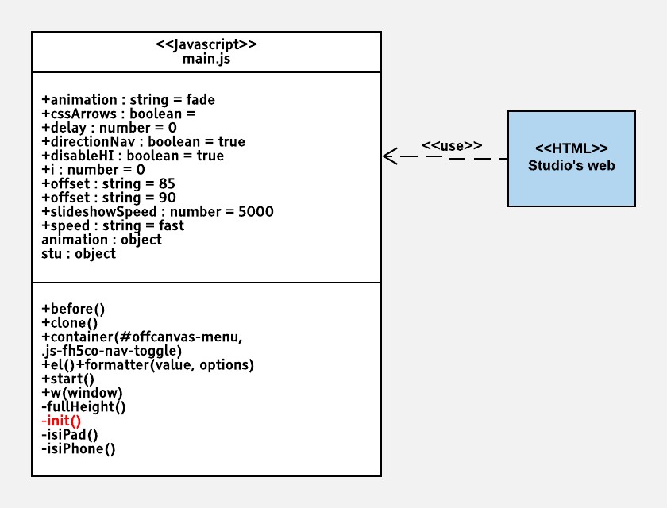

##### Class Specification

|  |  |  |  |  |
| --- | --- | --- | --- | --- |
| **Class** | main | | | |
| **Description** | Control Admin logout action | | | |
| **Base Class** | model | | | |
| **Source File** | Main.js | | | |
| **Namespace** | app/public/js/ | | | |
| **Attributes** | **N/A** | | | |
| **Methods** | **Name** | **Input** | **Output** | **Description** |
| logout | Request | View | Logout the current User |

##### Sequence Diagram

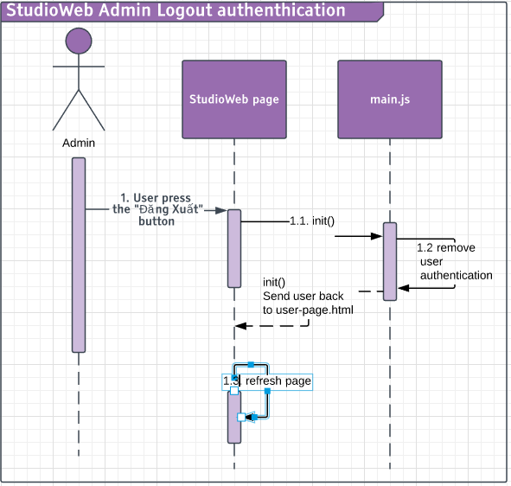

#### Change Password

##### Description

Admin can change password.

##### Design

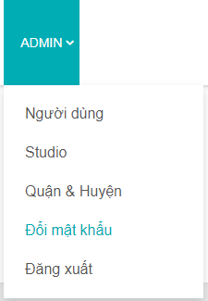

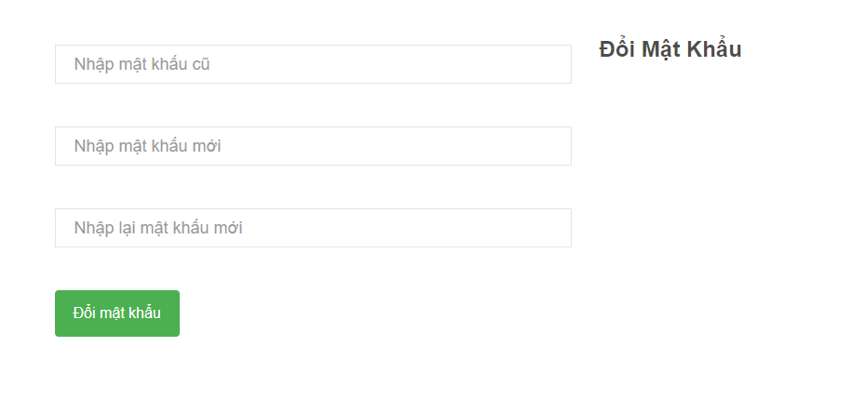

##### Class Diagram

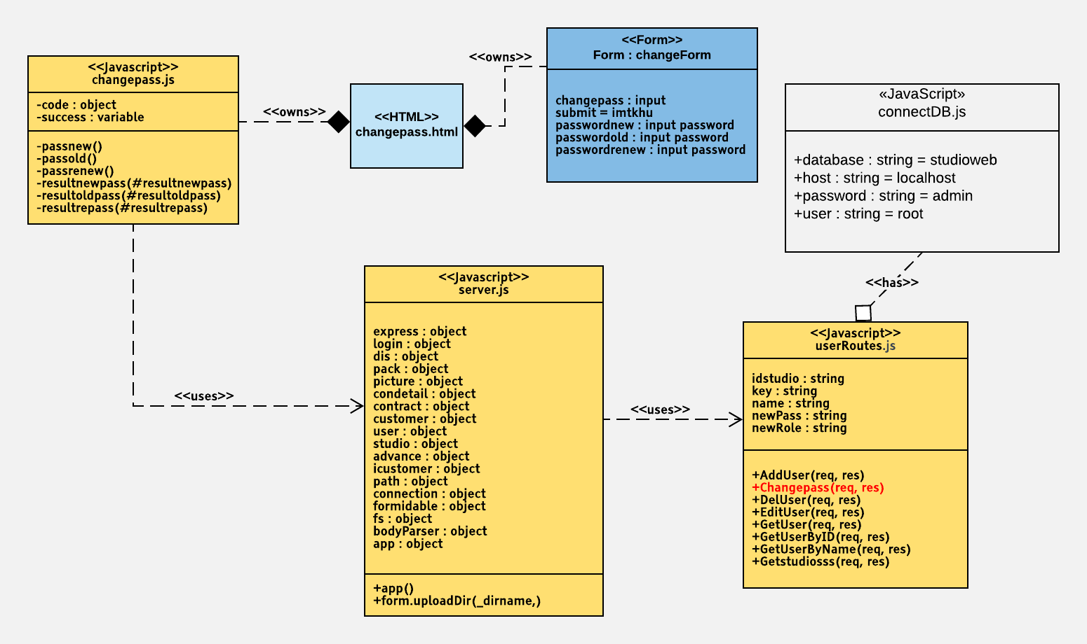

##### Class Specification

|  |  |  |  |  |
| --- | --- | --- | --- | --- |
| **Description** | Control Admin change password action | | | |
| **Base Class** | Controller | | | |
| **Source File** | userRoutes.js | | | |
| **Namespace** | app/public/routes/ | | | |
| **Attributes** | **N/A** | | | |
| **Methods** | **Name** | **Input** | **Output** | **Description** |
| changepass | Request, result | View | Change the password of the current user |

##### Sequence Diagram

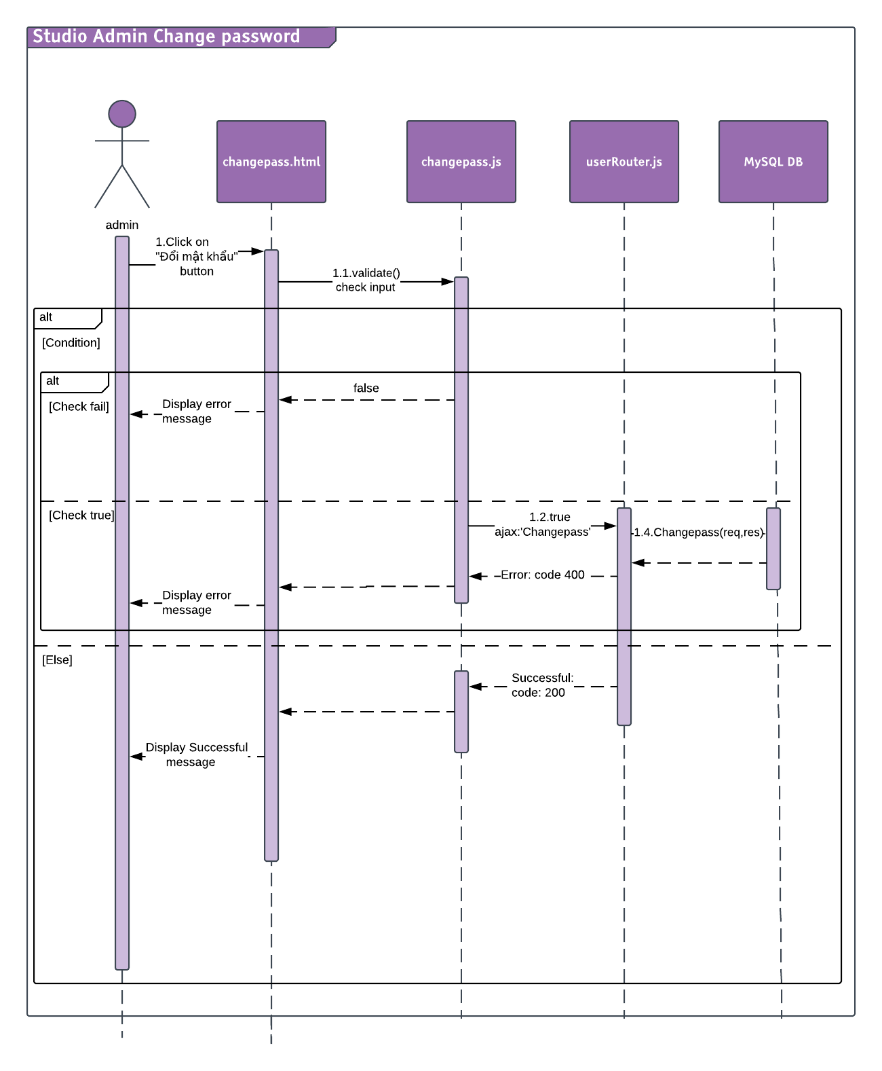

#### Forgot Password

##### Description

Admin can change password if fogot old password.

##### Design

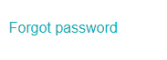

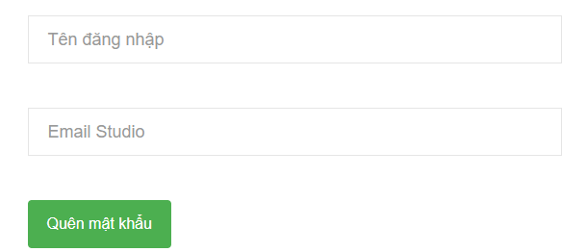

##### Class Diagram

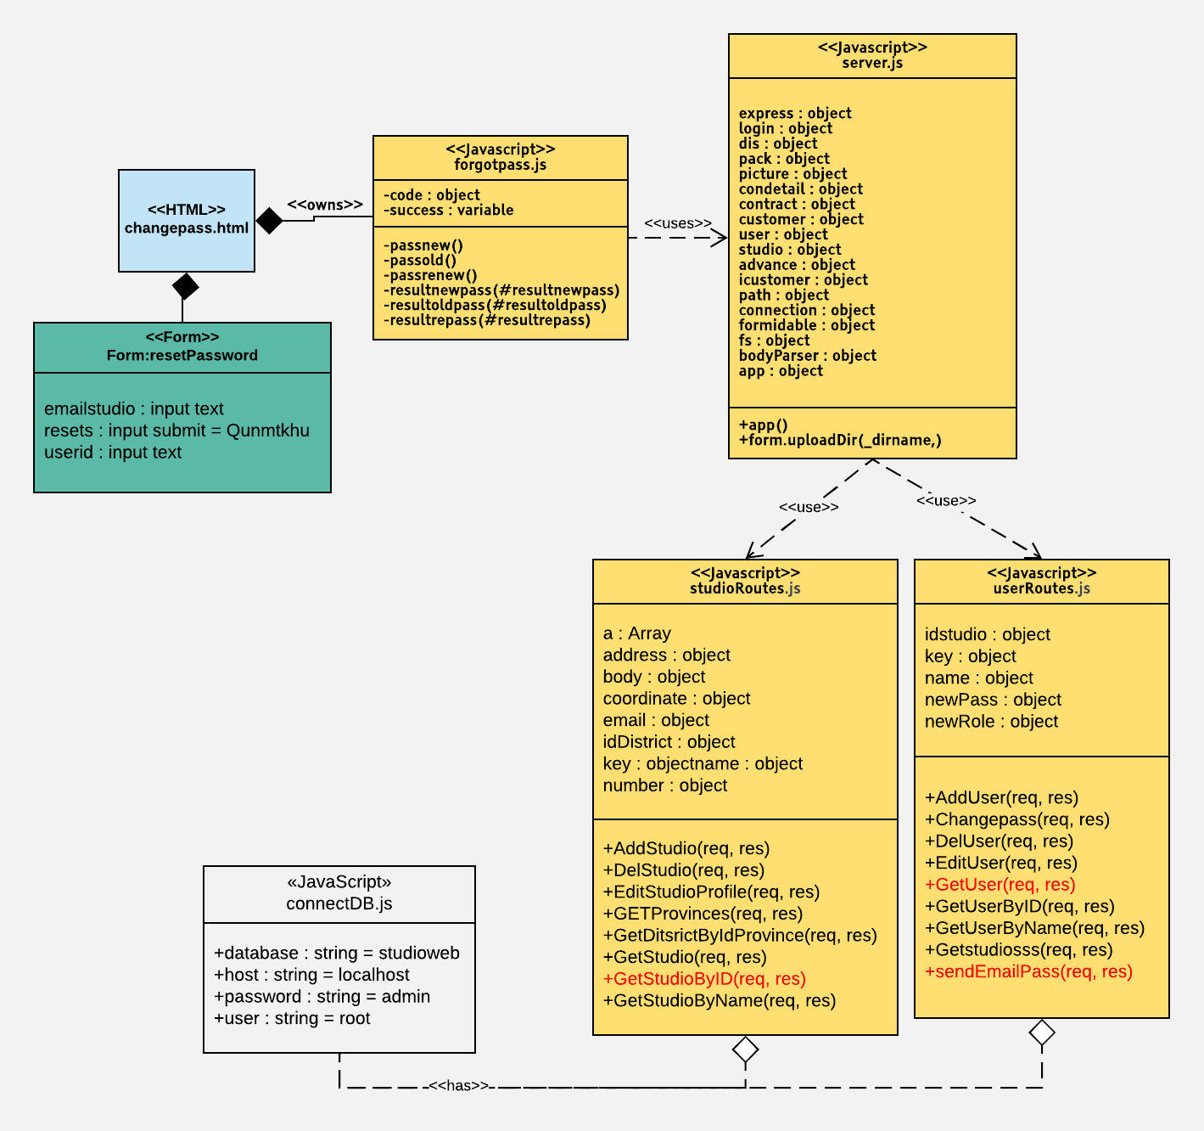

##### Class Specification

|  |  |  |  |  |
| --- | --- | --- | --- | --- |
| **Description** | Control Admin forgot password action | | | |
| **Base Class** | Controller | | | |
| **Source File** | userRoutes.js | | | |
| **Namespace** | app/public/routes/ | | | |
| **Attributes** | **N/A** | | | |
| **Methods** | **Name** | **Input** | **Output** | **Description** |
| SendEmailPass | Request, result | View | Change the password of the current user |
|  | GetUser | Request, result | View | Get user |

|  |  |  |  |  |
| --- | --- | --- | --- | --- |
| **Description** | Specify which Studio does user belong to | | | |
| **Base Class** | Controller | | | |
| **Source File** | studioRoutes.js | | | |
| **Namespace** | app/public/routes/ | | | |
| **Attributes** | **N/A** | | | |
| **Methods** | **Name** | **Input** | **Output** | **Description** |
| GetStudioByID | Request, result | View | Get studio by User ID |

##### Sequence Diagram

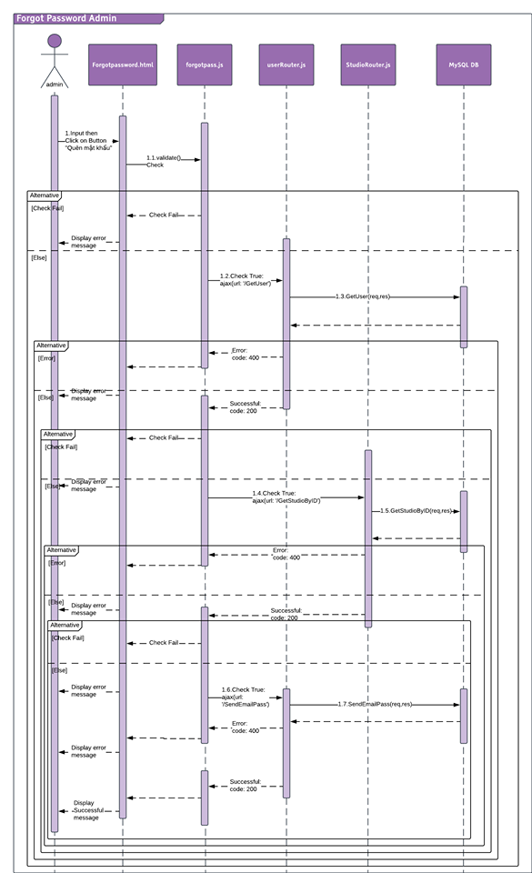

#### Search & View Province/District

##### Description

Admin can search and view province, district information.

##### Design

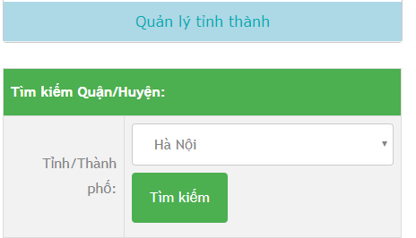

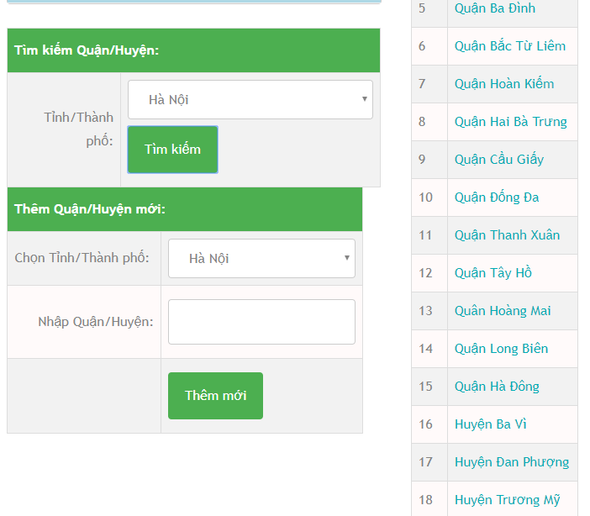

##### Class Diagram

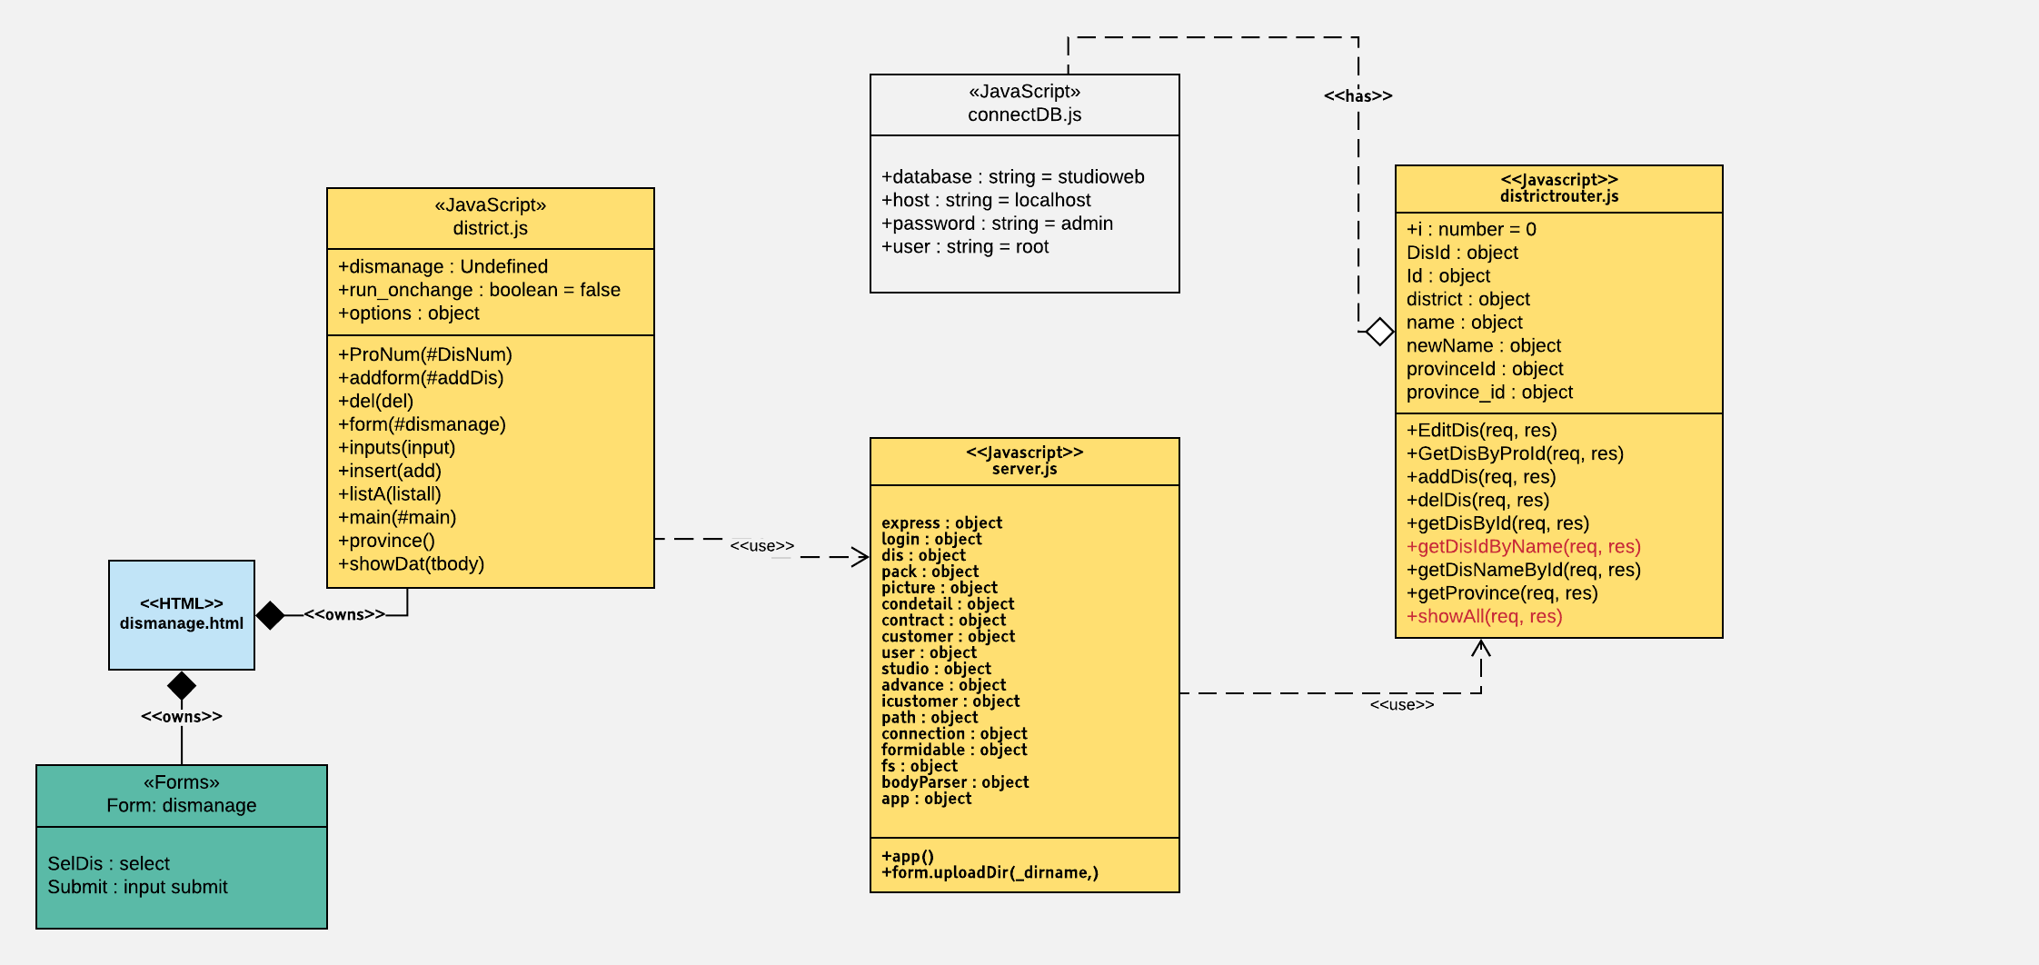

##### Class Specification

|  |  |  |  |  |
| --- | --- | --- | --- | --- |
| **Description** | Specify which Studio does user belong to | | | |
| **Base Class** | Controller | | | |
| **Source File** | districtRoutes.js | | | |
| **Namespace** | app/public/routes/ | | | |
| **Attributes** | **N/A** | | | |
| **Methods** | **Name** | **Input** | **Output** | **Description** |
| GetProvince | Request, result | View | Get province to bind to combobox |
|  | Dismanage | Request, result | View | Search and display district |

##### Sequence Diagram

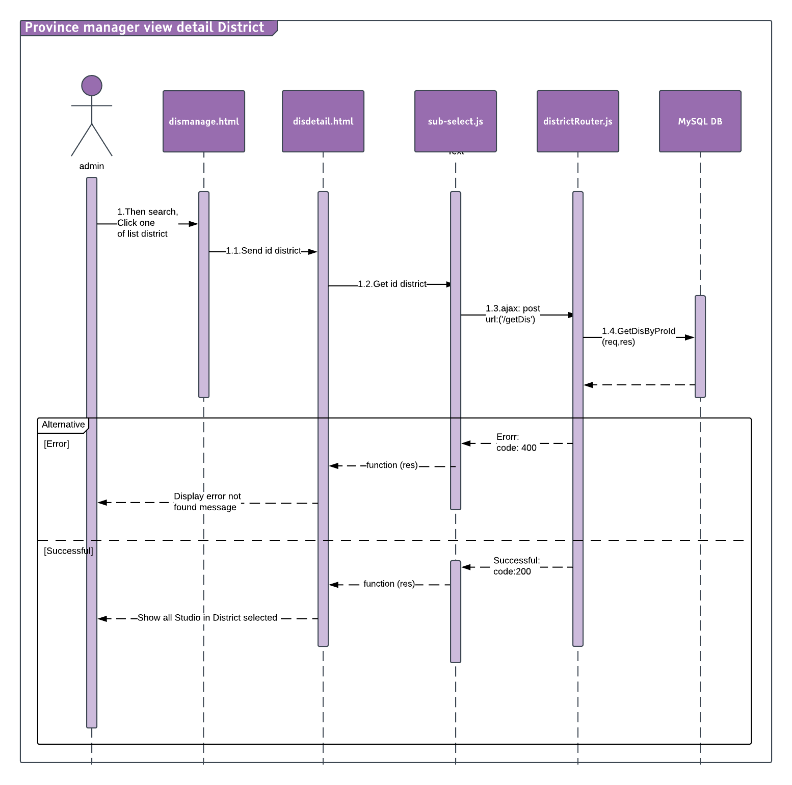

#### Add Province/District

##### Description

Admin can add more Province/District.

##### Design

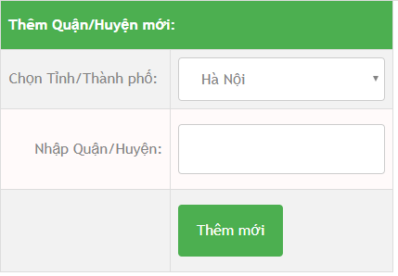

##### Class Diagram

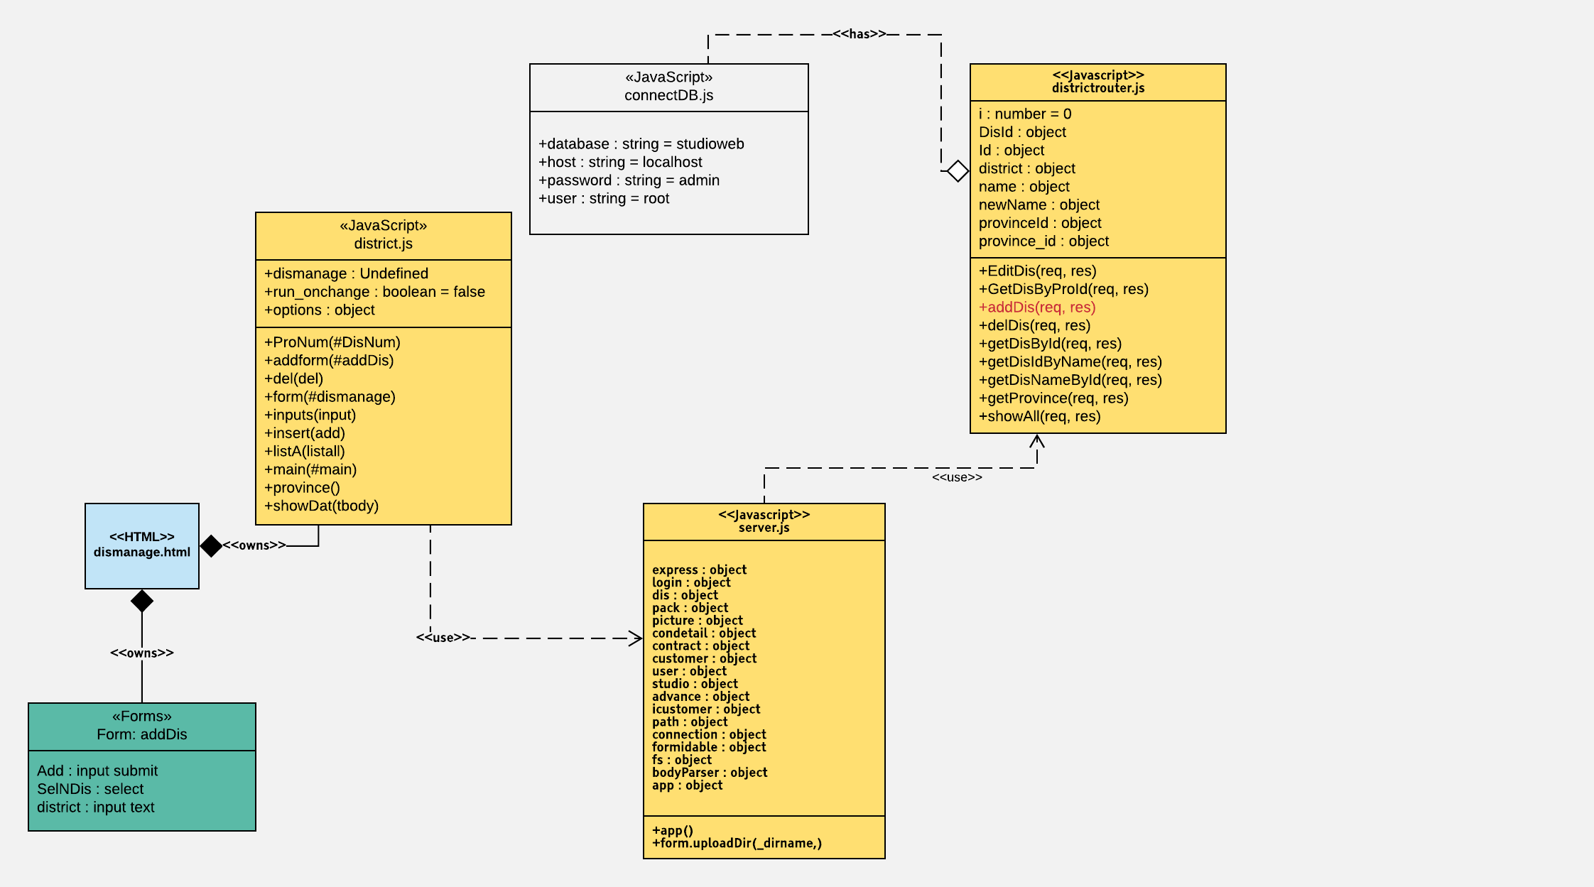

##### Class Specification

|  |  |  |  |  |
| --- | --- | --- | --- | --- |
| **Description** | Specify which Studio does user belong to | | | |
| **Base Class** | Controller | | | |
| **Source File** | districtRoutes.js | | | |
| **Namespace** | app/public/routes/ | | | |
| **Attributes** | **N/A** | | | |
| **Methods** | **Name** | **Input** | **Output** | **Description** |
| GetProvince | Request, result | View | Get province to bind to combobox |
|  | AddDis | Request, result | View | Add new district |

##### Sequence Diagram

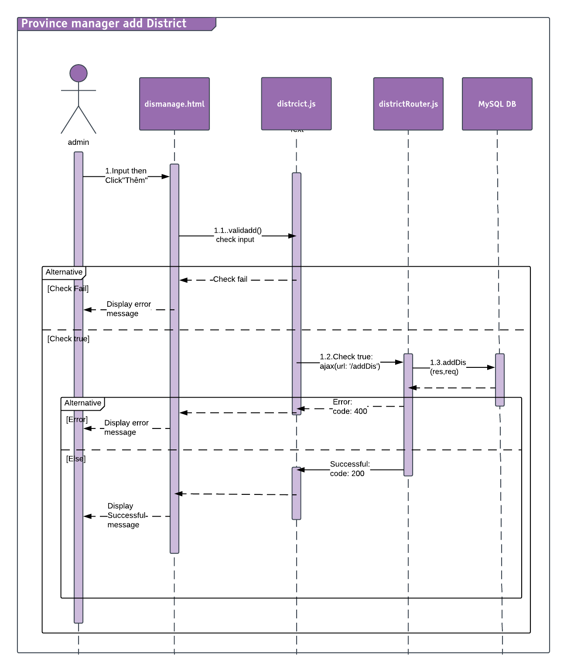

#### Edit Province/District

##### Description

Addmin can edit Province/District information.

##### Design

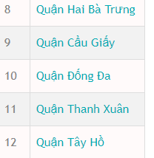

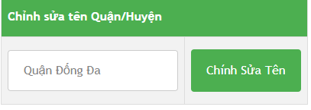

##### Class Diagram

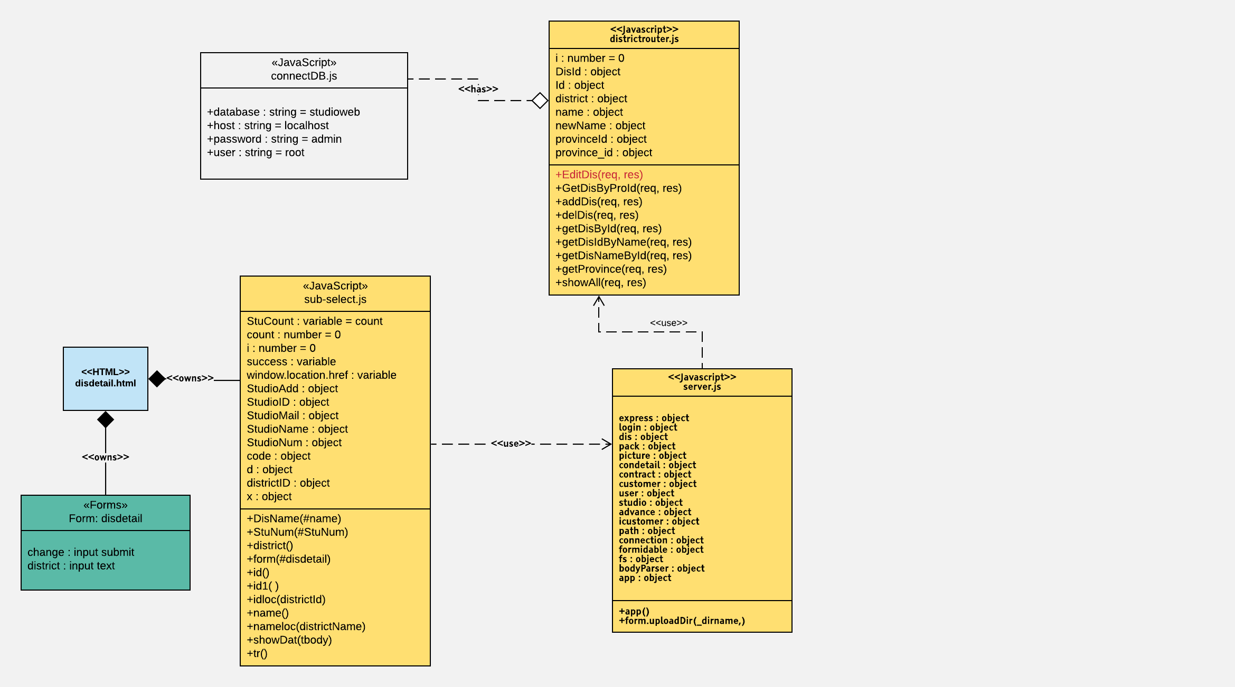

##### Class Specification

|  |  |  |  |  |
| --- | --- | --- | --- | --- |
| **Description** | Specify which Studio does user belong to | | | |
| **Base Class** | Controller | | | |
| **Source File** | districtRoutes.js | | | |
| **Namespace** | app/public/routes/ | | | |
| **Attributes** | **N/A** | | | |
| **Methods** | **Name** | **Input** | **Output** | **Description** |
| GetProvince | Request, result | View | Get province to bind to combobox |
|  | EditDis | Request, result | View | Edit one district |

##### Sequence Diagram

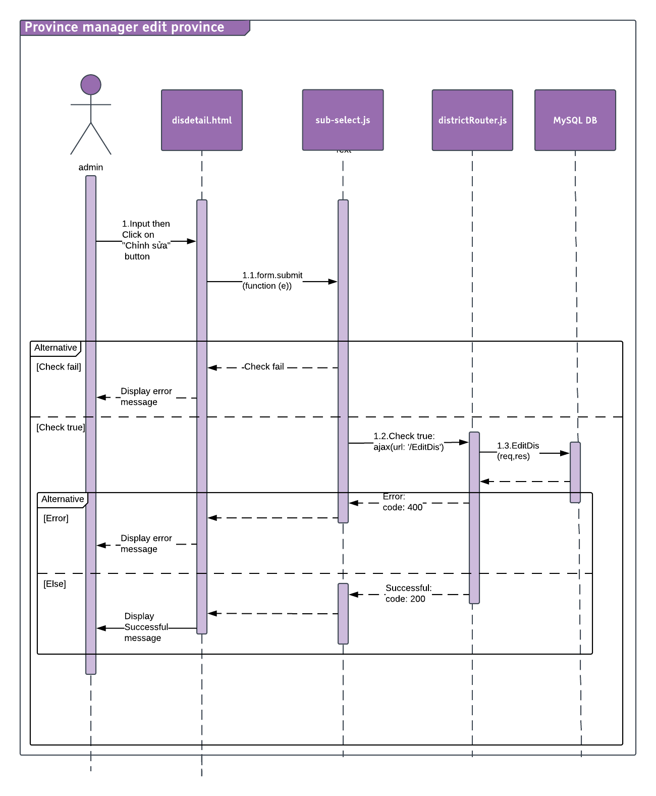

#### Delete Province/District

##### Description

Admin can delete Province/District.

##### Design

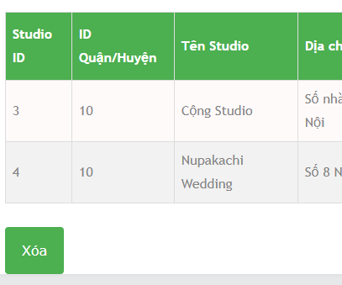

##### Class Diagram

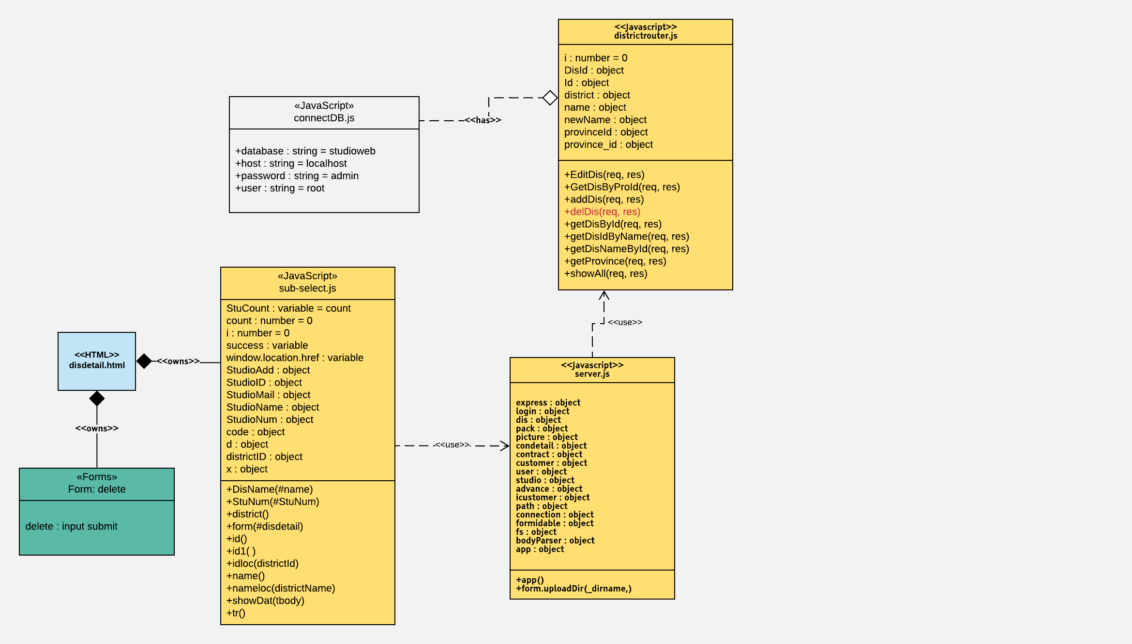

##### Class Specification

|  |  |  |  |  |
| --- | --- | --- | --- | --- |
| **Description** | Specify which Studio does user belong to | | | |
| **Base Class** | Controller | | | |
| **Source File** | districtRoutes.js | | | |
| **Namespace** | app/public/routes/ | | | |
| **Attributes** | **N/A** | | | |
| **Methods** | **Name** | **Input** | **Output** | **Description** |
| GetDisById | Request, result | View | Get district info by distirct ID |
|  | delDis | Request, result | View | Delete one district |

##### Sequence Diagram

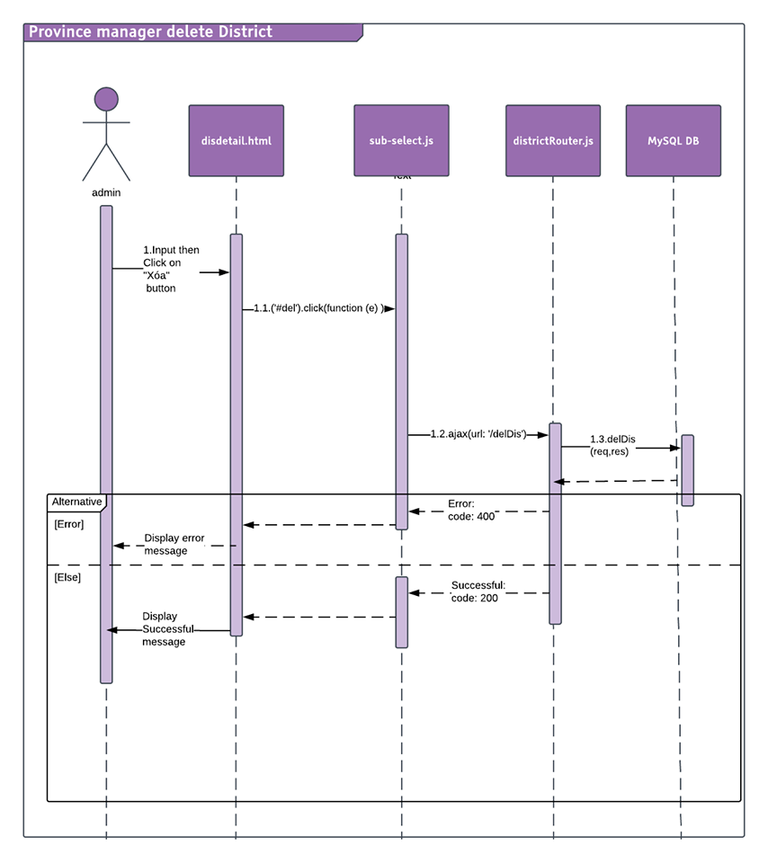

#### Search & view Studio

##### Description

Admin can search and view studio information.

##### Design

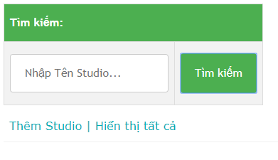

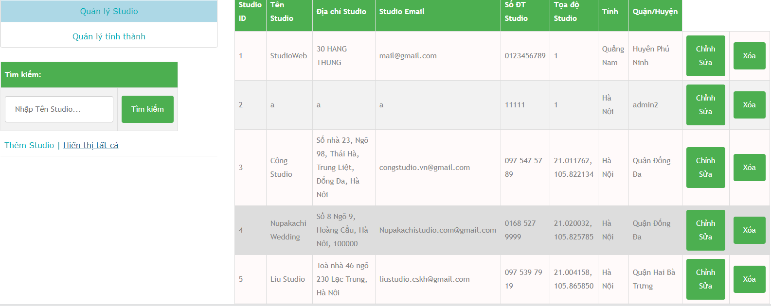

##### Class Diagram

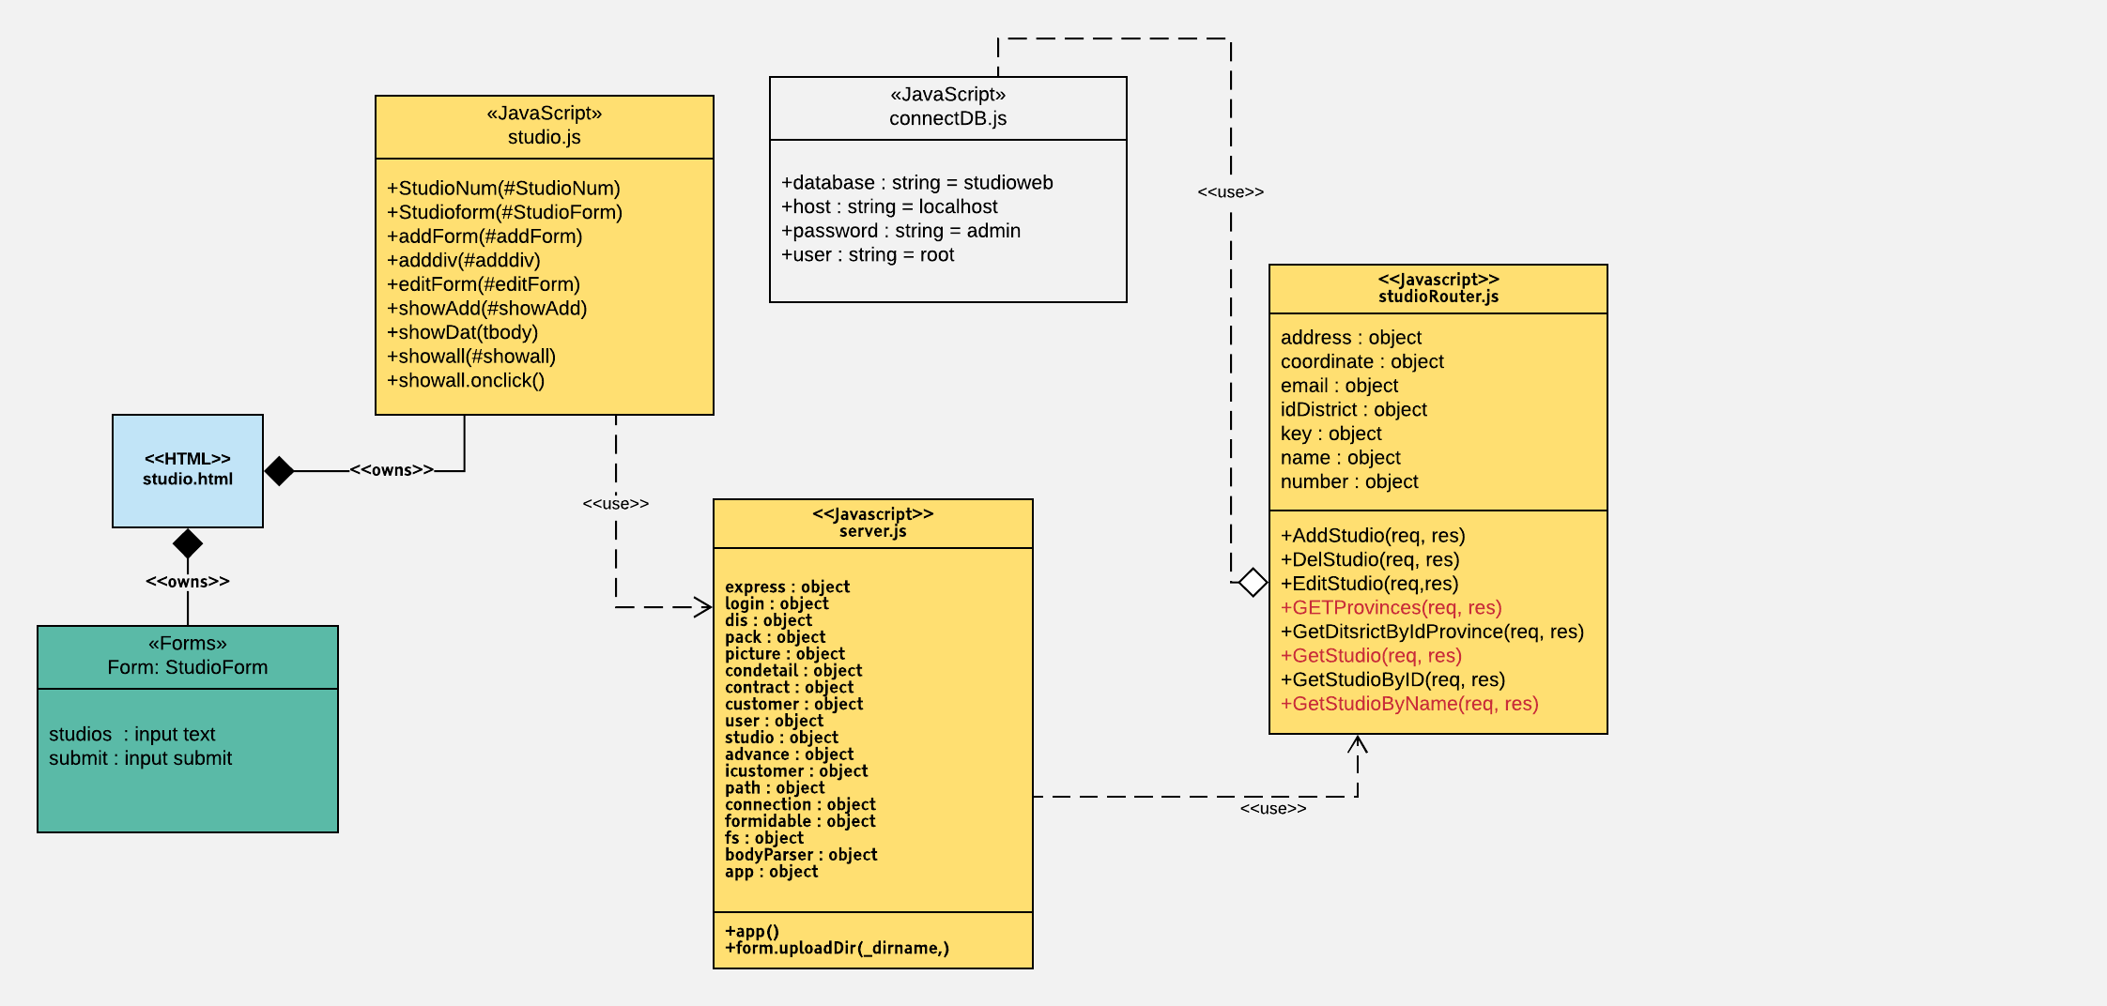

##### Class Specification

|  |  |  |  |  |
| --- | --- | --- | --- | --- |
| **Description** | Get Studio information | | | |
| **Base Class** | Controller | | | |
| **Source File** | studioRoutes.js | | | |
| **Namespace** | app/public/routes/ | | | |
| **Attributes** | **N/A** | | | |
| **Methods** | **Name** | **Input** | **Output** | **Description** |
| GetStudio | Request, result | View | Get all Studio info to bind combobox |
|  | GetStudioByName | Request, result | View | Search Studio info by studio name |

|  |  |  |  |  |
| --- | --- | --- | --- | --- |
| **Description** | Specify which Studio does user belong to | | | |
| **Base Class** | Controller | | | |
| **Source File** | districtRoutes.js | | | |
| **Namespace** | app/public/routes/ | | | |
| **Attributes** | **N/A** | | | |
| **Methods** | **Name** | **Input** | **Output** | **Description** |
| GetProvince | Request, result | View | Get province to bind to combobox |

##### Sequence Diagram

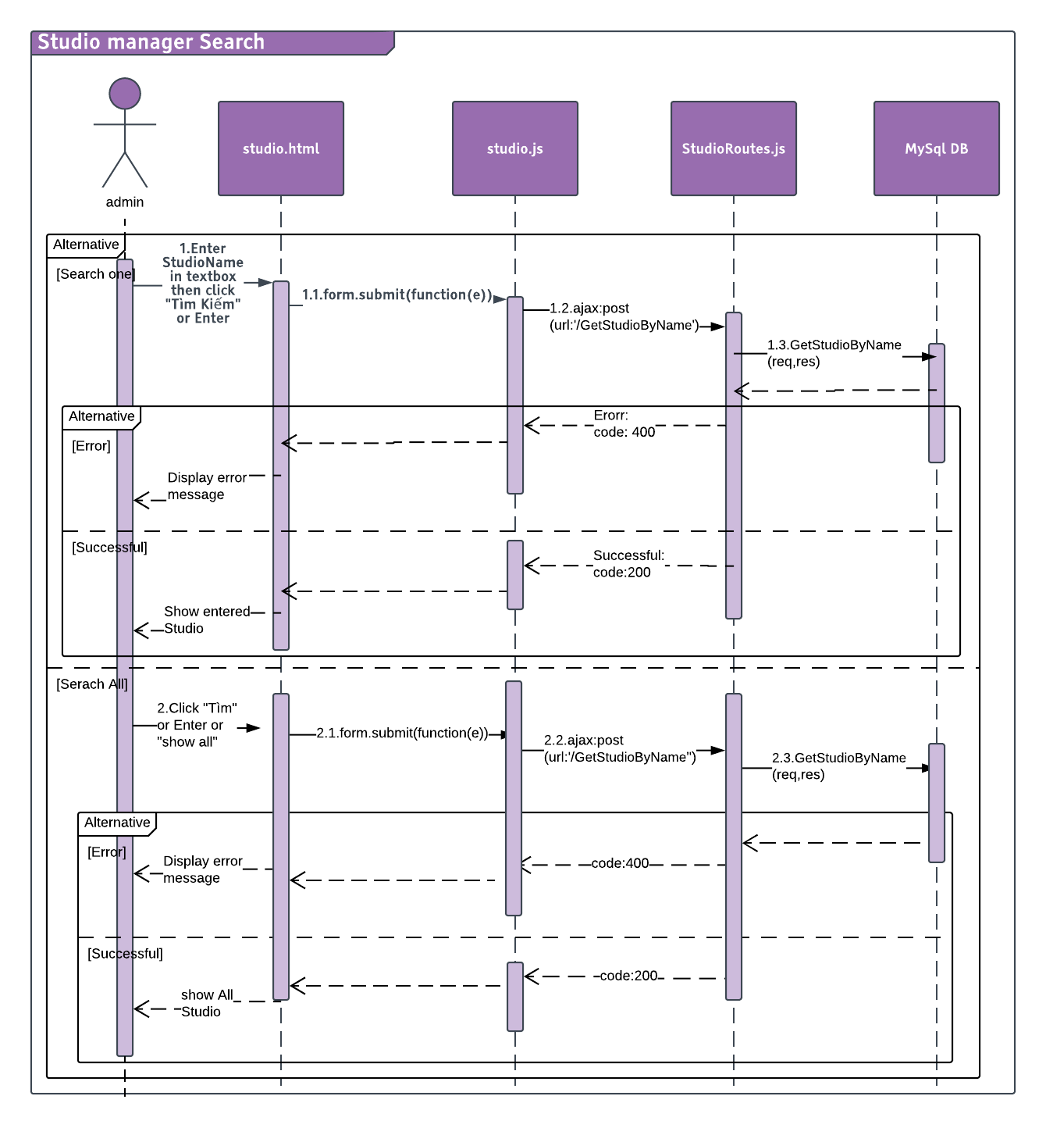

#### Add Studio

##### Description

Admin can add more Studio.

##### Design

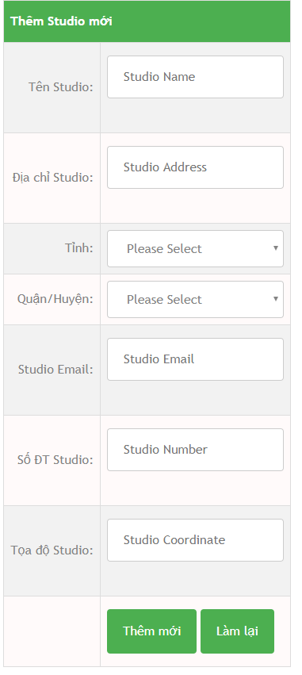

##### Class Diagram

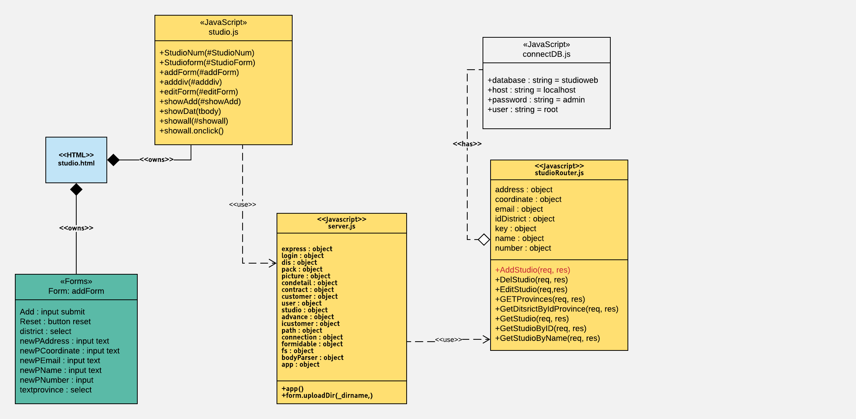

##### Class Specification

|  |  |  |  |  |
| --- | --- | --- | --- | --- |
| **Description** | Add new Studio | | | |
| **Base Class** | Controller | | | |
| **Source File** | studioRoutes.js | | | |
| **Namespace** | app/public/routes/ | | | |
| **Attributes** | **N/A** | | | |
| **Methods** | **Name** | **Input** | **Output** | **Description** |
| AddStudio | Request, result | View | Add new studio into the system |

##### Sequence Diagram

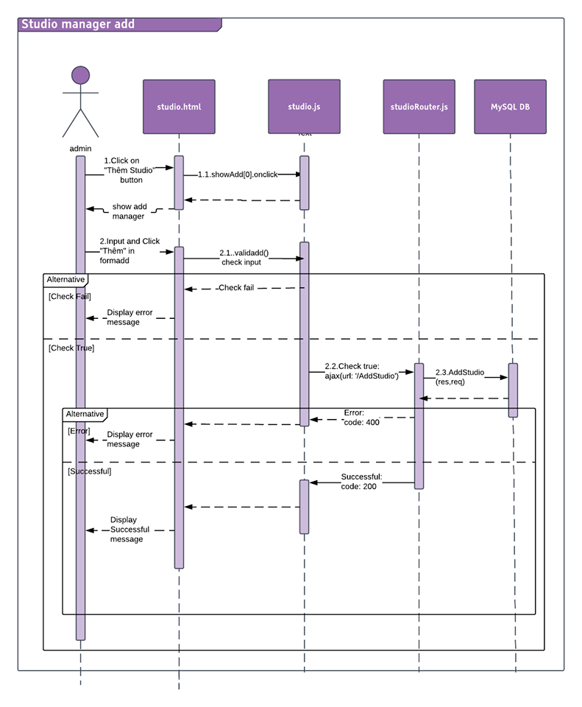

#### Edit Studio

##### Description

Admin can change Studio information.

##### Design



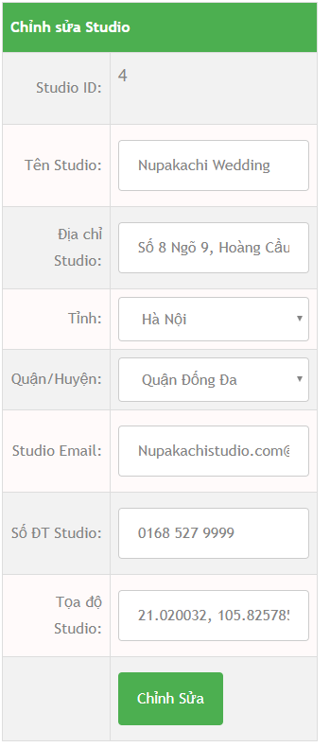

##### Class Diagram

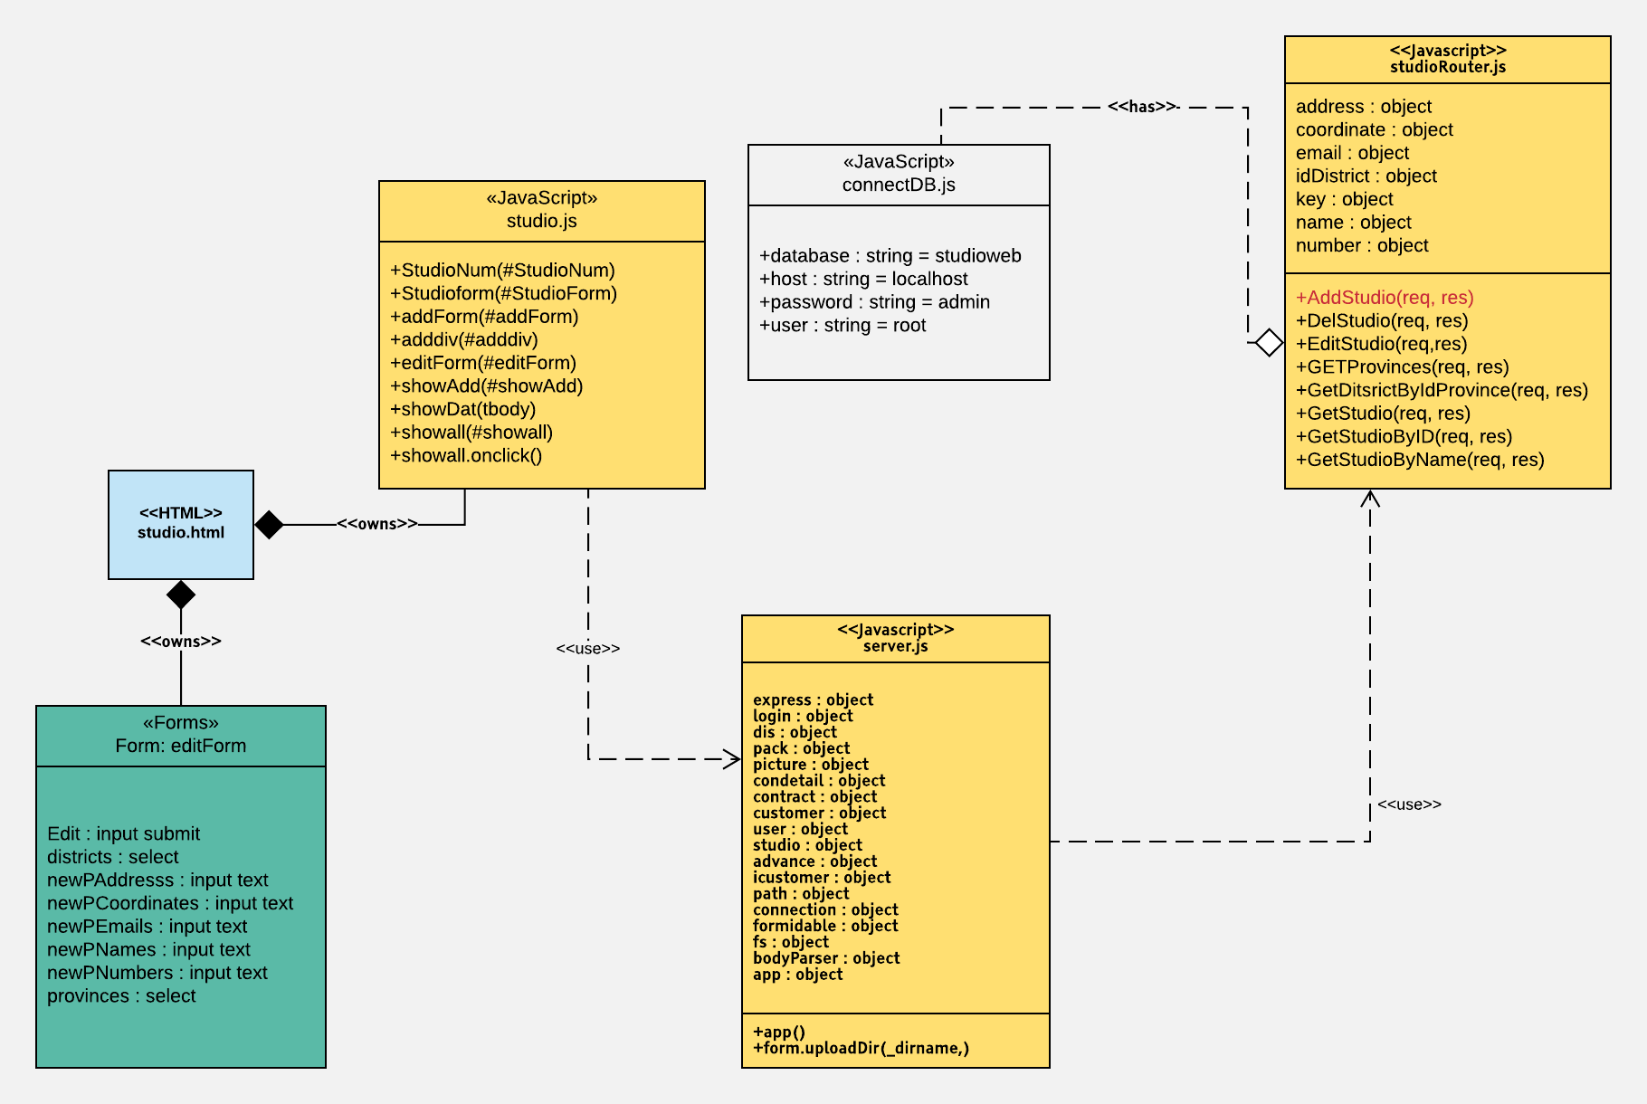

##### Class Specification

|  |  |  |  |  |
| --- | --- | --- | --- | --- |
| **Description** | Edit a Studio | | | |
| **Base Class** | Controller | | | |
| **Source File** | studioRoutes.js | | | |
| **Namespace** | app/public/routes/ | | | |
| **Attributes** | **N/A** | | | |
| **Methods** | **Name** | **Input** | **Output** | **Description** |
| EditStudio | Request, result | View | Add new studio into the system |

##### Sequence Diagram

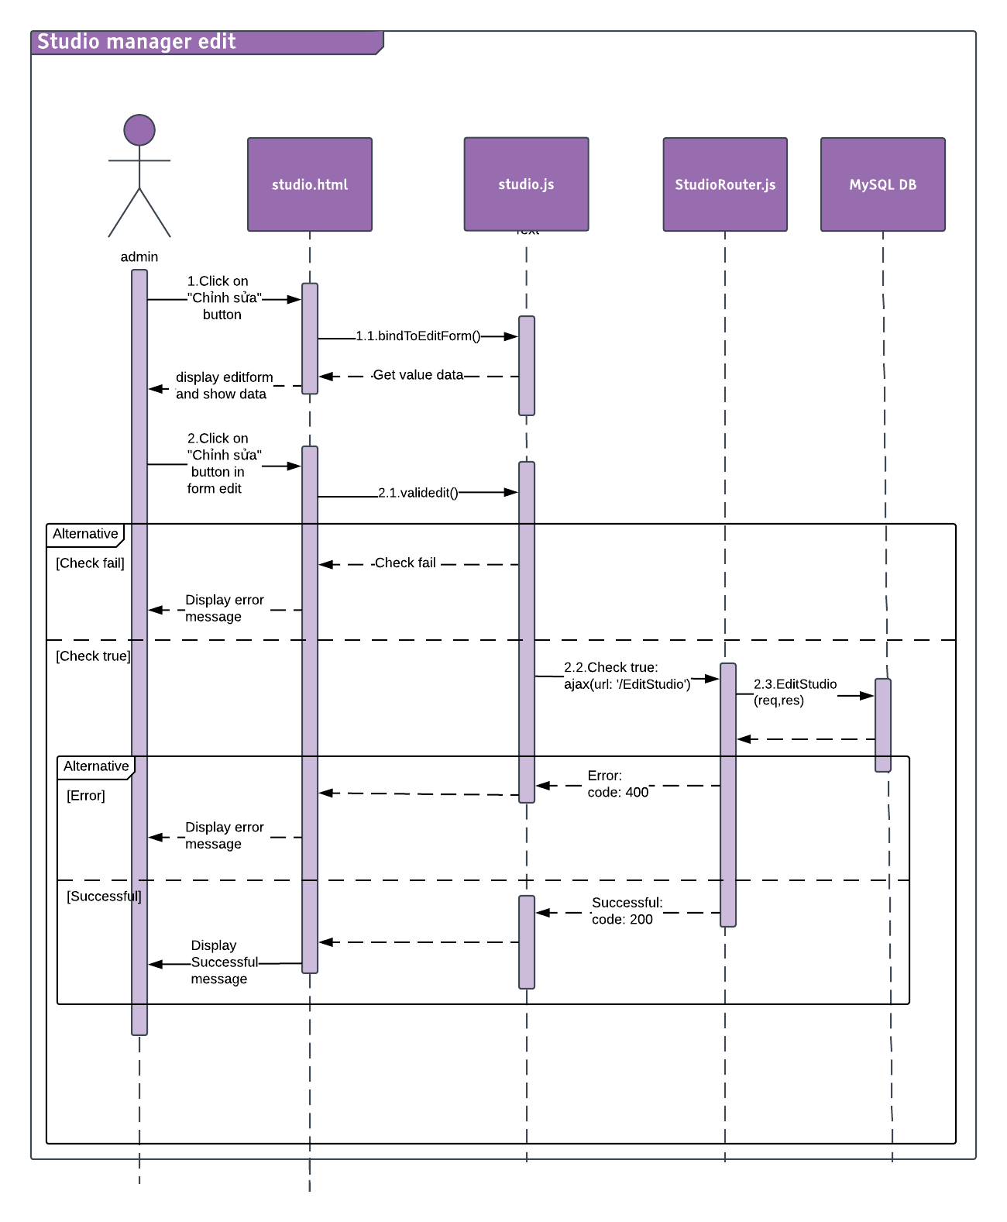

#### Delete Studio

##### Description

Admin can delete Studio.

##### Design



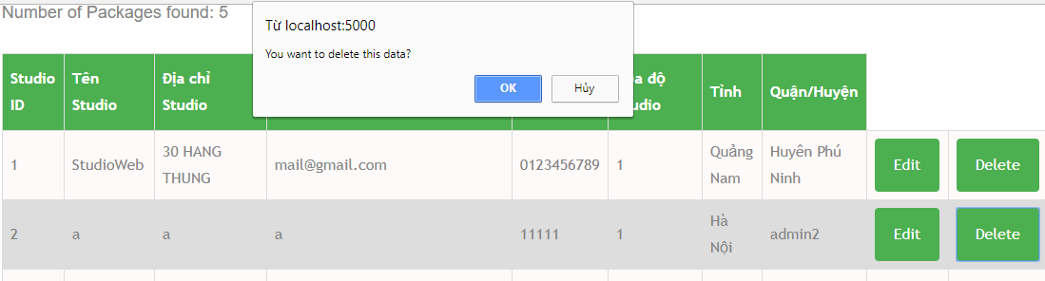

##### Class Diagram

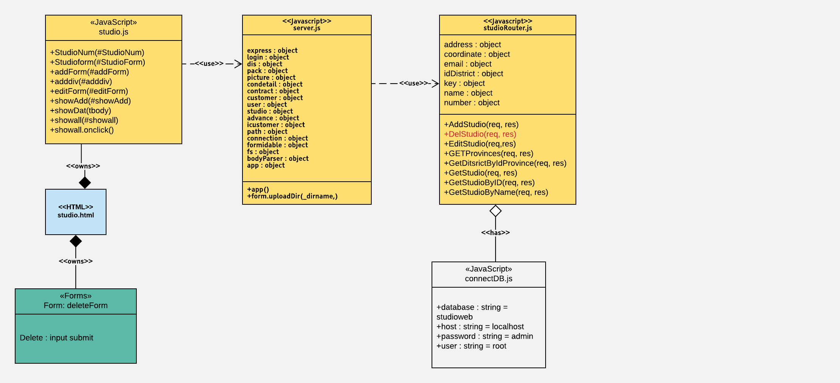

##### Class Specification

|  |  |  |  |  |
| --- | --- | --- | --- | --- |
| **Description** | Edit a Studio | | | |
| **Base Class** | Controller | | | |
| **Source File** | studioRoutes.js | | | |
| **Namespace** | app/public/routes/ | | | |
| **Attributes** | **N/A** | | | |
| **Methods** | **Name** | **Input** | **Output** | **Description** |
| EditStudio | Request, result | View | Add new studio into the system |

##### Sequence Diagram

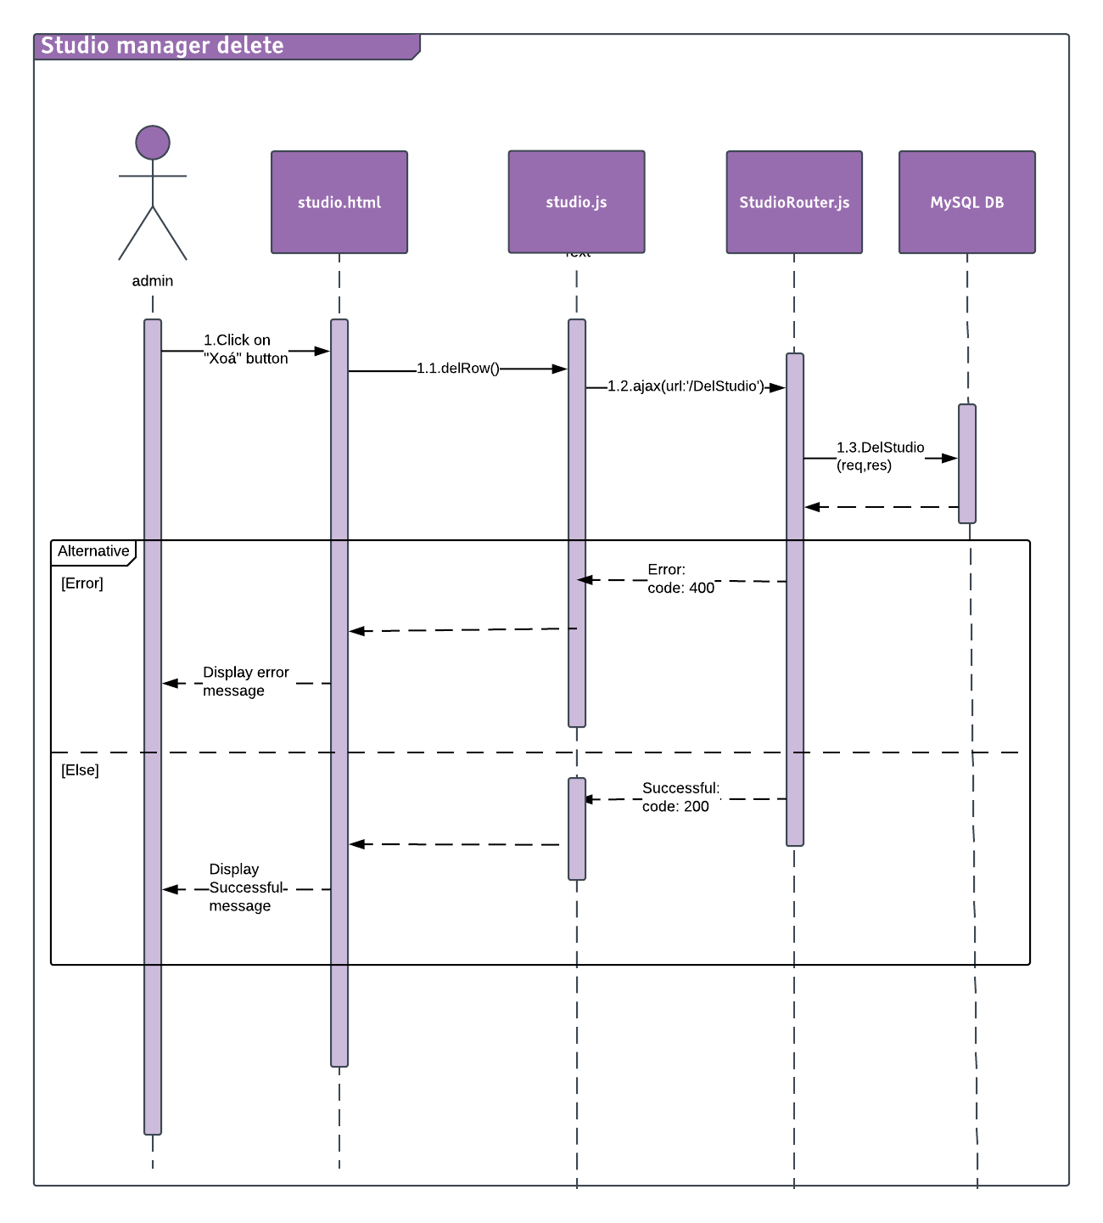

#### Search and View Studio Manager

##### Description

Admin can search and view studio Manager information.

##### Design

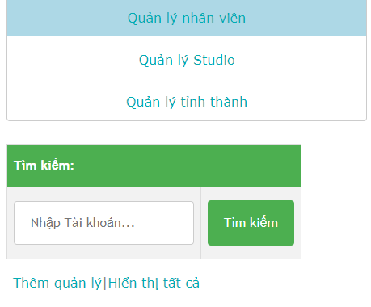

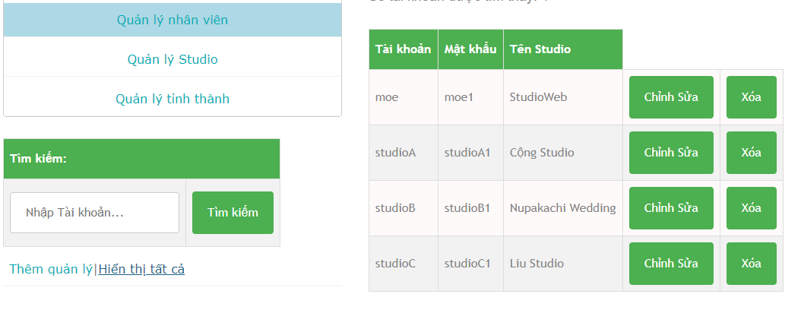

##### Class Diagram

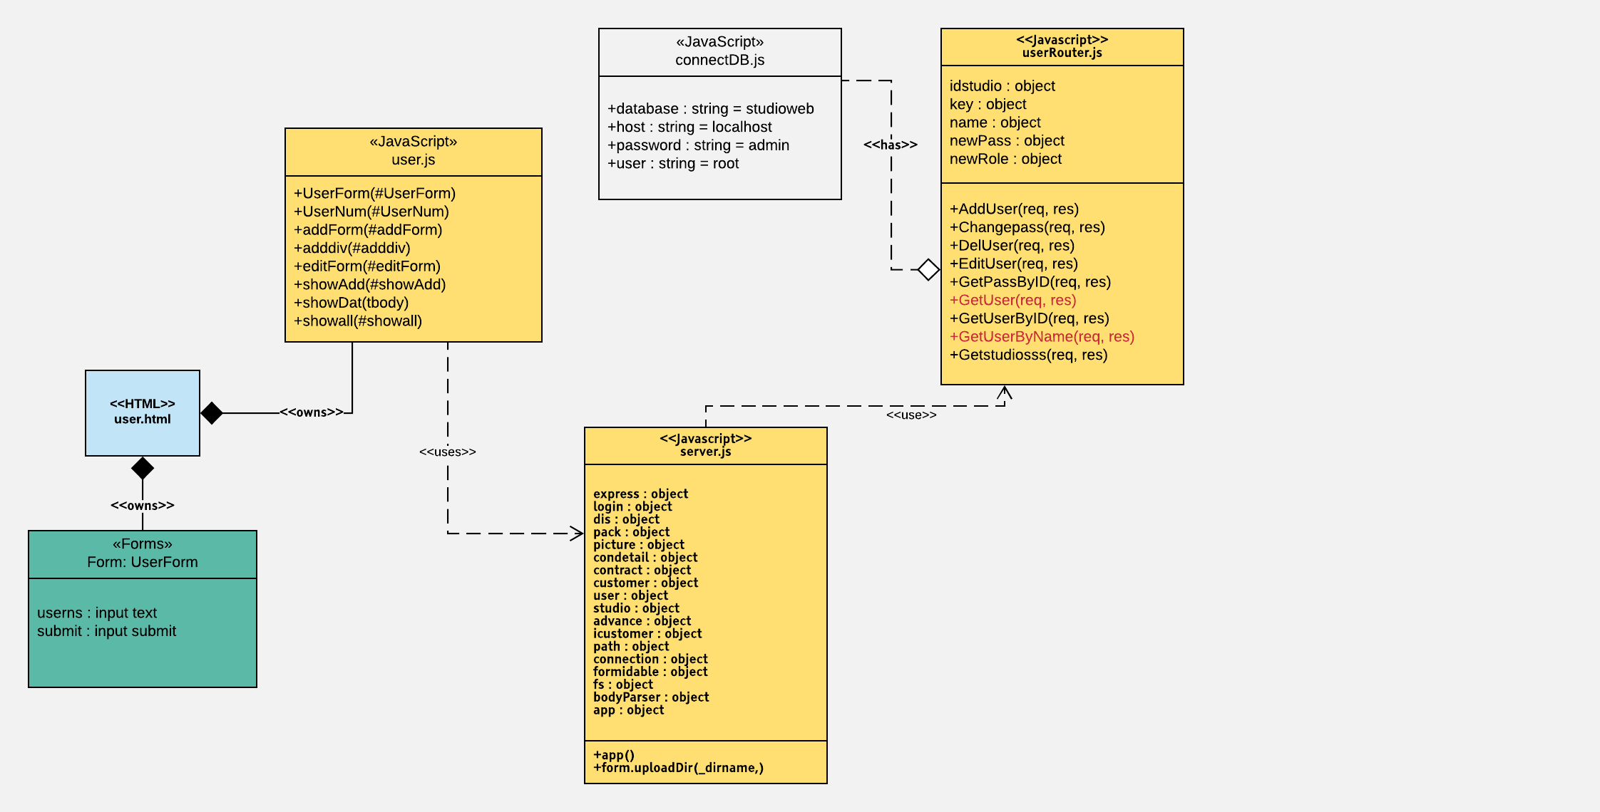

##### Class Specification

|  |  |  |  |  |
| --- | --- | --- | --- | --- |
| **Description** | View and Search a Manager | | | |
| **Base Class** | Controller | | | |
| **Source File** | UserRoutes.js | | | |
| **Namespace** | app/public/routes/ | | | |
| **Attributes** | **N/A** | | | |
| **Methods** | **Name** | **Input** | **Output** | **Description** |
| GetStudio | Request, result | View | Get Studio Info to bind combobox to find User by Studio |
|  | GetUser | Request, result | View | Show all user |

##### Sequence Diagram

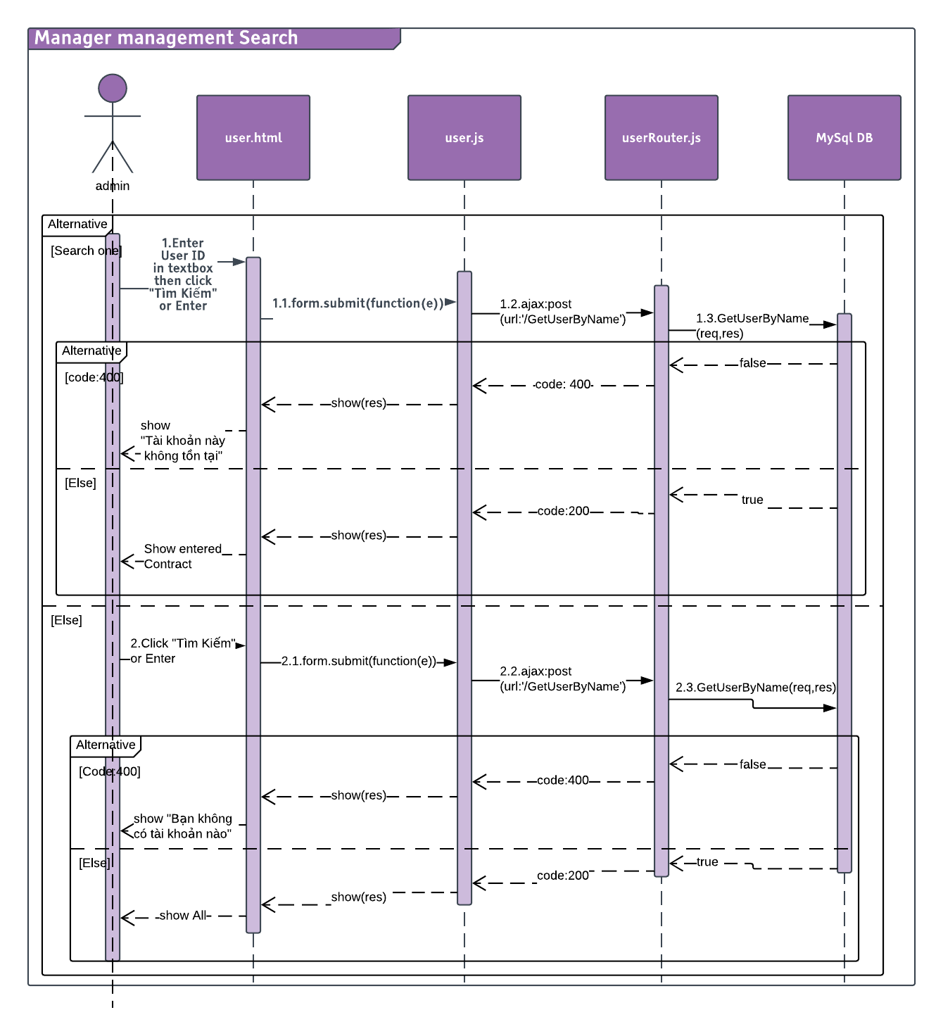

#### Add Studio Manager

##### Description

Admin can add more Studio Manager.

##### Design

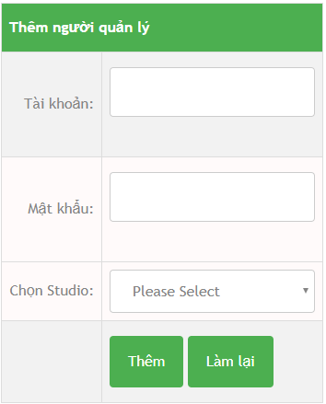

##### Class Diagram

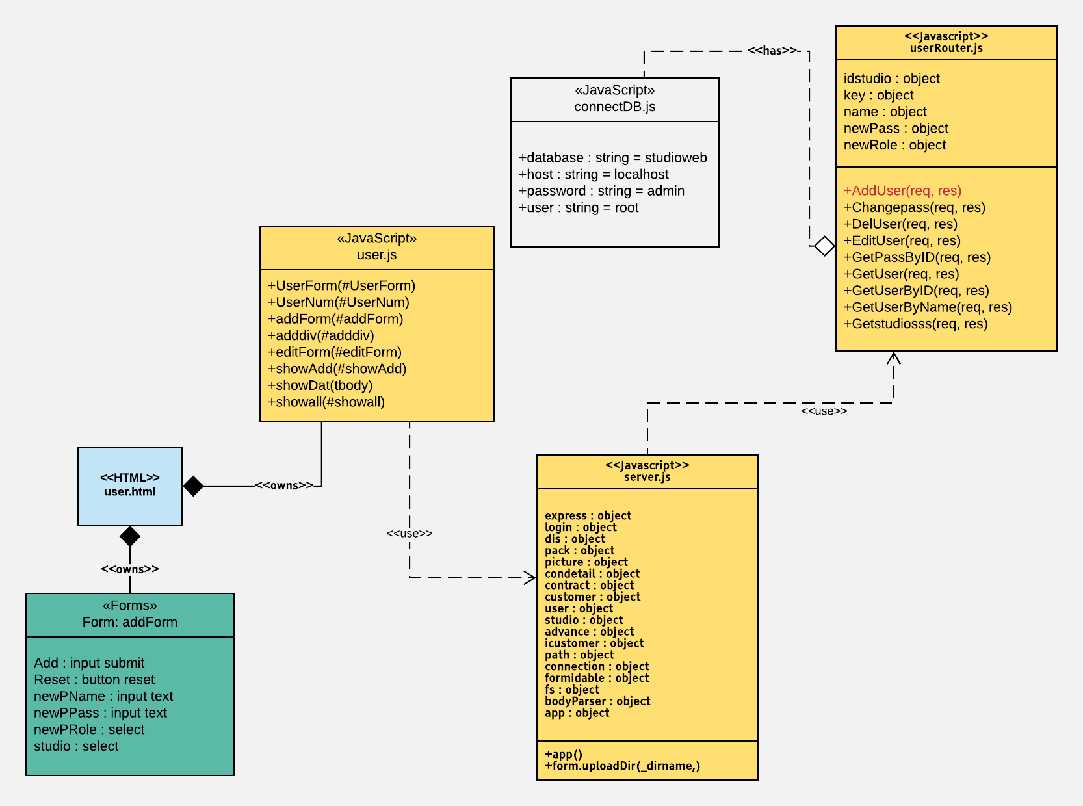

##### Class Specification

|  |  |  |  |  |
| --- | --- | --- | --- | --- |
| **Description** | Add a manager | | | |
| **Base Class** | Controller | | | |
| **Source File** | UserRoutes.js | | | |
| **Namespace** | app/public/routes/ | | | |
| **Attributes** | **N/A** | | | |
| **Methods** | **Name** | **Methods** | **Name** | **Methods** |
| AddUser | Request, result | AddUser | Edit user name, studio user belong and password |

##### Sequence Diagram

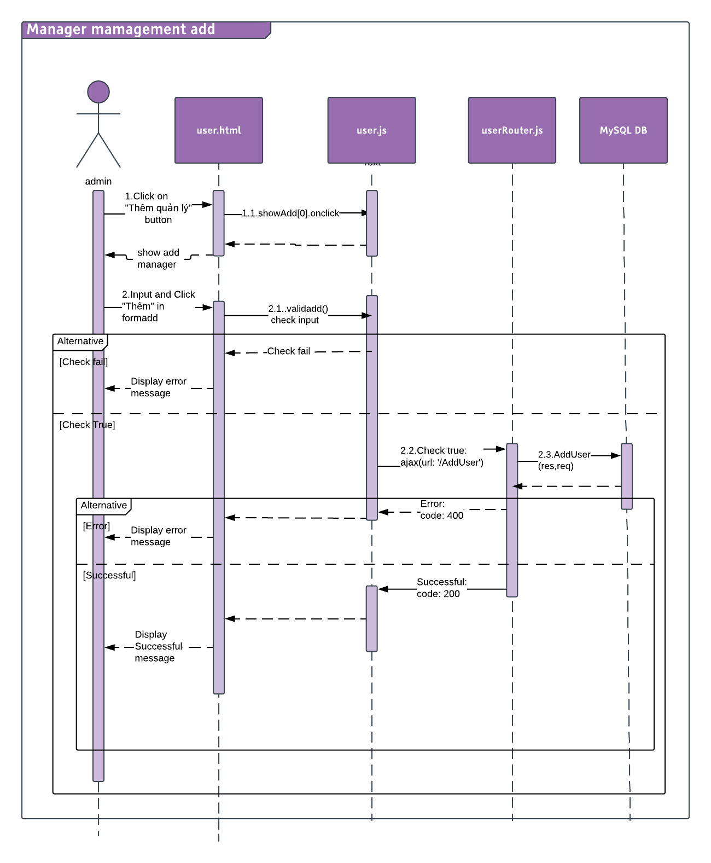

#### Edit Studio Manager

##### Description

Admin can edit Studio Manager information.

##### Design

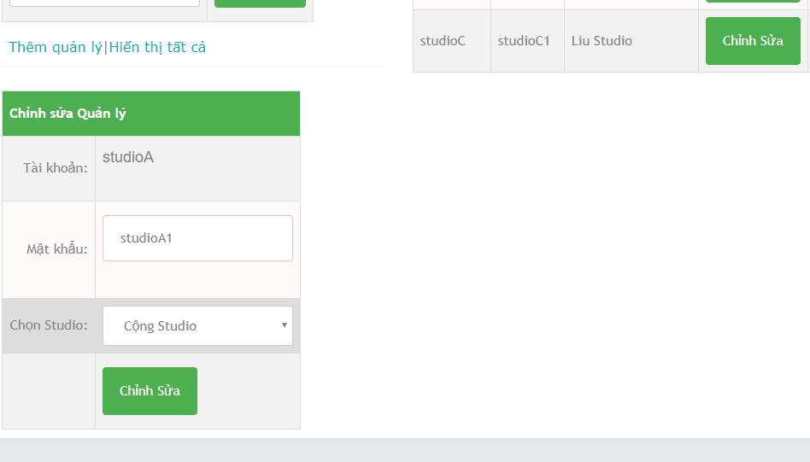

##### Class Diagram

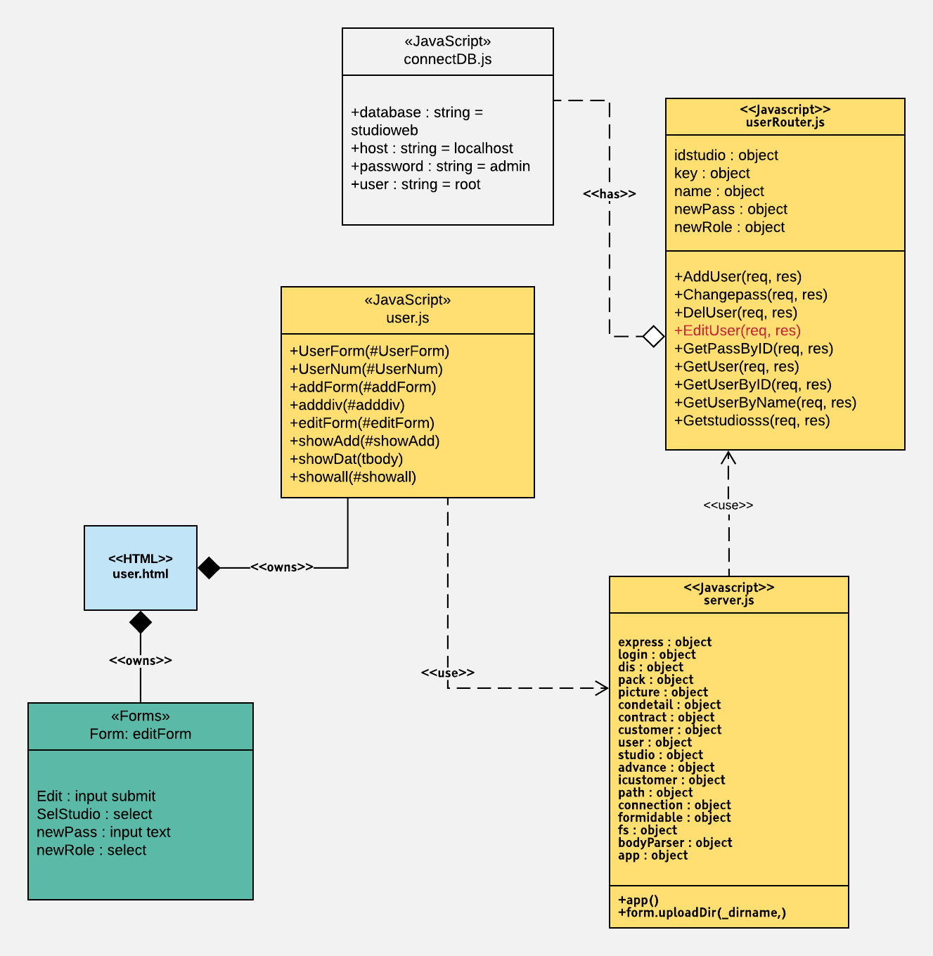

##### Class Specification

|  |  |  |  |  |
| --- | --- | --- | --- | --- |
| **Description** | Edit an user’s info | | | |
| **Base Class** | Controller | | | |
| **Source File** | UserRoutes.js | | | |
| **Namespace** | app/public/routes/ | | | |
| **Attributes** | **N/A** | | | |
| **Methods** | **Name** | **Input** | **Output** | **Description** |
| EditUser | Request, result | View | Edit user name, studio user belong and password |

##### Sequence Diagram

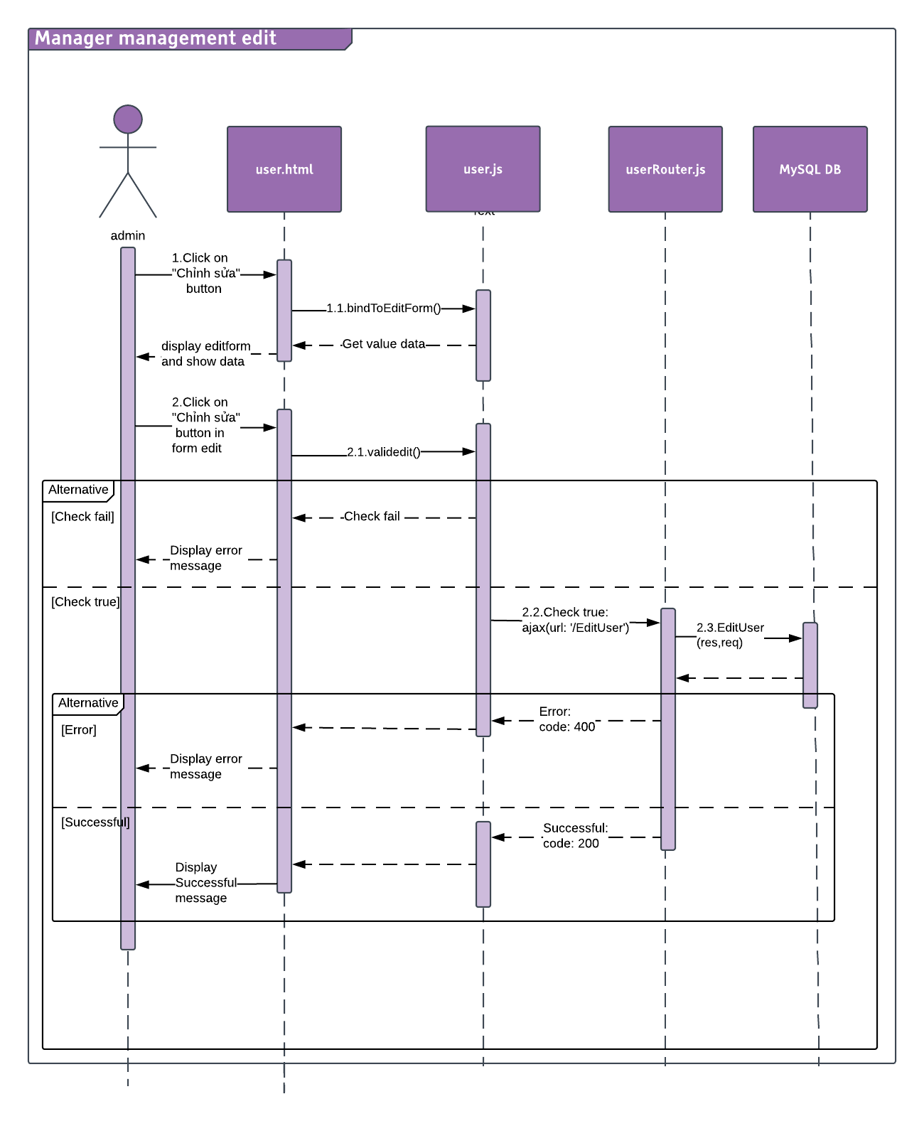

#### Delete Studio Manager

##### Description

Admin can delete Studio Manager.

##### Design

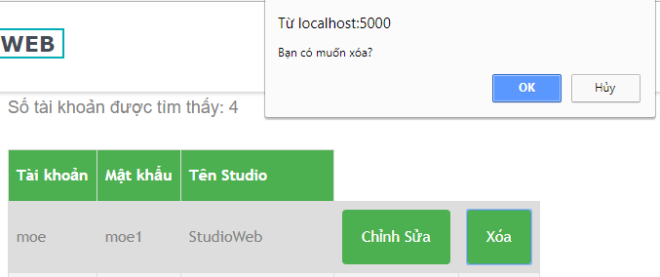

##### Class Diagram

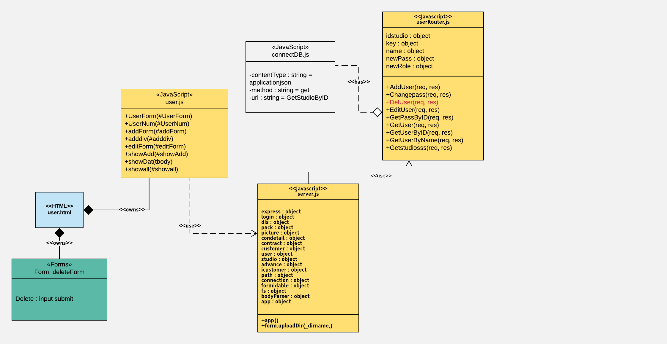

##### Class Specification

|  |  |  |  |  |
| --- | --- | --- | --- | --- |
| **Description** | Delete an user | | | |
| **Base Class** | Controller | | | |
| **Source File** | UserRoutes.js | | | |
| **Namespace** | app/public/routes/ | | | |
| **Attributes** | **N/A** | | | |
| **Methods** | **Name** | **Input** | **Output** | **Description** |
| DelUser | Request, result | View | Delete an user from the system |

##### Sequence Diagram

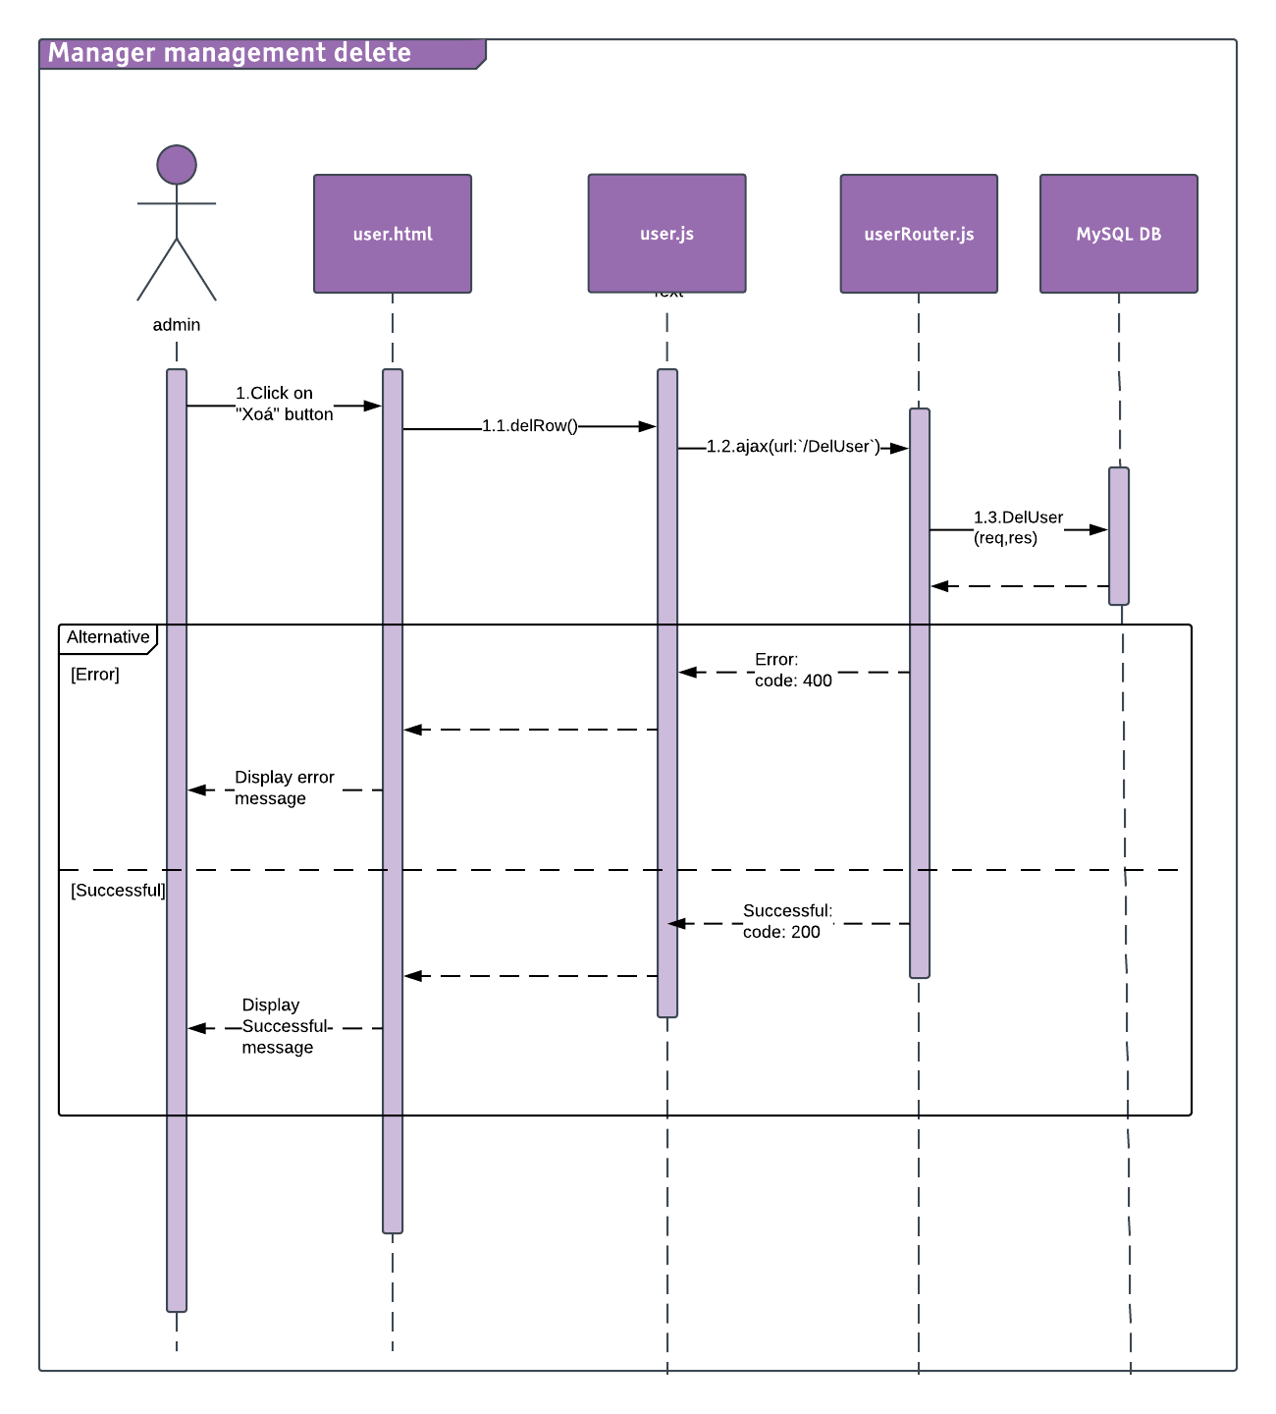

### Manager

#### Login

##### Description

Mamanger can Login to the systems.

##### Design



##### Class Diagram



##### Class Specification

|  |  |  |  |  |
| --- | --- | --- | --- | --- |
| **Class** | loginRoutes | | | |
| **Description** | Control Manager login action | | | |
| **Base Class** | Controller | | | |
| **Source File** | loginRoutes.js | | | |
| **Namespace** | app/public/routes/ | | | |
| **Attributes** | **N/A** | | | |
| **Methods** | **Name** | **Input** | **Output** | **Description** |
| login | Request, result | View | Allow user to login into the system |

##### Sequence Diagram

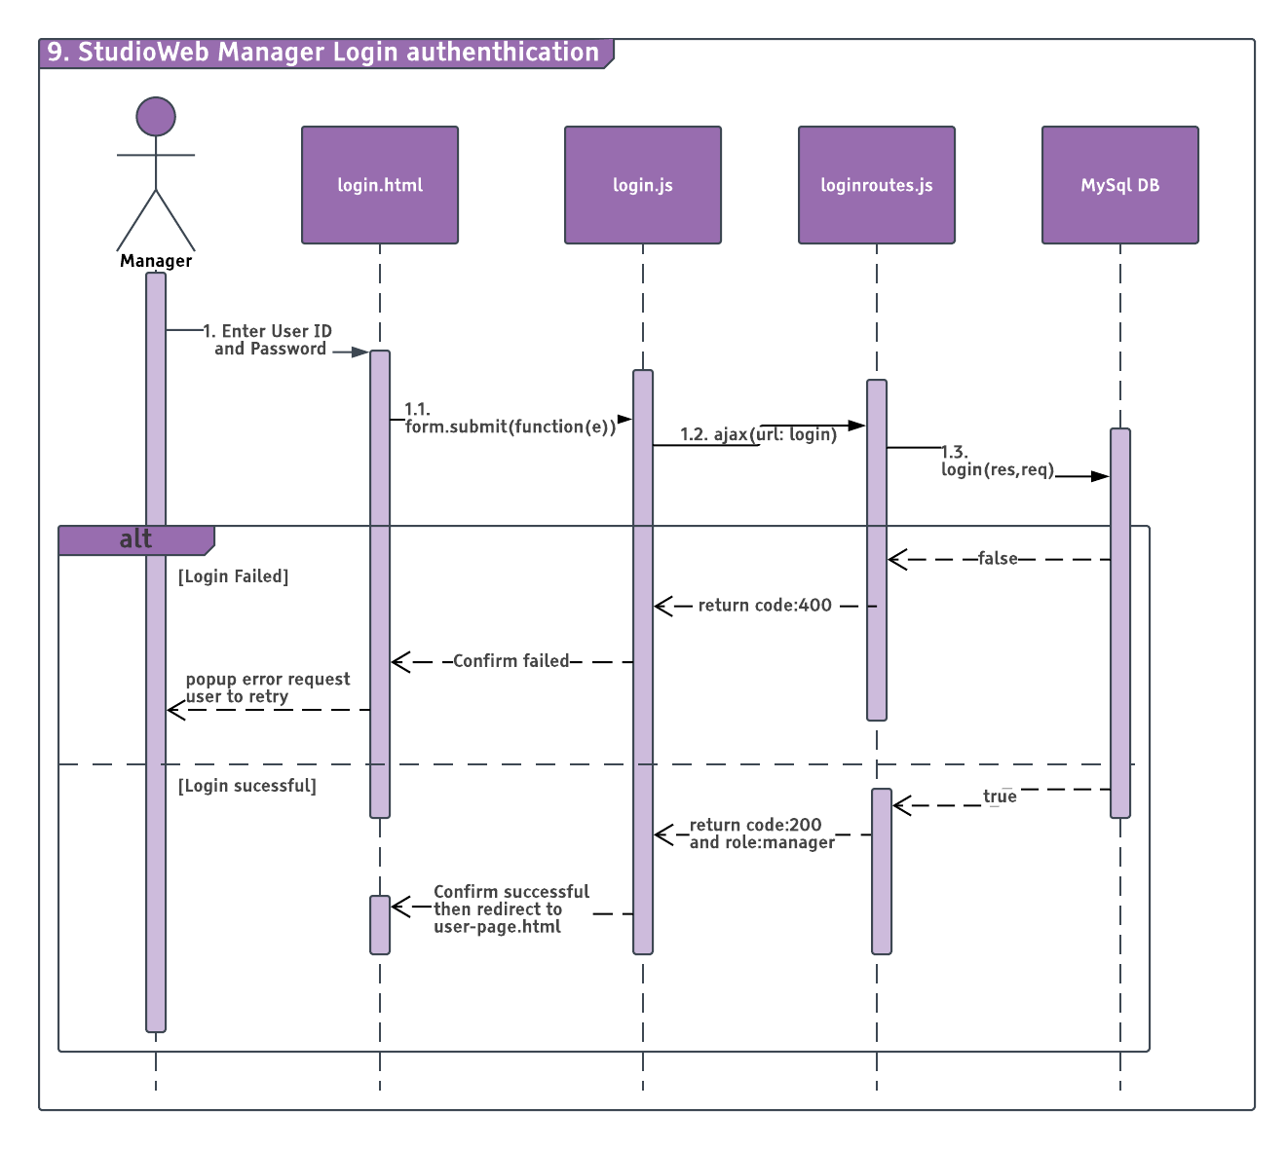

#### Logout

##### Description

Manager can Logout the system.

##### Design

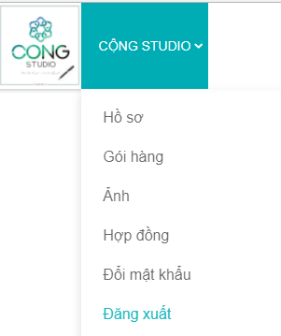

##### Class Diagram



##### Class Specification

|  |  |  |  |  |
| --- | --- | --- | --- | --- |
| **Class** | main | | | |
| **Description** | Control Manager logout action | | | |
| **Base Class** | model | | | |
| **Source File** | Main.js | | | |
| **Namespace** | app/public/js/ | | | |
| **Attributes** | **N/A** | | | |
| **Methods** | **Name** | **Input** | **Output** | **Description** |
| logout | Request | View | Logout the current User |

##### Sequence Diagram

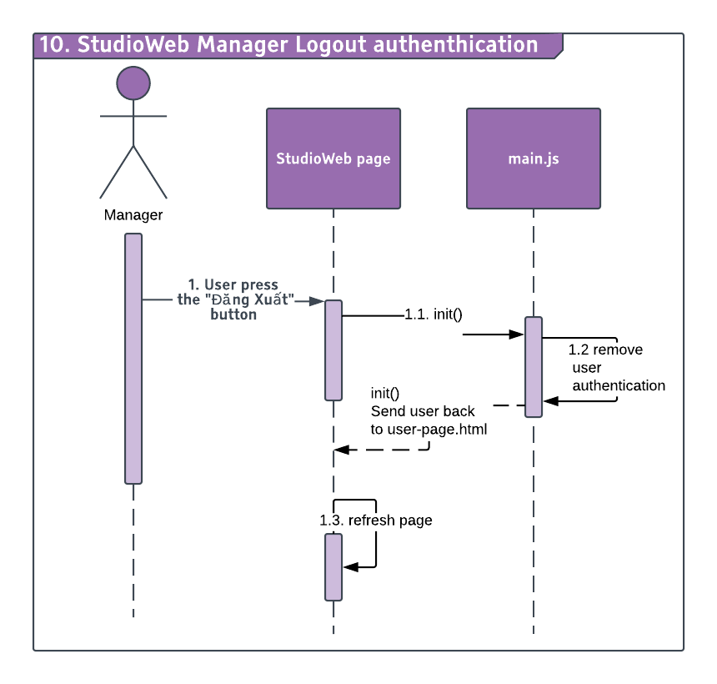

#### Change Password

##### Description

Manager can change password.

##### Design

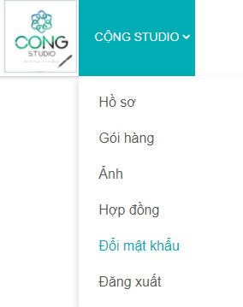

##### Class Diagram



##### Class Specification

|  |  |  |  |  |
| --- | --- | --- | --- | --- |
| **Description** | Control Manager change password action | | | |
| **Base Class** | Controller | | | |
| **Source File** | userRoutes.js | | | |
| **Namespace** | app/public/routes/ | | | |
| **Attributes** | **N/A** | | | |
| **Methods** | **Name** | **Input** | **Output** | **Description** |
| changepass | Request, result | View | Change the password of the current user |

##### Sequence Diagram

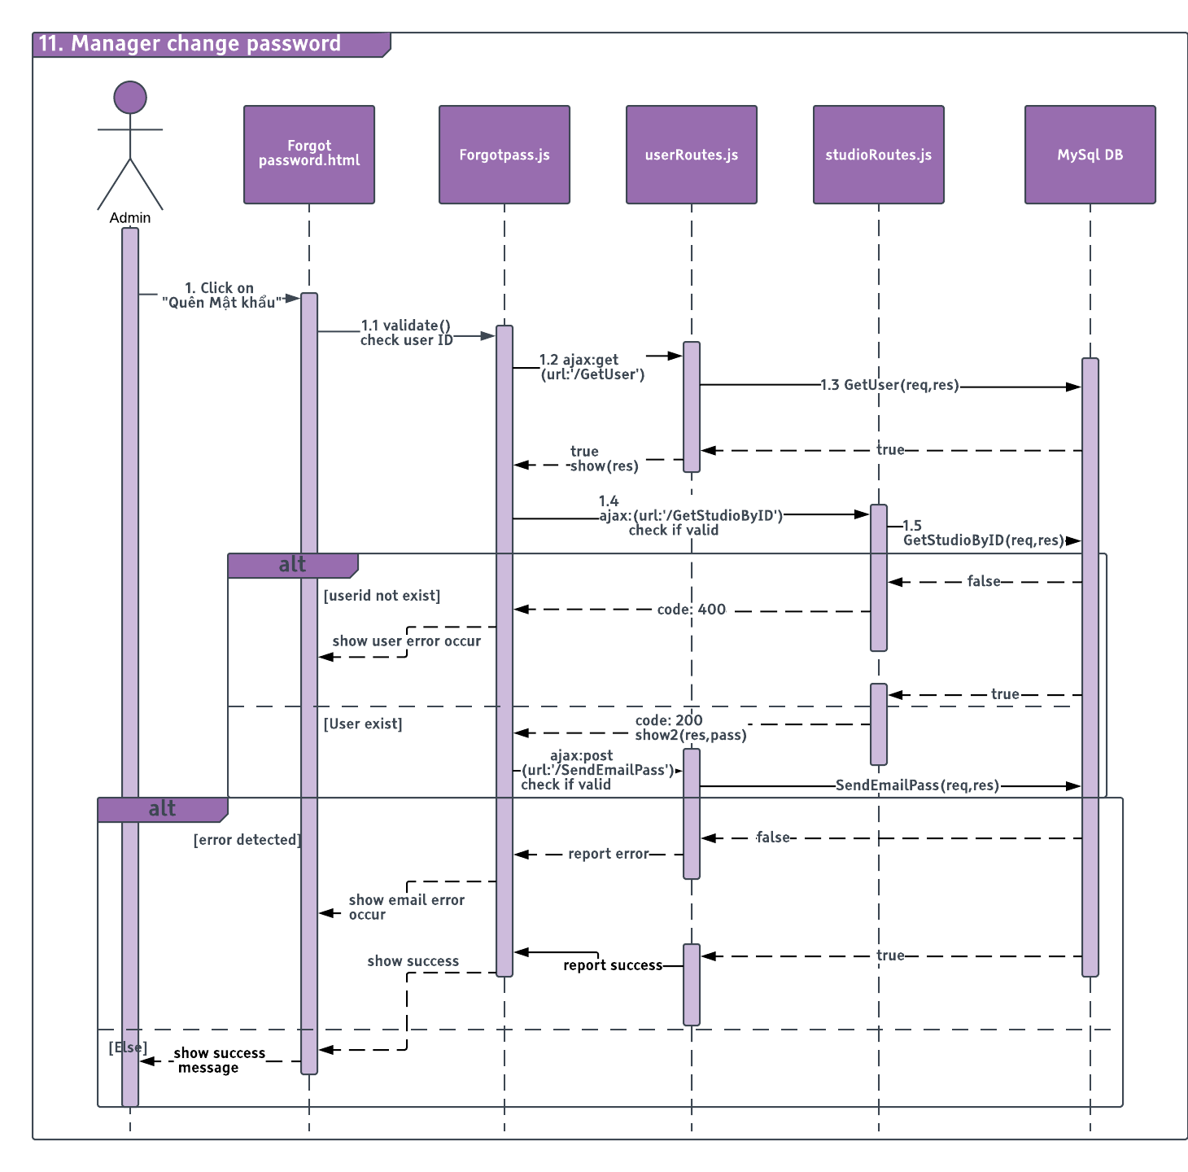

#### Forgot Password

##### Description

Manager can change password if fogot old password.

##### Design





##### Class Diagram



##### Class Specification

|  |  |  |  |  |
| --- | --- | --- | --- | --- |
| **Description** | Control Manager forgot password action | | | |
| **Base Class** | Controller | | | |
| **Source File** | userRoutes.js | | | |
| **Namespace** | app/public/routes/ | | | |
| **Attributes** | **N/A** | | | |
| **Methods** | **Name** | **Input** | **Output** | **Description** |
| SendEmailPass | Request, result | View | Change the password of the current user |
|  | GetUser | Request, result | View | Get user |

|  |  |  |  |  |
| --- | --- | --- | --- | --- |
| **Description** | Specify which Studio does user belong to | | | |
| **Base Class** | Controller | | | |
| **Source File** | studioRoutes.js | | | |
| **Namespace** | app/public/routes/ | | | |
| **Attributes** | **N/A** | | | |
| **Methods** | **Name** | **Input** | **Output** | **Description** |
| GetStudioByID | Request, result | View | Get studio by User ID |

##### Sequence Diagram

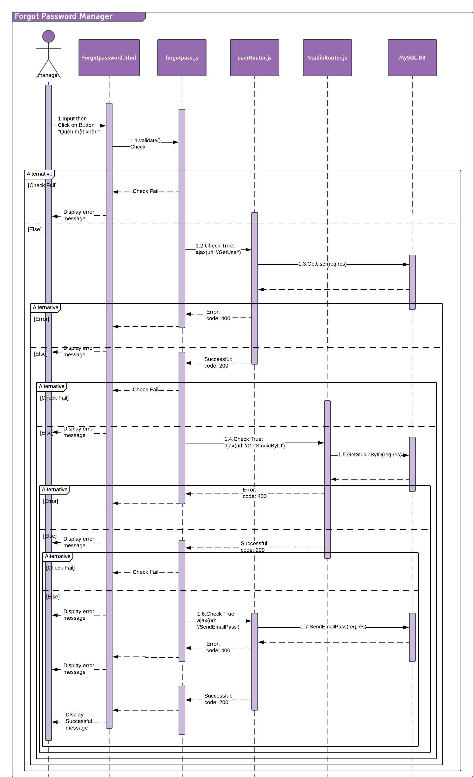

#### Search & View Contract Information

##### Description

Manager can search and view Contract.

##### Design

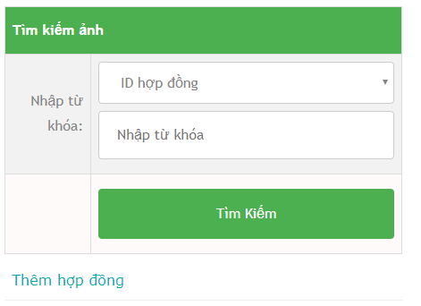

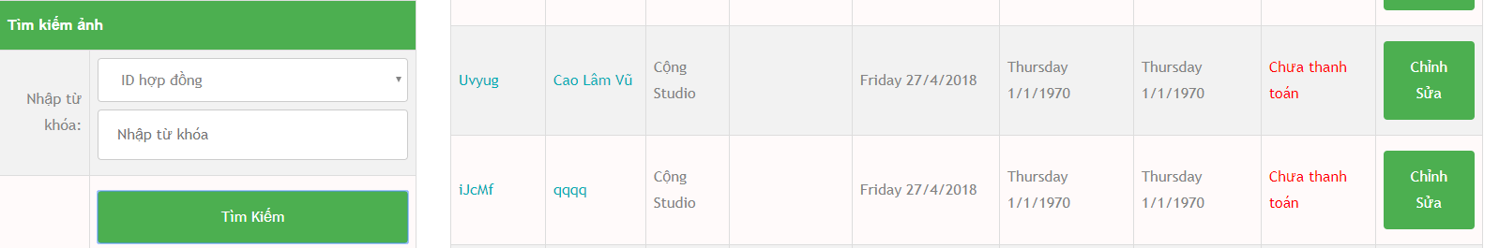

##### Class Diagram

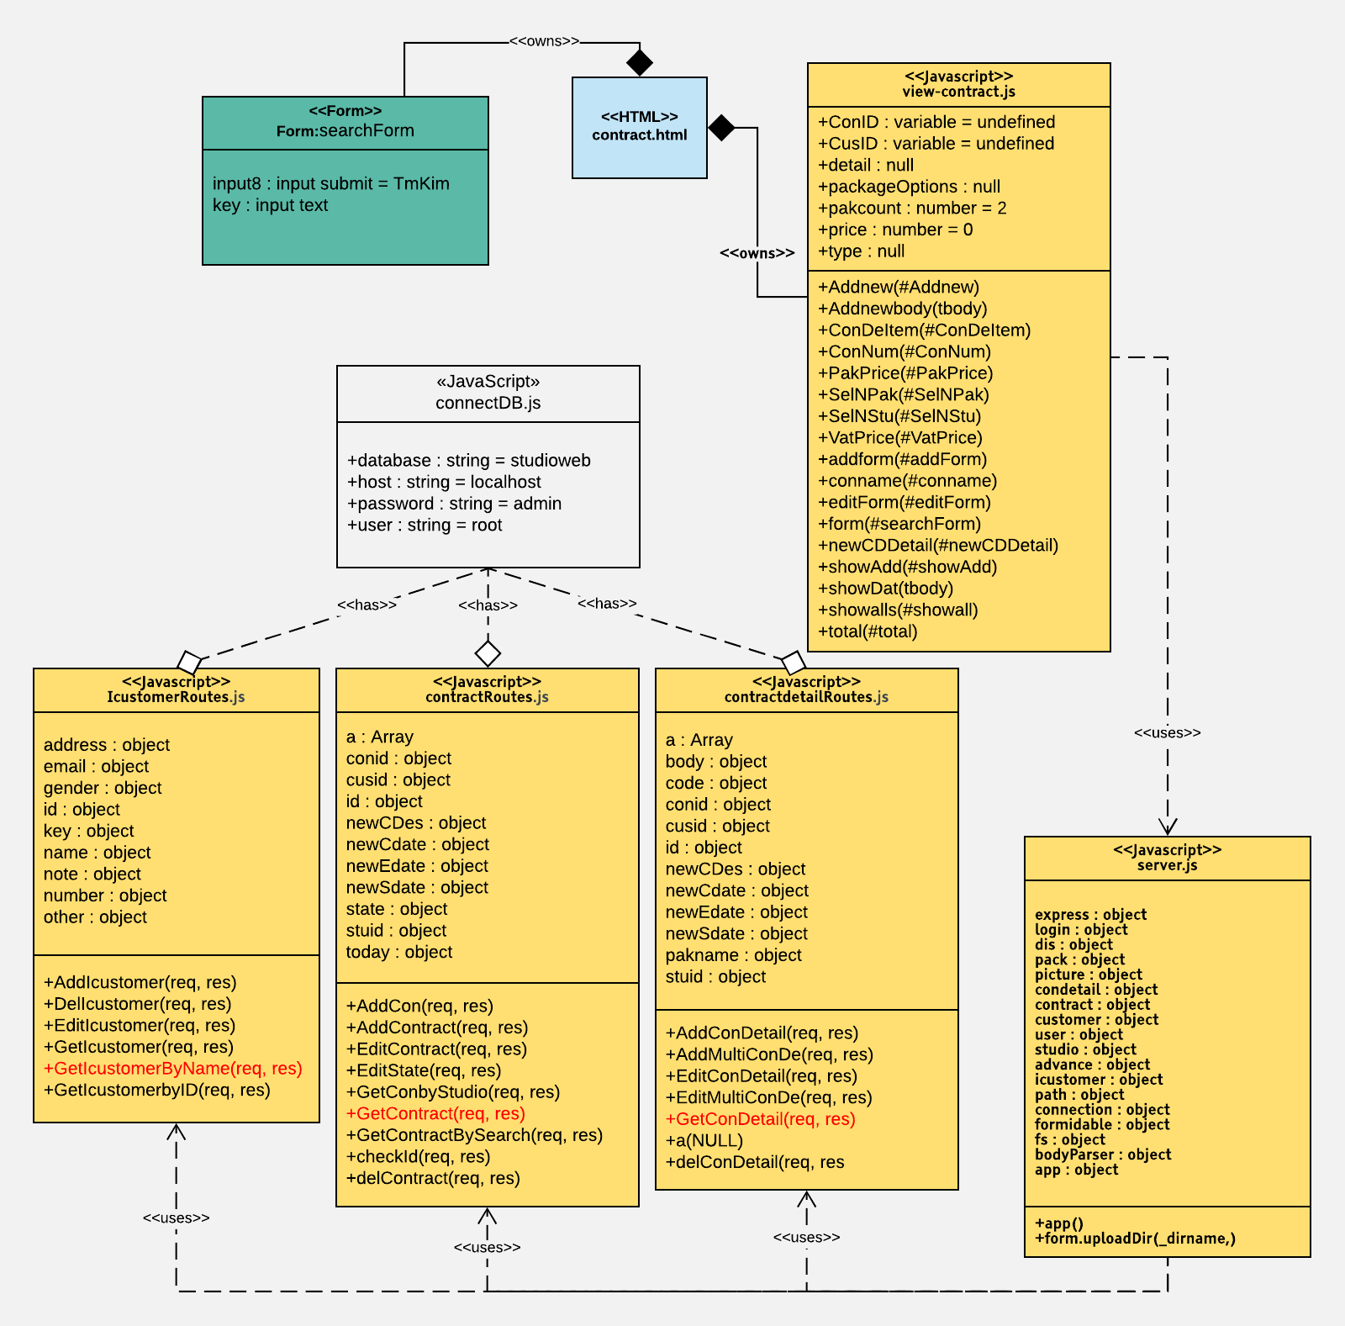

##### Class Specification

|  |  |  |  |  |
| --- | --- | --- | --- | --- |
| **Description** | Search and view Contract action | | | |
| **Base Class** | Controller | | | |
| **Source File** | contractRoutes.js | | | |
| **Namespace** | app/public/routes/ | | | |
| **Attributes** | **N/A** | | | |
| **Methods** | **Name** | **Input** | **Output** | **Description** |
| GetconByStudio | Request, result | View | Get contract by Studio ID |

##### Sequence Diagram

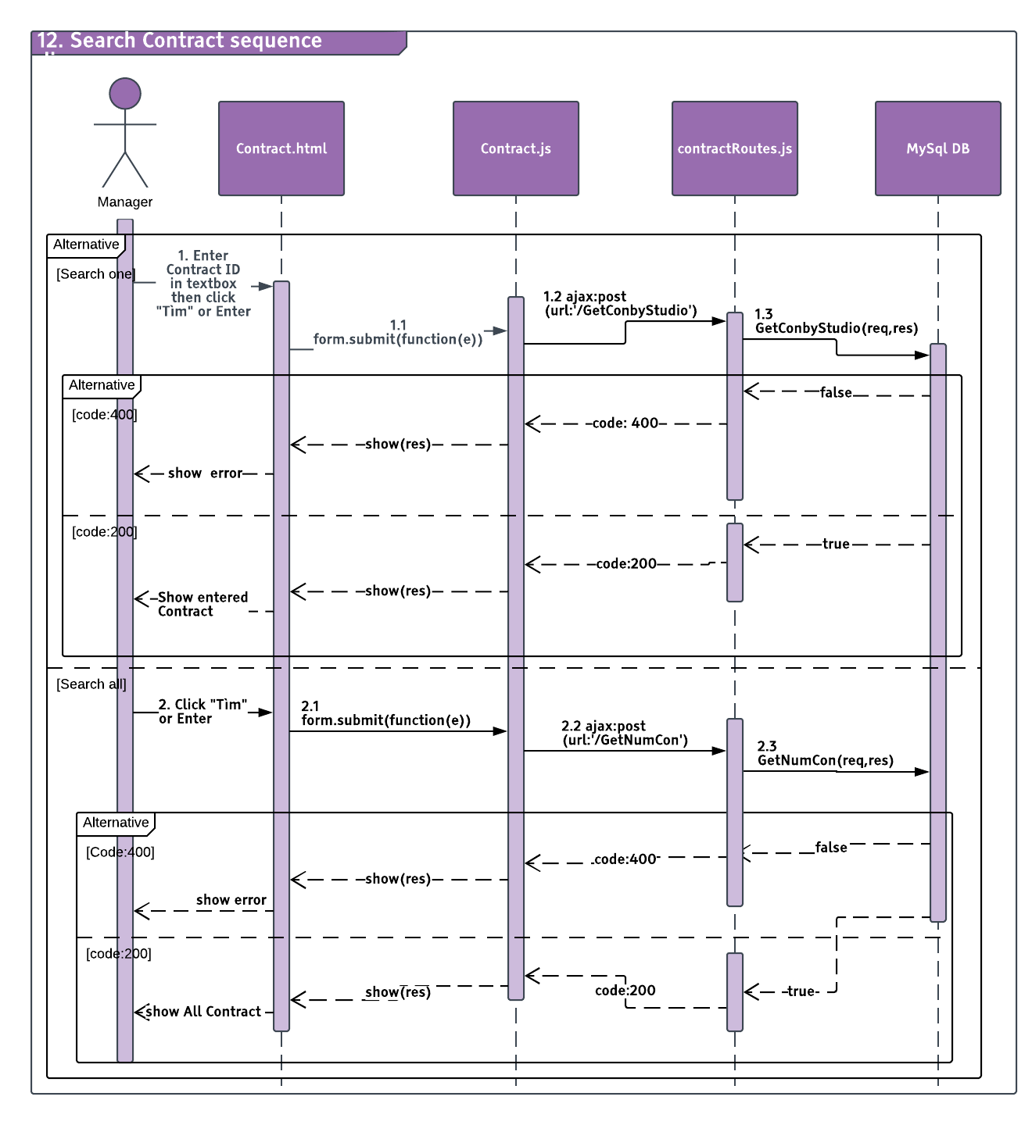

#### Add Contract

##### Description

Manager can add more Contract.

##### Design

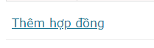

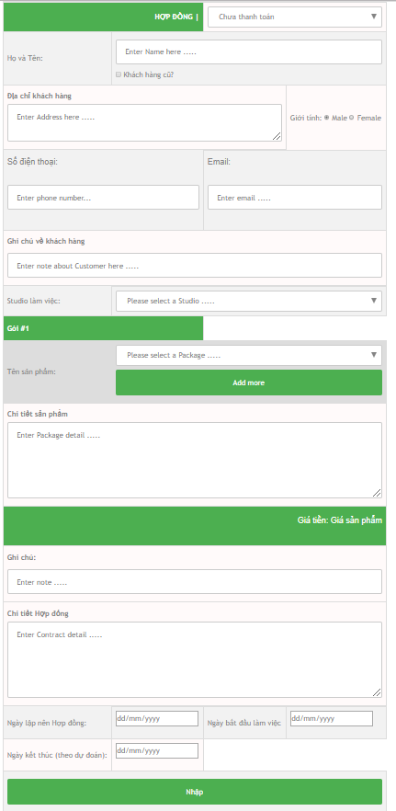

##### Class Diagram

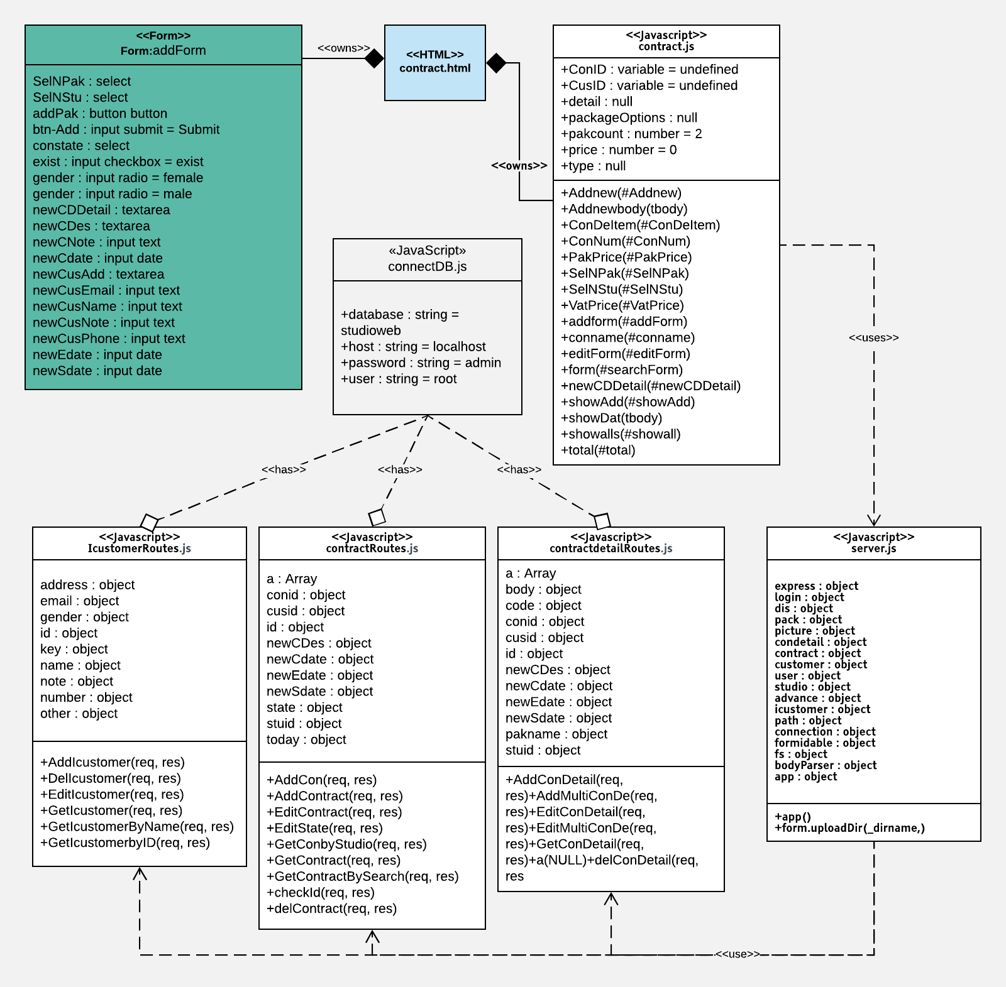

##### Class Specification

|  |  |  |  |  |
| --- | --- | --- | --- | --- |
| **Description** | Manager add contract action | | | |
| **Base Class** | Controller | | | |
| **Source File** | contractrouter.js, IcustommerRouter.js, contractdetailrouter.js | | | |
| **Namespace** | app/public/routes/ | | | |
| **Attributes** | **N/A** | | | |
| **Methods** | **Name** | **Input** | **Output** | **Description** |
| GetcustomByName | Request, result | View | Get Customer by Custummer Name |
|  | AddIcustomer | Request, result | View | Add new customer |
|  | AddContract | Request, result | View | Add new contract |
|  | AddMultiConDe | Request, result | View | Add new Contract Detail |

##### Sequence Diagram

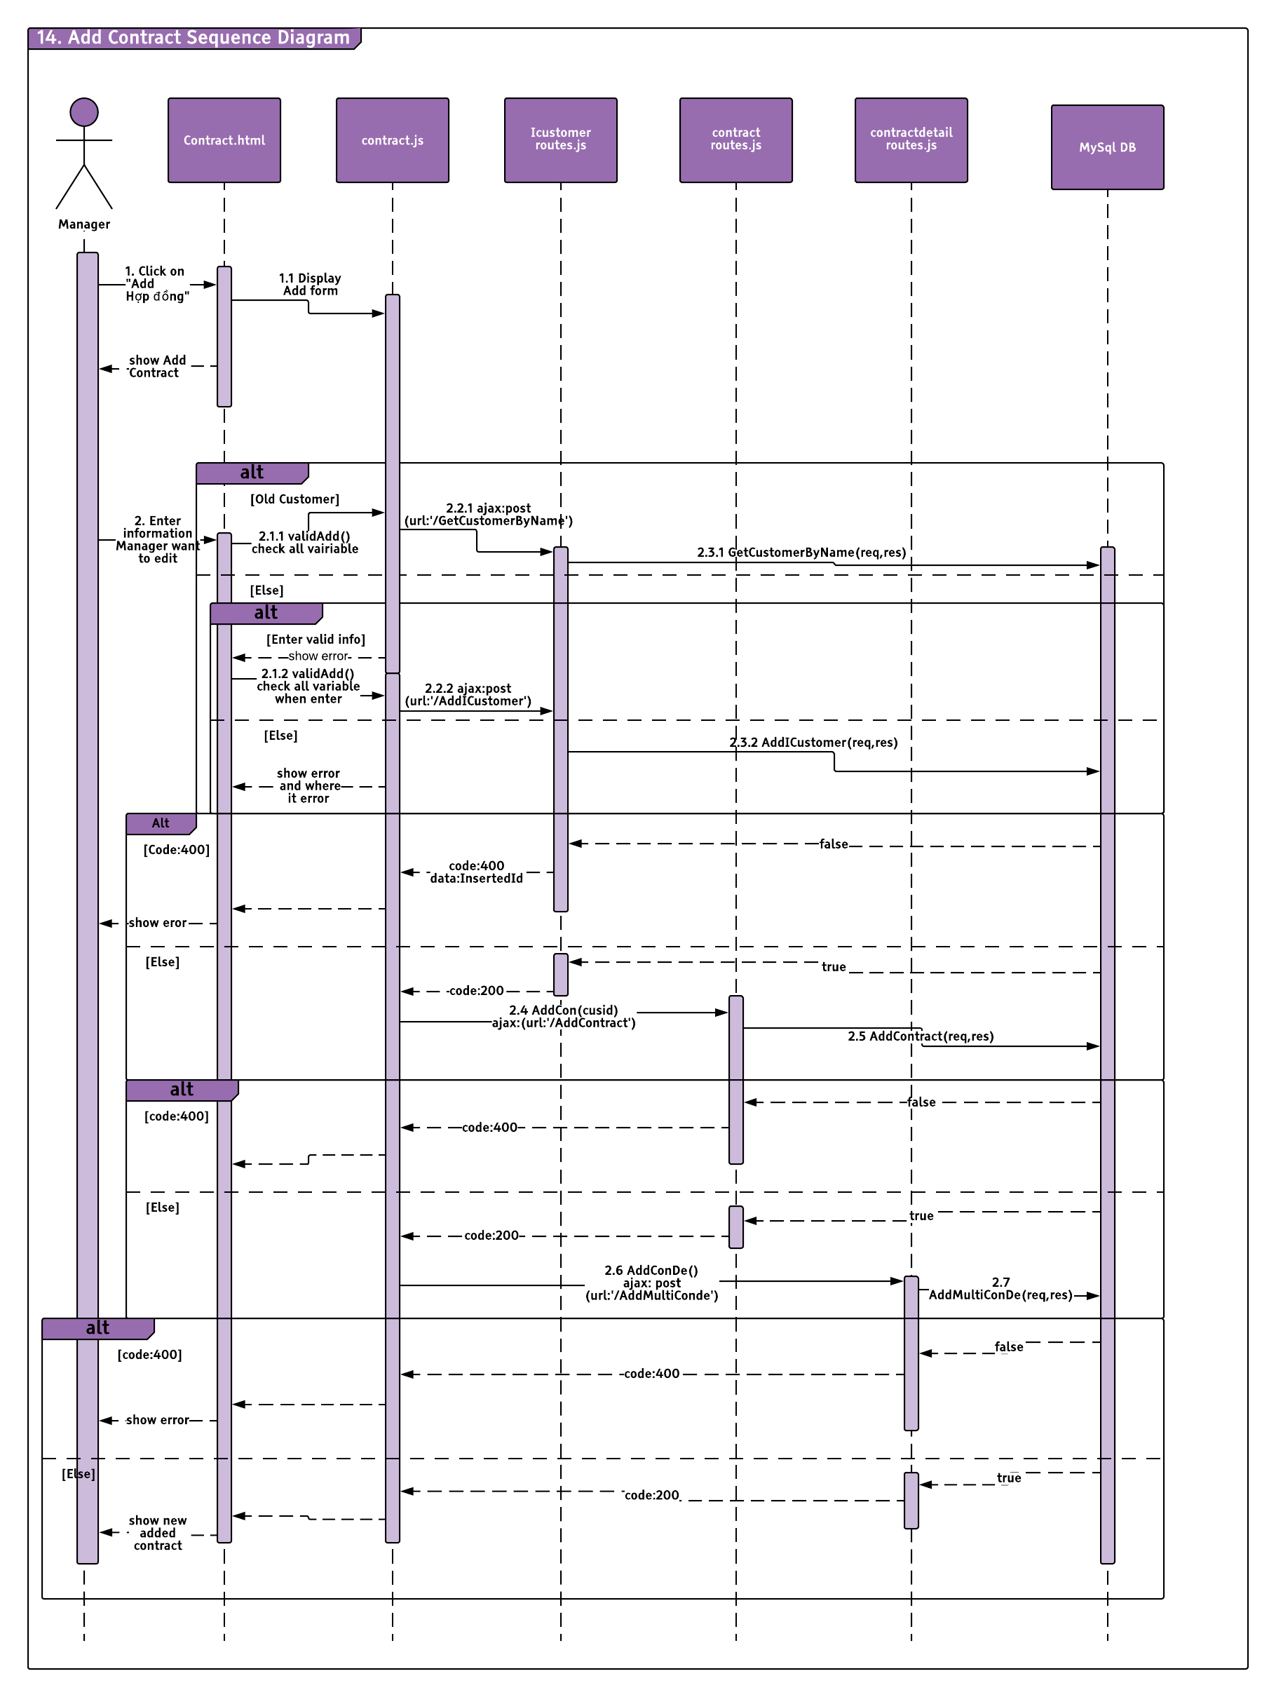

#### Edit Contract

##### Description

Manager can edit Contract.

##### Design

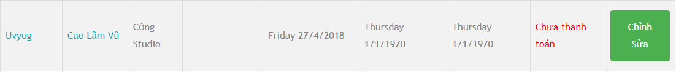

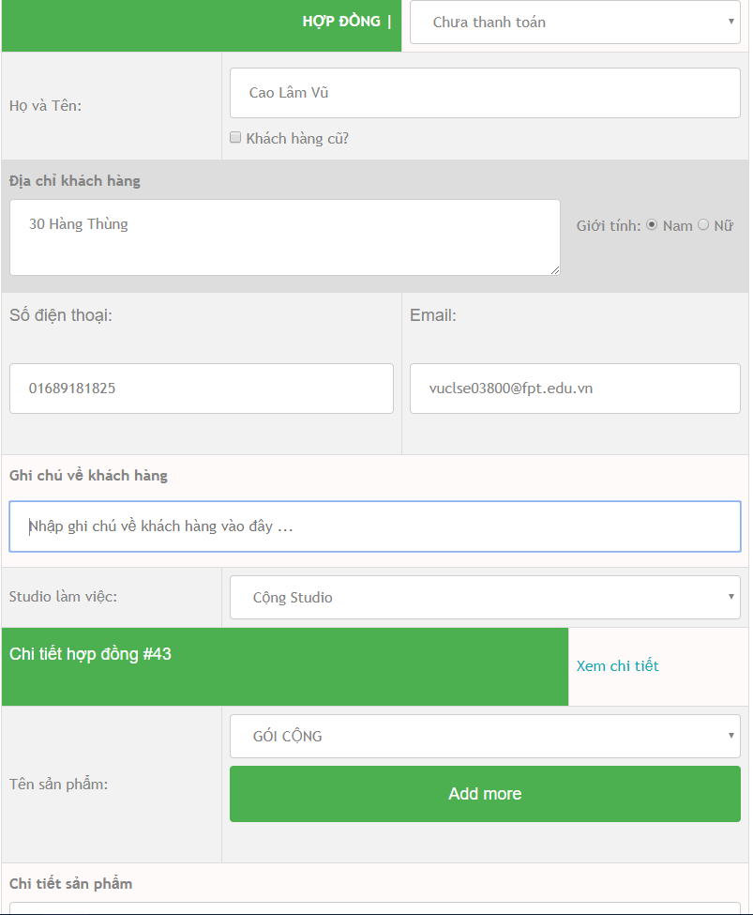

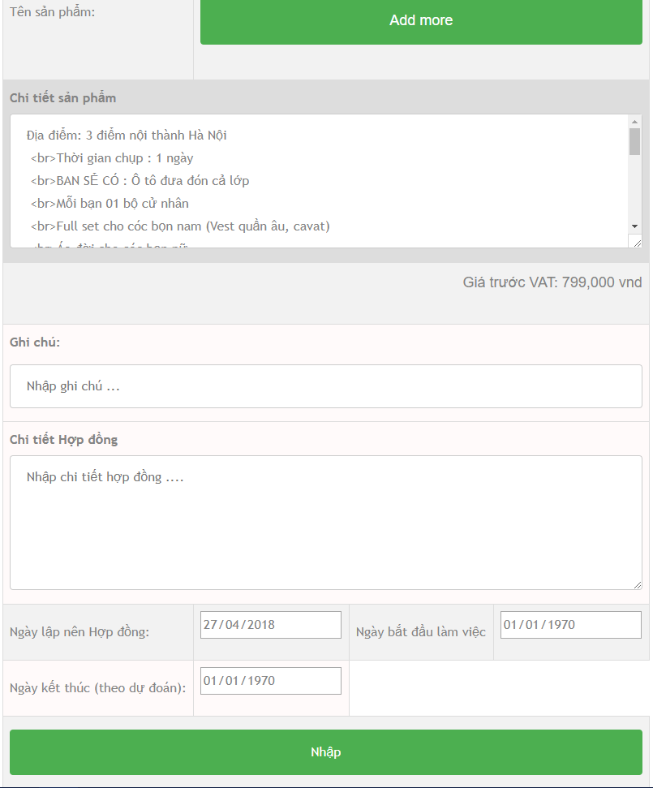

##### Class Diagram

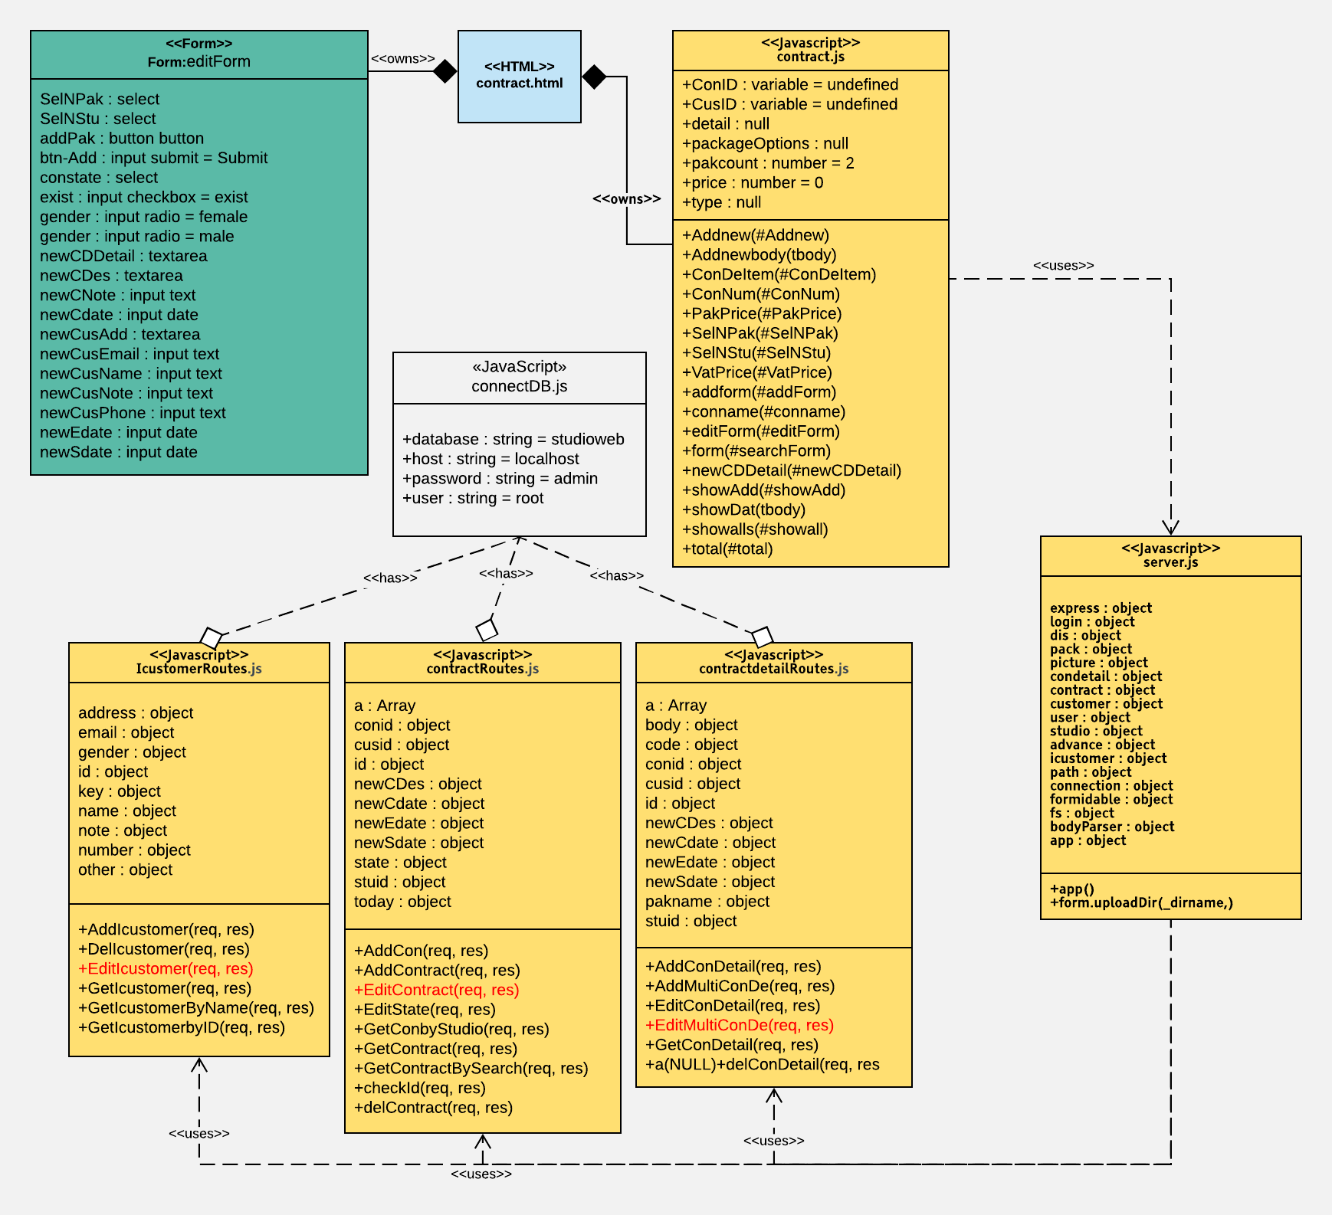

##### Class Specification

|  |  |  |  |  |
| --- | --- | --- | --- | --- |
| **Description** | Manager edit contract action | | | |
| **Base Class** | Controller | | | |
| **Source File** | contractrouter.js, IcustommerRouter.js, contractdetailrouter.js | | | |
| **Namespace** | app/public/routes/ | | | |
| **Attributes** | **N/A** | | | |
| **Methods** | **Name** | **Input** | **Output** | **Description** |
| EditICustomer | Request, result | View | Edit Custommer by Customer ID |
|  | EditContract | Request, result | View | Edit one Contract by Contract ID |
|  | EditMultiConDe | Request, result | view | Edit Contract Detail by Condetail ID |

##### Sequence Diagram

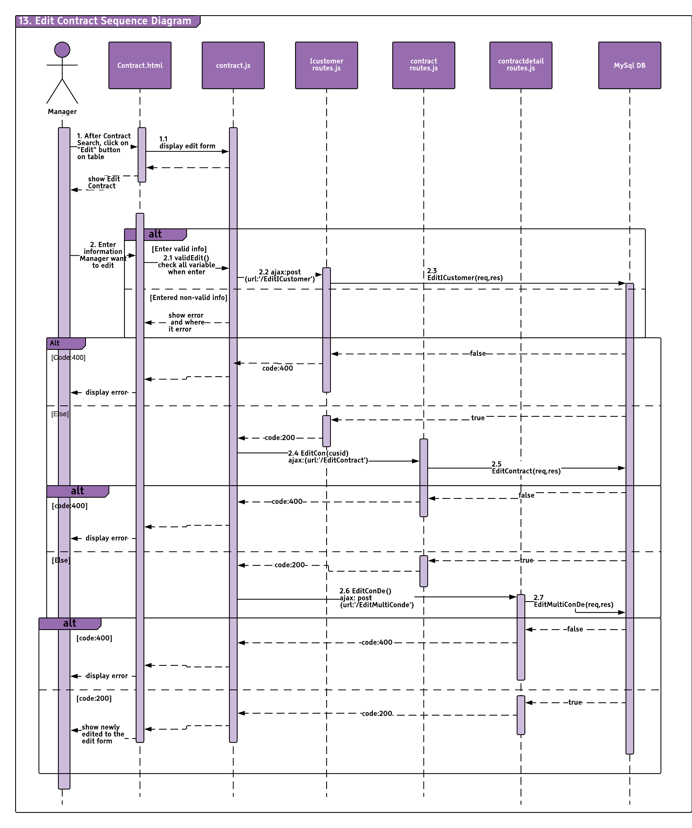

#### Search & View Package

##### Description

Manager can search and view Packkage.

##### Design

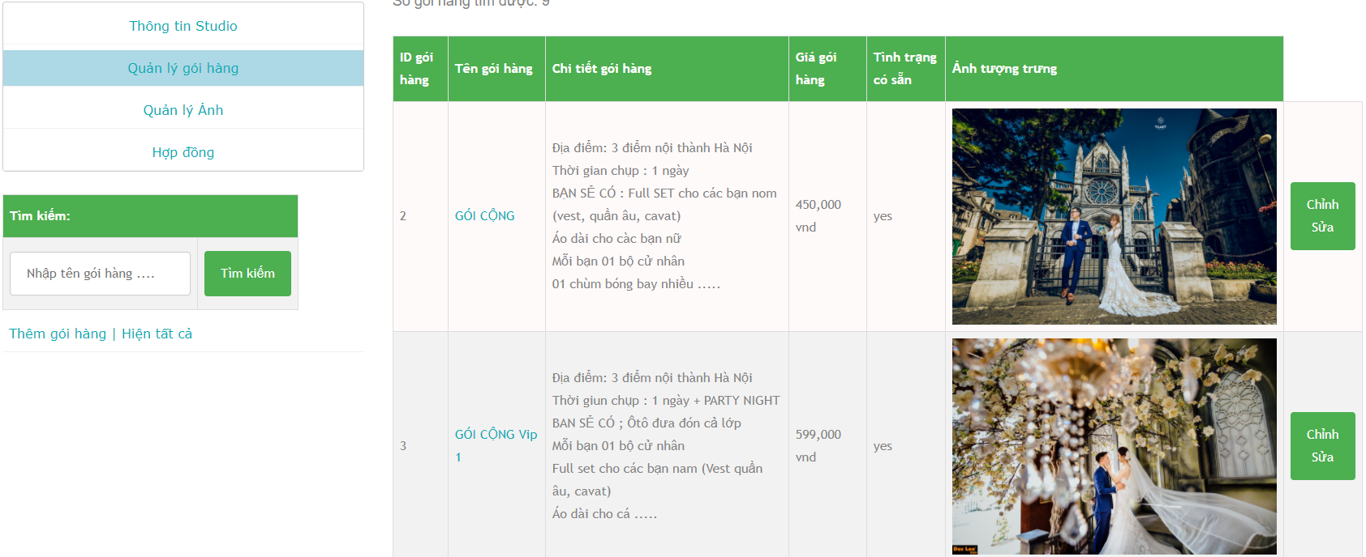

##### Class Diagram

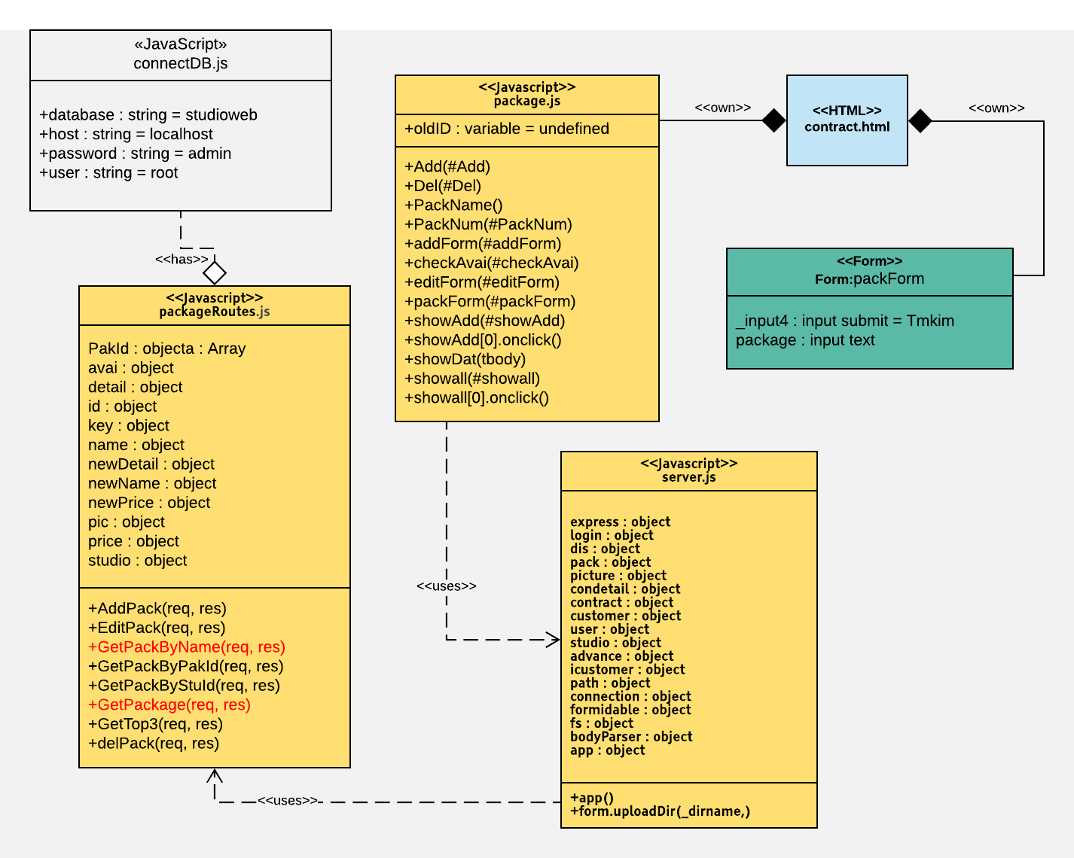

##### Class Specification

|  |  |  |  |  |
| --- | --- | --- | --- | --- |
| **Description** | Search and view package action | | | |
| **Base Class** | Controller | | | |
| **Source File** | packageRoutes.js | | | |
| **Namespace** | app/public/routes/ | | | |
| **Attributes** | **N/A** | | | |
| **Methods** | **Name** | **Input** | **Output** | **Description** |
| GetPacByName | Request, result | View | Get Package info by Name Package |

##### Sequence Diagram

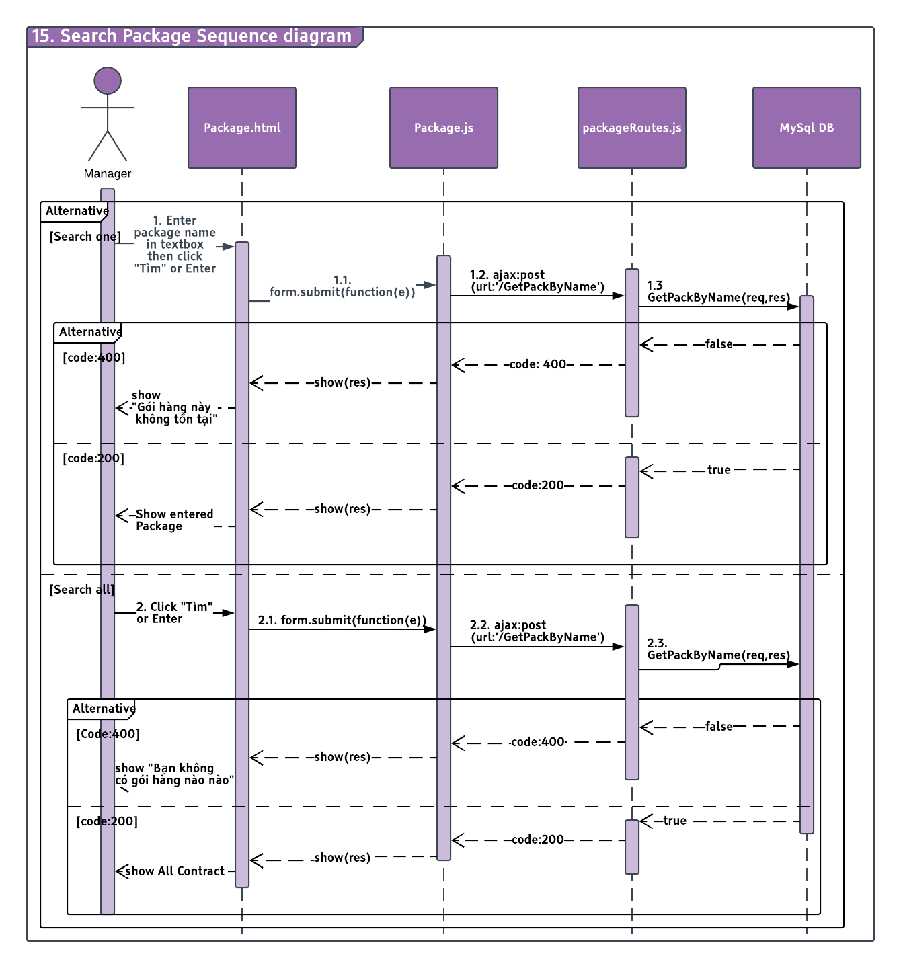

#### Add Package

##### Description

Manager can Add package.

##### Design

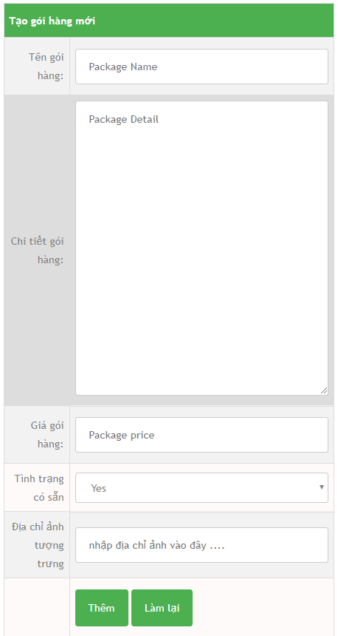

##### Class Diagram

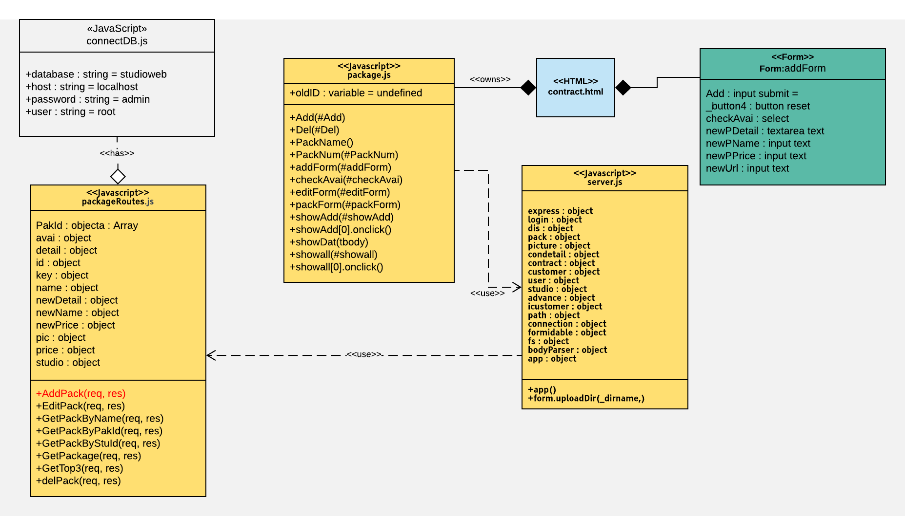

##### Class Specification

|  |  |  |  |  |
| --- | --- | --- | --- | --- |
| **Description** | Add pakage action | | | |
| **Base Class** | Controller | | | |
| **Source File** | packageRoutes.js | | | |
| **Namespace** | app/public/routes/ | | | |
| **Attributes** | **N/A** | | | |
| **Methods** | **Name** | **Input** | **Output** | **Description** |
| AddPack | Request, result | View | Add one package by Package ID |

##### Sequence Diagram

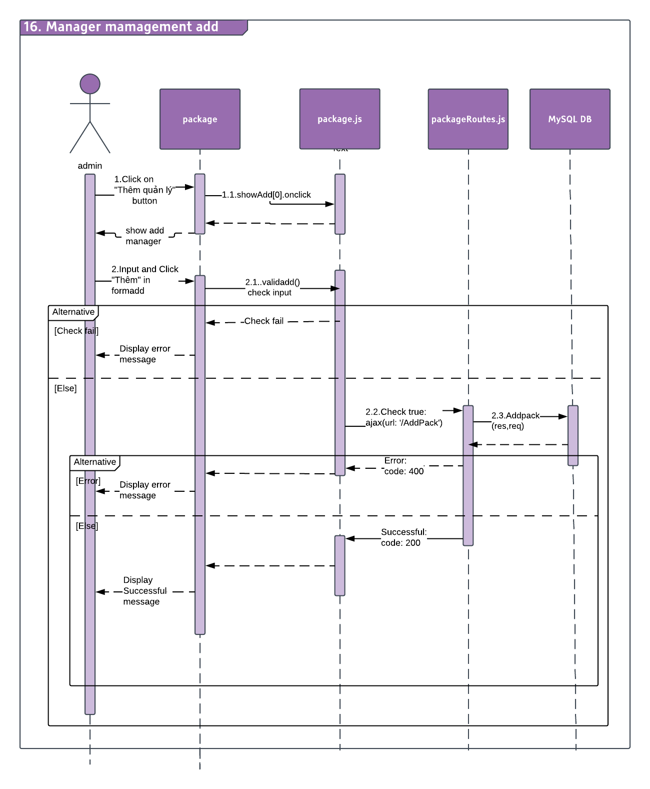

#### Edit Package

##### Description

Manager can edit package.

##### Design

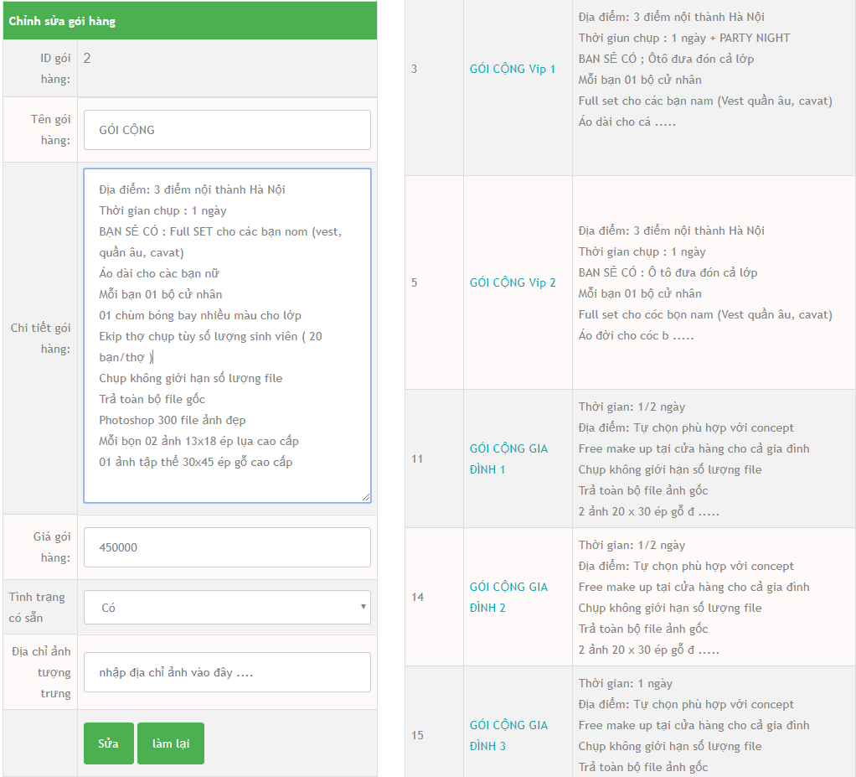

##### Class Diagram

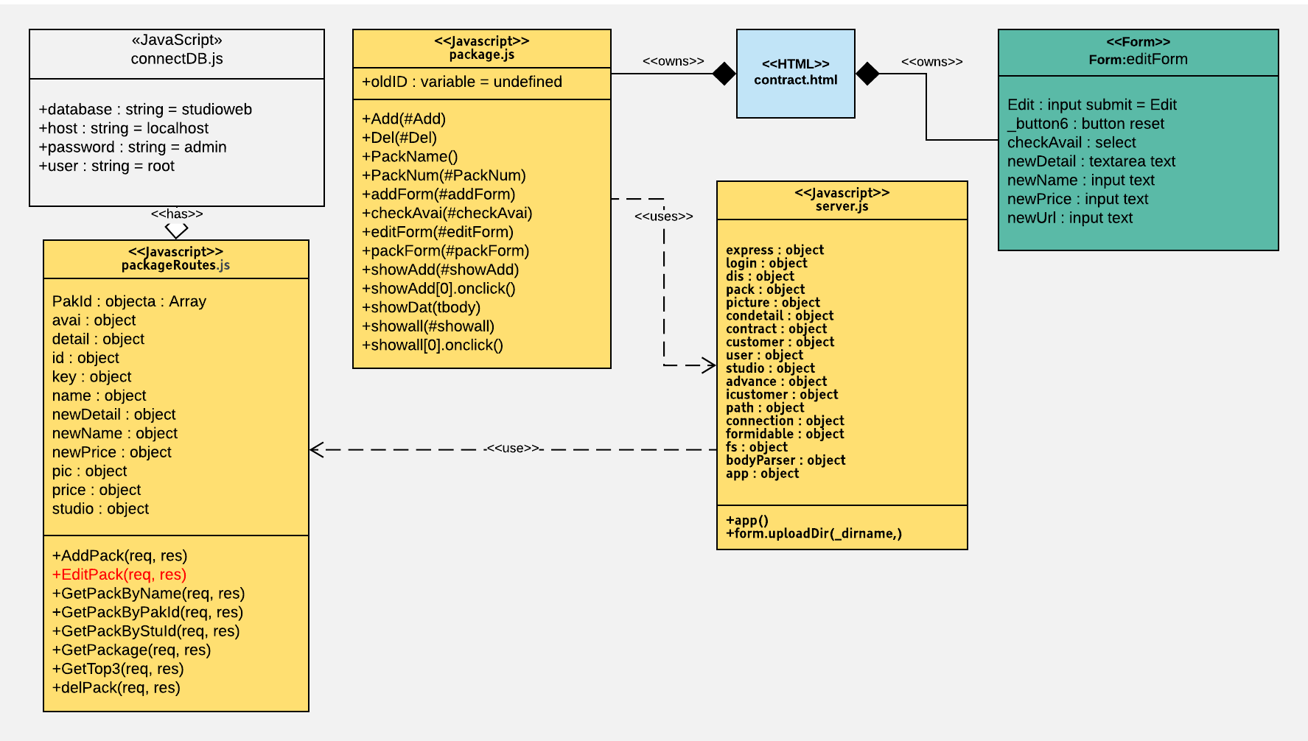

##### Class Specification

|  |  |  |  |  |
| --- | --- | --- | --- | --- |
| **Description** | Edit package action | | | |
| **Base Class** | Controller | | | |
| **Source File** | packageRoutes.js | | | |
| **Namespace** | app/public/routes/ | | | |
| **Attributes** | **N/A** | | | |
| **Methods** | **Name** | **Input** | **Output** | **Description** |
| EditPack | Request, result | View | Edit one package by Package ID |

##### Sequence Diagram

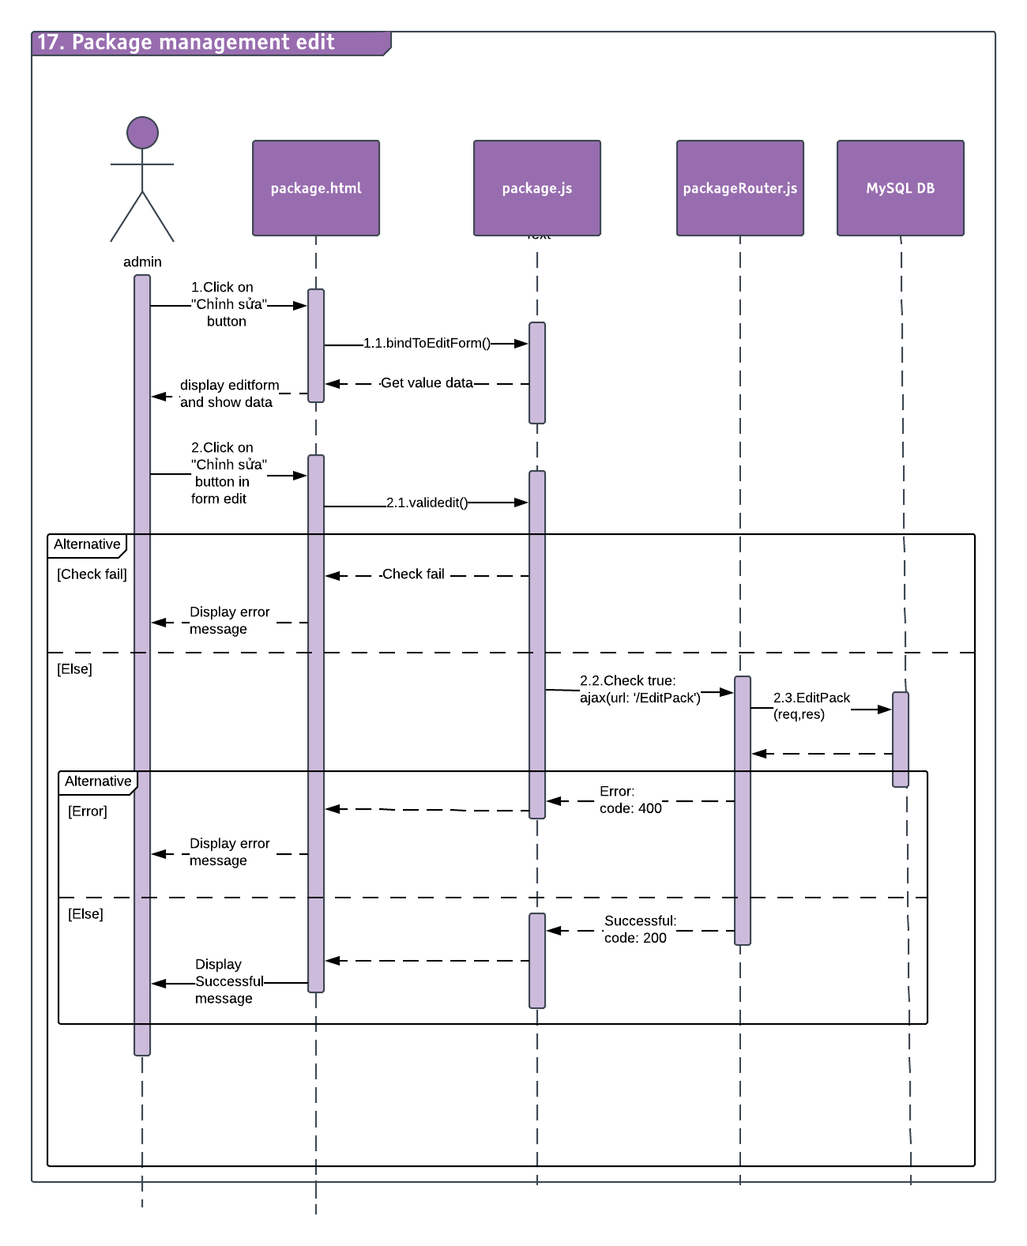

#### View & Search Picture

##### Description

Manager can view picture.

##### Design

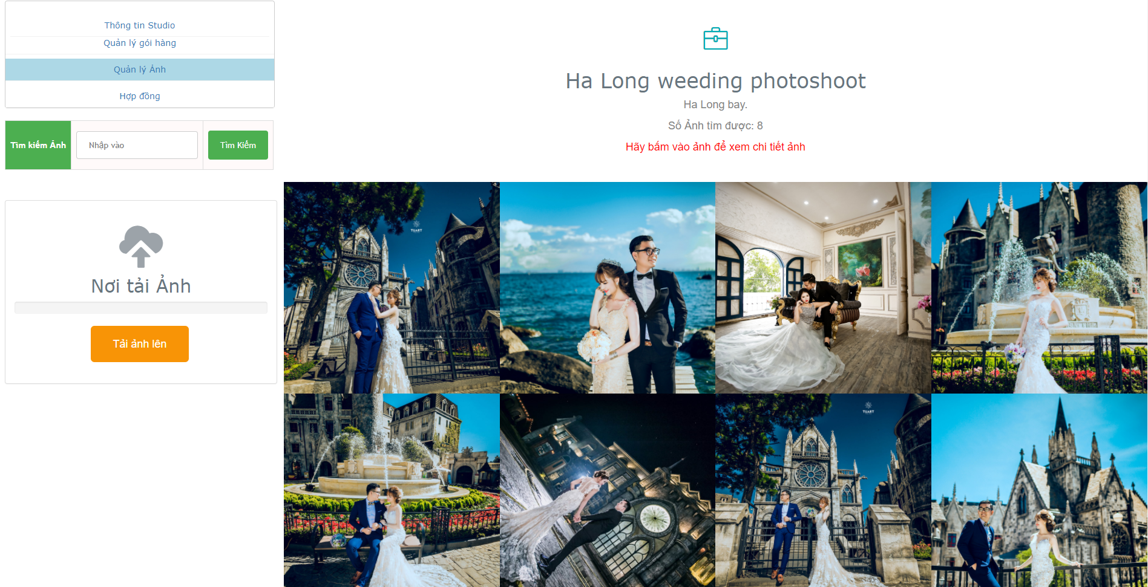

##### Class Diagram

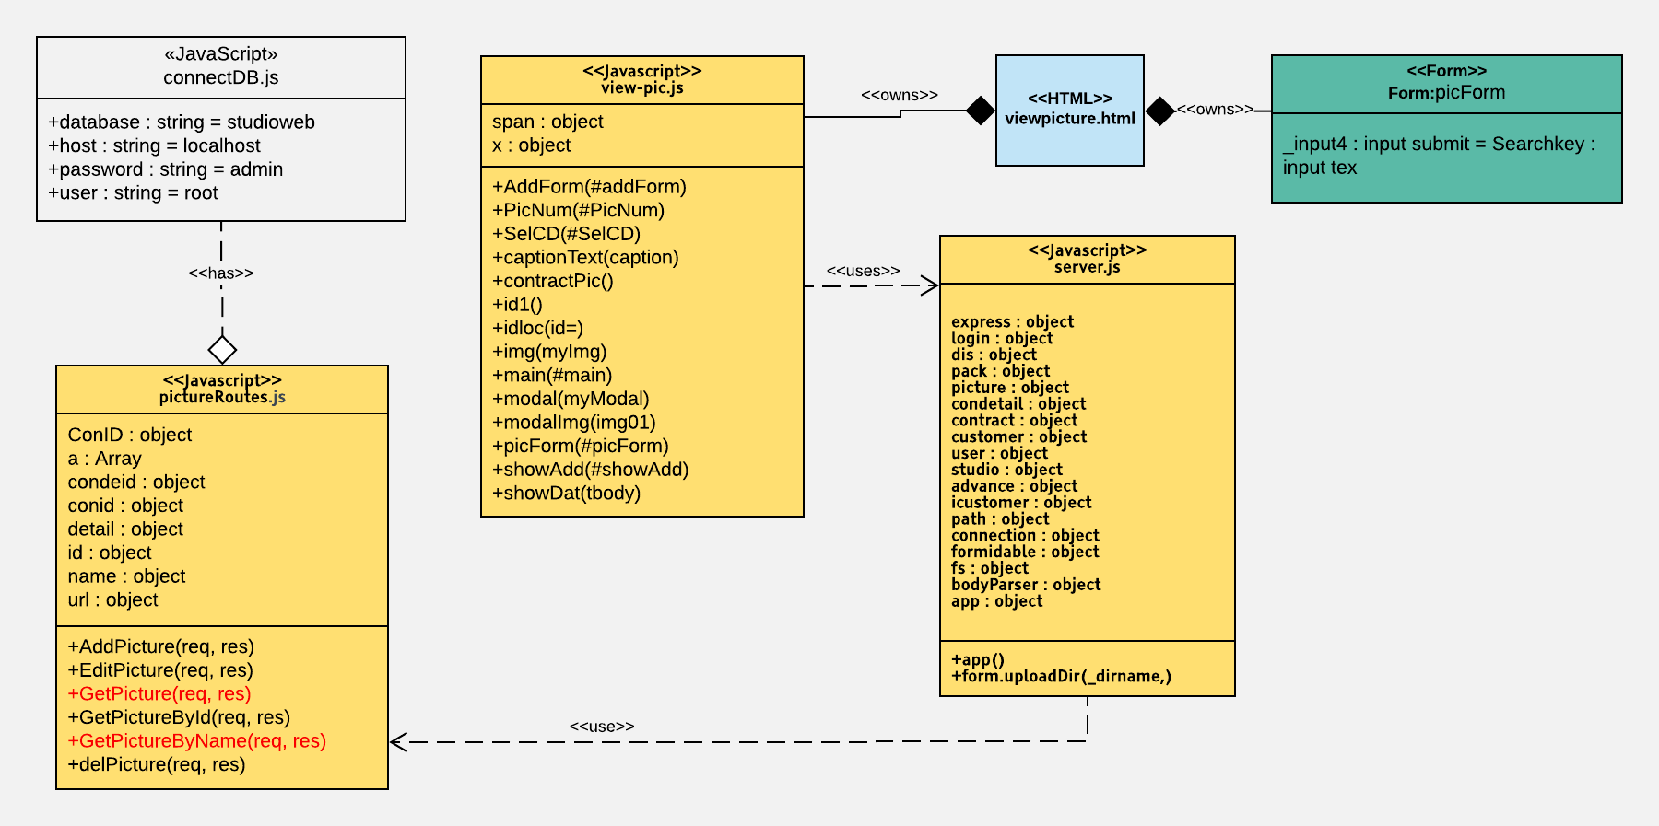

##### Class Specification

|  |  |  |  |  |
| --- | --- | --- | --- | --- |
| **Description** | Edit package action | | | |
| **Base Class** | Controller | | | |
| **Source File** | pictureRoutes.js | | | |
| **Namespace** | app/public/routes/ | | | |
| **Attributes** | **N/A** | | | |
| **Methods** | **Name** | **Input** | **Output** | **Description** |
| GetPicture | Request, result | View | Get Picture info by Name ID |

##### Sequence Diagram

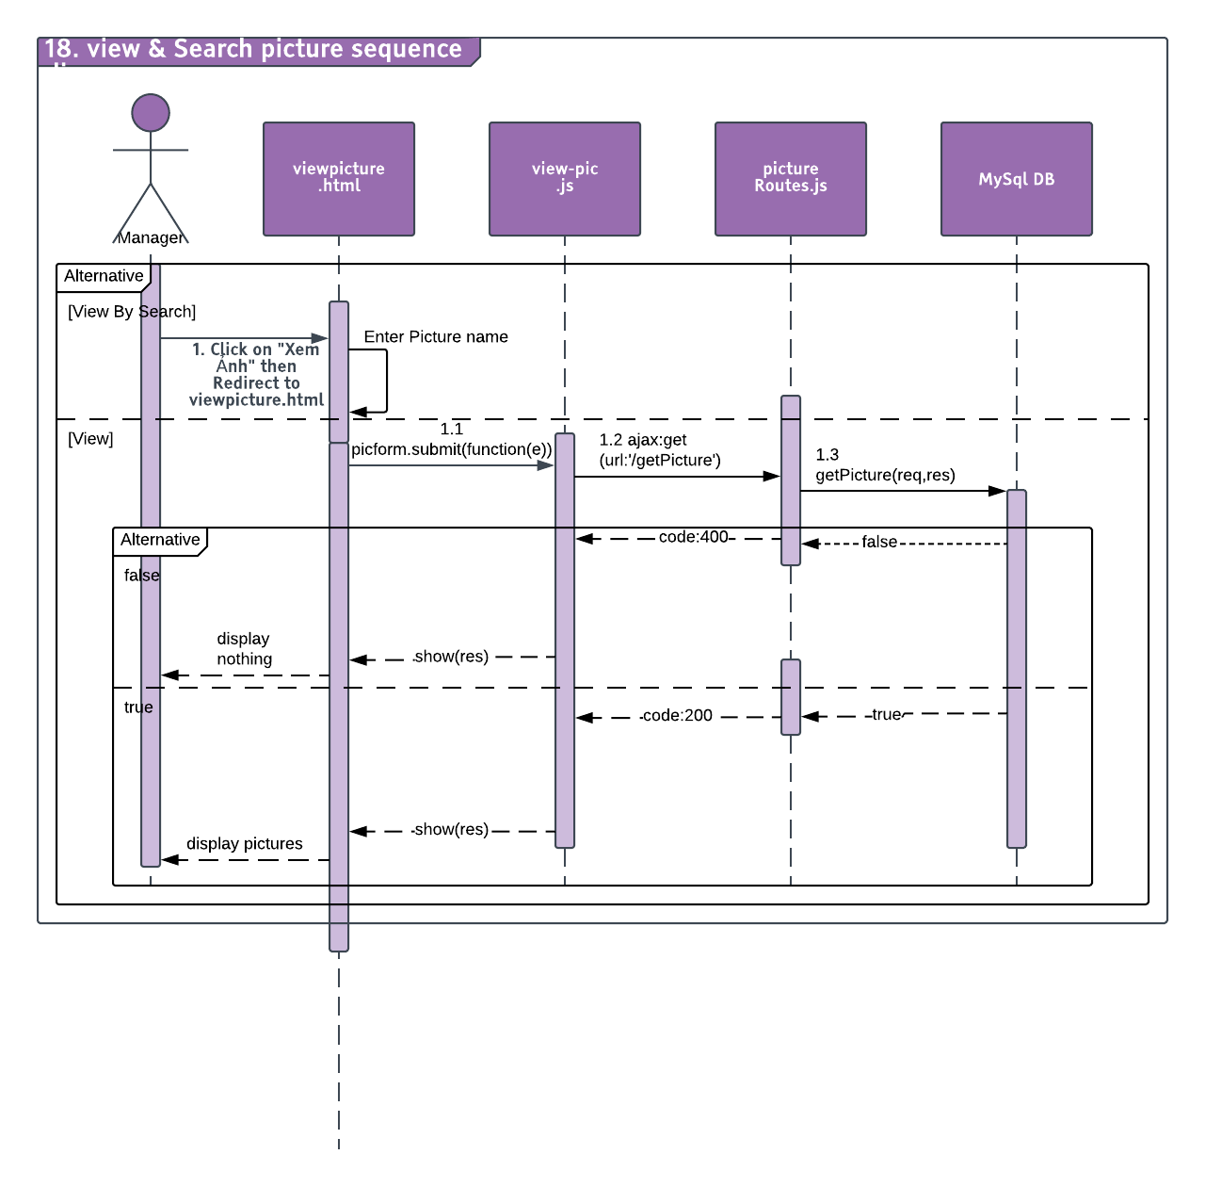

#### Edit Picture Info

##### Description

Manager can edit Picture info

##### Design

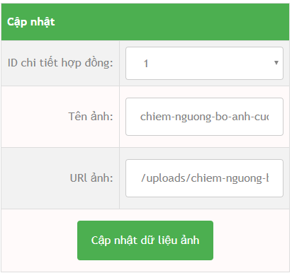

##### Class Diagram

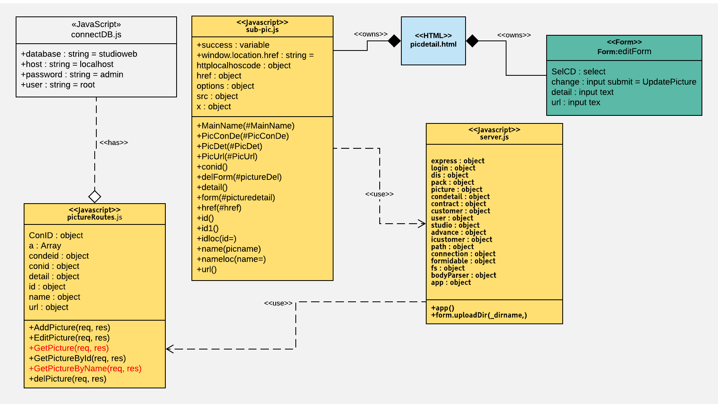

##### Class Specification

|  |  |  |  |  |
| --- | --- | --- | --- | --- |
| **Description** | Edit picture action | | | |
| **Base Class** | Controller | | | |
| **Source File** | packageRoutes.js | | | |
| **Namespace** | app/public/routes/ | | | |
| **Attributes** | **N/A** | | | |
| **Methods** | **Name** | **Input** | **Output** | **Description** |
|  | Request, result | View |  |

##### Sequence Diagram

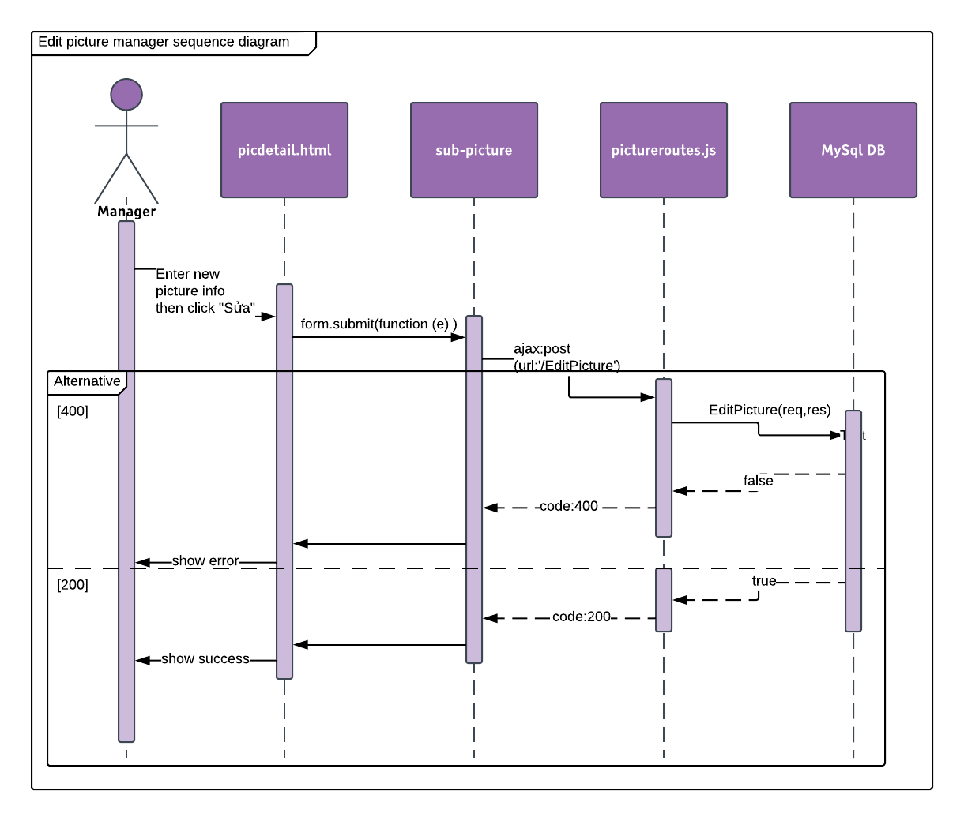

#### Upload Picture

##### Description

Manager can upload picture.

##### Design

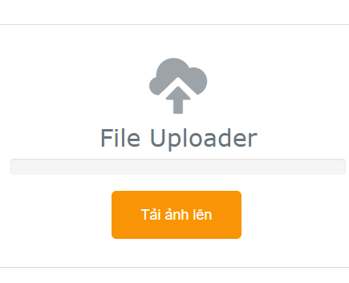

##### Class Diagram

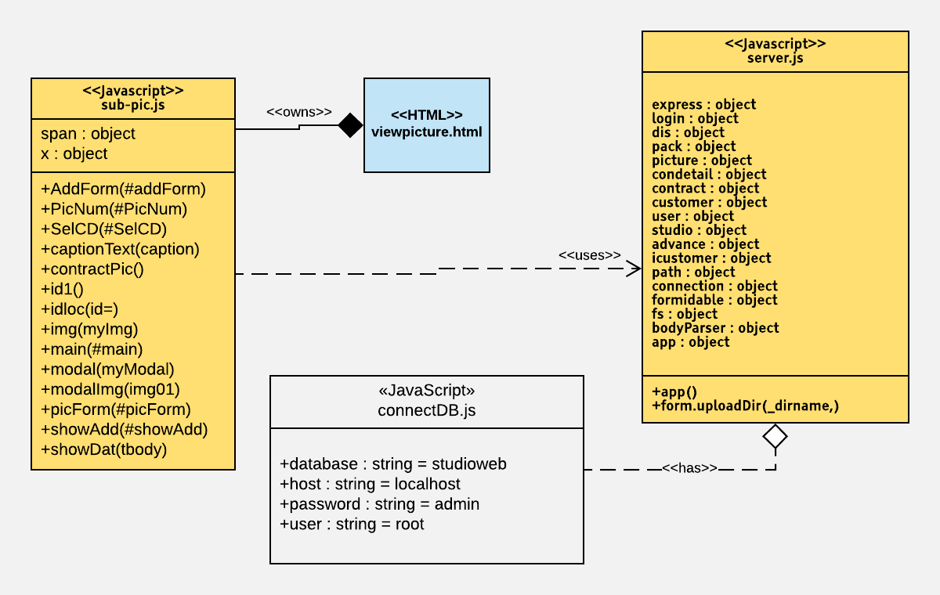

##### Class Specification

|  |  |  |  |  |
| --- | --- | --- | --- | --- |
| **Description** | Upload picture action | | | |
| **Base Class** | Controller | | | |
| **Source File** | pictureRoutes.js | | | |
| **Namespace** | app/public/routes/ | | | |
| **Attributes** | **N/A** | | | |
| **Methods** | **Name** | **Input** | **Output** | **Description** |
| upload | Request, result | View | Upload picture |

##### Sequence Diagram

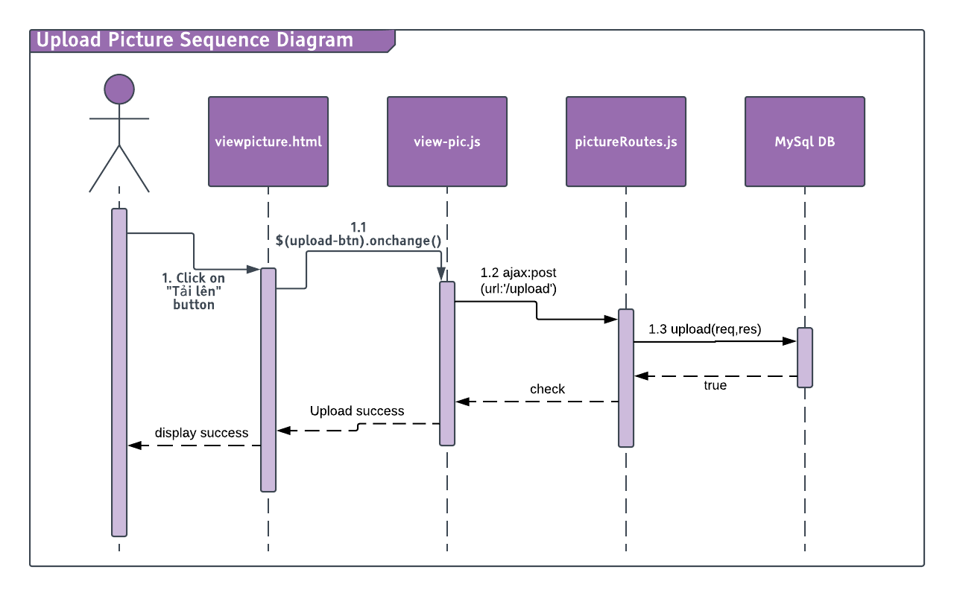

#### Delete Picture

##### Description

Manager can delete picture.

##### Design

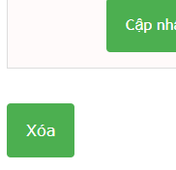

##### Class Diagram

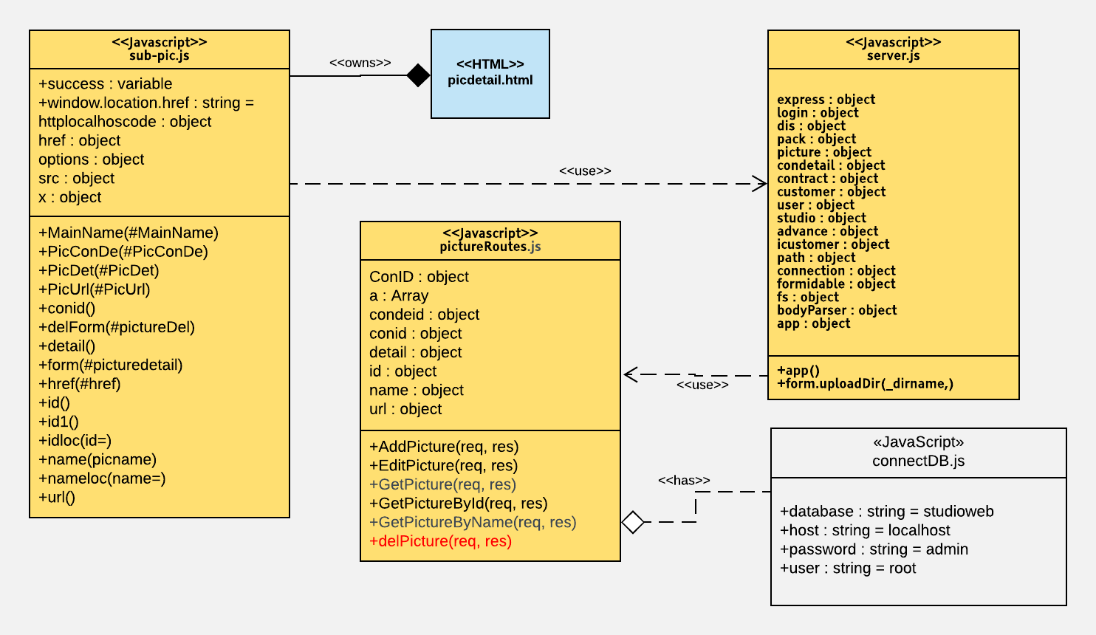

##### Class Specification

|  |  |  |  |  |
| --- | --- | --- | --- | --- |
| **Description** | Upload picture action | | | |
| **Base Class** | Controller | | | |
| **Source File** | pictureRoutes.js | | | |
| **Namespace** | app/public/routes/ | | | |
| **Attributes** | **N/A** | | | |
| **Methods** | **Name** | **Input** | **Output** | **Description** |
| DelPicture | Request, result | View | Delete picture by ID |

##### Sequence Diagram

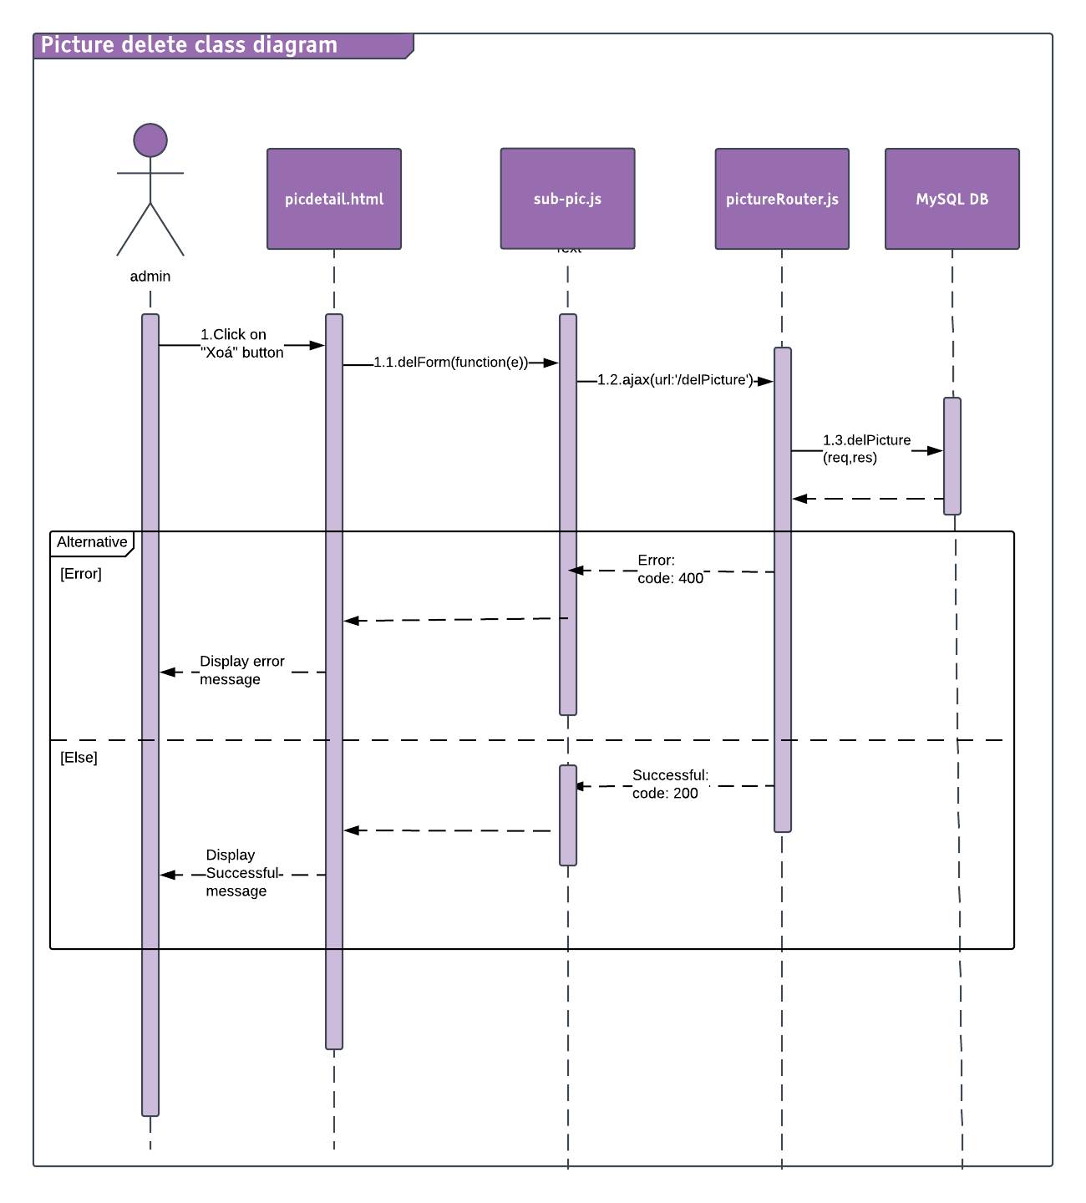

#### View Customer Information

##### Description

Manager can view Customer Information

##### Design

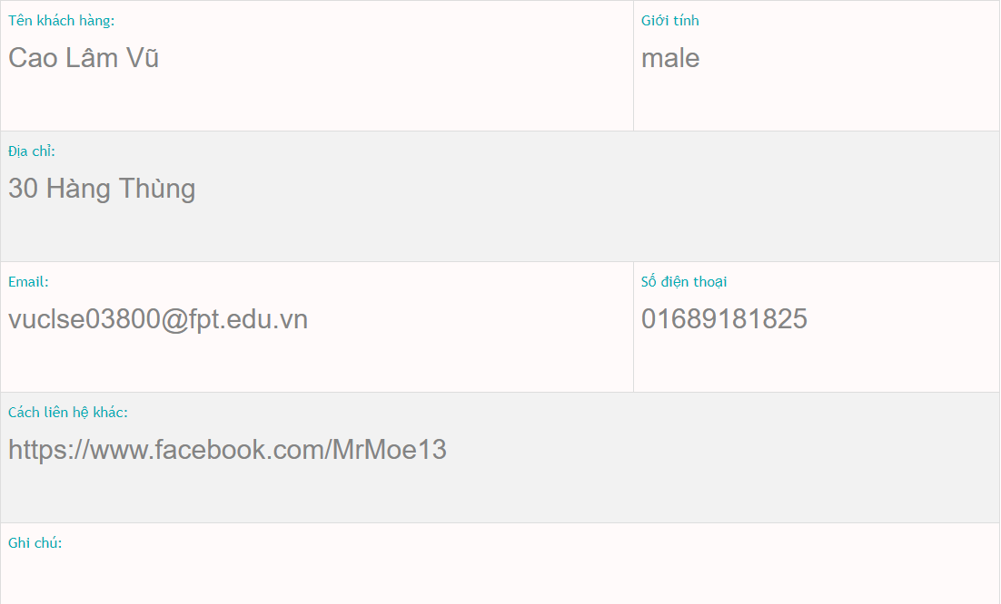

##### Class Diagram

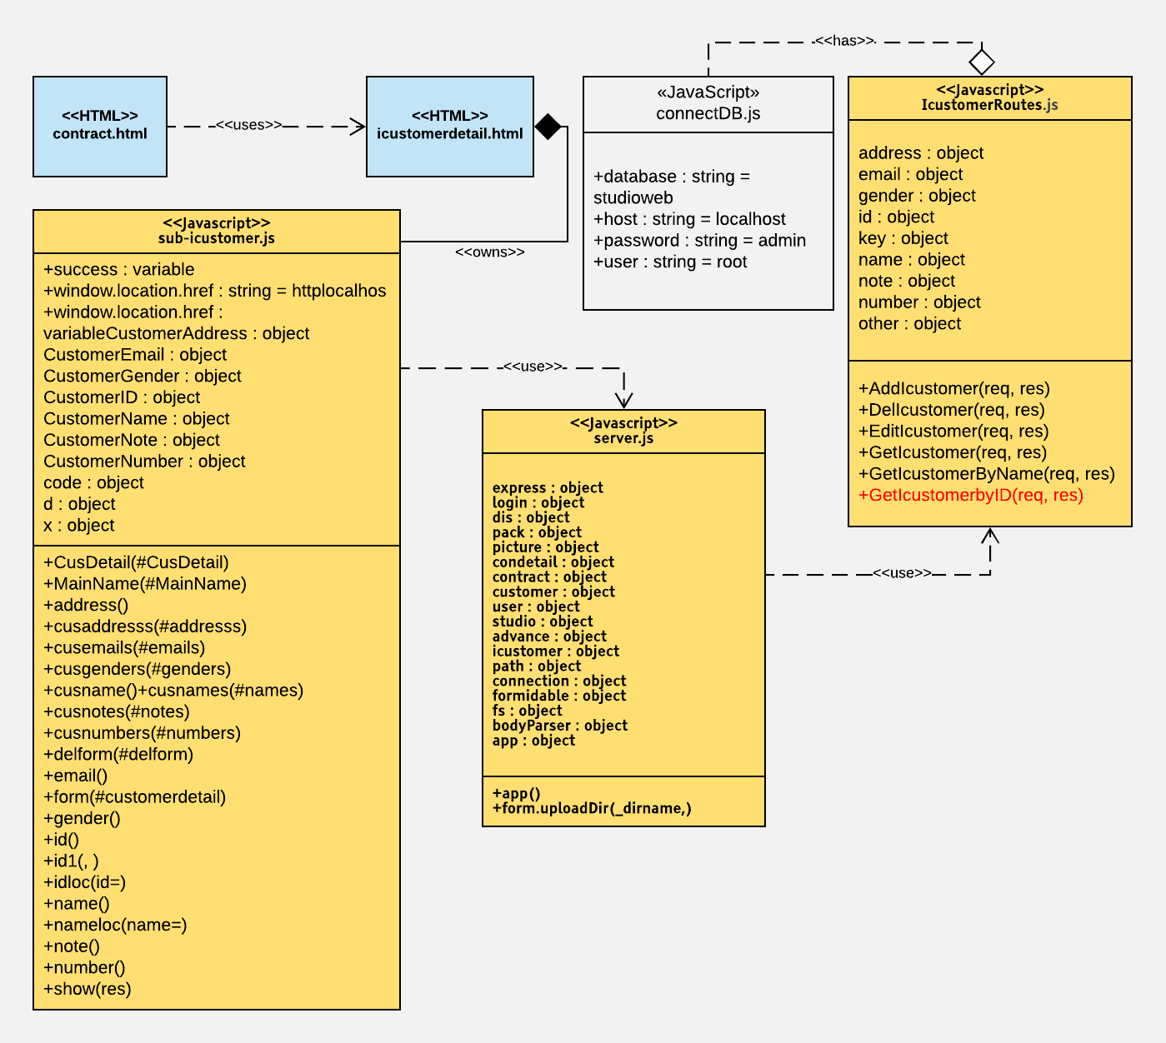

##### Class Specification

|  |  |  |  |  |
| --- | --- | --- | --- | --- |
| **Description** | Get customer information by name | | | |
| **Base Class** | Controller | | | |
| **Source File** | customerRoutes.js | | | |
| **Namespace** | app/public/routes/ | | | |
| **Attributes** | **N/A** | | | |
| **Methods** | **Name** | **Input** | **Output** | **Description** |
| GetICustomerByID | Request, result | View | Get Customer info by ID |

##### Sequence Diagram

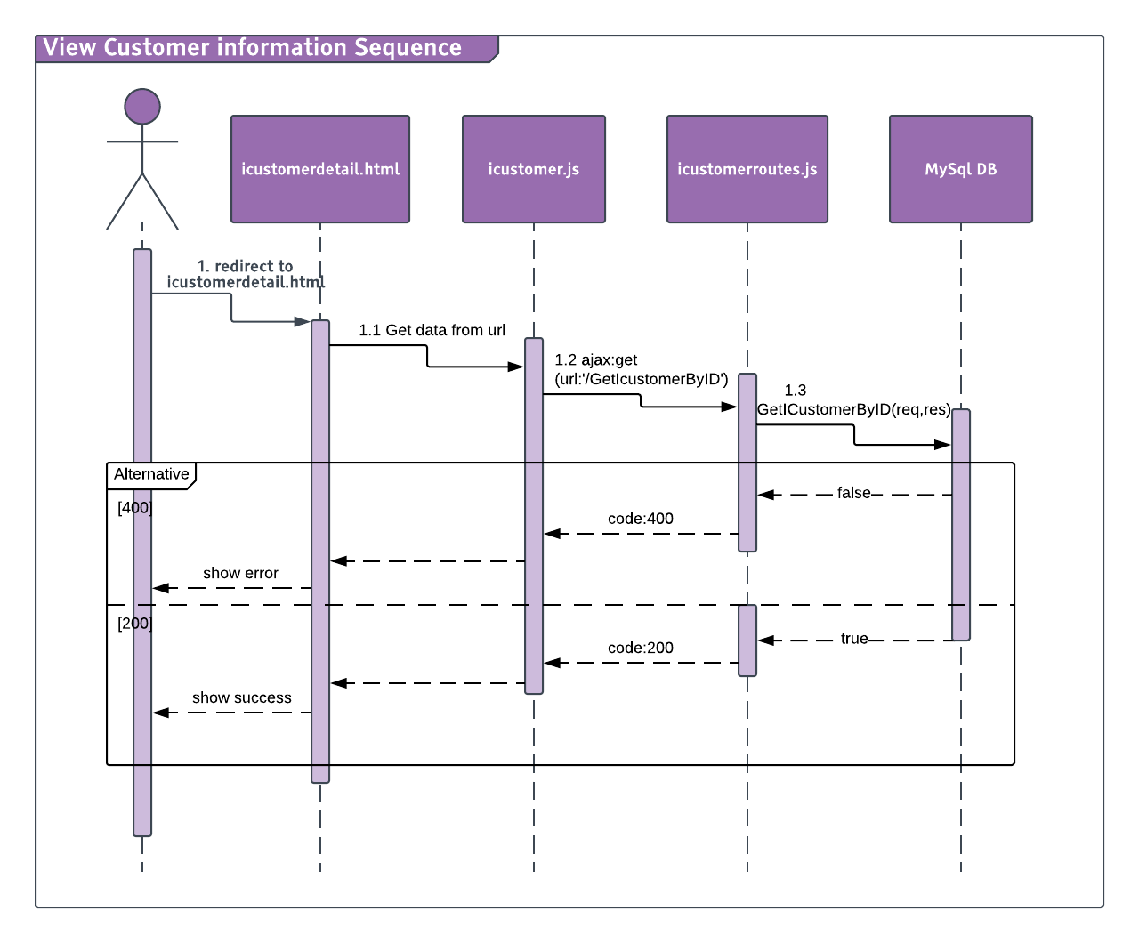

#### Edit Studio Profile

##### Description

Manager can edit their own studio information and picture to preview at Studio page

##### Design

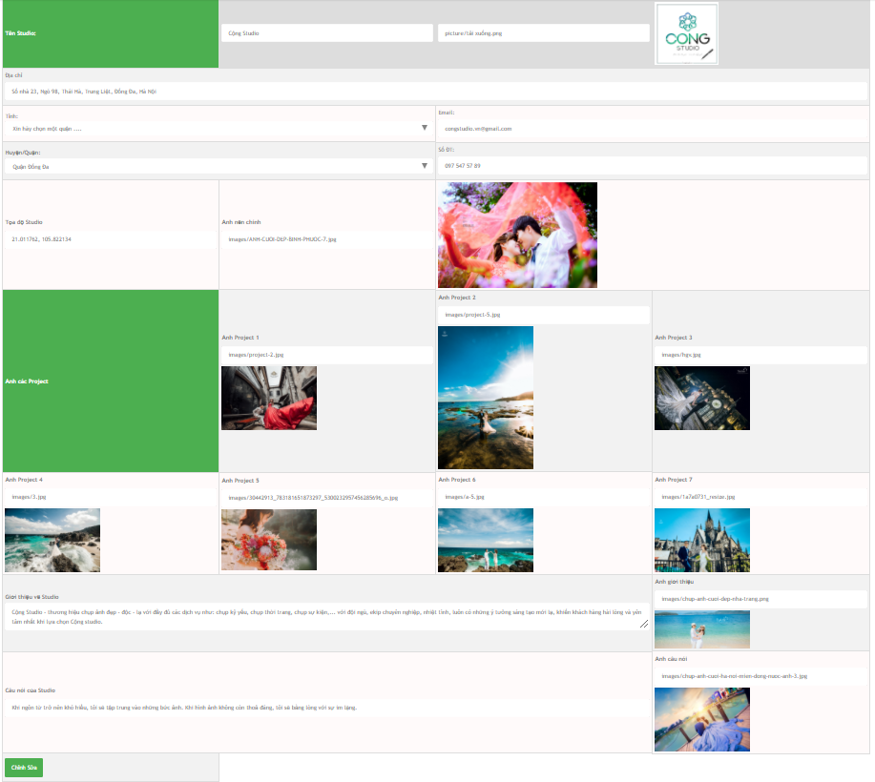

##### Class Diagram



##### Class Specification

|  |  |  |  |  |
| --- | --- | --- | --- | --- |
| **Description** | Edit Studio’s profile | | | |
| **Base Class** | Controller | | | |
| **Source File** | studioRoutes.js | | | |
| **Namespace** | app/public/routes/ | | | |
| **Attributes** | **N/A** | | | |
| **Methods** | **Name** | **Input** | **Output** | **Description** |
| EditStudioProfile | Request, result | View | Edit studio profile include info and preview picture |

##### Sequence Diagram

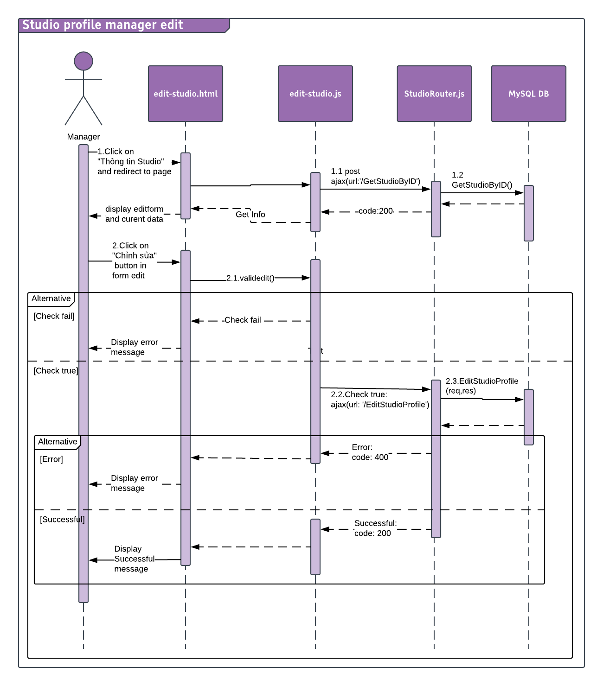

#### View Studio Profile

##### Description

Manager can view their own studio profile

##### Design



##### Class Diagram

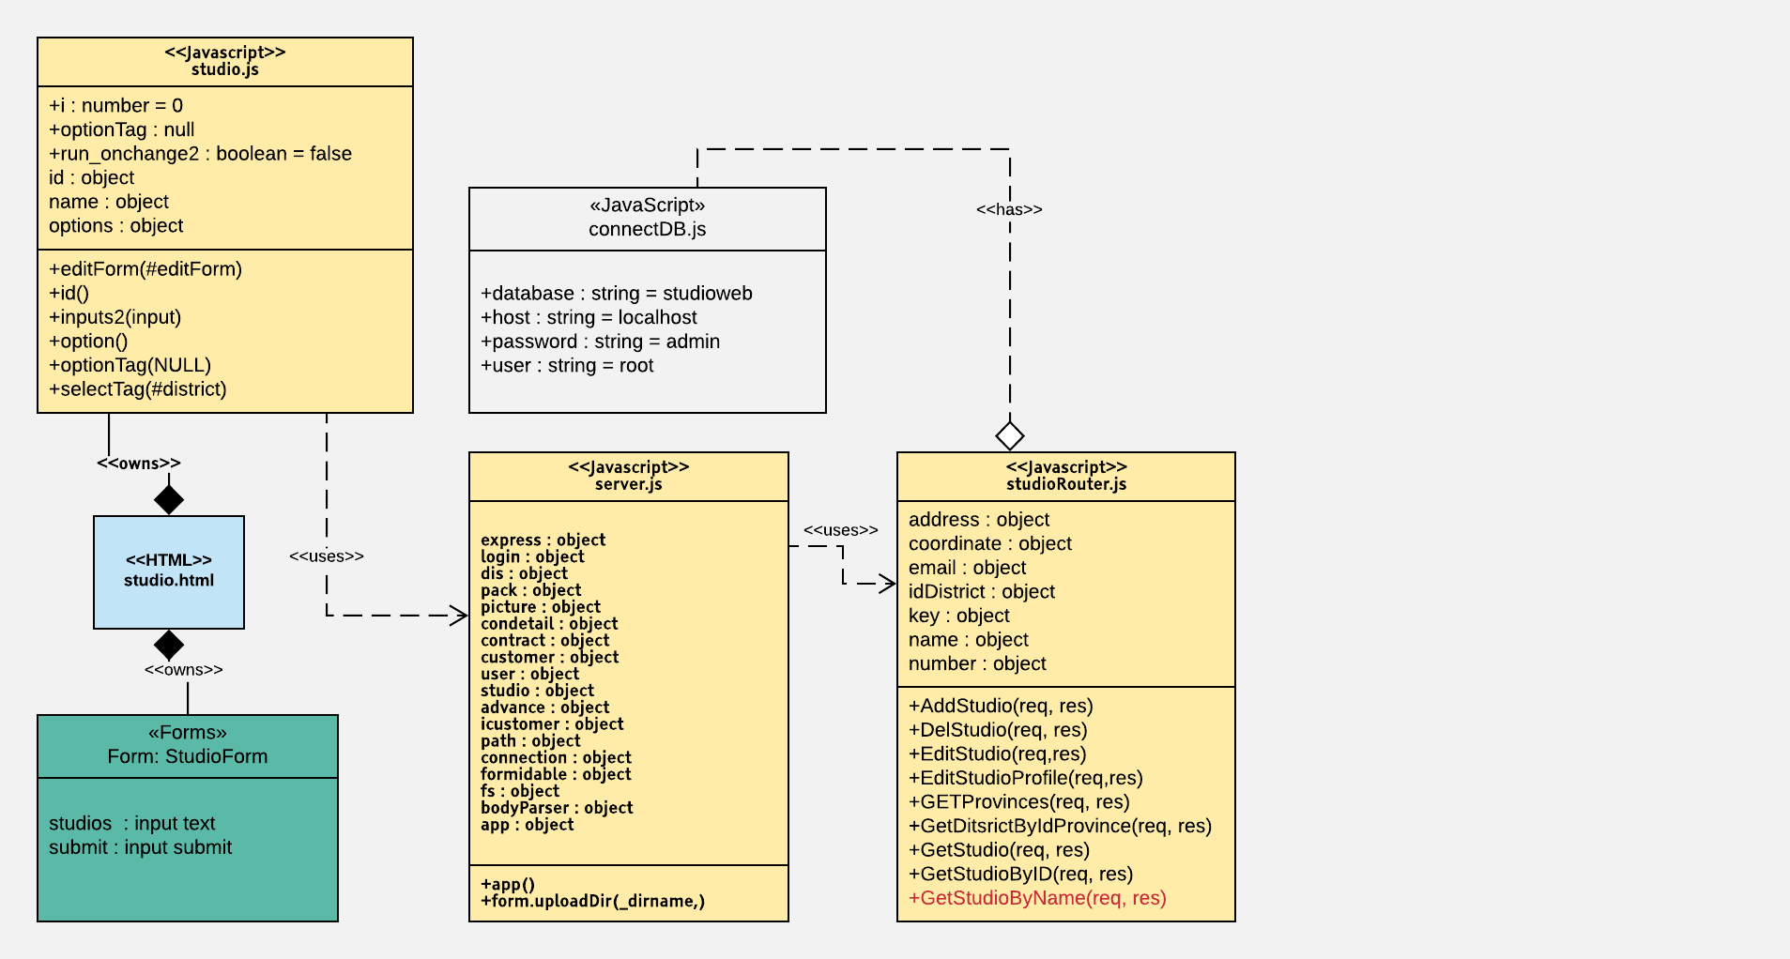

##### Class Specification

|  |  |  |  |  |
| --- | --- | --- | --- | --- |
| **Description** | View Studio’s profile | | | |
| **Base Class** | Controller | | | |
| **Source File** | studioRoutes.js | | | |
| **Namespace** | app/public/routes/ | | | |
| **Attributes** | **N/A** | | | |
| **Methods** | **Name** | **Input** | **Output** | **Description** |
| GetStudioByName | Request, result | View | View studio profile include info and preview picture |

##### Sequence Diagram

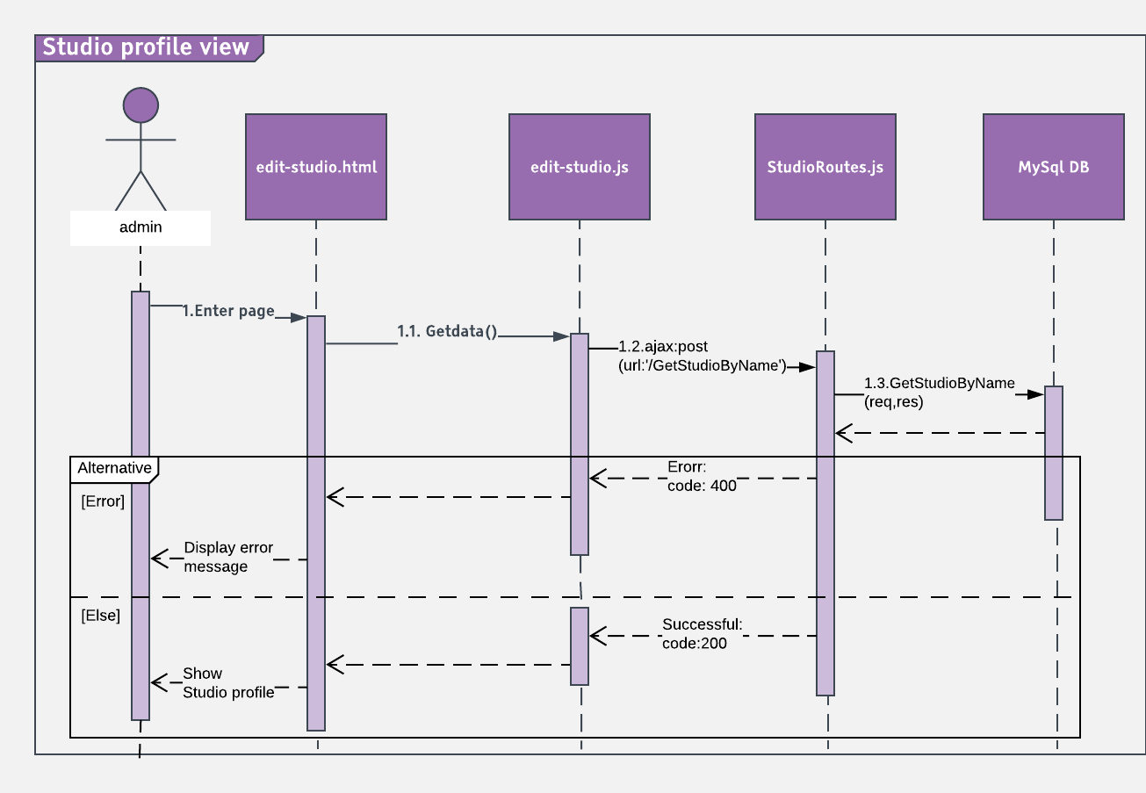

### Customer

#### See Studio Information

##### Description

Customer can see Studio basic information and location.

##### Design

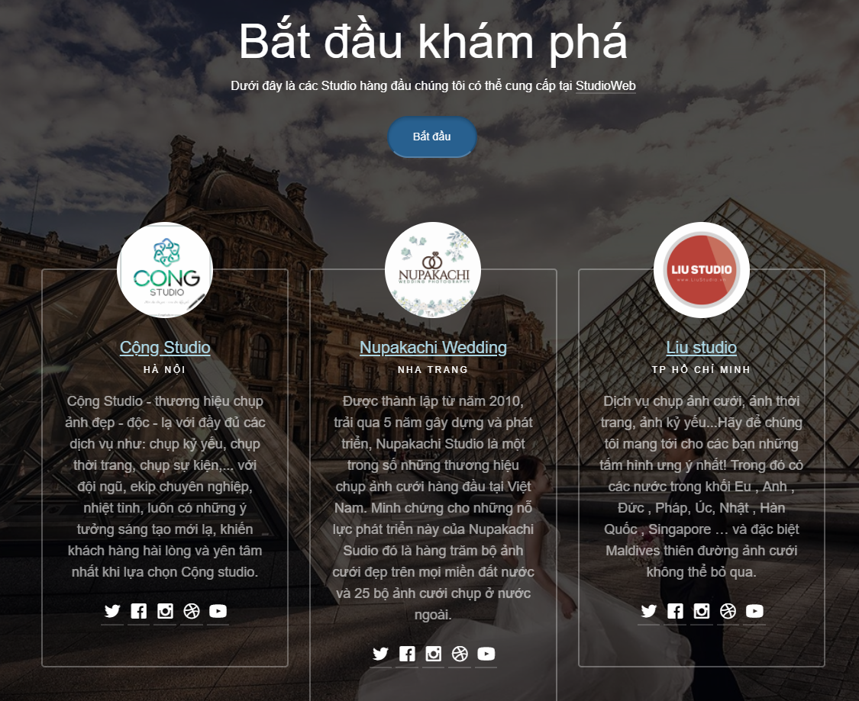

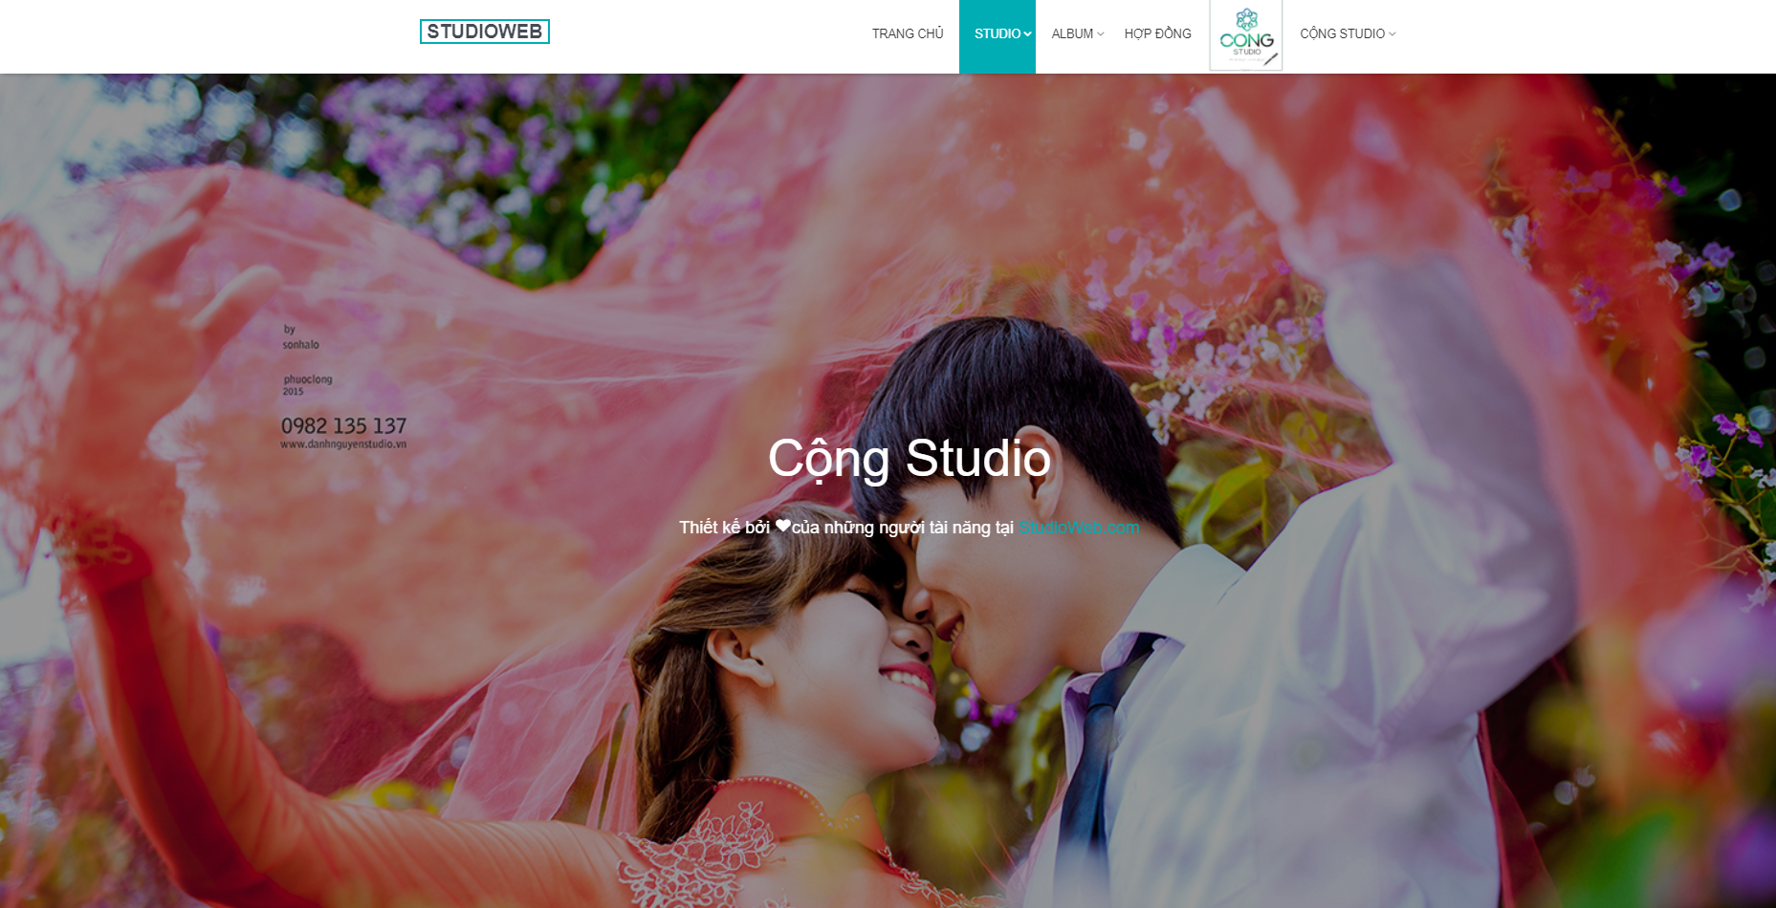

##### Class Diagram

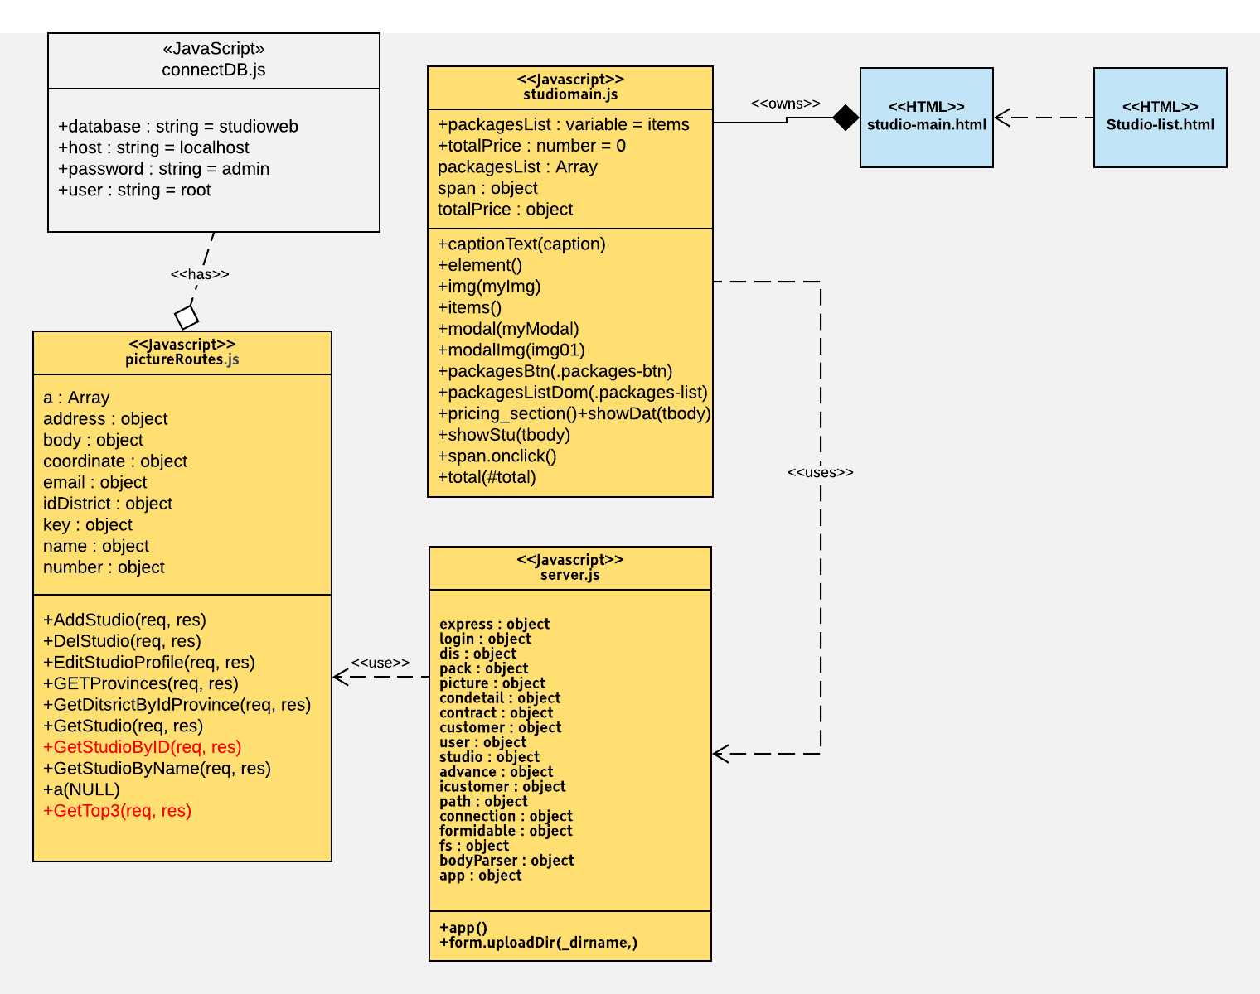

##### Class Specification

|  |  |  |  |  |
| --- | --- | --- | --- | --- |
| **Description** | Get Studio information | | | |
| **Base Class** | Controller | | | |
| **Source File** | studioRoutes.js | | | |
| **Namespace** | app/public/routes/ | | | |
| **Attributes** | **N/A** | | | |
| **Methods** | **Name** | **Methods** | **Output** | **Description** |
| GetStudioByID | Request, result | view | Get studio information By Studio ID to bind |

|  |  |  |  |  |
| --- | --- | --- | --- | --- |
| **Description** | Get 3 package to show | | | |
| **Base Class** | Controller | | | |
| **Source File** | packageRoutes.js | | | |
| **Namespace** | app/public/routes/ | | | |
| **Attributes** | **N/A** | | | |
| **Methods** | **Name** | **Methods** | **Output** | **Description** |
| GetTop3 | Request, result | view | Get top 3 first package of the current studio page |

##### Sequence Diagram

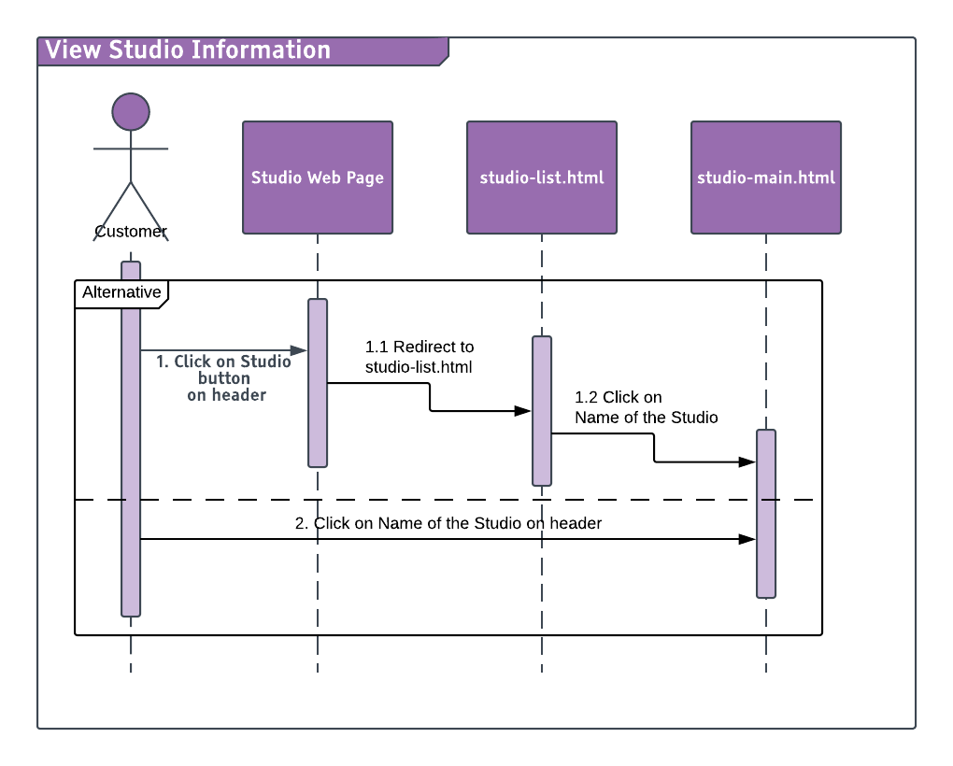

#### See Album

##### Description

Customer can see sample album.

##### Design

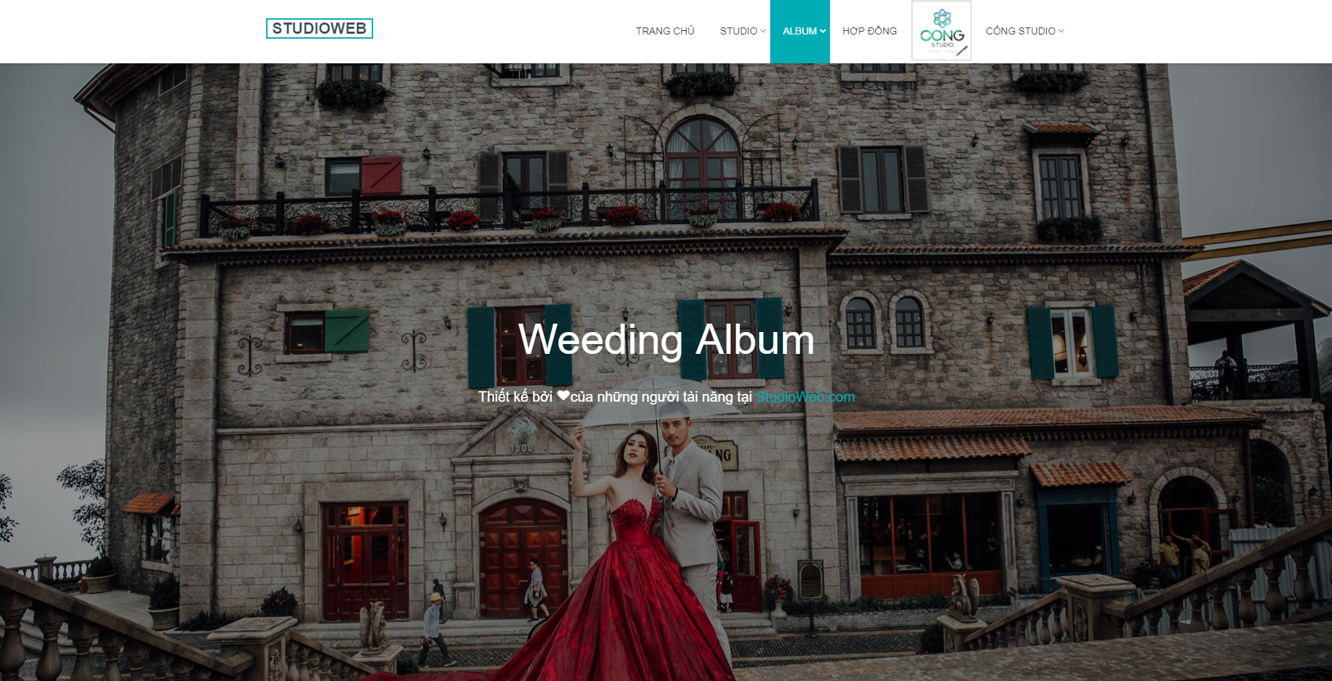

##### Class Diagram

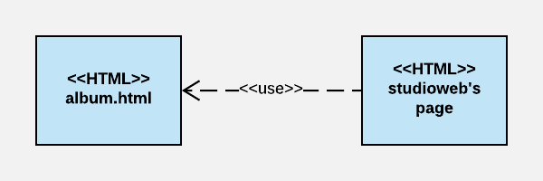

##### Sequence Diagram

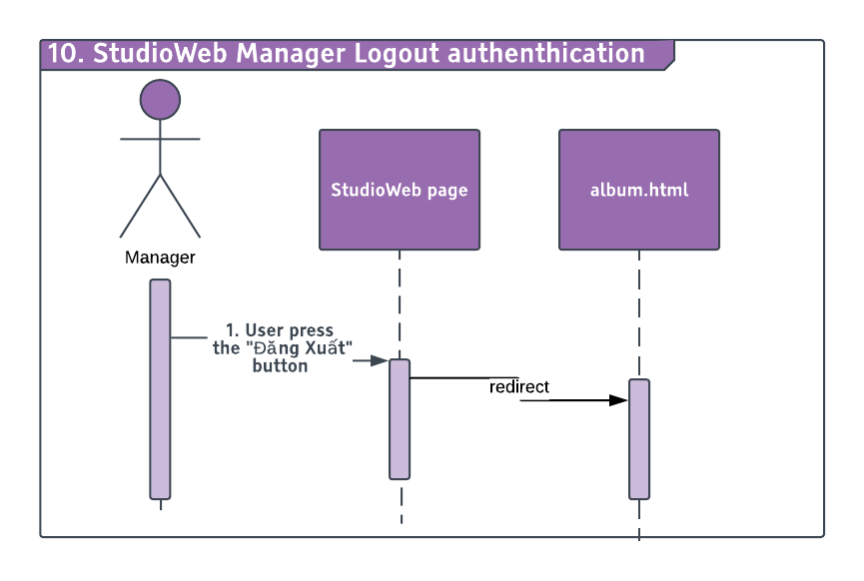

#### See package Information

##### Description

Customer can see Package detail information.

##### Design

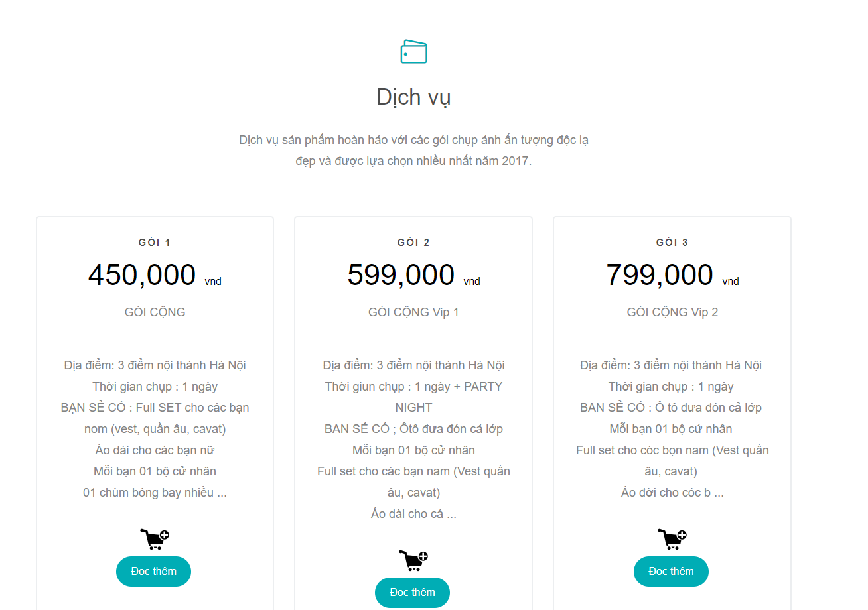

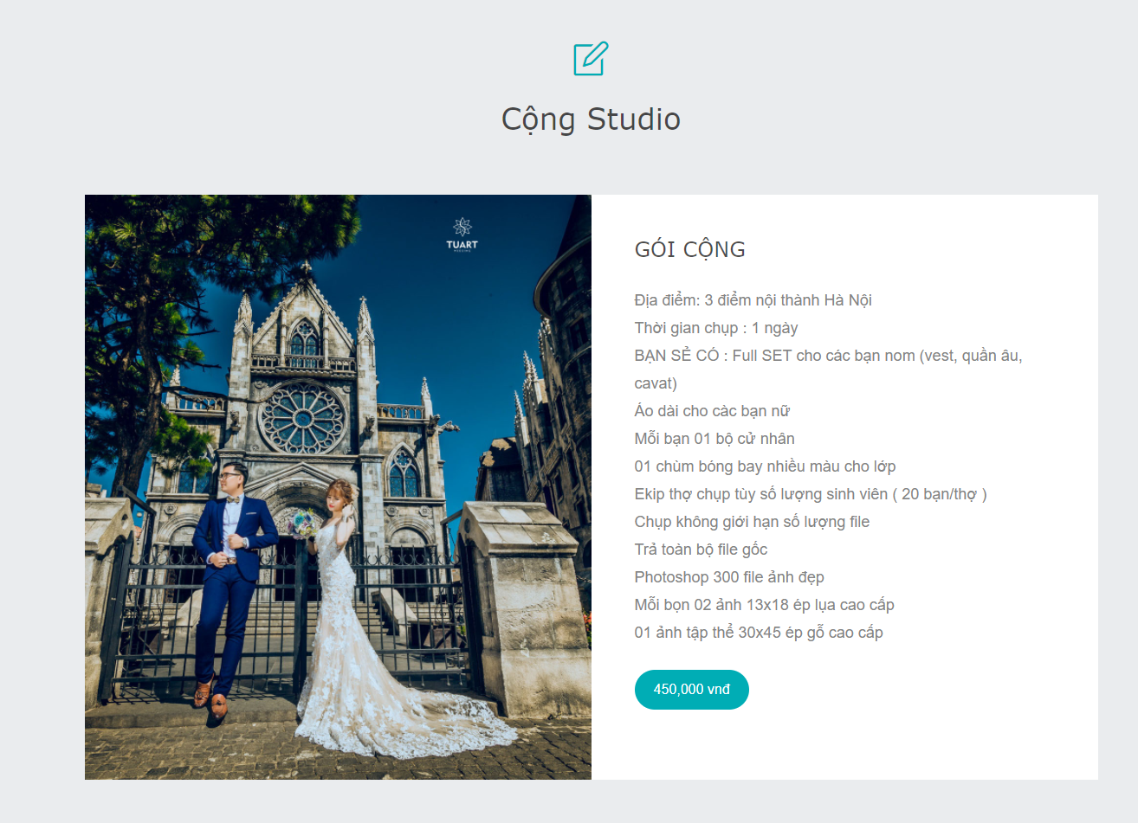

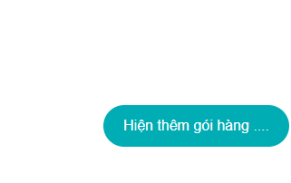

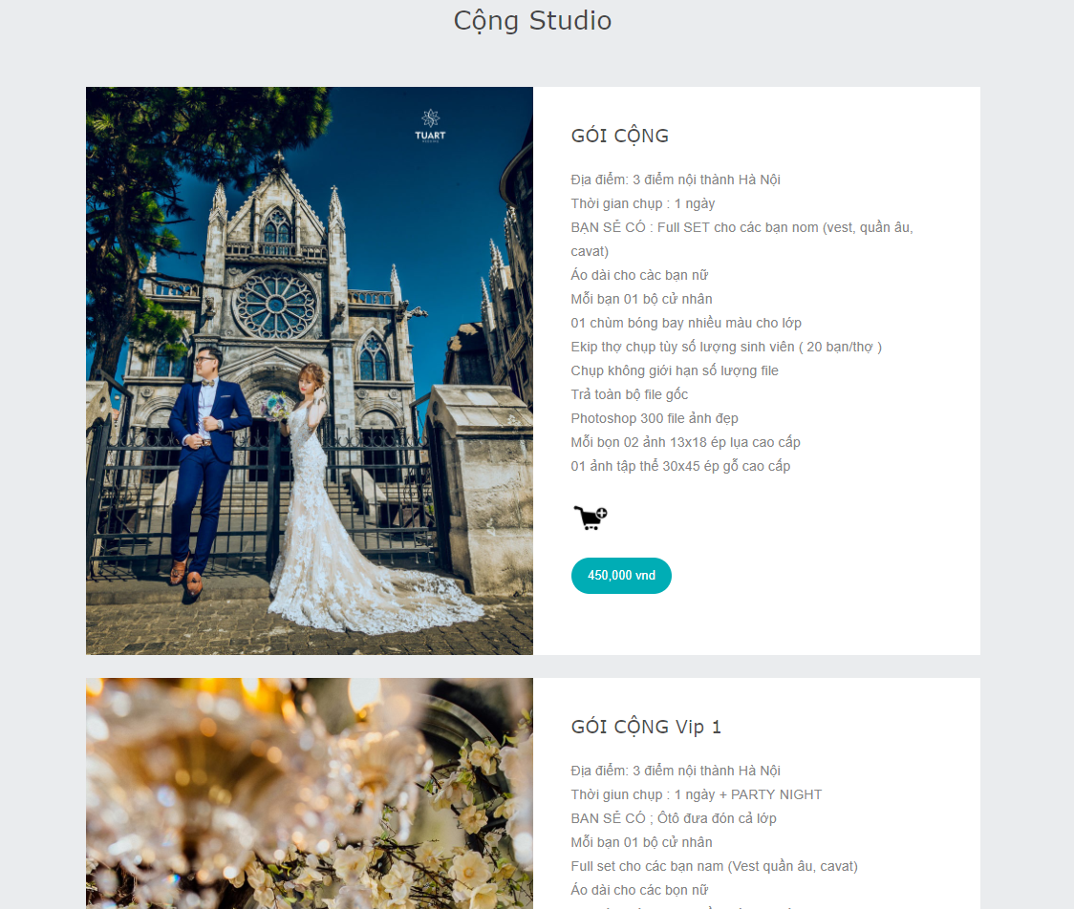

##### Class Diagram

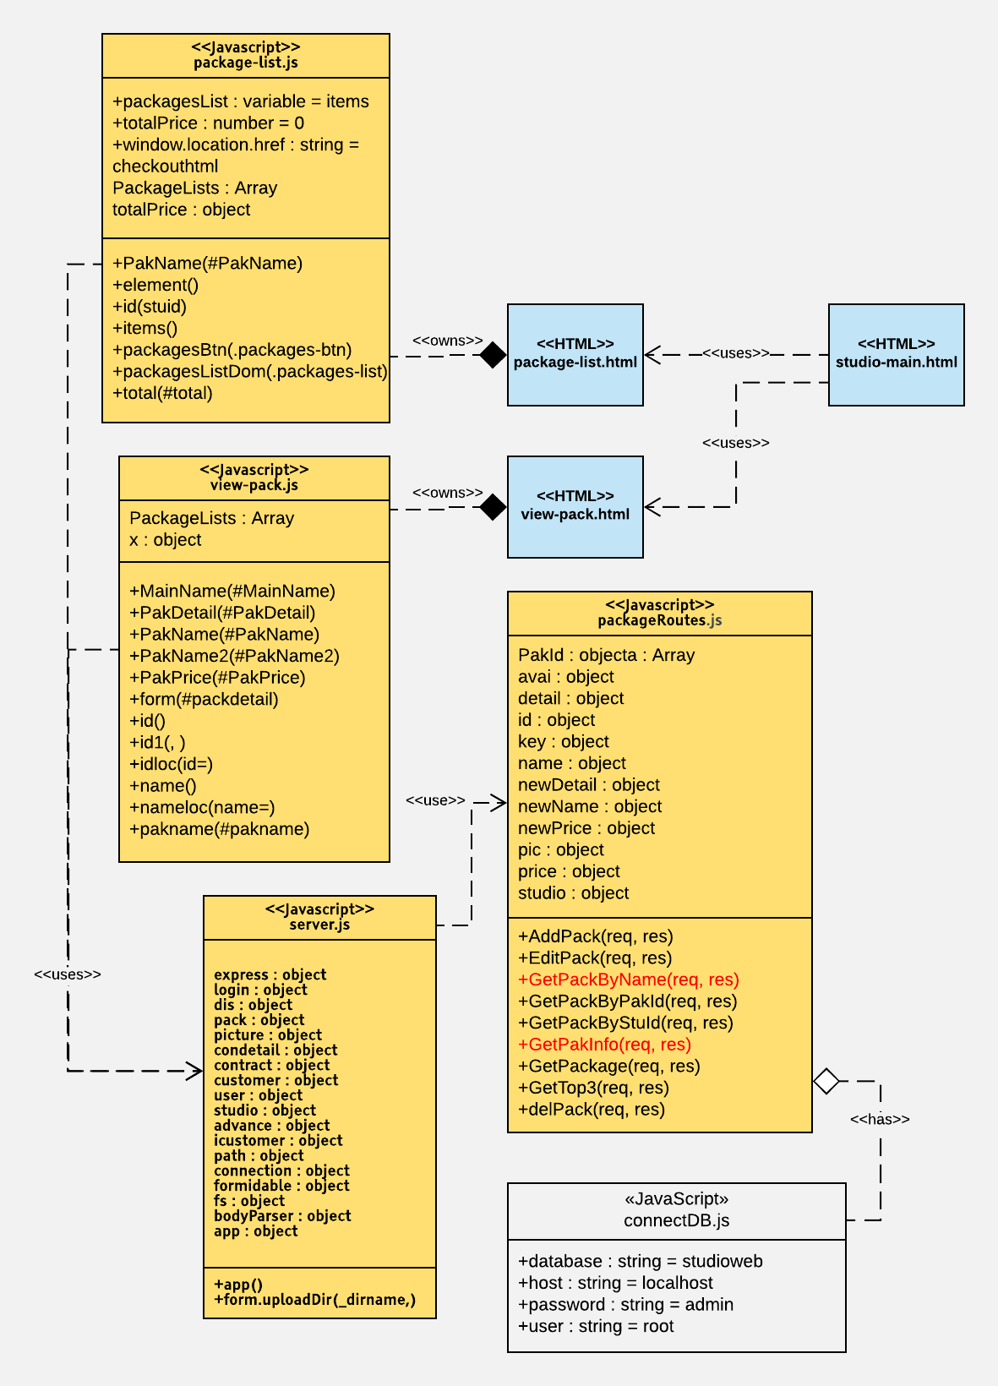

##### Class Specification

|  |  |  |  |  |
| --- | --- | --- | --- | --- |
| **Description** | Get package info | | | |
| **Base Class** | Controller | | | |
| **Source File** | packageRoutes.js | | | |
| **Namespace** | app/public/routes/ | | | |
| **Attributes** | **N/A** | | | |
| **Methods** | **Name** | **Methods** | **Output** | **Description** |
| GetPakInfo | Request, result | view | Get all package information by Studio ID |
|  | GetPackByName | Request, result | View | Get package information by Studio name |

##### Sequence Diagram

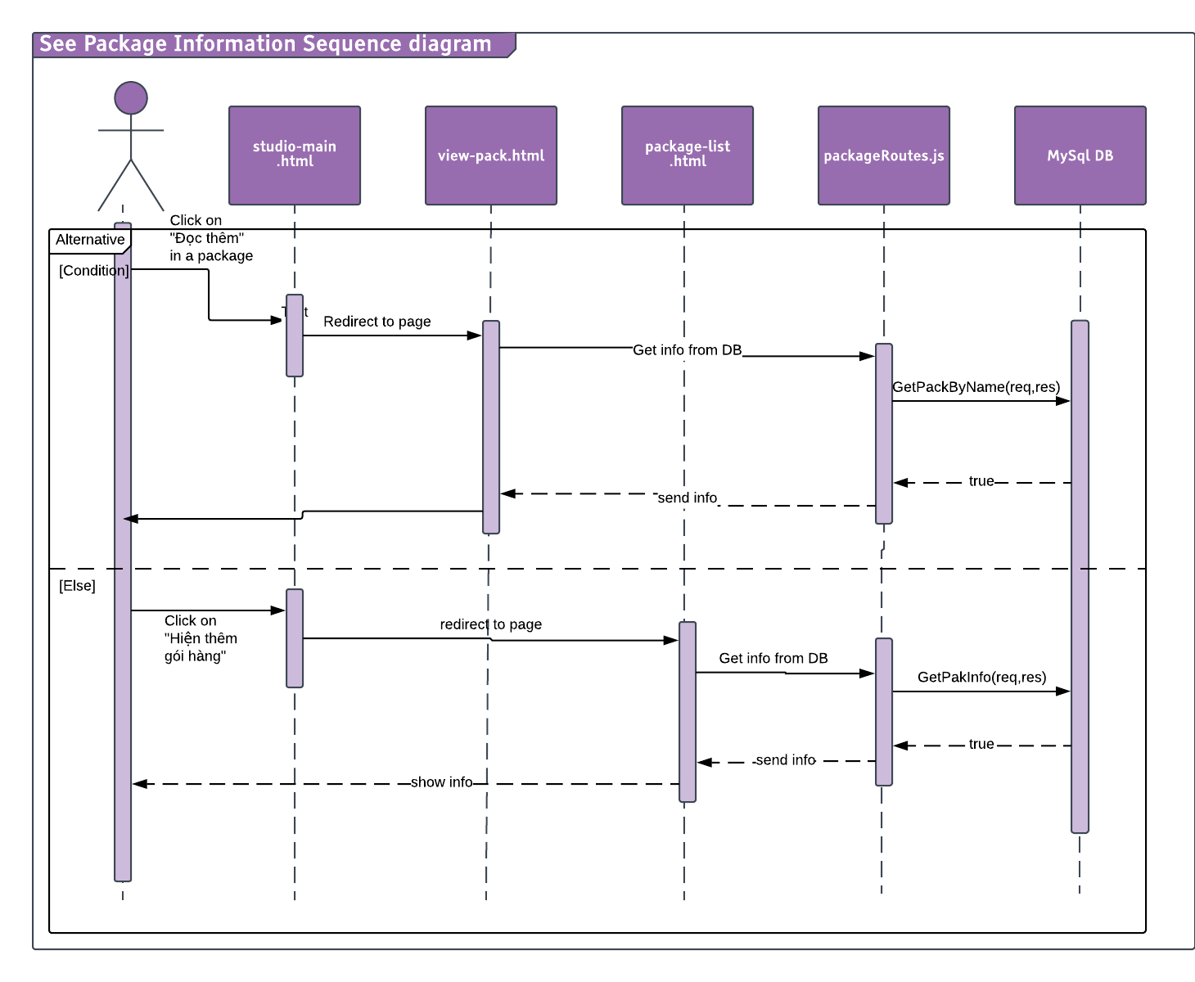

#### Order photo and leave information

##### Description

Customer can order a photo package and leave contact information.

##### Design

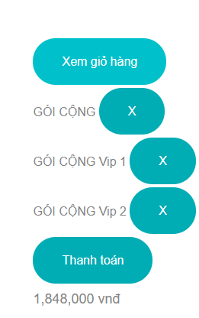

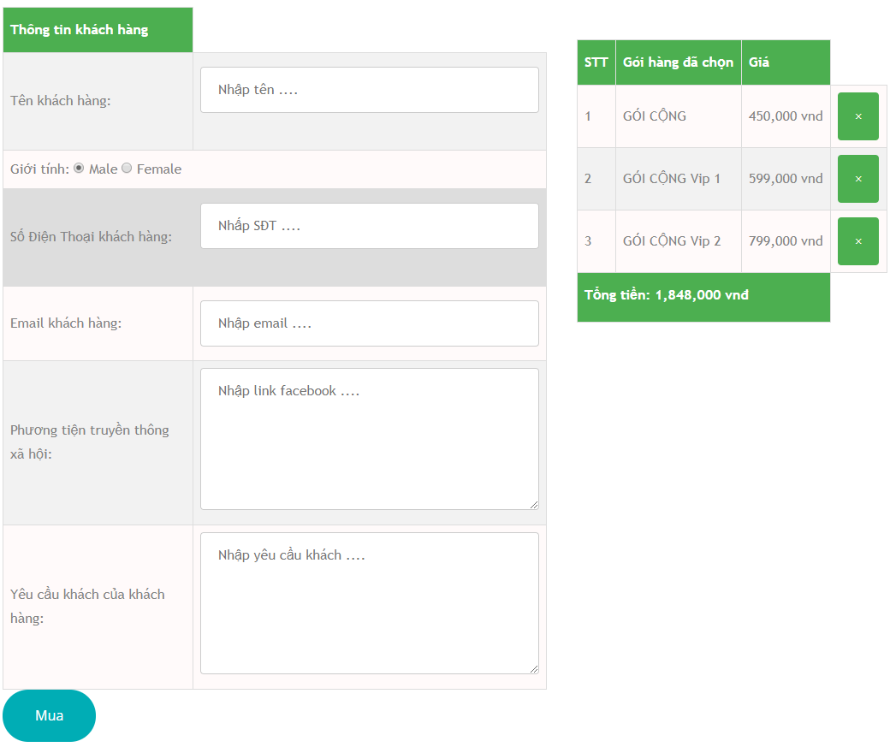

##### Class Diagram

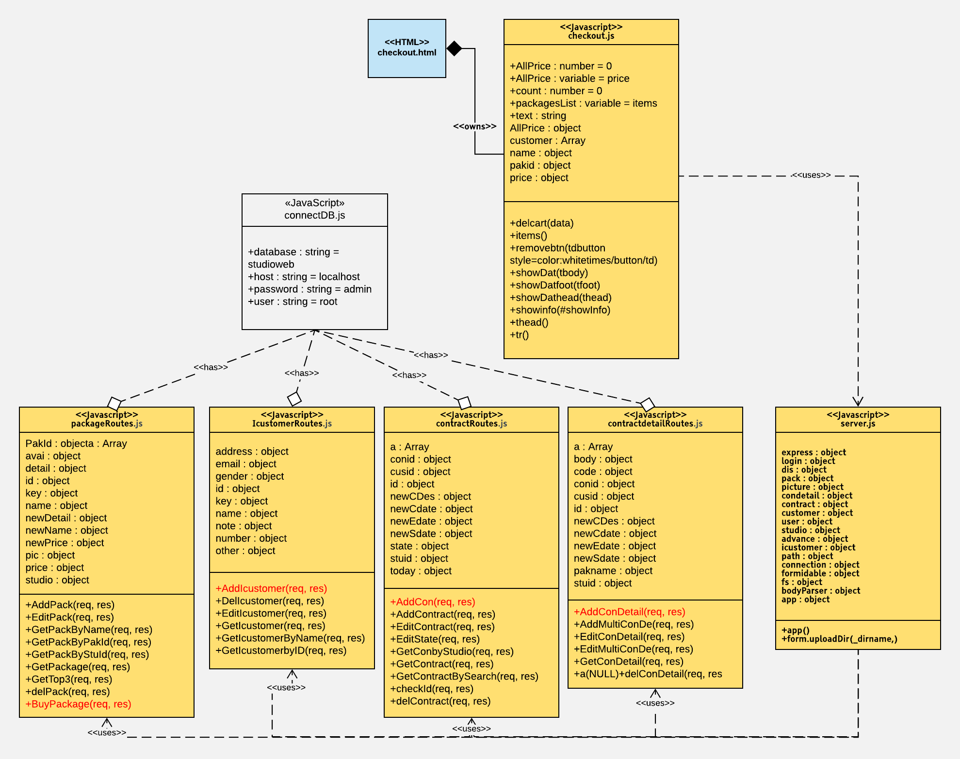

##### Class Specification

|  |  |  |  |  |
| --- | --- | --- | --- | --- |
| **Description** | Customer leave information and order for Manager to add contract action | | | |
| **Base Class** | Controller | | | |
| **Source File** | contractrouter.js, IcustommerRouter.js, contractdetailrouter.js, packageroutes.js | | | |
| **Namespace** | app/public/routes/ | | | |
| **Attributes** | **N/A** | | | |
| **Methods** | **Name** | **Input** | **Output** | **Description** |
| GetcustomByName | Request, result | View | Get Customer by Custummer Name |
|  | AddIcustomer | Request, result | View | Add new customer |
|  | AddContract | Request, result | View | Add new contract |
|  | AddMultiConDe | Request, result | View | Add new Contract Detail |
|  | BuyPackage | Request, result | View | After successful purchase, a new contract is created then it will send email to Customer about the detail of the contract |

##### Sequence Diagram

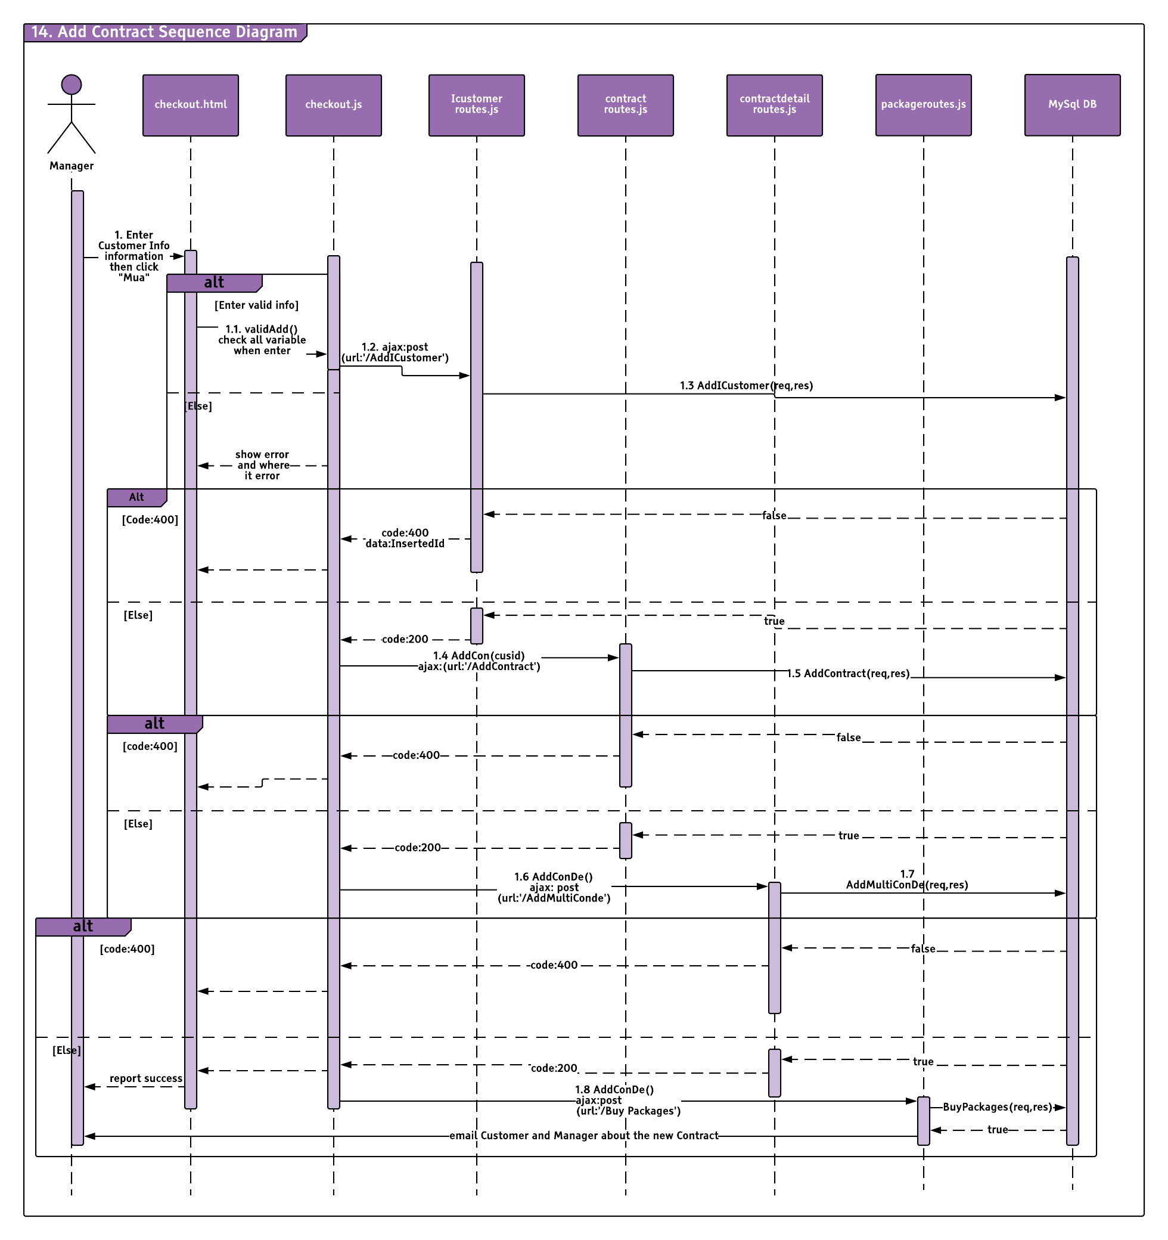

#### View Contract

##### Description

Customer can see and keep track of photo contract

##### Design

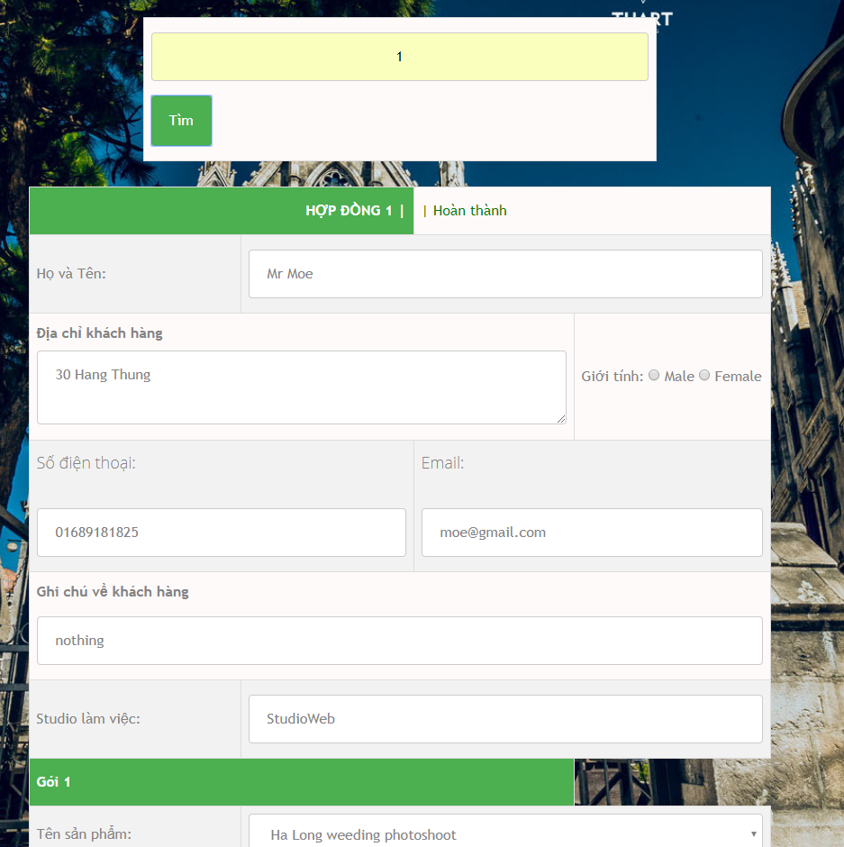

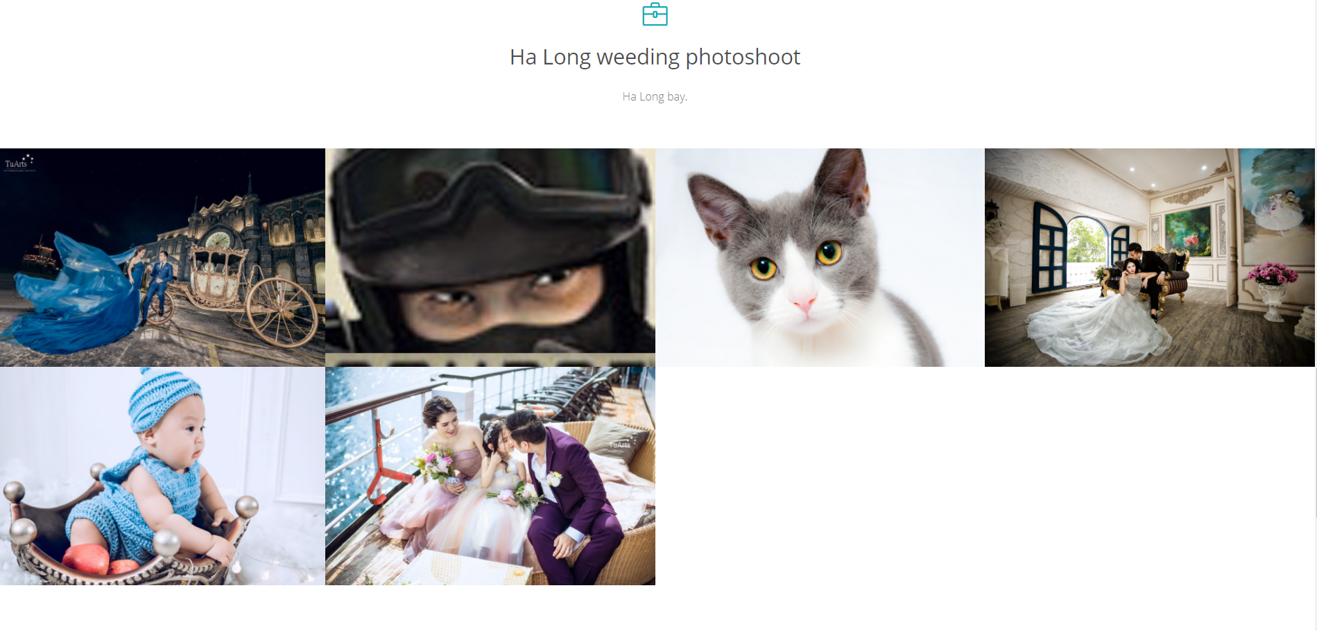

##### Class Diagram

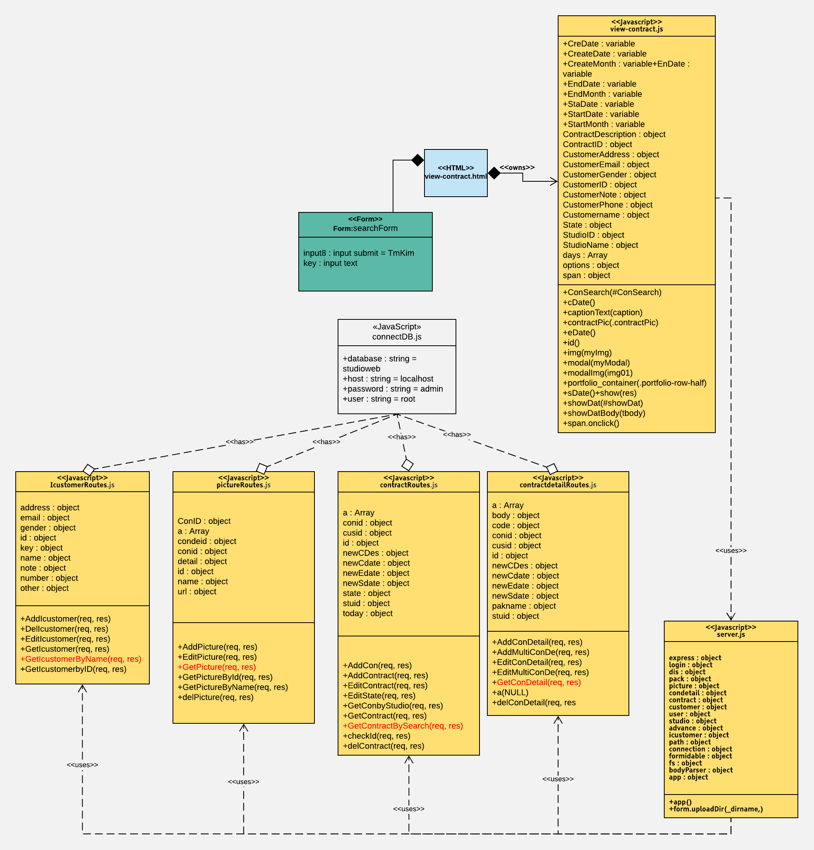

##### Class Specification

|  |  |  |  |  |
| --- | --- | --- | --- | --- |
| **Description** | Get contract related pictures to show | | | |
| **Base Class** | Controller | | | |
| **Source File** | PictureRoutes.js | | | |
| **Namespace** | app/public/routes/ | | | |
| **Attributes** | **N/A** | | | |
| **Methods** | **Name** | **Methods** | **Output** | **Description** |
| GetPicture | Request, result | view | Get all contract related pictures |

|  |  |  |  |  |
| --- | --- | --- | --- | --- |
| **Description** | Get Contract where customer enter contract ID | | | |
| **Base Class** | Controller | | | |
| **Source File** | contractRoutes.js | | | |
| **Namespace** | app/public/routes/ | | | |
| **Attributes** | **N/A** | | | |
| **Methods** | **Name** | **Methods** | **Output** | **Description** |
| GetContractBySearch | Request, result | view | Get entered contract info |

|  |  |  |  |  |
| --- | --- | --- | --- | --- |
| **Description** | Get all contract detail included in the customer contract | | | |
| **Base Class** | Controller | | | |
| **Source File** | contractdetailRoutes.js | | | |
| **Namespace** | app/public/routes/ | | | |
| **Attributes** | **N/A** | | | |
| **Methods** | **Name** | **Methods** | **Output** | **Description** |
| GetConDetail | Request, result | view | Get all detail of the contract |

##### Sequence Diagram

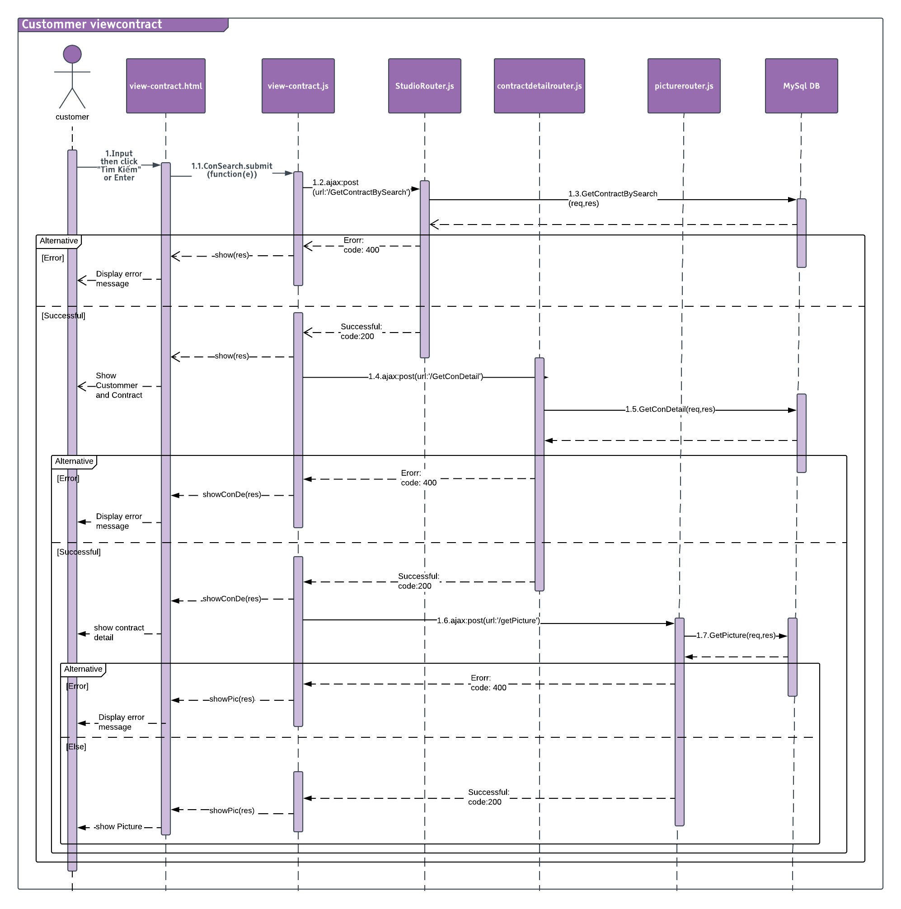

# SOFWARE TESTING ソフトウェアテスト

## Introduction　はじめに

### Purpose　目的

This is the comprehensive test plan of the Photographic Studio Management project. The purpose of this chapter describes scopes of test plan and activities which need to be taken during test process of project. It addresses the following items:

* Scope of Testing
* Requirement for Testing
* Test Strategy
* Test Resources
* Test Milestones
* Test Deliverables

### References　参照資料

| Title/File name | Author | Version |
| --- | --- | --- |
| PSM_UnitTestCases.xlxs | HuyNM | 1.0 |
| PSM_IntegrationTestCases.xlsx | DungPT | 1.0 |
| PSM_SystemTestCases.xlsx | DungPT | 1.0 |

### Background information　背景情報

The target of testing is ensured all functions will be run correctly. In addition, restrict maximum of defect during the using of Website. To do this target, Website have to:

* Pass all of the following stages of testing: Integration Testing, System Testing.
* Pass all of the following types of testing: Function Testing, User Interface Testing.
* Run normally in popular browser.

### Scope of testing　テスト範囲

The scope of test will be limited to testing on 3 browser: Google Chrome, Mozilla Firefox, Microsoft Edge.

## Constraints　制約事項

* Have more environments should be tested: Window XP, Window 8 … and more browsers: Chrome 53, Firefox, Microsoft Edge 38 …

### Risk listリスク一覧

|  |  |  |  |
| --- | --- | --- | --- |
| No | Risk | Mitigation | Contingencies |
|  | PC have problem during test | Fix a problem | Find a other PC |
|  | Tester may be sick in test phase or may leave the project before completion | + Discussing  + Committing  + Assigning tasks appropriately | + Persuading  + Reviewing and re-planning the whole project |
|  | Scope: SRS/SAD may be changed | + Discussing  + Reviewing the whole project frequently | + Re-planning test phase  + Re-creating test case |
|  | Time of Coding phase may last too long | + Committing  + Assigning tasks | Working over time |

Table 5.2.1 Risk list

## Requirements for Test　テスト要求

### Test items　テスト頭目

|  |  |  |  |
| --- | --- | --- | --- |
| No | Name of features and functions | Outline of features and functions | Note |
|  | Login | Sign in on PSM with admin or manager account. |  |
|  | Forgot Password to send request forgot password. |  |
|  |
|  |
|  |
|  |
|  | User Management  ( Admin Role ) | Search Manager of any Studio |  |
|  | Add Manager to any Studio |  |
|  | Edit Manager |  |
|  | Delete Manager |  |
|  | Studio Management  ( Admin Role ) | Search Studio |  |
|  | Add Studio |  |
|  | Edit Studio |  |
|  | Delete Studio |  |
|  | District Management  ( Admin Role ) | Search District |  |
|  | Add District |  |
|  | Edit District |  |
|  | Delete District |  |
|  | Studio Information  ( Manager Role ) | Edit Studio Infomation |  |
|  | Package Management  ( Manager Role ) | Search Package |  |
|  | Add Package |  |
|  | Edit Package |  |
|  | Picture Management  ( Manager Role ) | Search Picture |  |
|  | Add Picture |  |
|  | Edit Picture |  |
|  | Delete Picture |  |
|  | Upload Picture |  |
|  | Contract Management  ( Manager Role ) | Search Contract |  |
|  | Add Contract |  |
|  | Edit Contract |  |
|  | Edit Contract Detail |  |
|  | Delete Contract Detail |  |
|  | View Picture |  |
|  | Add Contract Detail |  |
|  | Edit Customer Information |  |
|  | Home Page  ( Customer ) | View Sample Picture |  |
|  | View About US |  |
|  | Studio List Page  ( Customer ) | View Information of Studio |  |
|  | Studio Detail Page  ( Customer ) | View Sample Picture |  |
|  | View Package |  |
|  | Add Package to Cart |  |
|  | Cart Page  ( Customer ) | Remove Package on Cart |  |
|  | Buy Package |  |
|  | Show Contract Code |  |
|  | Album Page  ( Customer ) | Show Sample Picture |  |
|  | Contract Page  ( Customer ) | Enter Contract Code |  |
|  | Show Contract |  |
|  | View Picture |  |

Table 5.3.1

## Test strategy　テスト戦略

### Test types テストタイプ

PSM will be tested by 3 level:

* **Level 1** : Unit testing

- Unit Testing will be done by developers.

- Testing all individual implemented methods, functions of XXXService.js files.

- Implemented function’s error message and database error message will be included in this test.

- When executing Unit Testing, if any bugs are fined, developers have to log bug on “Defect Log” file and fix it until it is correct.

Rule for filling test result:

|  |  |
| --- | --- |
| Test result pass | Pass |
| Test result fail | Fail |
| Do not test | Untested |
| Cannot test | N/A (Not available) |

* **Level 2** : Integration testing
* After finishing component testing, integration testing will be performed by testers.
* Material are integration test cases, high- level design and test tools.
* Integration test focuses on specific areas of use cases when all requirements are completed.
* Integration test should be performed to ensure all components incorporate well.

*Rule for filling test result:*

|  |  |
| --- | --- |
| Test result pass | Pass |
| Test result fail | Fail |
| Do not test | Untested |
| Cannot test | N/A (Not available) |

* **Level 3**: System testing
* After finishing integration testing and developers collect all functions and items, testers will be performed system testing, it means doing test whole system.
* If any bugs are found, developers have to fix and testers will verify them. System test is ended only when test cases are passed and no bug is found.

*Rule for filling test result:*

|  |  |
| --- | --- |
| Test result pass | Pass |
| Test result fail | Fail |
| Do not test | Untested |
| Cannot test | N/A (Not available) |

### Function Testing　機能テスト

* Function Testing is a type of software testing whereby the system is tested against the functional requirements/ specifications.
* Functions are tested by feeding them input and examining the output. Functional testing ensures that the requirements are properly satisfied by application. This type of testing is not concerned with how processing occurs, but rather, with results of processing.

|  |  |
| --- | --- |
| Test Objective: | Ensure proper target-of-test functionality, including navigation, data entry, processing, and retrieval. |
| Technique: | Execute each use case, use-case flow, or function, using valid and invalid data, to verify the following:  -    The expected results occur when valid data is used.  -    The appropriate error or warning messages are displayed when invalid data is used.  -    Each business rule is properly applied.  - Use Test tool |
| Completion Criteria: | -   All planned tests have been executed.  -     All identified defects have been addressed and closed |
| Special Considerations: | Identify or describe those items or issues (internal or external) that impact the implementation and execution of function test |

Table 5.4.3 Function Testing

### User Interface Testing　ユーザーインターフェーステスト

* User interface testing, a testing technique used to identify the presence of defects is a product/software under test by using GUI.
* GUI testing evaluates design elements such as layout, colors, [fonts](http://whatis.techtarget.com/definition/font), font sizes, labels, text boxes, text formatting, captions, buttons, lists, icons, links and content.

|  |  |
| --- | --- |
| Test Objective: | Verify the following:  Navigation through the target-of-test properly reflects business functions and requirements, including window-to-window, field-to-field, and use of access methods (tab keys, mouse movements, accelerator keys)  Window objects and characteristics, such as menus, size, position, state, and focus conform to standards. |
| Technique: | Create or modify tests for each window to verify proper navigation and object states for each application window and objects. |
| Completion Criteria: | Each window successfully verified to remain consistent with benchmark version or within acceptable standard. |
| Special Considerations: | Not all properties for custom and third party objects can be accessed. |

Table 5.4.4 User Interface Testing

### Test stages　テストステージ

| Type of Tests | Stage of Test | | |
| --- | --- | --- | --- |
| Unit Test | Integration Test | System Test |
| Function Test | X | X | X |
| User Interface Test | X |  | X |

Table 5.4.6 Test Stages

## Resource　リソース

### Human Resource　人的リソース

|  |  |  |  |
| --- | --- | --- | --- |
| Worker/Doer | Role | Specific Responsibilities/Comments | Location |
| DungPT | Test leader | Write Test Case, Test Report , Check bug | FPT University Vietnam |
| TrungNH | Tester | Fix Bug | FPT University Vietnam |
| VuCL | Tester | Fix Bug | FPT University Vietnam |

Table 5.5.1 Human Resource

### Test management　テスト管理

Test management is practice of organizing and controlling the process and artifacts required for testing effort.

The general goal of test management is to allow teams to plan, develop, execute, and assess all testing activities within the overall software development effort. This includes coordinating efforts of all those involved in the testing effort, tracking dependencies and relationships among test assets and, most importantly, defining, measuring, and tracking quality goals.

* **Test planning** is the overall set of tasks that address the questions of why, what, where, and when to test. The reason why a given test is created is called a test motivator (for example, a specific requirement must be validated). What should be tested is broken down into many test cases for a project. Where to test is answered by determining and documenting the needed software and hardware configurations. When to test is resolved by tracking iterations (or cycles, or time period) to the testing.
* **Test authoring** is a process of capturing the specific steps required to complete a given test. This addresses the question of how something will be tested. This is where somewhat abstract test cases are developed into more detailed test steps, which in turn will become test scripts (either manual or automated).
* **Test execution** entails running the tests by assembling sequences of test scripts into a suite of tests. This is a continuation of answering the question of how something will be tested (more specifically, how the testing will be conducted).
* **Test reporting** is how the various results of the testing effort are analyzed and communicated. This is used to determine the current status of project testing, as well as the overall level of quality of the application or system.

### Defect management　欠陥管理

Defect management is crucial to closing the loop between requirements, implementation and verification and validation. Traditional defect tracking management, implemented in a standalone fashion, can no longer address the complexity and pace of change in modern software development. Defect management processes must be tightly interlinked with all of the other software development processes. The defect management process contains the following elements:

* **Defect Discovery** – Identification and reporting of potential defects. The defect tracking software must be simple enough so that people will use it, but ensure that the minimum necessary information is captured. The information captured here should be enough to reproduce the defect and allow development to determine root cause and impact.
* **Defect Analysis & Prioritization** – The development team determines if the defect report corresponds to an actual defect, if the defect has already been reported, and what the impact and priority of the defect is. Prioritization and scheduling of the defect resolution is often part of the overall change management process for the software development organization.
* **Defect Resolution –** Here the development team determines the root cause, implements the changes needed to fix the defect, and documents the details of the resolution in the defect management software, including suggestions on how to verify the defect is fixed. In organizations using [Software Product Lines](http://www.mks.com/challenges/product-lines) approaches, or other shared component approaches, defect resolution may need to be coordinated across multiple branches of development.
* **Defect Verification** – The build containing the resolution to the defect is identified, and testing of the build is performed to ensure the defect truly has been resolved, and that the resolution has not introduced side effects or regressions. Once all affected branches of development have been verified as resolved, the defect can be closed.
* **Defect Communication** – This encompasses automatic generation of defect metrics for management reporting and process improvement purposes, as well as visibility into the presence and status of defects across all disciplines of the software development team.

## Test environment　たテスト環境

|  |  |  |
| --- | --- | --- |
| **Type of testing** | **Software** | **Hardware** |
| System test | * Microsoft Office Excel 2007. * Chrome Version 59.0.3071.115 | Personal computer for developing with the minimum configuration:   * Windows 7 Professional 32-bit * Intel® Core™ i5 * Installed memory (RAM): 4.00GB |
| Unit testing | * Chaijs v3.5.0 * Mocha v2.4.5 | Personal computer for developing with the minimum configuration:   * MacOS High Sierra * 2.5GHz Intel Core i5 * Installed memory (RAM): 4.00GB |

Table 5.6: Test environment

## Test Milestones　テストマイルストーン

|  |  |  |
| --- | --- | --- |
| Milestone Task | Start Date | End Date |
| Create Test Plan | 10/02/2018 | 02/04/2018 |
| Review & update TP | 05/03/2018 | 02/04/2018 |
| Create Unit Test | 07/03/2018 | 02/04/2018 |
| Review & Update Unit Test | 09/03/2018 | 02/04/2018 |
| Create Integration Test case | 14/03/2018 | 02/04/2018 |
| Review & Update Integration TC | 20/03/2018 | 02/04/2018 |
| Create System Test case | 27/03/2018 | 02/04/2018 |
| Review & Update System TC | 01/04/2018 | 02/04/2018 |

Table 5.7 Test Milestones

## Deliverables　納品物

| No | Deliverables | Responsibilities | Delivered Date |
| --- | --- | --- | --- |
|  | Test Plan | DungPT,HuyNM | 10/02/2018 |
|  | Unit Test Cases | HuyNM | 07/03/2018 |
|  | Integration Test Cases | DungPT | 14/03/2018 |
|  | System Test cases | DungPT | 30/03/2018 |
|  | Test reports | DungPT,HuyNM | 02/04/2018 |

Table 5.8 Deliverables

## Test Case　テストケース

Refer to:

* PSM_Unit TestCase_v1.0. xlxs
  + PSM_IntegrationTestCase_v1.0.xlsx
  + PSM _SystemTestCase_v1.0.xlsx

Sample Test Cases :

* **Login Page Test Cases** :

|  |  |  |  |  |  |  |  |  |
| --- | --- | --- | --- | --- | --- | --- | --- | --- |
| **Test case id** | **Test cases** | **Priority** | **Preconditions** | **Input test data** | **Steps to be executed** | **Expected results** | **Pass / Fail /  Untested / Cannot test** | **Comments** |
| 1 | Test if user is able to login successfully. | A | User must be registered already | Correct ID Correct Password | 1. Enter correct ID and Password  2. Click Submit button | User must successfully login to the web page | Pass |  |
| 2 | Test if unregistered users is not able to login to the site | A |  | Incorrect ID Incorrect Password | 1. Enter incorrect ID and Password  2. Click Submit button | Proper error must be displayed and prompt to enter login again | Pass |  |
| 3 | Test with valid ID and empty Password field | B | User must be registered already | Valid ID Empty Password field | 1. Enter the valid ID and empty Password field   2. Click Submit button | Proper error must be displayed and prompt to enter login again | Pass |  |
| 4 | Test with empty ID field and valid Password field | B | User must be registered already | Empty ID field Valid Password | 1. Empty ID field.  2. Enter valid Password.  3. Click Submit button. | Proper error must be displayed and prompt to enter login again | Pass |  |
| 5 | Test with empty ID field and empty Password field | A |  |  | 1. Empty ID and Password field.  2. Click Submit button | Proper error must be displayed and prompt to enter login again | Pass |  |
| 6 | Check of the Password is masked on the screen i.e., Password must be in bullets or asterisks | B |  |  | 1. Enter anything in Password field. | The Password field should display the characters in asterisks or bullets such that the Password is not visible | Pass |  |
| 7 | After logging in try to copy/cut the Password and paste it on another screen(Passwords are usually in * such that its not visible on the screen) | B |  |  | 1. Enter ID and Password in the respective fields. Copy the Password field's content (which is in *s)  2. Paste the content on another screen | Password shouldn’t get pasted / Password should not be visible on the screen | Pass |  |
| 9 | Test if user is able to send forgot password request. | A | Exist user name and Studio mail | Enter exist user name and Studio mail | 1. Enter exist user name and Studio mail  2. Click Forgot Password button | User request must be send and successful notification  must be displayed | Pass |  |
| 10 | Test with empty User Name and empty Studio mail | A |  |  | 1. Empty user name and Studio mail  2. Click Forgot Password button | Proper error must be displayed and prompt to input again | Pass |  |
| 11 | Test with empty User Name and Correct Studio mail | A |  |  | 1. Empty user name  2. Enter Correct Studio mail   3. Click Forgot Password button | Proper error must be displayed and prompt to input again | Pass |  |
| 12 | Test with correct User Name and empty Studio mail | A |  |  | 1. Enter Correct user name  2. Empty Studio mail field  3. Click Forgot Password button | Proper error must be displayed and prompt to input again | Pass |  |

* **User Management Test Cases** :

|  |  |  |  |  |  |  |  |  |
| --- | --- | --- | --- | --- | --- | --- | --- | --- |
| **Test case id** | **Test cases** | **Priority** | **Preconditions** | **Input test data** | **Steps to be executed** | **Expected results** | **Pass/Pass** | **Comments** |
| 13 | Test if user is able to search successfully. | A |  |  | 1. Click search button | All User Management  must be display | Pass |  |
| 14 | Test with a part of  correct User Name. | B | User must have user account  already | A part of user  name | 1. Enter a part of user  name on search field.  2. Click search button | Just display user  have User Name like  search value | Pass |  |
| 15 | Test with correct user name. | A | User must have user account  already | Correct User Name | 1. Enter correct user  name on search field.  2. Click search button | Just display user  have User Name like  search value | Pass |  |
| 16 | Test with character  not match with any  User Name. | A |  | Character  not match with any User Name | 1. Enter character  not match with any  User Name on search field.  2. Click search button | Proper error must be displayed | Pass |  |
| 17 | Test Add User hyperlink. | A |  |  | 1. Click on Add User hyperlink. | Add User form must be display. | Pass |  |
| 18 | Test Show All hyperlink. | B |  |  | 1. Click one Show All hyperlink. |  | Pass |  |
| 19 | Test if user is able to add user successfully. | A |  | Enter Valid data all field and  Select one Studio | 1. Enter Valid data on all field.  2. Choose one Studio.  3. Click add button | User must be added  and successful notification  must be displayed | Pass | Valid data is : User Name : Not special character , Not empty, In range 6 ~ 32 character Password : In range 6 ~ 32 character, Not empty. Studio : Must be select |
| 20 | Test if empty User Name and valid all other field. | B |  | Empty User Name, valid all other field Select one Studio | 1. Empty User Name.  2. Enter valid Password.  3. Click add button. | Proper error must be displayed and prompt to enter add again | Pass | Valid data is : User Name : Not special character , Not empty, In range 6 ~ 32 character Password : In range 6 ~ 32 character, Not empty. Studio : Must be select |
| 21 | Test if User Name have special character and valid all other field. | B |  | Enter User Name have special character. Valid all other field. Select one Studio | 1. Enter User Name have special character.  2. Enter valid all other field.  3. Select one user role.  4. Click add button. | Proper error must be displayed and prompt to enter add again | Pass | Valid data is : User Name : Not special character , Not empty, In range 6 ~ 32 character Password : In range 6 ~ 32 character, Not empty. Studio : Must be select |
| 22 | Test if User Name less than 6 character and valid all other field. | B |  | Enter User Name less than 6 character. Valid all other field. Select one Studio Select one user role. | 1. Enter User Name less than 6 character.  2. Enter valid all other field.  3. Click add button. | Proper error must be displayed and prompt to enter add again | Pass | Valid data is : User Name : Not special character , Not empty, In range 6 ~ 32 character Password : In range 6 ~ 32 character, Not empty. Studio : Must be select |
| 23 | Test if User Name more than 32 character and valid all other field. | B |  | Enter User Name more than 32 character. Valid all other field. Select one Studio | 1. Enter User Name more than 32 character.  2. Enter valid all other field.  3. Click add button. | Proper error must be displayed and prompt to enter add again | Pass | Valid data is : User Name : Not special character , Not empty, In range 6 ~ 32 character Password : In range 6 ~ 32 character, Not empty. Studio : Must be select |
| 24 | Test if empty Password and valid all other field. | B |  | Empty Password , valid User Name Select one Studio Select one user role | 1. Empty Password.  2. Enter valid User Name.  3. Click add button. | Proper error must be displayed and prompt to enter add again | Pass | Valid data is : User Name : Not special character , Not empty, In range 6 ~ 32 character Password : In range 6 ~ 32 character, Not empty. Studio : Must be select |
| 25 | Test if Password less than 6 character and valid all other field. | B |  | Enter Password less than 6 character. Valid all other field. Select one Studio | 1. Enter Password less than 6 character.   2. Enter valid all other field.  3. Click add button. | Proper error must be displayed and prompt to enter add again | Pass | Valid data is : User Name : Not special character , Not empty, In range 6 ~ 32 character Password : In range 6 ~ 32 character, Not empty. Studio : Must be select |
| 26 | Test if Password more than 32 character and valid all other field. | B |  | Enter Password more than 32 character.  Valid all other field. Select one Studio | 1. Enter Password more than 32 character.  2. Enter valid all other field.  3. Select one user role.  4. Click add button. | Proper error must be displayed and prompt to enter add again | Pass | Valid data is : User Name : Not special character , Not empty, In range 6 ~ 32 character Password : In range 6 ~ 32 character, Not empty. Studio : Must be select |
| 27 | Test if not selected Studio and valid all other field | B |  | Valid all field but not selected Studio | 1. Enter Valid data on all field but not selected Studio.  2. Click add button. | Proper error must be displayed and prompt to enter add again | Pass | Valid data is : User Name : Not special character , Not empty, In range 6 ~ 32 character Password : In range 6 ~ 32 character, Not empty. Studio : Must be select |
| 28 | Test reset button | A |  | Enter value in any field | 1. Enter value in any field.  2. Click reset button. | All field should be clear | Pass |  |
| 29 | Test delete button | A |  |  | 1. Click delete button. | Confirm notification must be displayed. If admin click OK button that user will be delete | Pass |  |
| 30 | Test edit button | A |  | Click edit button | 1. Click Edit button. | Edit user form should be visible, all field should have old data, User Name must can not change | Pass | All field have old data User Name is read only |
| 31 | Test if empty Password field. Studio is selected. | B |  | Empty Password , Select one Studio | 1. Empty Password.  2. Select one Studio.  3. Click edit button. | Proper error must be displayed and prompt to enter edit again | Pass |  |
| 32 | Test if Password less than 6 character. Studio is selected. | B |  | Enter Password less than 6 character, Select one Studio | 1. Enter Password less than 6 character.  2. Select one Studio.  3. Click edit button. | Proper error must be displayed and prompt to enter edit again | Pass | Valid data is : User Name : Not special character , Not empty, In range 6 ~ 32 character Password : In range 6 ~ 32 character, Not empty. Studio : Must be select |
| 33 | Test if Password more than 32 character. Studio is selected. | B |  | Enter Password more than 32 character, Select one Studio | 1. Enter Password more than 32 character.  2. Select one Studio.  3. Click edit button. | Proper error must be displayed and prompt to enter edit again | Pass | Valid data is : User Name : Not special character , Not empty, In range 6 ~ 32 character Password : In range 6 ~ 32 character, Not empty. Studio : Must be select |
| 34 | Test if user is able to edit successfully. | A |  | Valid data, Select Studio. | 1. Enter valid in all field and select Studio.  2. Click edit button. | User must be edited  and successful notification  must be displayed | Pass | Valid data is : User Name : Not special character , Not empty, In range 6 ~ 32 character Password : In range 6 ~ 32 character, Not empty. Studio : Must be select |

## Test Report　テストレポート

### Unit Test Report

|  |  |  |  |  |  |  |
| --- | --- | --- | --- | --- | --- | --- |
| **No** | **Module code** | **Pass** | **Fail** | **Untested** | **N/A** | **Number of test cases** |
|  | Login Page | 1 | 0 | 0 | 0 | 1 |
|  | Forgot Password | 1 | 0 | 0 | 0 | 1 |
|  | User Management | 1 | 0 | 0 | 0 | 1 |
|  | Studio Management | 1 | 0 | 0 | 0 | 1 |
|  | District Management | 1 | 0 | 0 | 0 | 1 |
|  | Studio Profile | 1 | 0 | 0 | 0 | 1 |
|  | Package Management | 1 | 0 | 0 | 0 | 1 |
|  | Picture Management | 1 | 0 | 0 | 0 | 1 |
|  | Contract Management | 1 | 0 | 0 | 0 | 1 |
|  | Studio Page | 1 | 0 | 0 | 0 | 1 |
|  | **Sub total** | 10 | 0 | 0 | 0 | 10 |

### Integration Test Report　統合テストレポート

|  |  |  |  |  |  |  |
| --- | --- | --- | --- | --- | --- | --- |
| **No** | **Module code** | **Pass** | **Fail** | **Untested** | **N/A** | **Number of**  **test cases** |
|  | Login Page | 12 | 0 | 0 | 0 | 12 |
|  | User Management | 22 | 0 | 0 | 0 | 22 |
|  | Studio Management | 46 | 0 | 0 | 0 | 46 |
|  | District Management | 9 | 0 | 0 | 0 | 9 |
|  | Manager Login | 4 | 0 | 0 | 0 | 5 |
|  | Studio Profile | 14 | 0 | 0 | 0 | 28 |
|  | Package Management | 17 | 0 | 0 | 0 | 26 |
|  | Contract Management | 75 | 3 | 0 | 0 | 94 |
|  | Picture Management | 16 | 0 | 0 | 0 | 16 |
|  | Home Page | 11 | 0 | 4 | 0 | 15 |
|  | Studio List Page | 5 | 0 | 0 | 0 | 5 |
|  | Studio Detail Page | 8 | 0 | 0 | 0 | 8 |
|  | Cart Page | 10 | 0 | 0 | 0 | 12 |
|  | Contract Page | 4 | 0 | 0 | 0 | 4 |
|  | Album Page | 0 | 0 | 1 | 0 | 1 |
|  | **Sub total** | 261 | 3 | 5 | 0 | 261 |

### System Test Report　システムテストレポート

|  |  |  |  |  |  |  |
| --- | --- | --- | --- | --- | --- | --- |
| **No** | **Module code** | **Pass** | **Fail** | **Untested** | **N/A** | **Number of test cases** |
|  | Login Page | 7 | 0 | 0 | 0 | 7 |
|  | Forgot Password | 7 | 0 | 0 | 0 | 7 |
|  | User Management | 11 | 0 | 0 | 0 | 11 |
|  | Studio Management | 12 | 0 | 0 | 0 | 12 |
|  | District Management | 6 | 0 | 0 | 0 | 6 |
|  | Studio Profile | 3 | 0 | 0 | 0 | 3 |
|  | Package Management | 10 | 0 | 0 | 0 | 10 |
|  | Picture Management | 10 | 0 | 0 | 0 | 10 |
|  | Contract Management | 19 | 0 | 0 | 0 | 19 |
|  | Studio Page | 13 | 0 | 1 | 0 | 14 |
|  | **Sub total** | 99 | 0 | 1 | 0 | 99 |

### Test Report　テストレポート

|  |  |  |  |  |
| --- | --- | --- | --- | --- |
| **P** | Pass | Fail | Untested | N/A |
| **Unit Test** | 10 | 0 | 0 | 0 |
| **Integration Test** | 261 | 6 | 5 | 0 |
| **System Test** | 99 | 0 | 1 | 0 |
| **Total** | **370** | **6** | **6** | **0** |

Table 5.10.7

# USER MANUAL　ユーザーマニュアル

## Home Page /ホームページ

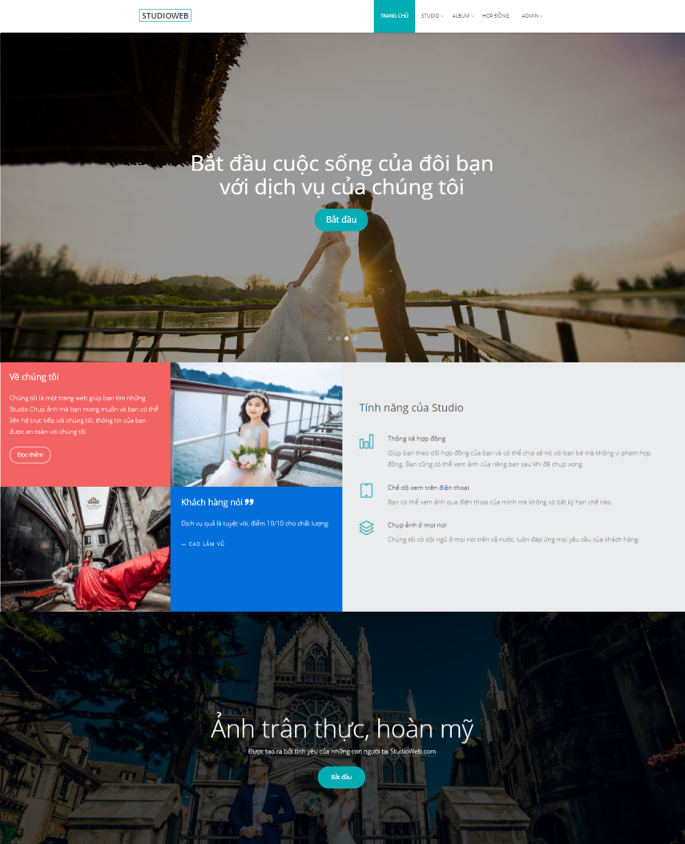

## Admin Guidelines /管理者ガイドライン

### Login/**ログイン**

*Step 1*: Click “Đăng nhập “on header in Home Page. System will display the Login page.

ホームページのヘッダーにある“Đăng nhập”をクリックします。 ログインページが表示されます。

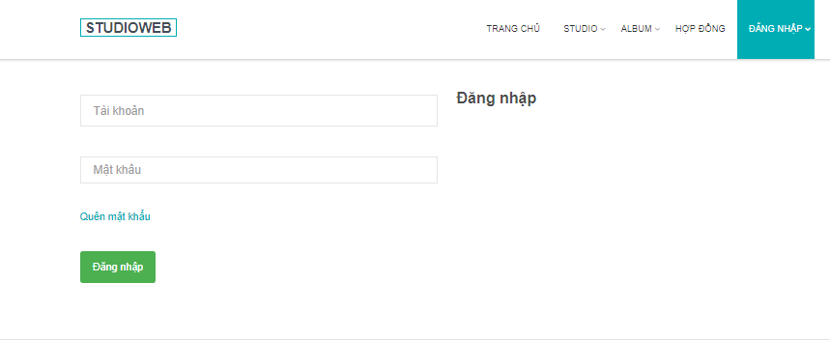

*Step 2*: Enter login credentials and click “Đăng nhập “to log in.

ログイン資格情報を入力して “ログインのために”Đăng Nhập “をクリックします。

### Log out /ログアウト

*Step 1*: Click “Đăng xuất “in the top right corner.

右上隅にある “Đăng xuất “をクリックします。

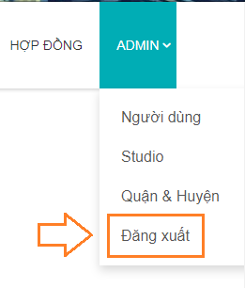

### Admin Manager /管理者マネージャ

After login successfully with admin, account admin will be display.

管理者とのログインに成功すると、管理者アカウントが表示されます。

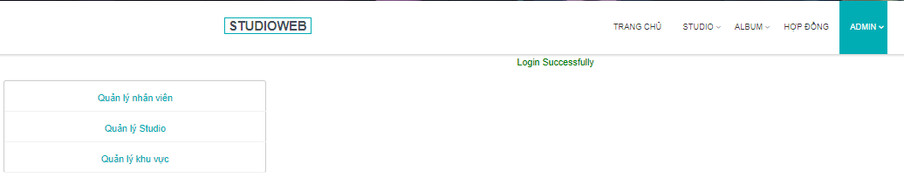

### List Manager /リストマネージャー

Click “Quản lý nhân viên “link to open List Manager page.

リストマネージャーページ‐を開くために “Quản lý nhân viên “というリンクをクリックします。

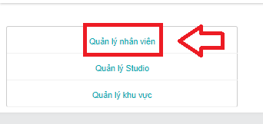

### Search Manager /検索マネージャ

*Option 1:*

オプション1 :

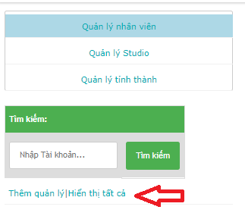

Click “Hiển thị tất cả “link to display all Manager.

すべてのマネージャを表示するには、 “Hiển thị tất cả “ をクリックします。

*Option 2:*

オプション2：

*Step 1:* Empty Search field.

ステップ1 : 空の検索フィールド。

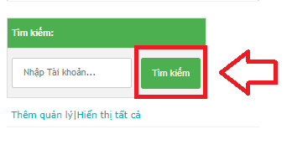

*Step 2:* Click “Tìm Kiếm “ button. All Managers will be display.

ステップ 2: “Tìm Kiếm “というボタンをクリックします。すべてのマネージャーが表示されます。

*Option 3*:

オプション3:

*Step 1:* Enter correct “Tài khoản “or a part of “Tài khoản “in Search text field.

ステップ 1: 検索テキストフィールドに正確な “Tài khoản “または “Tài khoản “の一部を入力します。

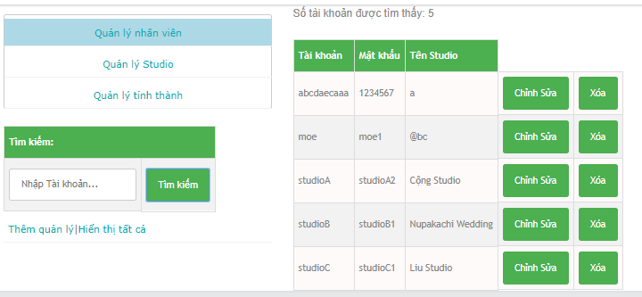

*Step 2:* Click button “Tìm Kiếm “. All Managers have “Tài Khoản “like search value will be display.

ステップ 2:。 “Tìm Kiếm “.というボタンをクリックします。検索している価値と同じような “Tài Khoản “があるすべてのマネージャーが表示されます。

### **Edit Manager /編集マネージャ**

*Step 1:* Click “Chỉnh sửa “button. “Chỉnh sửa quản lý “form will be display.

ステップ 1: “Chỉnh sửa “ボタンをクリックします。 “Chỉnh sửa quản lý “フォームが表示されます。

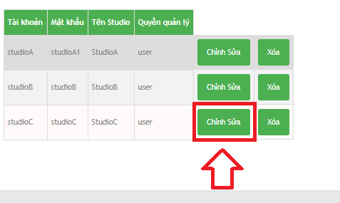

*Step 2:* Enter new Password on “Mật khẩu “field.

ステップ 2: “Mật khẩu “フィールドに新しいパスワードを入力します。

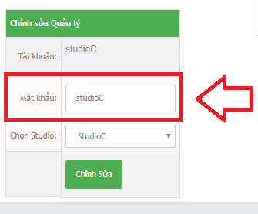

* New Password rules : /新しいパスワードルール：
  + In range 6 ~ 32 character. / 6字から32文字まで。
  + Not empty. /空ではありません。
  + Can contain special character (!@#$%^&*). /特殊文字（！@＃$％^＆*）を含むことができます。

*Step 3:* Select Studio.

ステップ 3: スタジオを選択します。

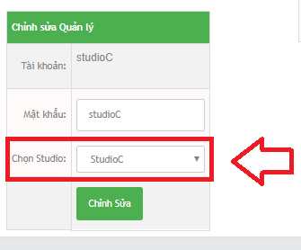

*Step 4:* Click “Chỉnh sửa “button.

ステップ 4: “Chỉnh sửa “というボタンをクリックします。

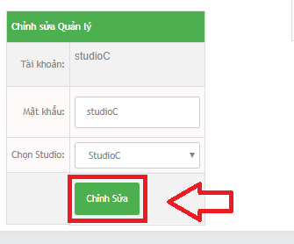

### **Delete Manager /マネージャを削除**

*Step 1:* Click “Xóa “ button.

ステップ 1: “Xóa “というボタンをクリックします。

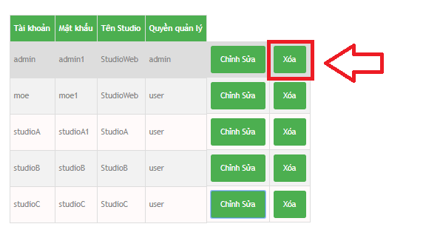

*Step 2:* Click OK button on confirm window.

ステップ 2: “Xóa “というボタンをクリックします。

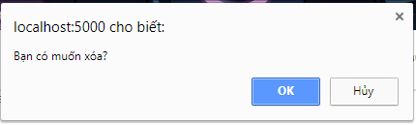

4. Add Manager /マネージャを追加

Click “Thêm quản lý “link to open “Thêm người quản lý “form.

“Thêm người quản lý “フォームを開くために “Thêm quản lý “をリンクをクリックして、。

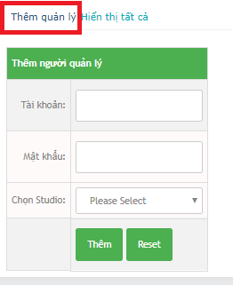

*Step 1:* Enter new Manager Account on “Tài khoản “field.

ステップ 1: “Tài khoản “フィールドに 新しい管理者アカウントを入力します。

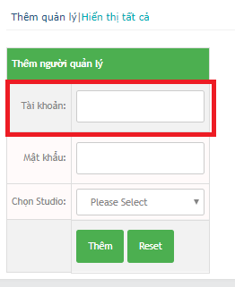

* New Manager Account rules : / 新しいマネージャアカウントルール：
  + Not special character. /特殊文字ではありません。
  + Not empty. /空ではありません。
  + In range 6 ~ 32 character. /範囲は6〜32文字です。

*Step 2:* Enter new Password in “Mật khẩu “field.

ステップ 2: “Mậtkhẩu “フィールドに新しいパスワードを入力します。

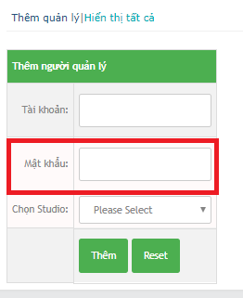

* New Password rules : / 新しいパスワードルール:
  + In range 6 ~ 32 character. 範囲は6〜32文字です。
  + Not empty. 空ではありません。
  + Can contain special character (!@#$%^&*).特殊文字（！@＃$％^＆*）を含むことができます。

*Step 3:* **Select Studio.**

ステップ 3: **スタジオを選択**

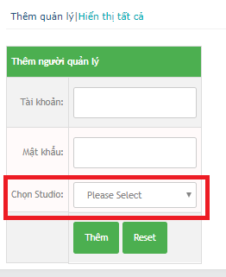

*Step 4:* Click “Thêm “button.

ステップ 4: “Thêm “というボタンをクリックします。

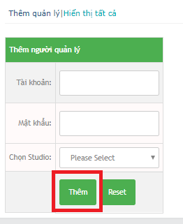

Reset button to clear all field.

すべてのフィールドをクリアするするためにリセットボタンをクリック。

### Studio Manager. /スタジオマネージャー。

Click “Quản lý Studio “link to open Studio Manager form.

スタジオマネージャーフォームを開くには、 “Quản lý Studio “リンクをクリックします。

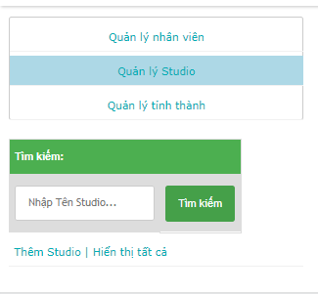

### Search Studio /スタヂオを検索します。

Option 1:

オプション 1:

Click “Hiển thị tất cả “link to display all Studio.

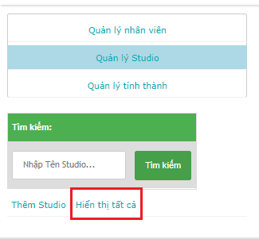

Option 2:

オプション 2:

*Step 1:* Empty Search field.

ステップ 1: 空の検索フィールド。

*Step 2:* Click “Tìm kiếm “button. All Studios will be display

ステップ 2: “Tìm kiếm “ボタンをクリックします。 すべてのスタジオが表示されます

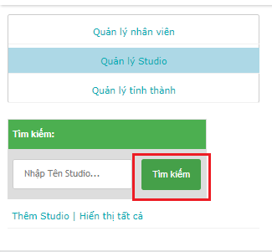

Option 3:

オプション 3:

*Step 1:* Enter correct or a part of “Tên Studio “.

ステップ 1: “Tên Studio “の一部または全部を入力します。

*Step 2:* Click “Tìm kiếm “button. All Studio have “Tên Studio “like search value will be display.

ステップ 2: “Tìm kiếm “ボタンをクリックします。 すべてのスタジオに “Tên Studio “という検索値が表示されます。

### Show Studio location/スタジオロケーションを表示。

Click “Tọa độ Studio “link to open Studio location on Google Map page.

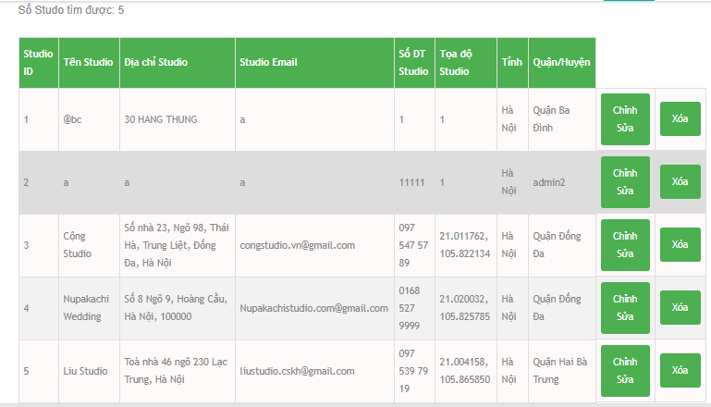Googleマップページでスタジオの場所を開くには “Tọa độ Studio “リンクをクリック、

### Edit Studio / スタヂオの編集

*Step 1:* Click “Chỉnh sửa “button to open “Chỉnh sửa Studio “form.

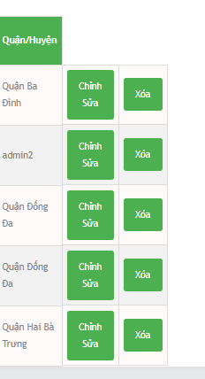 ステップ 1： “Chỉnh sửa Studio “フォームを開くには “Chỉnh sửa “ボタンをクリック。

*Step 2:* Enter new Studio Name on “Tên Studio “field.

ステップ 2: “Tên Studio “欄に新しいスタジオ名を入力します。

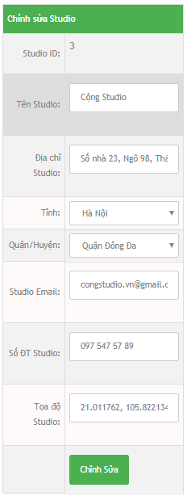

* New Studio Name rules : “Tên Studio “欄に新しいスタジオ名を入力してください。
  + Not empty. 空ではありません。
  + In range 6 ~ 32 character. 範囲は6〜32文字です。

*Step 3:* Enter new Studio Adress on “Địa chỉ Studio “field.

ステップ 3： “Địa chỉ Studio “欄に新しいスタジオアドレスを入力します。

* New Studio Adress rules : 新しいスタジオアドレスのルール：
  + Not empty. 空ではありません。
  + In range 6 ~ 32 character. 範囲は6〜32文字です。

*Step 4:* Select “Tỉnh “.

ステップ 4： “Tỉnh “を選択します。

*Step 5:* Select “Quận / Huyện “.

ステップ 5 ： “ “Quận / Huyện “を選択します。

Step 6 : Enter new Studio Email on Studio Email field.

ステップ 6

* New Studio Email rules :
  + Correct form.(abc@abc.abc)
  + Not empty. 空ではありません。
  + Just allow “@ “, “. “character.
  + In range 6 ~ 32 character.

Step 7 : Enter new Studio Number on “Số ĐT Studio “filed.

ステップ 7

* New Studio Number rules :
  + Must be number.
  + Not empty. 空ではありません。
  + In range 10 ~ 12 character.

Step 8 : Enter new Studio Coordinate on “Tọa độ Studio “field.

ステップ 8

* New Studio Coordinate rules :
  + Not empty. 空ではありません。
  + Correct form. (Float number , Float number).

Step 9 : Click “Chỉnh Sửa “button.

ステップ 9

### Delete Studio.

*Step 1:* Click “Xóa “button.

ステップ 1:

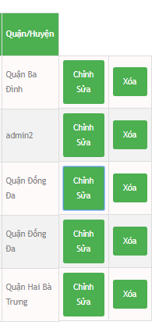

*Step 2:* Click OK button on confirm window.

ステップ 2:

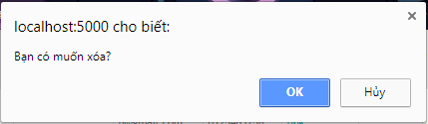

### Add Studio

*Step 1:* Click “Thêm Studio “link to open “Thêm Studio mới “form.

ステップ 1

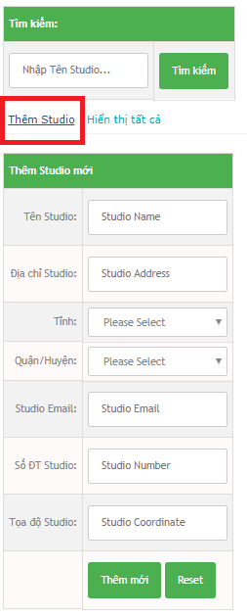

*Step 2:* Enter Studio Name on “Tên Studio “field.

ステップ 2:

* Studio Name rules :
  + Not special character.
  + Not empty. 空ではありません。
  + In range 6 ~ 32 character.

*Step 3:* Enter Studio Adress on “Địa chỉ Studio “field.

ステップ 3:

* Studio Adress rules :
  + Not empty. 空ではありません。
  + In range 6 ~ 32 character.

*Step 4:* Select “Tỉnh “.

ステップ 4:

*Step 5:* Select “Quận / Huyện “.

ステップ 5:

Step 6 : Enter Studio Mail on Studio Email field.

ステップ 6:

* Studio Email rules : スタジオ電子メールのルール：
  + Correct form.([abc@abc.abc)](mailto:abc@abc.abc)) 正しい形式（abc@abc.abc）
  + Not empty. 空ではありません。
  + Just allow “@ “, “. “character. “@ “、 “。 “キャラクター。
  + In range 6 ~ 32 character. 範囲は6〜32文字です。

Step 7 : Enter Studio Number on “Số ĐT Studio “field.

ステップ 7: “Số ĐT Studio “フィールドにスタジオ番号を入力します。

* Studio Number rules : スタジオ番号の規則：
  + Must be number. 数字であること。
  + Not empty. 空ではありません。
  + In range 10 ~ 12 character. 範囲は10〜12文字です。

Step 8 : Enter Studio Coordinate on “Tọa độ Studio “field. “Tọa độ Studio “フィールドにスタジオ座標を入力します。

ステップ 8:

* Studio Coordinate rules : Studio Coordinateのルール：
  + Not empty. 空ではありません。
  + Correct form. (Float number , Float number). 正しい形式。 （フロート数、フロート数）。

Step 9 : Click “Thêm mới “button.

ステップ 9: “Thêm mới “ボタンをクリックします。

Reset button to clear all text field. すべてのテキストフィールドをクリアするためにリセットボタンをクリック。

### District Manager /地区マネージャー。

Click “Quản lí tỉnh thành “link to display District manager form.

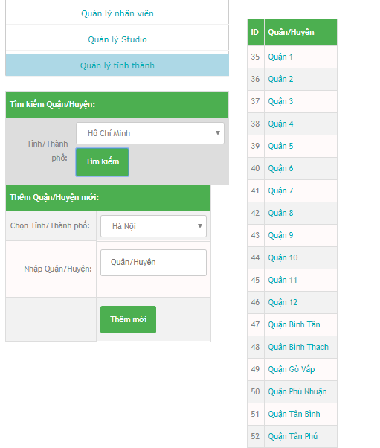地区マネージャーフォームを表示するには、 “Quản lí tỉnh thành “リンクをクリック。

### Search District /地区の検索

*Step 1:* Select “Tỉnh / Thành phố “.

ステップ 1: “ “Tỉnh / Thành phố “ “を選択します。

*Step 2:* Click “Tìm kiếm “button.

ステップ 2: “Tìm kiếm “ボタンをクリックします。

### Add new District/新しい地区を追加します。

*Step 1:* Choose “Tỉnh / Thành Phố “.

ステップ 1: “Tỉnh/ThànhPhố “を選択します。

*Step 2:* Enter new District on “Nhập Quận / Huyện “field.

ステップ 2: “Nhập Quận/Huyện “欄に新しい地区を入力します。

* New Dictrict rules : 新しいDictrictルール
  + Not special character. 特殊文字ではありません。
  + Not empty. 空ではありません。
  + In range 6 ~ 32 character. 範囲は6〜32文字です。

*Step 3:* Click “Thêm mới “button.

ステップ 3: “Thêm mới “ボタンをクリックします。

## Manager Guidelines.マネージャガイドラン。

### **Login ログイン**

*Step 1:* Click “Đăng nhập “on header in Home Page. System will display the Login page.

ステップ 1: “Đăng nhập “をクリックします。 ログインページが表示されます。

*Step 2:* Enter login credentials and click “Đăng nhập “to log in.

ステップ 2: ログイン資格情報を入力し、ログインのために “Đăng nhập “をクリック。

* After login Manager page will be display.

ログインマネージャページが表示されます。

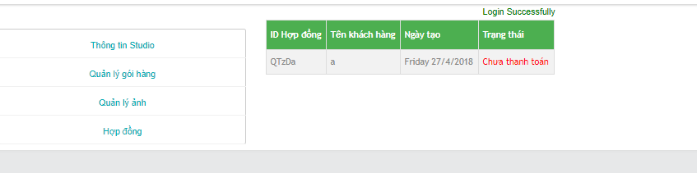

### Logoutログアウト

Click “Đăng xuất “in the top right corner.

右上隅にある “Đăng xuất “をクリックします。

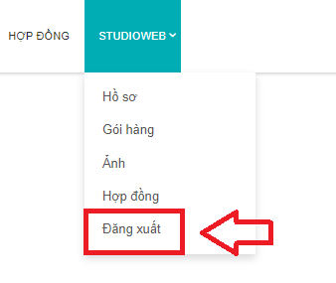

### Studio Profileスタジオのプロフィール

Click “Thông tin Studio “link to display Studio Profile form.

“Thông tin Studio “リンクをクリックすると、スタジオのプロフィールフォームが表示されます。

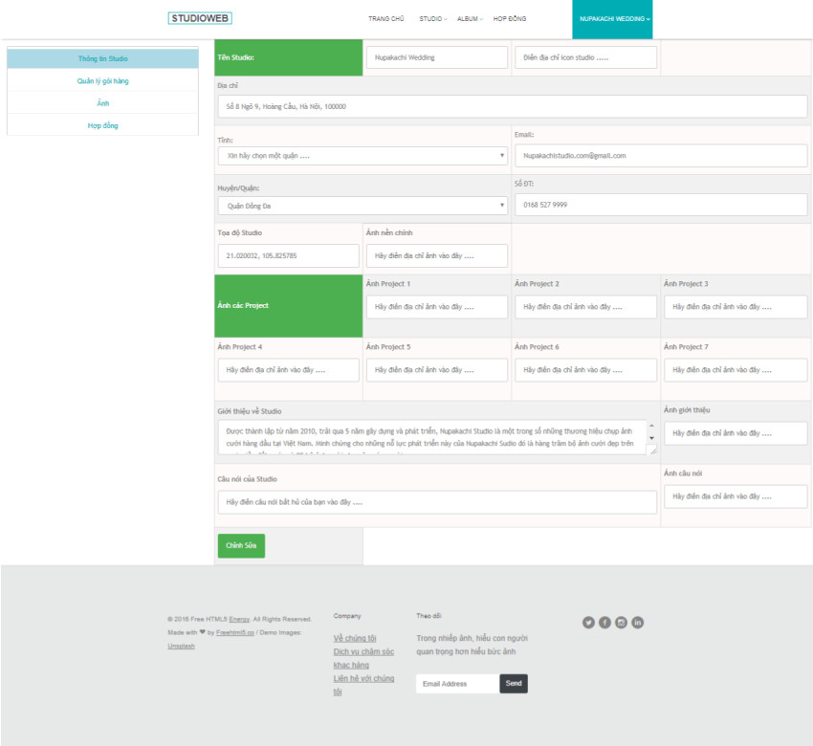

### Edit Studio Profile / スタヂオプロフィールを編集

*Step 1:* Edit field want to edit.

ステップ 1：編集したいフィールドを編集します。

*Step 2:* Click “Chỉnh sửa “button.

ステップ 2： “Chỉnh sửa “ボタンをクリックします。

### Package Manager ・パッケージマネージャー

Click “Quản lí gói dịch vụ “link to display Package Manager form.

パッケージマネージャフォームを表示するには、 “Quản lí gói dịch vụ “リンクをクリックします。

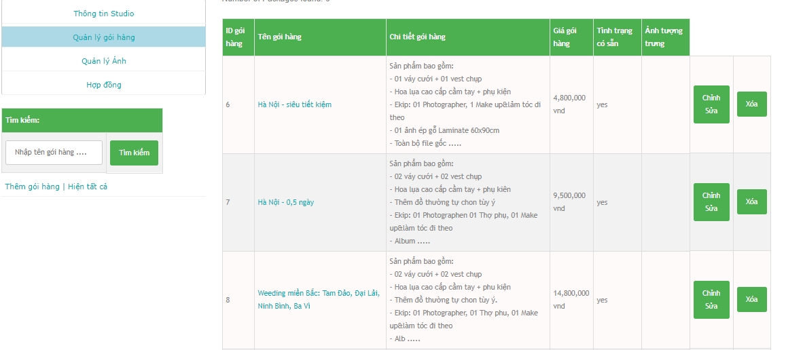

### Search Package 検索パッケージ

Option 1 : Click “Hiển thị tất cả “link to display all package.

オプション 1: すべてのパッケージを表示するには、リンクをクリックします。

Option 2 :

オプション 2:

*Step 1:* Empty Search field.

ステップ 1: 空の検索フィールド。

*Step 2:* Click Search button. All package will be display.

ステップ 2: 検索ボタンをクリックします。すべてのパッケージが表示されます。

Option 3 :

オプション 3:

*Step 1:* Enter correct or a part of Package Name to search field.

ステップ 1: フィールドを検索するためにパッケージ名またはパッケージ名の一部を入力します。

*Step 2:* Click Search button, All package have package name like search value will be display.

ステップ 2: 検索ボタンをクリックすると、検索値とおなじようなパッケージ名があるすべてのパッケージが表示されます。

### Edit Package ・パッケージの編集

*Step 1:* Click “Chỉnh Sửa “ button to display Edit Package form.

ステップ 1: パッケージの編集フォームを表示するには “ Chỉnh Sửa “ボタンをクリックします

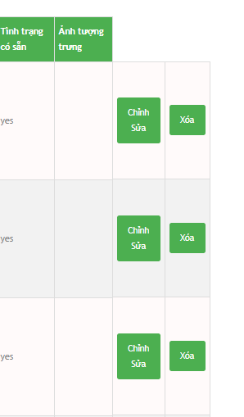

Step 2: Enter new Package Name. 新しいパッケージ名を入力します。

ステップ 2:

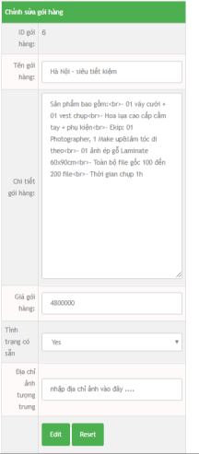

* New Package Name rules : 新しいパッケージ名規則：
  + Not special character. 特殊文字ではありません。
  + Not empty. 空ではありません。
  + In range 6 ~ 32 character. 範囲は6〜32文字です。

*Step 3:* Enter new Package Detail.

ステップ 3: 新しいパッケージの詳細を入力します。

* New Package Detail rules : 新しいパッケージ詳細ルール：
* Not empty. 空ではありません。

*Step 4:* Enter new Package Price.

ステップ 4: 新しいパッケージ価格を入力してください。

* New Package Price rules : 新しいパッケージ価格ルール：
  + Must be number bigger than 0. 00.0より大きい数字であること

*Step 5:* Select Package Availability.

ステップ 5：パッケージ可用性を選択します。

Step 6 : Click Edit button.

ステップ 6 : “EDIT “ボタンをクリックします。

Reset button to clear all field.

すべてのフィールドをクリアするするにはリセットボタンをクリック。

### Delete Package. パッケージを削除します。

*Step 1:* Click “Xóa “ button.

ステップ 1: “Xóa “ボタンをクリックします。

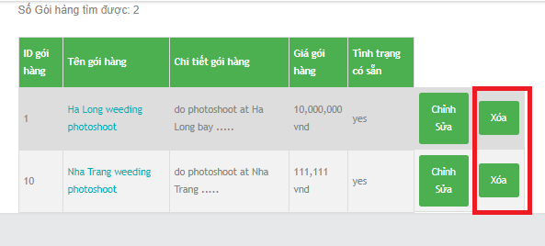

*Step 2:* Click OK button on confirm window.

ステップ 2: 確認画面で “OK “ボタンをクリックしてください。



### Picture Manager 画像マネージャ

Click “Quản lý ảnh “link to display Picture Manager.

画像マネージャを表示するには、 “Quản lý ảnh “リンクをクリックします。

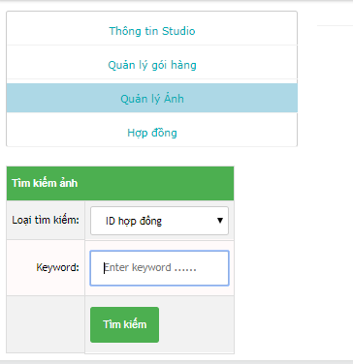

### Search Contract Detail by keyword/キーワード別検索契約の詳細

Option 1 :

オプション 1

*Step 1:* Select Search Type is “ID hợp đồng “.

ステップ 1: 検索タイプの選択は “ID hợp đồng “である。

*Step 2:* Enter correct ContractID on keyword field.

ステップ 2: キーワードフィールドに正しいContractIDを入力します。

*Step 3:* Click “Tìm kiếm “button.

ステップ 3: “Tìm kiếm “ボタンをクリックします。

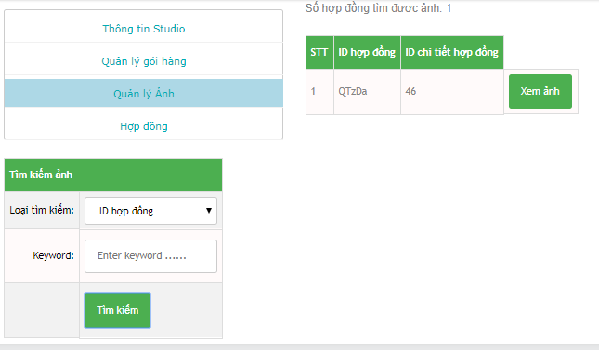

Option 2 :

オプション 2:

*Step 1:* Select SearchType is “Tên khách hàng “.

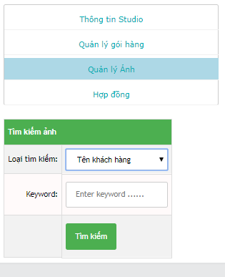

ステップ 1: 検索タイプを選択するには、 “Tên khách hàng “をクリックします。

*Step 2:* Enter correct or a part of Customer Name on keyword field.

ステップ 2: キーワードフィールドに顧客名の一部または全部を入力します。

*Step 3:* Click “Tìm kiếm “button.

ステップ 3: “Tìm kiếm “ボタンをクリックします。

### View Picture写真を見ます

Click “Xem ảnh “button to open Picture Detail page.

“Xem ảnh “ボタンをクリックすると、写真の詳細ページが開きます。

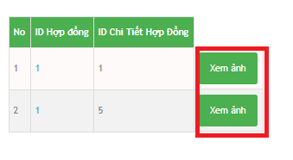

### Search Picture検索画像

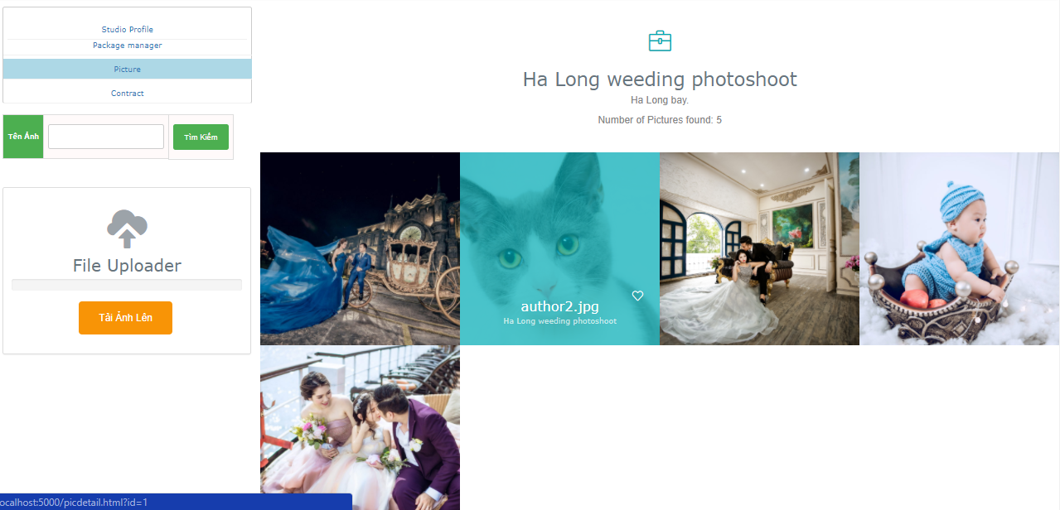

*Step 1:* Enter correct or a part of Picture Name on “Tên Ảnh “field.

ステップ 1: “Tên Ảnh “欄に画像名の一部または全部を入力します。

*Step 2:* Click “Tìm Kiếm “button.

ステップ 2: “Tìm Kiếm “ボタンをクリックします。

### Upload Picture

*Step 1:* Click “Tải Ảnh Lên “button.

ステップ 1: “Tải Ảnh Lên “ボタンをクリックします。

*Step 2:* Choose picture file on computer.

ステップ 2: コンピュータ上の画像ファイルを選択します。

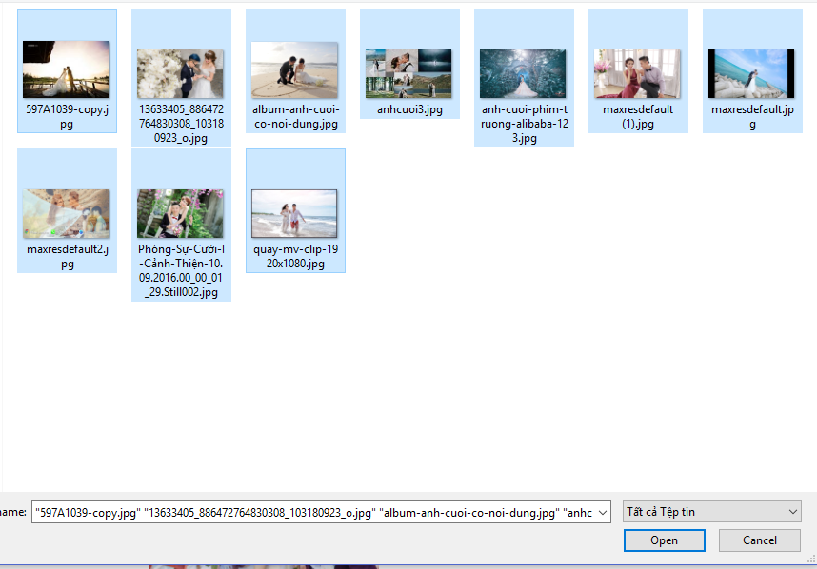

*Step 3:* Click “Open” button.

ステップ 3: “OPEN “ボタンをクリックします。

### Update Picture Detail 写真の詳細を更新します。

*Step 1:* Click Picture want to update to open Picture Detail form.

ステップ 1: “ピクチャ詳細 “フォームを開くために更新したいピクチャをクリックします。

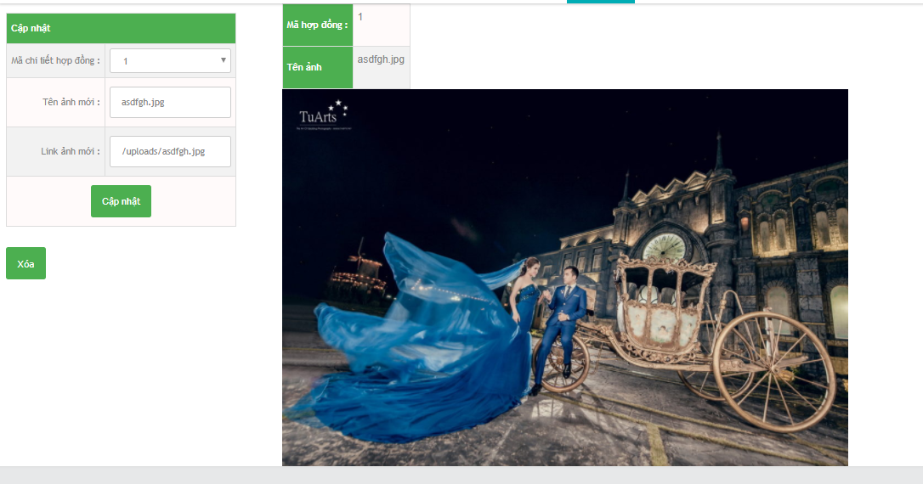

*Step 2:* Select “Mã chi tiết hợp đồng “.

ステップ 2: “Mã chi tiết hợp đồng “を選択します。

*Step 3:* Enter new Picture Name in “Tên ảnh mới “field.

ステップ 3: 新しい画像名を “Tên ảnh mới “フィールドに入力します。

*Step 4:* Enter new Picture URL on “Link ảnh mới “field.

ステップ 4: “Link ảnh mới “フィールドに新しい画像URLを入力します。

*Step 5:* Click “Cập nhật “button.

ステップ 5: “Cậpnhật “ボタンをクリックします。

### Delete Picture. 画像を削除します。

*Step 1:* Click Picture want to delete to open Picture Detail form.

ステップ 1: “画像を削除する “をクリックして、 “画像の詳細 “フォームを開きます。

*Step 2:* Click “Xóa “button.

ステップ 2: “Xóa “ボタンをクリックします。

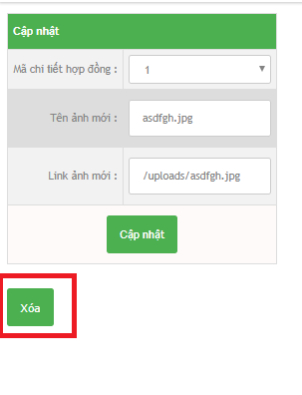

*Step 3:* Click OK button on confirm window.

ステップ 3: 確認ウィンドウで “OK “ボタンをクリックします。



### Contract Manager 契約マネージャー

Click “Hợp đồng “link to open Contract Manager page.

契約マネージャーページを開くために “Hợp đồng “リンクをクリック、。

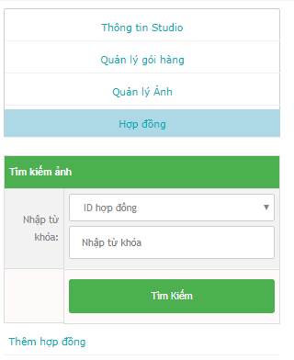

### Search Contract 検索契約

Option 1 : オプション 1

*Step 1:* Empty keyword field.

ステップ 1: 空のキーワードフィールド。

*Step 2:* Click “Tìm kiếm “button. All Contract will be display.

ステップ 2: “Tìm kiếm “ボタンをクリックします。すべての契約が表示されます。

Option 2 : オプション 2

*Step 1:* Select Seach type is “ID hợp đồng “.

ステップ 1: 選択するタイプは “ID hợp đồng “です。

*Step 2:* Enter correct Contract ID in “Nhập từ khóa “field.

ステップ 2: “Nhập từ khóa “フィールドに正しい契約IDを入力します。

*Step 3:* Click “Tìm kiếm “button. All Contract have Contract ID equal Search value will be display.

ステップ 3: “Tìm kiếm “ボタンをクリックします。検索値とおなじような契約IDがある契約が表示されます。

Option 3 :

*Step 1:* Select Search type is “Tên khách hàng “.

検索タイプを “Tên khách hàng “を選択します。

ステップ 1:

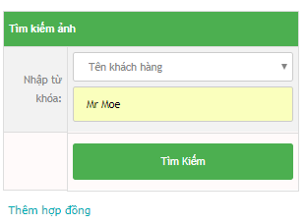

*Step 2:* Enter correct or a part of exsit Customer Name on “Nhập từ khóa “field.

“Nhập từ khóa “欄にお客様の氏名の一部または全部を入力します。

ステップ 2:

*Step 3:* Click “Tìm kiếm “button. All Contract have Customer Name like Search value will be display.

ステップ 3: “Tìmkiếm “ボタンをクリックします。検索値とおなじような顧客名があるすべての契約が表示されます。

Option 4 : オプション4：

*Step 1:* Select Search type is “Số ĐT khách hàng “.

ステップ 1: 検索タイプを “Số ĐT khách hàng “にします。

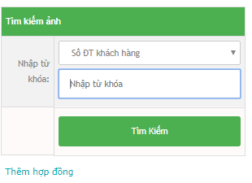

*Step 2:* Enter correct or a part of exsit Customer Phone on “Nhập từ khóa “field.

ステップ 2: “Nhập từ khóa “欄に顧客電話番号の一部または全部を入力します。

*Step 3:* Click “Tìm kiếm “button. All Contract have Customer Phone like keyword value will be display.

ステップ 3: “Tìm kiếm “ボタンをクリックします。キーワードの値とおなじような観客電話番号があるすべての契約が表示されます。

Edit Contract. 契約の編集

*Step 1:* Click “Sửa “button to display Edit Contract form.

ステップ 1:契約編集フォームを表示するには、 “Sửa “ボタンをクリックします。



*Step 2:* Select “Tình trạng hợp đồng “.

ステップ 2: “Tình trạng hợp đồng “を選択します。

*Step 3:* Edit field want to edit.

ステップ 3: 編集したいフィールドを編集します。

* Edit Contract rules : 契約ルールの編集
  + Customer Name : 顧客名
    - Not empty. 空ではありません。
    - Not special character. 特殊文字ではありません。
    - In range 6 ~ 32 character. 範囲は6〜32文字です。
    - Not number. 番号ではありません。
  + Address : 住所
    - Not empty. 空ではありません。
    - In range 6 ~ 32 character. 範囲6〜32文字
  + Gender : 性別
    - Just select only one. 1つだけを選択する.
  + Phone : 電話
    - Not empty. 空ではありません。
    - Must be number. 番号であること.
    - In range 10 ~ 12 character. 範囲は10〜12文字です。
  + Email : 電子メール
    - Must be correct form. 正しい形式でなければなりません.
    - Not empty. 空ではありません。
    - Just allow '@','.' character. '@' '、' '。'を許可するだけです。キャラクター。
    - In range 6 ~ 32 character. 範囲は6〜32文字です。
  + Studio working : スタジオウォーク：
    - Must choose 選択する必要があります。
    - Name of product: 製品名
    - Must choose 選択する必要があります。
    - Package detail : パッケージの詳細：
    - Not empty：
  + Contract detail : 契約の詳細
    - Not empty
    - Create date : 作成日
    - Must choose. 選択する必要があります。
    - Must smaller or equal with Start date and End Date. 開始日と終了日以下でなければなりません。
    - Start date : 開始日
    - Must choose. 選択する必要があります。
    - Must smaler or equal with End date. 終了日がより鈍いか等しい。
    - End Date : 終了日
    - Must choose bigger or equal with Create date and Start Date. 作成日と開始日より大きいか等しいかを選択すること。

*Step 4:* Click “Submit “button.

ステップ 4: “Submit “ボタンをクリックします。

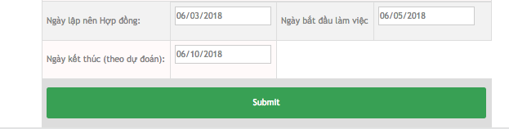

### Add Contract 契約を追加します。

*Step 1:* Click “Thêm hợp đồng “link to display Add Contract form.

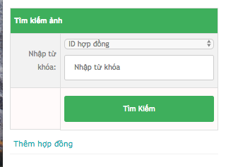ステップ 1: 契約書式を表示するには “Thêm hợp đồng “リンクをクリックします。

*Step 2:* Select Contract status.

ステップ 2: 契約ステータスを選択します。

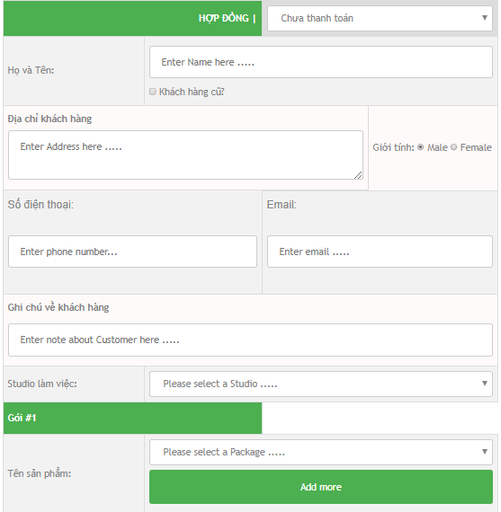

*Step 3:* Enter Customer Name

ステップ 3: 顧客名を入力します。

* + Customer Name rules :
  + Not empty. 空ではありません。
  + Not special character. 特殊文字ではありません。
  + In range 6 ~ 32 character. 特殊文字であること。
  + Not number. 番号ではありません。

*Step 4:* If Customer is old Customer Click checkbox “Khách hàng cũ? “to skip enter Adress, Gender, Email, Note.

ステップ 4: 古い顧客の場合は、 アドレス、性別、電子メール、注記 “をスキップするために、 “Khách hàng cũチェックボックスをクリック

*Step 5:* Enter Customer Adress on “Địa chỉ khách hàng “field.

ステップ 5: “Địa chỉ khách hàng “欄に顧客の住所を入力します。

* Adress rules : 住所規則：
* Not empty. 空ではありません。
* In range 6 ~ 32 character. 範囲は6〜32文字です。

Step 6 : Select Gender

ステップ 6: 性別を選択します。

Step 7 : Enter Customer Phone on “Số điện thoại “field.

ステップ 7: “Số điện thoại “欄に顧客電話番号を入力します。

* Phone rules : 電話規則：
  + Not empty. 空ではありません。
  + Must be number. 番号でなければなりません。

Step 8 : Enter Customer Email on Email field.

ステップ 8: “電子メールフィールドに顧客の電子メールを入力 “。

* Email rules : メールルール：
  + Must be correct form. 正しい形式でなければなりません。
  + Not empty. 空ではありません。
  + Just allow '@','.' character. '@'、 '。'を許可するだけです。キャラクター。
  + In range 6 ~ 32 character. 範囲は6〜32文字です。

Step 9 : Enter Note or not on “Ghi chú về khách hàng “field.

ステップ 9: “Ghi chú về khách hàng “フィールドにノートするかしないか入力します。

Step 10 : Select Package in “Tên sản phẩm “dropdown list.

ステップ10： "Tên Sản phẩm"ドロップダウンリストでパッケージを選択します。

If Customer buy more than one Package. Click “Nhập thêm “button to add more package.

ステップ 10: 観客が追加で購入する場合は、パッケージを追加するには “Nhập thêm “ ボタンをクリックします。

Step 11 : Enter Note or not on “Ghi chú : “field.

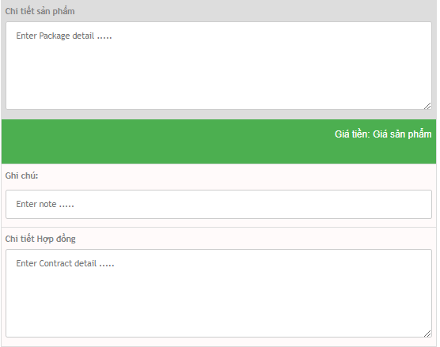

ステップ 11: “Ghi chú： “フィールドにノートまたはないを入力しますStep 12 : Enter Contract Detail on “Chi tiết hợp đồng “field.

ステップ 12: “Chi tiết hợp đồng “フィールドに契約の詳細を入力します。

Step 13 : Select “Ngày lập nên hợp đồng “.

ステップ 13: “Ngàylậpnênhợpđồng “を選択します。

Step 14 : Select “Ngày bắt đầu làm việc “.

ステップ 14: “Ngàybắtđầulàmviệc “を選択します。

Step 15 : Select “Ngày kết thúc ( theo dự đoán ) “.

ステップ 15: “**Ngày kết thúc（theo dự đoán） “を選択します。**

Step 16 : Click “Nhập “.

ステップ 16: “Nhập “をクリックします。

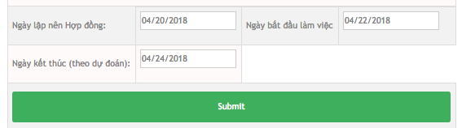

### View Contract Detail. 契約の詳細を表示します。

Click “ID Hợp đồng “link to open Contract Detail page.

契約の詳細ページを開くには “ID Hợp đồng “リンクをクリックします。

### Edit Contract Detail. 契約の詳細を編集します。

*Step 1:* Click “Sửa “button.

ステップ 1: “Sửa “ボタンをクリックします。

*Step 2:* Edit field want to edit.

ステップ 2: 編集したいフィールドを編集します。

*Step 3:* Click “Chỉnh sửa “button.

ステップ 3: “Chỉnhsửa “ボタンをクリックします。

### Delete Contract Detail. 契約の詳細を削除します。

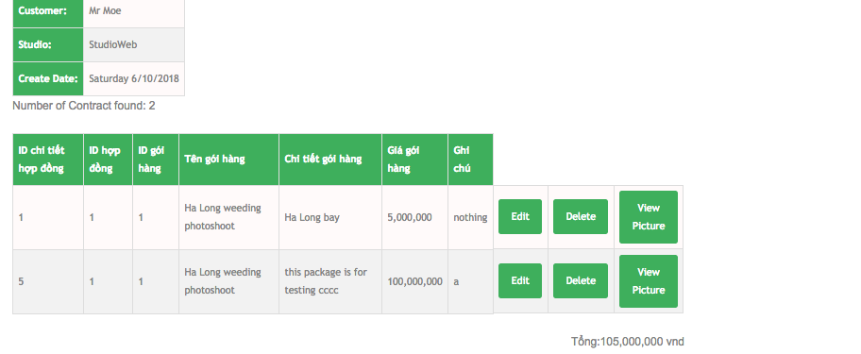

*Step 1:* Click “Xóa “button.

ステップ 1: “Xóa “ボタンをクリック。

*Step 2:* Click OK button on confirm window.

ステップ 2: 確認ウィンドウで “OK “ボタンをクリックします。

### View Picture form Contract Detail. 画像形式の契約の詳細を表示します。

Click “Xem ảnh “button to open Picture Detail Page.

画像の詳細ページが開くには “Xem ảnh “ボタンをクリックします、。

### Add new Picture Detail. 新しい画像の詳細を追加します。

*Step 1:* Click “Thêm mới chi tiết hợp đồng “link to display Add new Picture Detail form.

ステップ 1: “Thêm mới chi tiết hợp đồng “フォームが表示されるように、 “リンクをクリック “をクリックします。

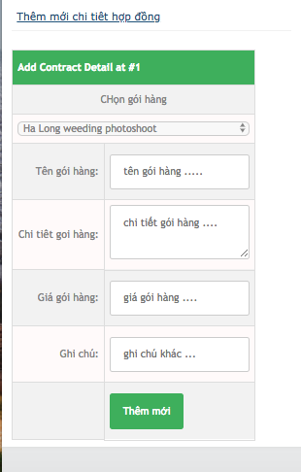

*Step 2:* Enter Package Name on “Tên gói dịch vụ “field.

ステップ 2: “Tên gói dịch vụ “欄にパッケージ名を入力します。

* Package Name rules : パッケージ名規則：
  + Not special character. 特殊文字ではありません。
  + Not empty. 空ではありません。
  + In range 6 ~ 32 character. 範囲は6〜32文字です。

*Step 3:* Enter Package Detail on “Chi tiết gói dịch vụ “field.

ステップ 3: “Chi tiết gói dịch vụ “フィールドにパッケージの詳細を入力します。

* Package Detail rules : パッケージの詳細ルール：
  + Not empty. 空ではありません。 。

*Step 4:* Enter Package Price on “Giá gói dịch vụ “field.

ステップ 4: “Giá gói dịch vụ “欄にパッケージ価格を入力します。

* Package Price rules : パッケージ価格ルール：
  + Must be number bigger than 0. 0より大きい数であること。

*Step 5:* Enter Not or not on “Ghi chú “field.

ステップ 5: “Ghichú “フィールドにはNotを入力します。

Step 6 : Click “Thêm mới “ button.

ステップ 6: “Thêmmới “ボタンをクリックします。

## Customer Guidelines. 顧客ガイドライン。

### Open Home Page ホームページを開く。

Option 1 : Click “ StudioWeb “ logo on header.

オプション1：ヘッダの “StudioWeb “ロゴをクリックします。

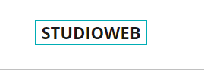

Option 2 : Click “Trang Chủ “button on header.

オプション2：ヘッダーの “TrangChủ “ボタンをクリックします。

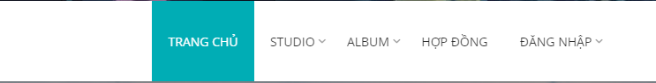

### View Studio Listスタジオリストを表示します。

Option 1 : Click “Studio” button on header.

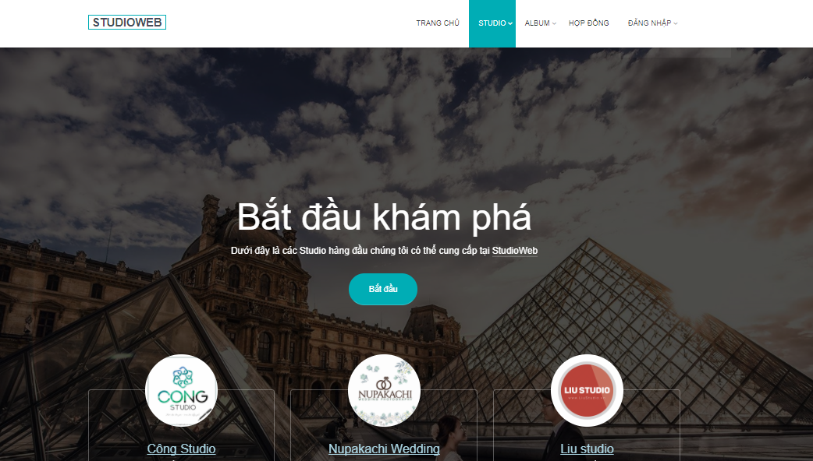オプション1：ヘッダー上の “Studio “ボタンをクリックします。

Option 2 : Click one in three Studios “Bắt đầu “ button on Home Page.

オプション2：ホームページの3つの “Bắt đầu “ボタンの1つをクリックします。

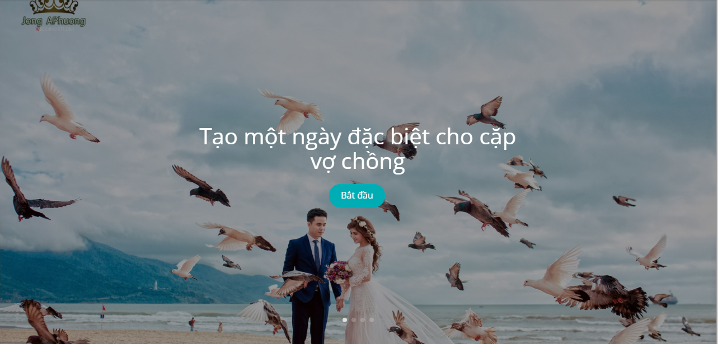

### View Studio Detail Page Studio Studioスタジオの詳細ページスタジオを表示する

Option 1 : オプション1 ：

*Step 1:* Take the mouse on Studio to open Studio list dropdown list.

ステップ 1: スタジオリストのドロップダウンリストを開くには、 スタジオでマウスを操作します、。

*Step 2:* Click Studio want to view.

ステップ 2: 見たいスタジオをクリックします。

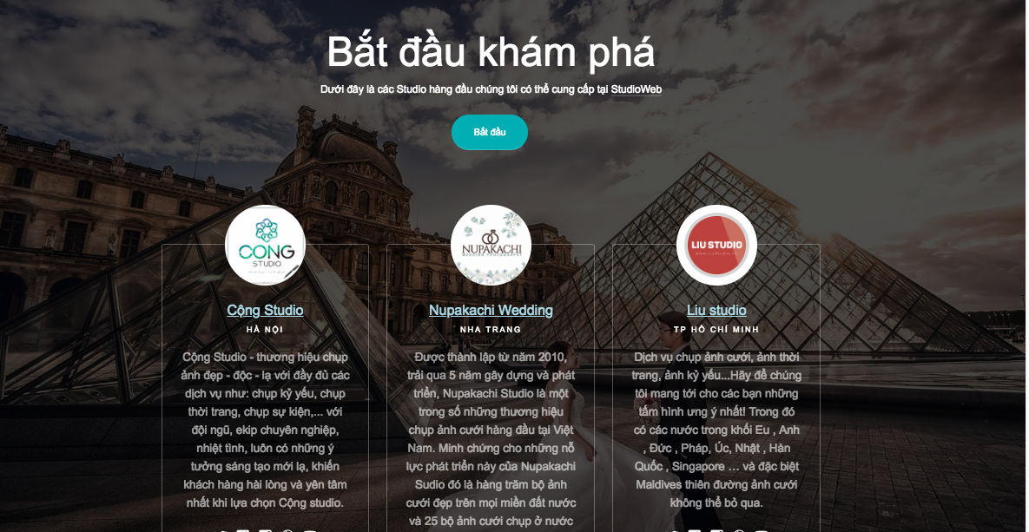

Option 2 :

*Step 1:* Click Studio button on header to open Studio list page.

ステップ 1: スタジオリストページを開くには、 ヘッダーのスタジオボタンをクリックします。

*Step 2:* Click Studio Name link to open Studio Detail page.

ステップ 2: スタジオの詳細ページを開くにはスタジオ名リンクをクリックします。、

### View Package Detailパッケージの詳細を表示します。

*Step 1:* On Studio Detail page. Scroll page to view list of Package.

ステップ 1: スタヂオの詳細ページ。パッケージのリストを表示するページをスクロールします。

*Step 2:* Click “Xem thêm “button to open Package Detail page.

ステップ 2：Package Detailページを開くためには “Xem thêm “ボタンをクリック

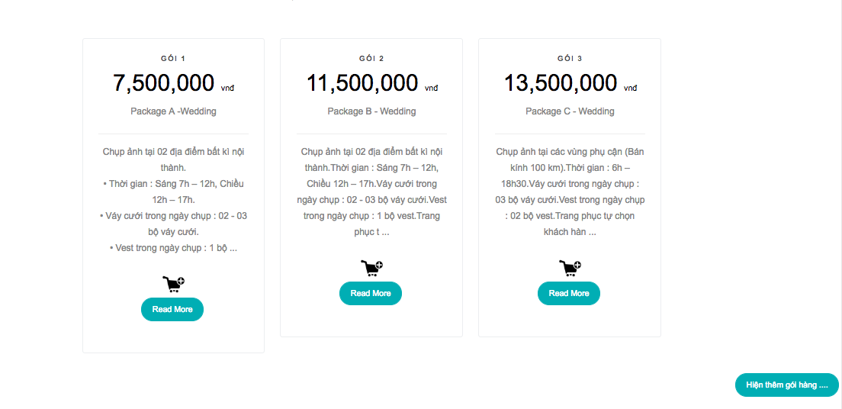

### Add Package on Cart. カートにパッケージを追加します。

*Step 1:* On Package list in Studio Detail. Click Cart icon of Package want to buy.

ステップ 1: スタジオの詳細のパッケージリスト購入したいパッケージのカートアイコンをクリックしてください。

*Step 2:* Click Open Cart button Cart Detail page.

ステップ 2: カートを開くボタンをクリックします。カートの詳細ページ。

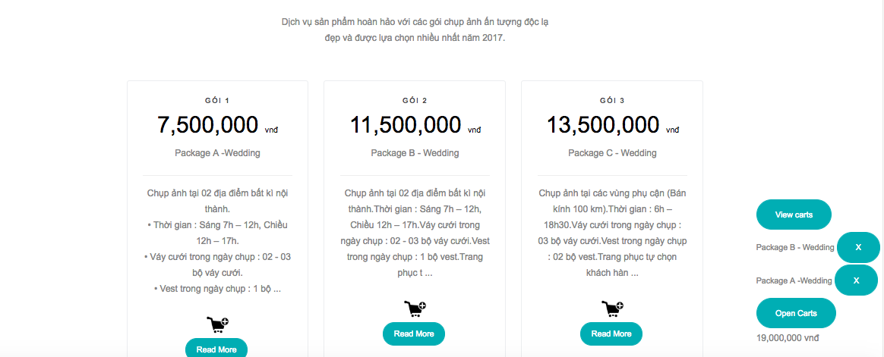

*Step 3:* Enter Name on ”Tên khách hàng “field.

ステップ 3:“ Tên khách hàng“ フィールドに名前を入力します。

*Step 4:* Select Gender.

ステップ 4: 性別を選択します。

*Step 5:* Enter Phone Number on “Số ĐT khách hàng “field.

ステップ 5:“ Số ĐT khách hàng“ 欄に電話番号を入力します。

Step 6 : Enter Customer Email on Customer Email field.

ステップ 6: 顧客電子メールに顧客電子メールを入力します。

Step 7 : Enter Customer Facebook link on Customer Facebook field.

ステップ 7: 顧客のFacebookフィールドにCustomer Facebookのリンクを入力します。

Step 8 : Enter Note or not on Note field.

ステップ 8: メモフィールドに注釈を入力するか否かを入力します。

Step 9 : Click Buy button.

ステップ 9:購入ボタンをクリックします。

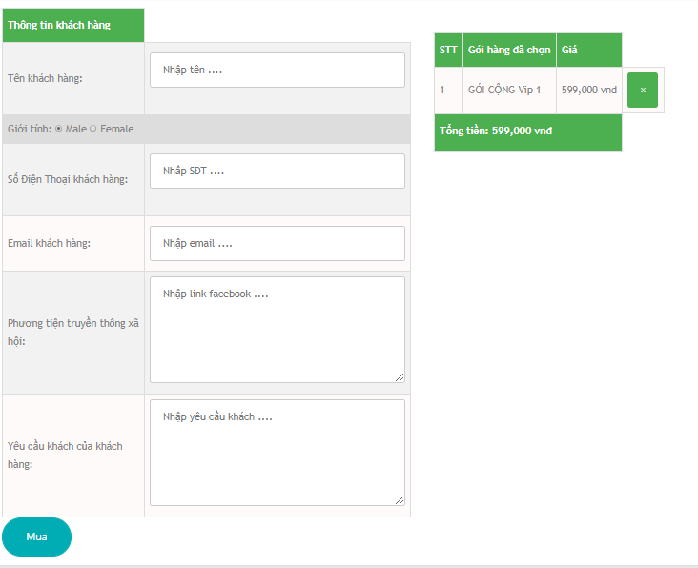

### View review Album. アルバムを見ます。

Click “Album” button on header to display review album on Studio.

ヘッダーの “Album “ボタンをクリックすると、スタジオにレビューアルバムが表示されます。

### View one of Album type. アルバムタイプの1つを表示します。

*Step 1:* Click on Album header in menu.

ステップ 1: ヘッダーのアルバムボタンにマウスを移動します。

*Step 2:* Click one of Album type in Album list dropdown list.

ステップ 2: アルバムリストドロップダウンリストでアルバムタイプをクリックします。

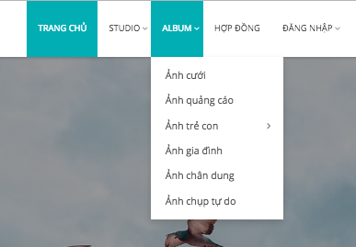

### Show own Contract. 自分の契約を表示します。

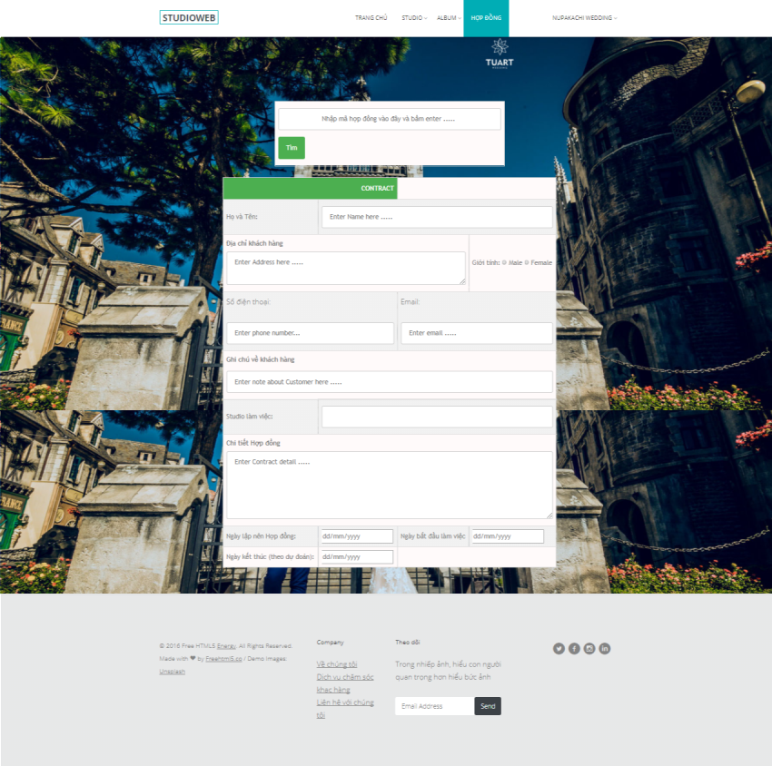

*Step 1:* Click Contract button on header.

ステップ 1: ヘッダーの契約ボタンをクリックします。

*Step 2:* Enter Contract code to display Customer contract.

ステップ 2: 顧客契約を表示するために契約コードを入力します。

### Show About Us. 私たちについて

Click “Về chúng tôi “link on footer to open About us page.

私たちに関してはページを開くためにフッターの “Về chúng tôi “リンクをクリックします。

